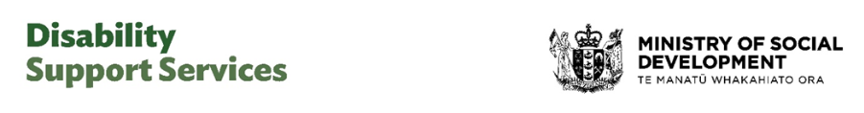
9 February 2026

Update on improvements to assessment, allocation and flexible funding
This update is about delivering the first stage of improvements to the way Disability Support Services (DSS) funds support for disabled people, families, whānau and carers.
In September 2025, the Government announced improvements to disability support services.
The changes are informed by what the disability community told us.
These changes are about:
- making the system fairer and more consistent.
- giving disabled people more choice and control over their flexible funding.
- the first of these improvements begin from mid-February.

What is happening in February
The February changes are about improving the way disabled people’s needs are assessed and funding is allocated for supports.
From mid-February, all NASCs (Needs Assessment Service Co-ordination organisations) and Enabling Good Lives sites will begin to assess people’s needs and allocate funding in the same way.
This will make things fairer and more consistent across the country, no matter where you live.

Who the February changes affect
You will experience these changes if you are applying for the first time, or when you have a reassessment in the future.

What will be different
Before the assessment, you will receive clear information on what to expect.
Families’ and carers’ needs may also be part of the assessment, if their support is important to the disabled person’s needs and wellbeing.
After your assessment, you will have a clear plan focused on your needs and the purpose of your funding and supports.
These changes respond to feedback from the disability community that the process has been confusing and inconsistent.

What is happening in April
You will get more choice and control over how you use your flexible funding on supports for your disability needs.
The purchasing rules will be removed.
If you get flexible funding, you will be given a budget so you know how much you can spend.
You are expected to stay within your budget.
There will be support if you need it to help manage your budget.

How will budgets be set?
Your budget will be based on what you were spending between June 2023 and June 2025.
If your assessed needs and funding have changed recently, that will be taken into account too.
No one will get less than what they have previously spent.

When will disabled people hear more about their budgets?
We will let people know about their budgets for flexible funding ahead of the April changes.
You don’t need to do anything now.
Your NASC, Enabling Good Lives site or hosts will continue to support you to navigate the system.
Remember, the purchasing rules still apply until April. This is the case even if you have just had an assessment.
Thank you to the disability community for your feedback and patience as we begin to deliver these improvements.

More information
There is more information about the changes on the Disability Support Services website at www.disabilitysupport.govt.nz/dsschanges
End of Update on improvements to assessment, allocation and flexible funding
This Large Print document is adapted by Blind Citizens NZ from the standard document provided by Disability Support Services | Ministry of Social Development

