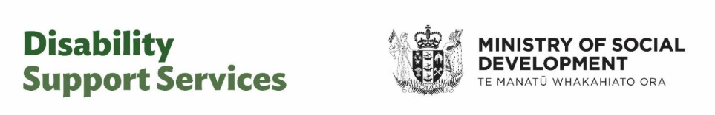

Information to help you prepare for your assessment or re-assessment
Your assessment conversation will be with a Needs Assessment and Service Co-ordination agency (NASC) or an Enabling Good Lives (EGL) site.
The purpose of a needs assessment is to have a conversation with you, so we can understand:
- your day-to-day life – how things are right now, for you, your whānau and carers;
- what types of support might help you, your whānau and carers live the life you want;
- how much support you need and at what times of the day.
To give you time to think about the things you would like to share, and what is important for us to know, here is a list of topics that your NASC or EGL site may discuss with you.
Not all these topics may relate to you and your situation. They are examples to help you prepare. You may find it helpful to make notes and bring these with you.
Your daily routines – what are your daily routines, what helps to make the harder parts of the day easier, when are you at your busiest?
The important people in your life – who is important, who provides support, how do you maintain relationships, and what helps your supporters be available?
Your involvement outside of your home – what is your involvement in your community? Do you participate in education, work, cultural or recreational activities? Are there other opportunities you would like to get involved in?
Your skills and knowledge – what are your life skills, strengths, and interests? How do these help you learn and make you happy?
Keeping yourself safe – how do you keep yourself safe and manage any risks?
Your decisions and choices – what do you make decisions about?
If you have carers – how do they take a break? How do they maintain balance in their life, and what else could help them to do that?
If this is a re-assessment – has your situation changed since your last assessment?

After your assessment conversation

You will be sent a summary of your conversation
After you have had your assessment conversation, your NASC or EGL site, will send you a summary of your conversation. It is important this summary accurately reflects your needs and the conversation you had with your NASC or EGL site.
You will have time to review this summary. You can talk to your family, whānau or a trusted support person about it.
It is important you tell your NASC or EGL site if you agree or if anything needs to change. You can also provide extra information. If your NASC or EGL site does not hear from you or cannot contact you, in some cases this may delay your supports being allocated.

Your NASC or EGL will recommend supports
If this is your first assessment: Your NASC or EGL site will determine if you are eligible for DSS-funded support. They will then talk with you about the types of support that are available, and the ways it can be provided.
Not every disabled person who has an assessment is eligible for DSS-funded support. If you are not eligible, the NASC or EGL site may recommend other types of support that could help you and your whānau and carers.
If you are having a re-assessment: Your NASC or EGL site will consider any changes in your situation and needs, and the DSS-funded support you are eligible for. They will talk with you about the types of support that are available, and the ways it can be provided. They may also recommend other types of support that could help you and your whānau and carers.

If you are not happy with the outcome
If you are unhappy with a decision by your NASC or Enabling Good Lives site, first talk with them to try and find a solution. You can ask your NASC or Enabling Good Lives site for a review of any part of your assessment process, including decisions about your support allocation.
The DSS website has more information on seeking a review, giving feedback or making a complaint: www.disabilitysupport.govt.nz/feedback. If you have no internet access, call 0800 566 601 – choose option 1 to reach DSS – Monday to Friday 8:30am to 5pm.
The Health and Disability Commissioner website has information on the rights of people who use health and disability services: www.hdc.org.nz. Or you can call 0800 11 22 33.
If you are Deaf, hard of hearing, deafblind, speech impaired or find it hard to talk, you can use the New Zealand Relay Service. Go to www.nzrelay.co.nz
End of information | Information to help you prepare for your assessment or re-assessment
This Large Print document is adapted by Blind Citizens NZ from the standard document provided by Disability Support Services

