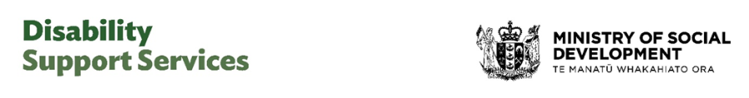
March/April 2026 - Factsheet

More choice, control, and certainty for disabled people with flexible funding

Changes from 1 April 2026 will give more choice, control, certainty, and continuity for disabled people who use flexible funding.
These changes affect people who get flexible funding – including Individualised Funding, Carer Support and some hosted Enabling Good Lives Personal Budgets. (They do not apply to Choice in Community Living.)
The changes reflect feedback from the disability community during consultation in 2025.

From 1 April:
- allocated budgets for flexible funding will continue the same as they are now.
- the purchasing rules for flexible funding will be removed.
- there will be more support to help people manage their flexible funding in line with their plan.

Allocated budgets for flexible funding
Your allocated budgets for flexible funding will continue the same as they are now.
Earlier we said that we would set new budgets by looking at what people spent in previous years.
We no longer need to do that.
We have worked to stabilise the system and the way people’s needs are assessed and funding is allocated.
This means people’s current flexible funding allocations will not change.

Purchasing rules
The purchasing rules for flexible funding will be removed form 1 April.
You must still use your flexible funding in line with your plan and disability needs – but you will have more choice over what supports work for you. This includes respite options for carers.
You need to keep your spending within your allocated budgets.
Flexible funding still cannot be used for drugs, alcohol, tobacco, gambling or illegal activities.
A few purchases will need pre-approval, such as:
- overseas travel.
- equipment – to confirm it is safe and right for your needs.
- complementary therapies that are not publicly funded.
- repeat purchases of similar items before the expected life of the item has expired.
- one-off purchases over the approval limit. For most people, the approval limit is $1,500. For a few people who have frequent support from their Host, the approval limit is $500.

More support
There will be more support to help you manage your flexible funding.
Hosts will provide guidance for people who have hosted flexible funding (either Individualised Funding or hosted Enabling Good Lives personal budgets).
Support from Hosts can include help with planning, keeping records, budgeting, managing workers (if relevant), and ensuring spending fits your plan and budgets.
- The level of support will be based on your situation and experience managing their funding. For some it will be light touch while others will need active, frequent support.
- Your Host will be in touch with you sometime from April onwards to talk about your support.

More information
To learn more about the April changes go to the DSS website: https://www.disabilitysupport.govt.nz/dsschanges
End of information | More choice, control, and certainty for disabled people with flexible funding
This Large Print document is adapted by Blind Citizens NZ from the standard document provided by Disability Support Services, Ministry of Social Development

