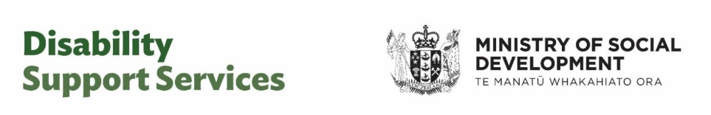
Information for people in tier 1: Managing your flexible funding and working with your host
This information sheet is for people who have hosted flexible funding and are in tier 1 of host guidance. It outlines your responsibilities to manage your flexible funding and the guidance you can expect from your host.

Hosted flexible funding
Hosted flexible funding means you have a flexible funding budget and a plan to arrange your own supports – and a host helps you to manage it.
Hosted flexible funding covers
- Individualised Funding (IF Personal Care, IF Household Management, IF Respite, Enhanced Individualised Funding).
- Hosted Enabling Good Lives Personal Budgets.
Your hosted flexible funding can be used for things that align with your funding plan and relate to your disability support needs.
If you are unsure about the purposes of your funding, your host can help you.

Tier 1 guidance
Everyone with hosted flexible funding gets guidance from their host.
There are four tiers which describe how often your host will check in and how much guidance you get.
- Tier 1 = minimal guidance.
- Tier 2 = occasional guidance.
- Tier 3 = regular guidance and coaching.
- Tier 4 = frequent and active guidance and coaching.
Your tier is based on your situation, your funding, and how experienced and confident you are managing your funding.
Your tier does not change how much funding you receive.
Being in tier 1 means:
- You are confident and experienced at managing your funding and meeting your responsibilities.
- You need minimal and infrequent guidance.
- Your host will talk with you at least once a year – but you can ask at any time.
Your tier can change over time. Your NASC or Enabling Good Lives site will consider your tier at your next assessment or review. Your host does not assign your tier.

Your responsibilities
These are your responsibilities when you are in tier 1.
If you are unsure about any of your responsibilities, your host can guide you.
You need to:
- Use your flexible funding in ways that relate to your disability support needs and align with your funding plan and the purposes of your funding.
- Self-verify your claims: this means it is up to you to make sure your claims are in line with your plan. There is a process for this – your host will show you what to do.
- Stay within your budget and make sure it lasts for your full funding period.
- Keep good records, including receipts, invoices, and employment records if you hire support workers.
- Send all receipts and invoices to your host, including invoices from independent contractors or self-employed people.
- Check if supports can be provided by other government agencies before using your flexible funding. Your host, NASC or Enabling Good Lives site can help you look at the options.
- Talk to your host before using your flexible funding for certain things, such as overseas travel, some equipment or purchases over a set limit. This is described below.
You cannot use your flexible funding for drugs, alcohol, tobacco, gambling or illegal activities.

When you must talk to your host before spending
You need to talk to your host about prior approval before you spend flexible funding on:
- Overseas travel
- Equipment;
- Complementary therapies;
- Repeat purchases of similar items before the item’s expected life is over;
- One-off purchases of items over $1,500.
Your host will tell you what information they need from you.
These discussions are about making sure the spending fits within your budget and aligns with your plan and purpose of your funding.

Your host’s responsibilities

Claims
Your host will process your claims.

Conversations
Near the end of your funding period, before your NASC or EGL site review, your host will talk with you about:
- The ways you are using your flexible funding.
- Does your spending meet the purposes in your funding plan?
- Are you having any difficulties managing your flexible funding?
- Are you getting the right amount of guidance and contact from your host?
- What is your plan for the coming year? Do you need to make any changes to your supports?

Questions and help
Contact your host at any time if you have questions about:
- using your flexible funding or making a claim;
- responsibilities like record keeping or employer obligations (if you hire workers);
- budgeting or how much flexible funding you have left.
Contact your NASC or Enabling Good Lives site if:
- your disability support needs have changed;
- you want to change the purposes in your funding plan.

More information
For more information on flexible funding, your responsibilities, host guidance and tiers, go to the Disability Support Services (DSS) website.
https://www.disabilitysupport.govt.nz/flexible-funding
[and https://tinyurl.com/mrhrw9ur]
End of information for people in tier 1: Managing your flexible funding and working with your host
This Large Print document is adapted by Blind Citizens NZ from the standard document provided by Disability Support Services, Ministry of Social Development

