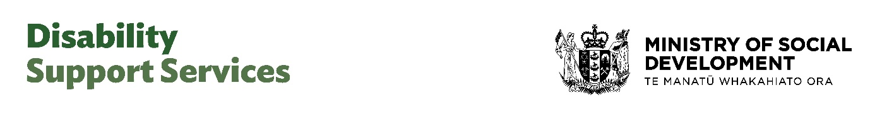

Fact sheet
Changes to assessments and allocations, and flexible funding
September 2025
This information is for disabled people, whānau, family and carers who use Disability Support Services (DSS).
From next year, there will be changes to DSS funded supports. These changes will make flexible funding easier to use. They follow on from very clear feedback received from the disability community earlier in the year.
The changes start from 1 February 2026 for people new to DSS. If you already get DSS funded supports, the changes start on 1 April 2026. Current arrangements remain in place until then.
The changes will apply to people who get their supports through a Needs Assessment Service Coordination (NASC).
At this stage, no changes are confirmed for Enabling Good Lives (EGL) sites. We are working with EGL Regional Leadership Groups to explore improvements for the different regions that EGL sites serve.

Main changes
- People will get more choice and control in their use of flexible funding.
- The purchasing guidelines will be removed.
- People who get flexible funding, will be provided with a budget for them to manage within.
- People will get guidance to help manage their budget. This will make flexible funding easier to use.
- All NASCs around the country will do their assessments the same way. This is so their decisions on support are fairer and more consistent.
- Families and carers will be included in assessments.

Assessment and allocation changes
All NASCs around the country will start doing their assessments the same way. This is to support a fairer and more consistent approach.
In the consultation we got feedback that the assessment can be stressful and confusing. People will get better information on the process and what they should expect.
Family, whānau and carers often play a critically important role in the support of disabled people.
Support for carers will be considered as part of the assessment process, where relevant to the needs of the disabled person.
Providing identifiable funding for this purpose will ensure relevant and helpful support for families and carers.
NASCs will develop a personal plan with disabled people to:
- focus on what the person wants and needs;
- address barriers linked to the person’s disability;
- be clear on the purpose of the funding.
Reassessments will be paused from February until October 2026. This will give NASCs time to implement these changes.
Disabled people can request urgent reassessments if their circumstances change.

Flexible funding changes
There are several changes for people who receive flexible funding through NASCs. These will make flexible funding easier to use.
- Purchasing guidelines, including the March 2024 changes, will be removed next year.
- Disabled people will be able to choose how they spend their flexible funding to address barriers linked to their disability.
- Flexible funding cannot be used to buy items such as alcohol, tobacco and gambling.
- A very limited number of purchases will require pre-approval. This includes international travel and one-off purchases above a set value limit.
Disabled people will get a budget so they know how much they can spend. They:
- are expected to manage within this budget;
- will get guidance to help manage their budget.
Disabled people should contact their NASC or Host if their needs change.
Flexible funding may not be the best option for some disabled people. NASCs will continue to work to find the best support for them.

Setting flexible funding budgets
From 1 April 2026, the purchasing guidelines, including the March 2024 changes, will be removed.
People already using flexible funding will be allocated a budget. This budget will be in place until the disabled person’s reassessment, and their supports are reviewed.
Flexible budgets will be reallocated based on how much the person has spent in the past (between June 2023 – June 2025).
It will take time for the new system to be set up. A transition period is needed so that disabled people can benefit from increased flexibility as quickly as possible

Timeline for changes
From 1 February 2026 People who are new to disability support services are assessed using the new system.
Reassessments will be paused until October 2026, unless urgent.
From 1 April 2026 People who already use flexible funding through a NASC will be allocated a budget. This will be informed by how much flexible funding they have used in the past.
Purchasing guidelines, including the March 2024 changes, will be removed.
DSS will work with NASCs and Hosts to introduce changes.
From 1 October 2026 Regular reassessments, including the development of personal plans, gets underway.

Find out more
We will keep you updated during this process.
More information about these changes is on the DSS website: https://www.disabilitysupport.govt.nz/disabled-people/changes-to-disability-support-services
disabilitysupport.govt.nz/dsschanges
Please email any questions to info@disabilitysupport.govt.nz
End of: Fact sheet | Changes to assessments and allocations, and flexible funding
This Large Print document is adapted by Blind Citizens NZ from the standard document provided by Disability Support Services

