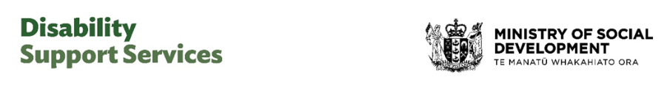

May 2026 factsheet – DSS Bill

Government introduces Disability Support Services Bill

What is happening
The Government has introduced a Disability Support Services Bill (the Bill) to Parliament.
The Bill is now going through the Parliamentary process.

What is Disability Support Services?
Disability Support Services (DSS) funds support for disabled people to help them live as independently as possible.
- Around 55,000 disabled people and their whānau in the community and residential care receive DSS-funded supports each year.
- Around 100,000 people access environmental support services (for example, equipment modifications and hearing aids).
- Around 26,000 children receive child development services each year to help them reach developmental milestones.

What would the Bill do?
The Bill builds on what disabled people, families, whānau, and carers have told us, and work already done to stabilise DSS.
DSS can be difficult to navigate. This Bill will improve that.
The Bill does three things:
- Creates a clear legal foundation for DSS.
- Sets out what it means when a disabled person employs a family member to provide care.
- Responds to the Supreme Court’s decision last December regarding paid family care.
The Bill provides a more transparent and consistent framework for policies and funding.
It reduces the risk of disruption and unexpected cost increases that could impact support for disabled people.
Court cases have highlighted issues with DSS. The Bill makes it clear that the Crown is not and was never intended to be the employer of family carers.

Family carers
Family and whānau play a significant and important role in caring for disabled people.
DSS is working on ways to better support carers. DSS will be seeking input from disabled people, family, whānau and carers.

What does this mean right now?
There are no changes to:
- current supports for disabled people, whānau and carers
- current funding allocations
- who can get disability support services.
People should continue to access support as they currently do.

Will supports change in the future?
The Bill is being considered by Parliament.
Any future changes would be decided through the Parliamentary process and would take time to put in place.
DSS will give information, work with stakeholders and consult the disability community on any future changes.

What happens next
The Bill will have its first reading in Parliament on 21 May.
After that, the Social Services and Community Select Committee will consider the Bill.
Information about the process is available on the New Zealand Parliament website.
- Select committees - New Zealand Parliament
- Resources in EasyRead and NZSL - New Zealand Parliament

More information
Minister Upston’s webpage

