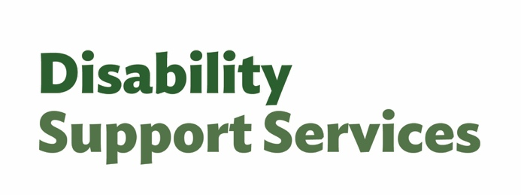
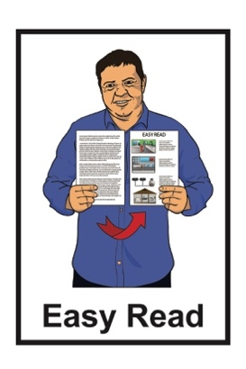

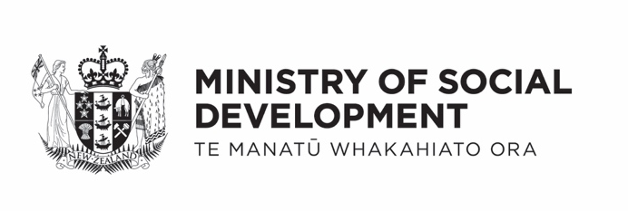

Factsheet – Updates to assessments and allocations and flexible funding


Published: February 2026

What you will find in here

Page number:


What this Easy Read is about 2

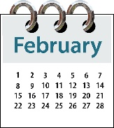
What is happening in February 4

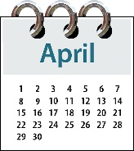
What is happening in April 9


Budgets 10


What happens now? 12

More information 13

What this Easy Read is about

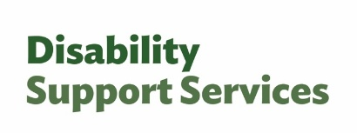
This Easy Read is from the Disability Support Services unit at the Ministry of Social Development.
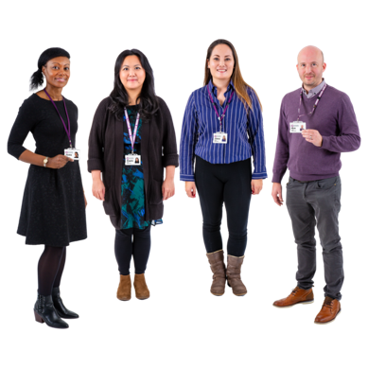

In this Easy Read we / us means Disability Support Services.

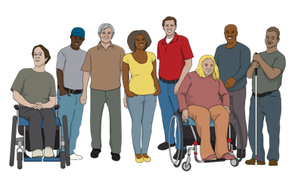
This information is for people who get supports from Disability Support Services.

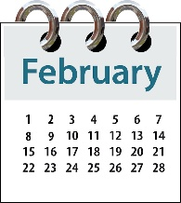
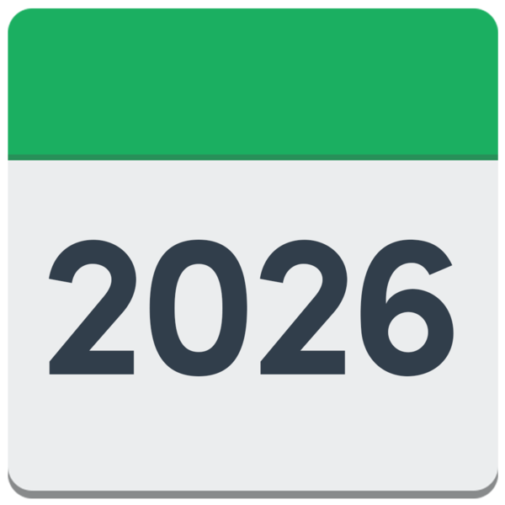
The information in this factsheet is true as of February 2026.


Some of the information in this factsheet may change in the future.

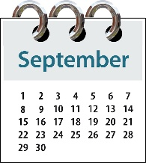
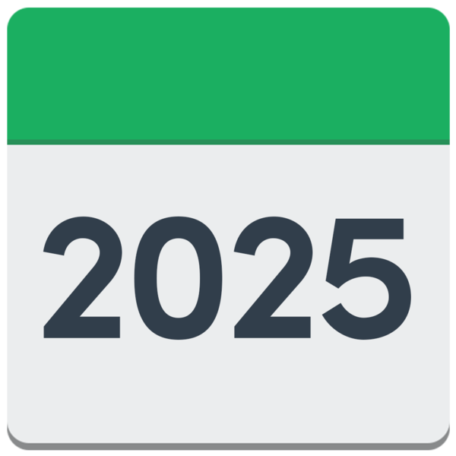
In September 2025 the Government said there would be changes to disability support services.

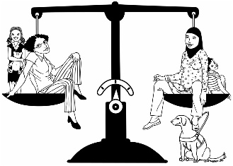
The changes are about:
making things fair for everyone
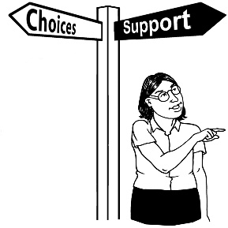
giving disabled people more choice and control over their flexible funding.


Here flexible funding is money from Disability Support Services that you can choose how to spend.

These changes will start from the middle of February 2026.

What is happening in February

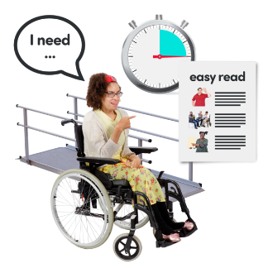
The February changes are about making a better way to:
find out what disabled people need

decide what funding is offered for supports.



From the middle of February 2026 these things will be done in the same way by all:
Needs Assessment Service Coordination organisations
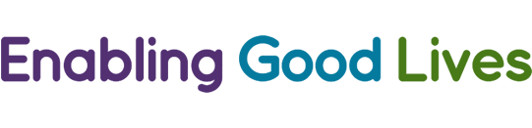
Enabling Good Lives sites.

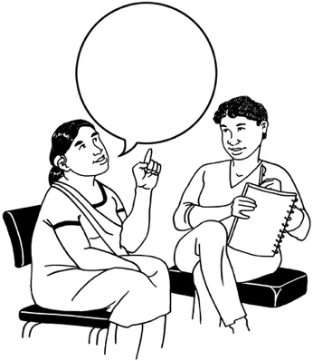
Disabled people can be supported by:
Needs Assessment Service
Coordination organisations
Enabling Good lives sites.

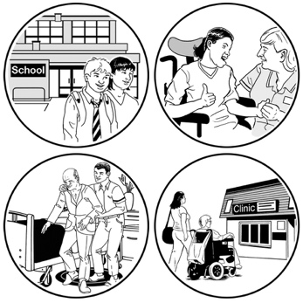
Both support disabled people to work out:
what they need for a good life
what support they can get.

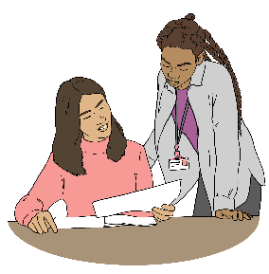
In this Easy Read Needs Assessment Service Coordination organisations are called NASCs.

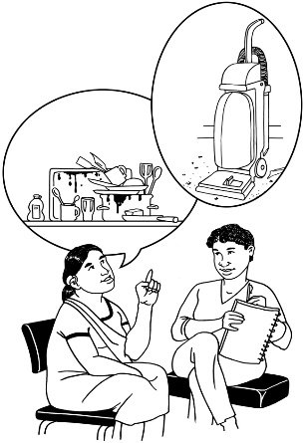
Here an assessment means
working with a NASC / Enabling Good Lives site to decide the support you:
need
will get.

Doing assessments the same way will make things:
fairer for everyone
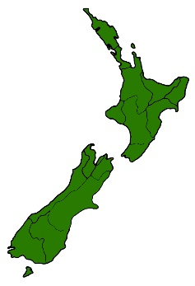
the same no matter where you live in New Zealand.

This change will be for people who:
are applying for DSS support for the first time
have a reassessment in the future.

Here a reassessment is when a NASC / Enabling Good Lives site checks you are getting the right support for your needs.

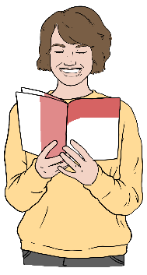
What will be different

Before the assessment you will be given information about what you can expect to happen.

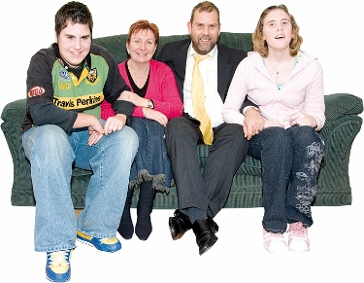
If support from other people is important to your needs then:

the needs of your
whānau / family may also
be part of the assessment
the needs of your carers may also be part of the assessment.


Whānau / family can also be carers.

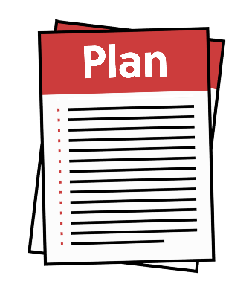
After your assessment you will have a clear plan about:
your needs
your disability supports.

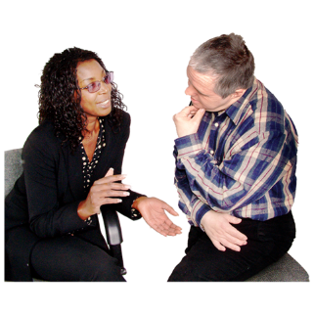
These changes have been made because we heard from the disability community that the way assessments were done was:

confusing
not the same everywhere.

What is happening in April

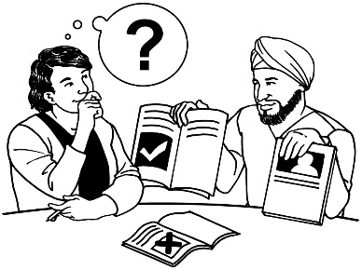
You will get more choice and control over how you use your flexible funding on disability supports.



The purchasing guidelines will be taken away.


The purchasing guidelines are the rules about how people can spend their disability support funding.

Budgets


You will be given a budget if you get flexible funding.


A budget tells you how much
money you can spend.


You cannot spend more than your budget says.


There will be support to manage your budget if you need it.

We will decide what your budget will be by looking at:
if your needs have changed
if your funding has changed
what you spent between:
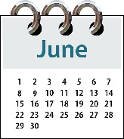
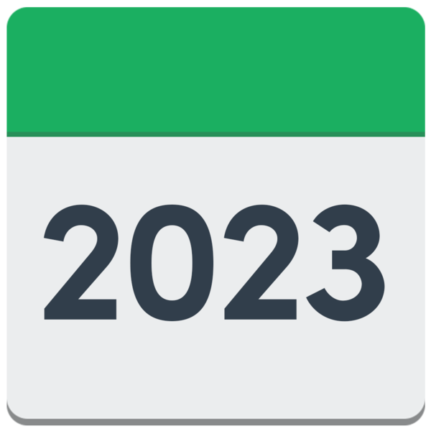
- June 2023
and
- June 2025.


No one will get less money than what they have spent before.

We will let people know about their budget for flexible funding before April 2026.

What happens now?


You do not need to do anything now.

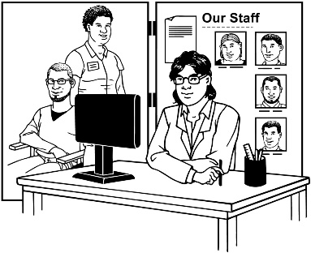
You will still be supported by your:
NASC
Enabling Good Lives site
Host.

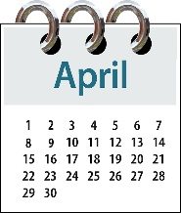
The purchasing guidelines will still be the rules we follow until April 2026.
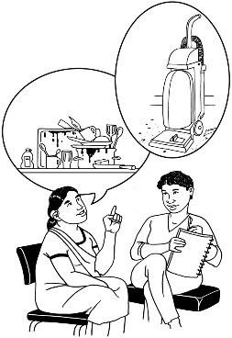

This will be true even if you have just had an assessment.

More information


Thank you to the disability community for:
telling us what you think
waiting for us to make these changes.


You can find more about the changes being made on the Disability Support Services website at:

https://bit.ly/4kivM9h
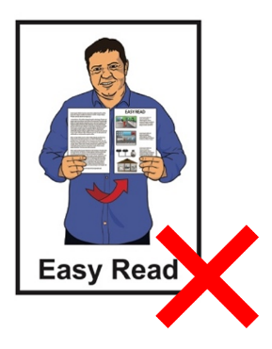

This website is not in Easy Read.

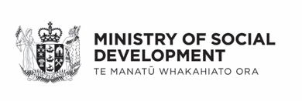
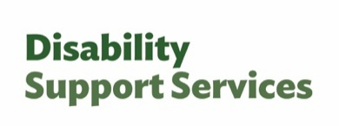
This information has been written by Disability Support Services Ministry of Social Development Te Manatū Whakahiato Ora.

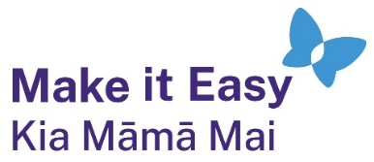
It has been translated into Easy Read by the Make it Easy Kia Māmā Mai service of People First New Zealand Ngā Tāngata Tuatahi.

The ideas in this document are not the ideas of People First New Zealand Ngā Tāngata Tuatahi.

All images used in this Easy Read document are subject to copyright rules and cannot be used without permission.


Make it Easy uses images from:

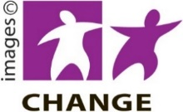
- Photosymbols

- Change Images


- Huriana Kopeke-Te Aho

- SGC Image Works

- T Wood


- Studio Rebeko

- Inga Kramer.

