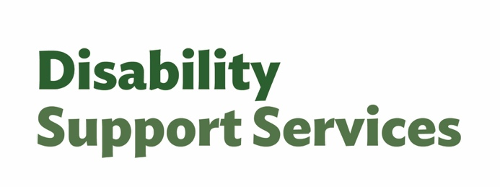
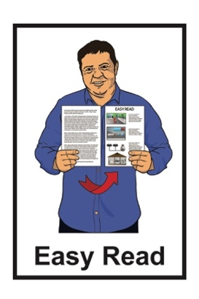
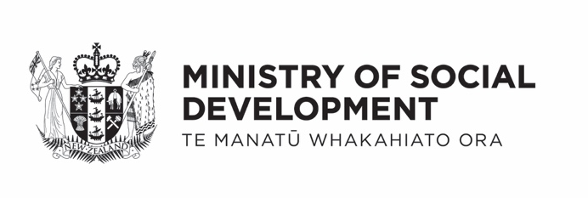

Factsheet:
Changes to flexible funding – more choice and control
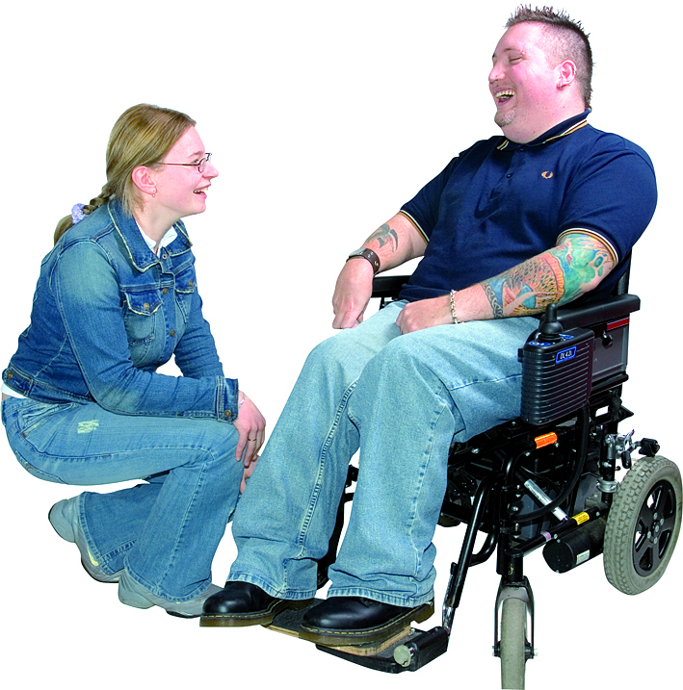

Published: March 2026

What this Easy Read is about

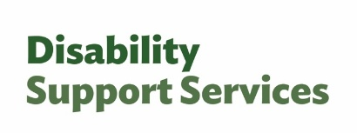
This Easy Read is from the Disability Support Services unit at the Ministry of Social Development.

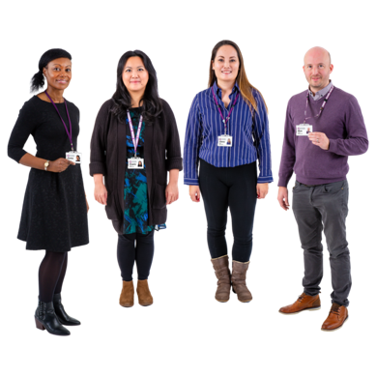
In this Easy Read we / us means Disability Support Services.

Disability Support Services is called DSS for short.

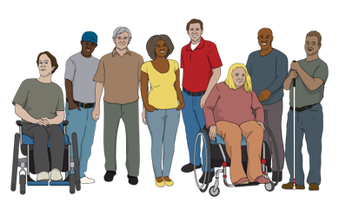
This information is for people who get supports from Disability Support Services.

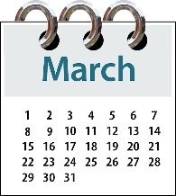
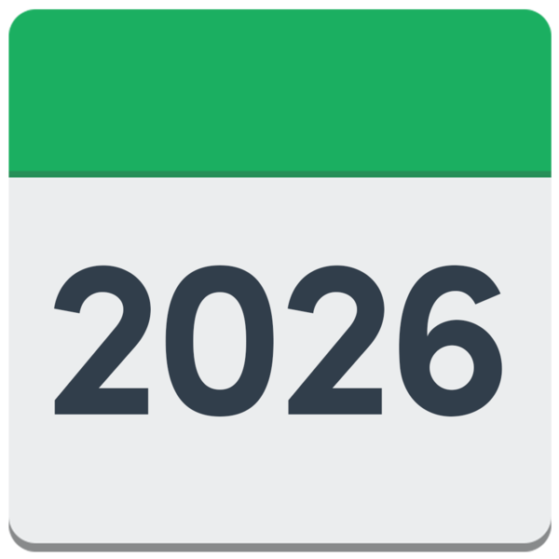
The information in this factsheet is true as of March 2026.


Some of the information in this factsheet may change in the future.

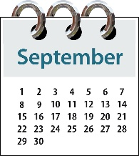
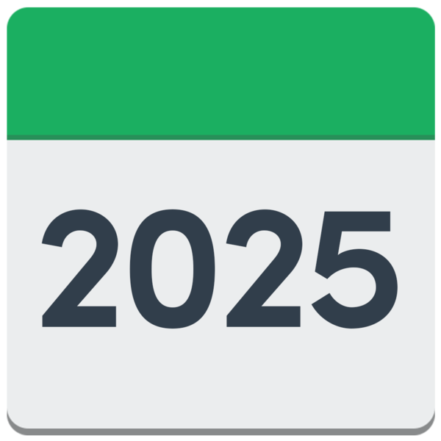
In September 2025 the Government said there would be changes to Disability Support Services.

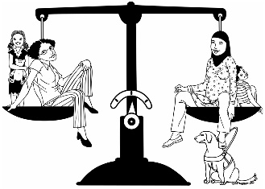
The changes are about:
making things fair for everyone
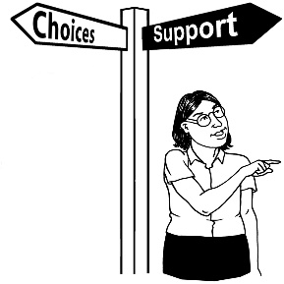
giving disabled people more choice and control over their flexible funding.


Here flexible funding is money from Disability Support Services that you can choose how to spend.

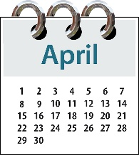
These changes will start from
1 April 2026.

What is happening in April


Allocated budgets for flexible funding will stay the same as they are now.


Allocated budgets means the amount of money DSS decides you get for flexible funding.



The purchasing rules for flexible funding will be taken away.


The purchasing rules are the rules about how people can spend their flexible funding.


There will be more support for people to manage their flexible funding.

Flexible funding budgets

Your allocated budget for flexible funding will stay the same.


Earlier we said we would set new budgets by looking at what people spent in the last few years.


We do not need to do that anymore.


We have made sure how we do things works better like:
the flexible funding system
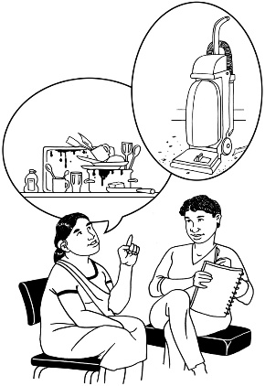
the way we find out:
- what people need
- what funding people get.

Purchasing rules

The purchasing rules for flexible funding will be taken away from
1 April 2026.

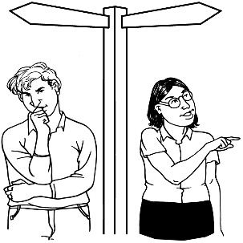
This means you will have more choice over what supports work for you.
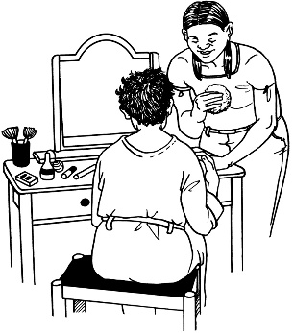

This change is also for respite options for carers.

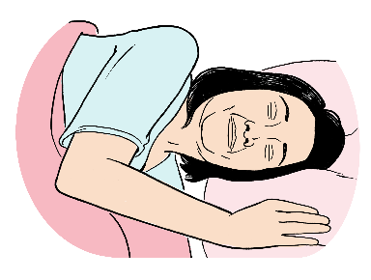
Respite options means the things that can support carers to have a break.

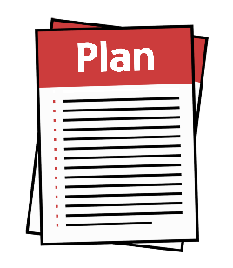
You will still need to use your flexible funding based on:
your funding plan
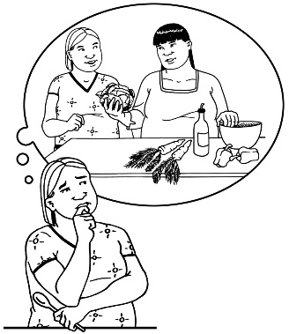
your disability needs
how much money you have in your budget.

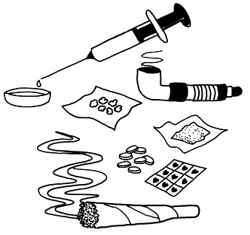
Flexible funding still cannot be used for:
drugs

alcohol like beer or wine
tobacco / smoking
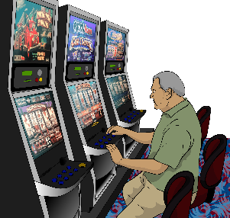
gambling
illegal activities / things that are against the law.


Here the law means the rules of
New Zealand that everyone must follow.

Some things will need pre-approval.
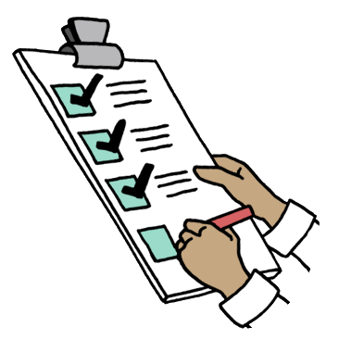

Pre-approval means your host has to say yes to you paying for that
support before you can get it.

A host takes care of your flexible funding.

A host can be:
a person
- a group


Some things that will need
pre-approval are:
overseas travel / going to another country
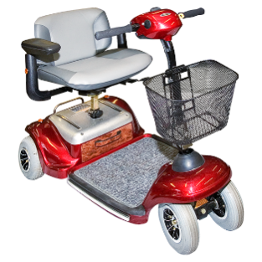
equipment like mobility aids
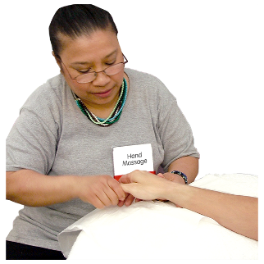
things you have bought before if they are not likely to have stopped working yet
complementary therapies

things you will only need to buy once that are over the approval limit.

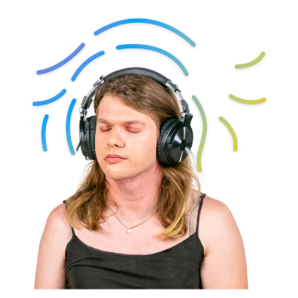
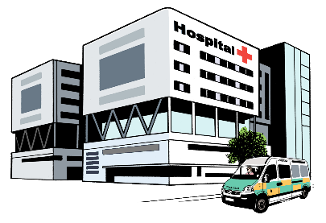
Complementary therapies are treatments to support your health
that are not usually used by the New Zealand health system like:
massage
meditation.


The approval limit means the most you can spend on 1 thing.

For most people the approval limit is 1 thousand 5 hundred dollars.

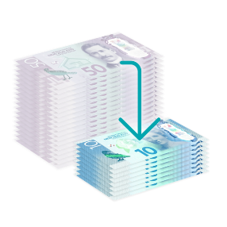
A few people who have had a lot of support from their host will have an approval limit of 5 hundred dollars.

More support


There will be more support for you to manage your flexible funding.


Hosts will offer support to people who have hosted flexible funding.


Hosted flexible funding means
your funding is taken care of by a host through:
Individualised Funding
or

Enabling Good Lives personal budget.

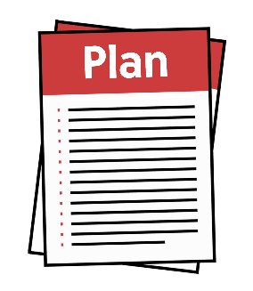
Support from hosts can be things like:
planning

keeping records
budgeting
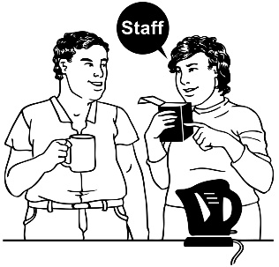
managing workers
making sure your spending fits your:
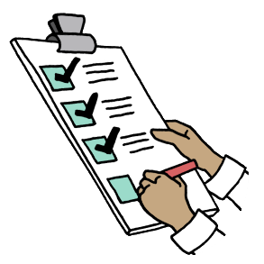
- plan
- budget.

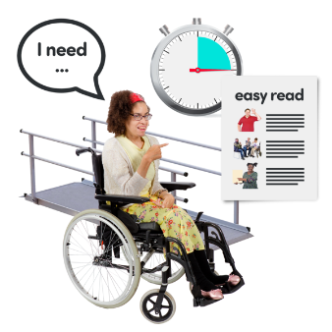
The amount of support you get will be based on:
your situation

what funding you get
how well you have managed your funding before.


Some people will need:
a lot of support
only a little support.
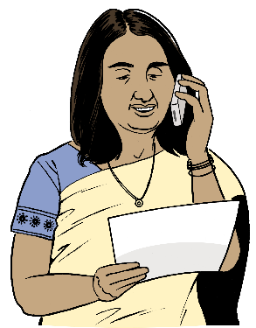

Your host will contact you after
1 April 2026 to talk about your support.

More information


You can find out more about the April 2026 changes on the DSS website at:

www.disabilitysupport.govt.nz/dsschanges


This website is not in Easy Read.

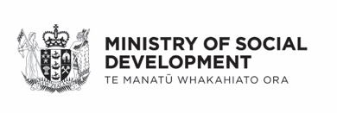
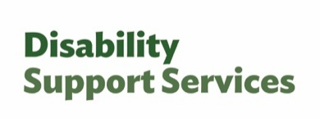
This information has been written by Disability Support Services Ministry of Social Development Te Manatū Whakahiato Ora.

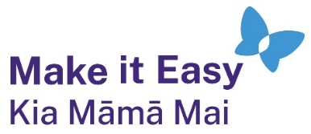
It has been translated into Easy Read by the Make it Easy Kia Māmā Mai service of People First New Zealand Ngā Tāngata Tuatahi.

The ideas in this document are not the ideas of People First New Zealand Ngā Tāngata Tuatahi.

All images used in this Easy Read document are subject to copyright rules and cannot be used without permission.

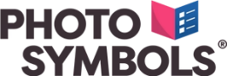
Make it Easy uses images from:

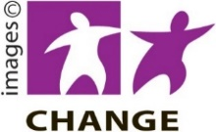
- Photosymbols

- Change Images


- Huriana Kopeke-Te Aho

- SGC Image Works

- T Wood


- Studio Rebeko

- Inga Kramer.

