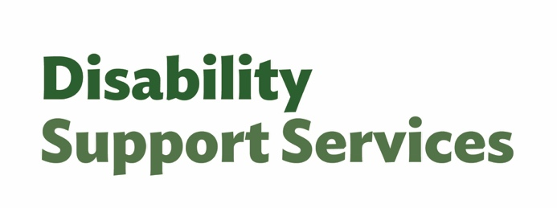
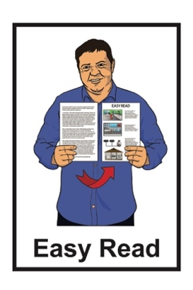

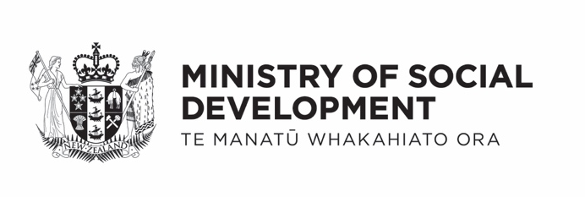

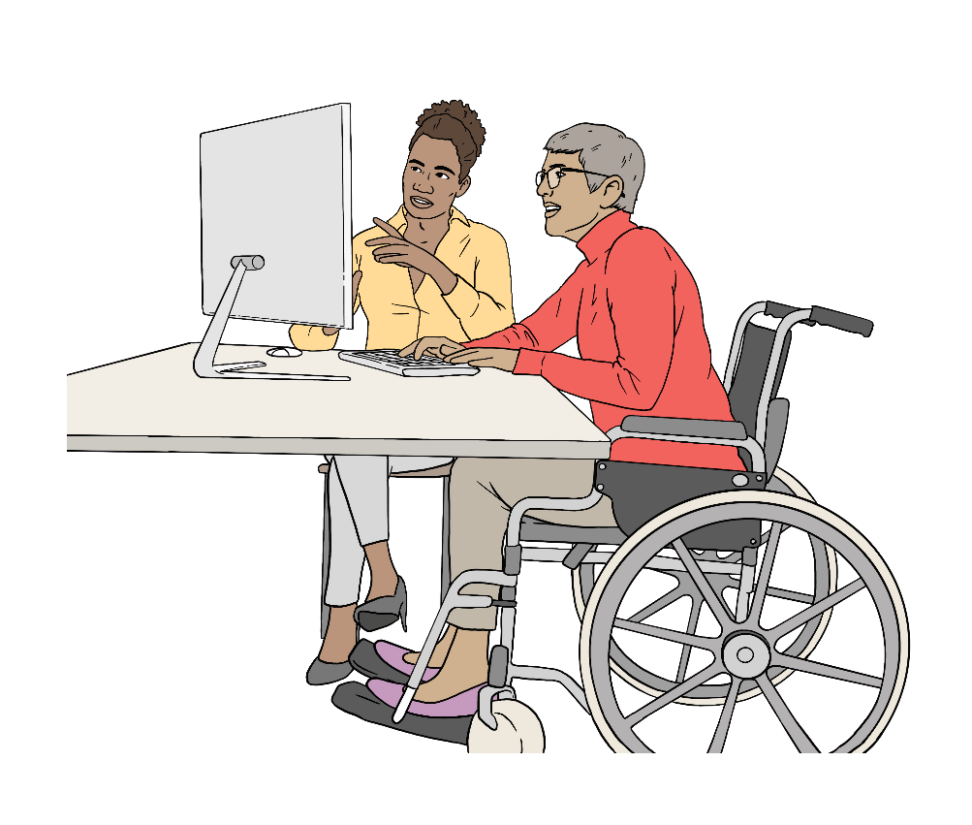
Managing your flexible funding and working with your host – Tier 2

Published: April 2026

What you will find in here

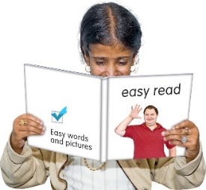
Page number:

About this Easy Read 2


Hosted flexible funding 6

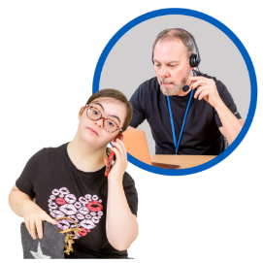
Tier guidance 8

Tier 2 guidance 12
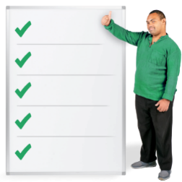

What you need to do in Tier 2 13


What your host needs to do
in Tier 2 20
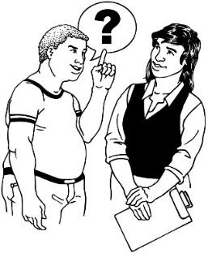

Questions and support 23

About this Easy Read

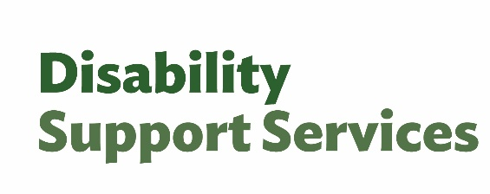
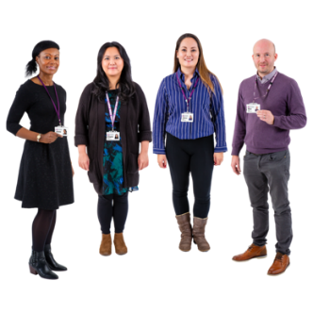
This Easy Read is from the
Disability Support Services unit at the Ministry of Social Development.
In this Easy Read:
DSS is short for
Disability Support Services
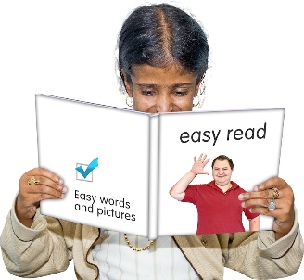
we / us means
Disability Support Services.

This Easy Read document is about Tier 2 guidance for people getting hosted flexible funding.
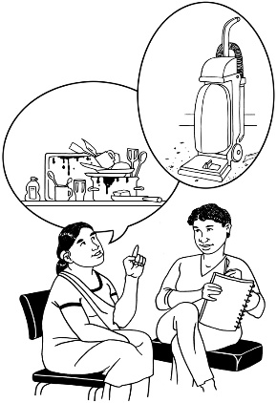

Guidance means the support your host gives you to manage your funding.

Here a tier means how much guidance you get from your host.

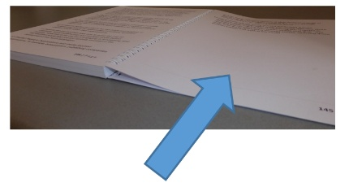
You can find out more about what each of the tiers means on page 6.

Hosted flexible funding means
a host supports you to plan / use your:

Individualised Funding
or

Enabling Good Lives personal budget.

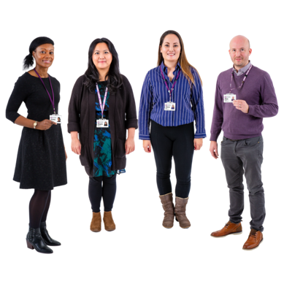
A host is a person / group who takes care of your flexible funding.


Enabling Good Lives is a different way of thinking about disability support.
Enabling Good Lives is about having:
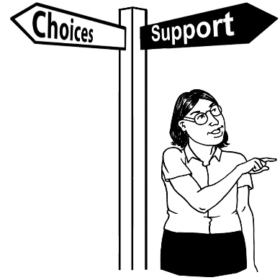
choice and control in your life
the support you need and want
a good life.
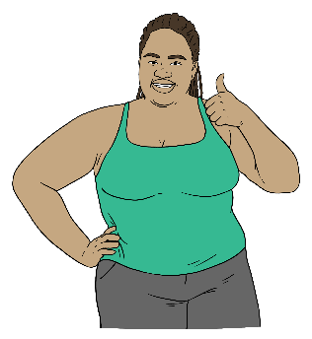

Enabling Good Lives is also called EGL.

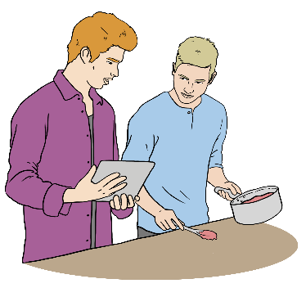
Individualised Funding is a kind of funding that means the disabled person can decide what support they need.

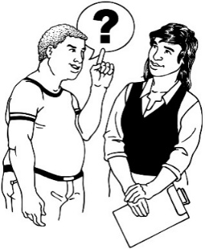
You can ask your host if you do not know what tier you are in.

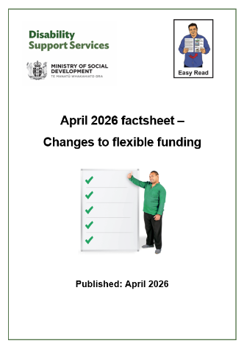
There is an Easy Read with more information called:

April 2026 factsheet –
Changes to flexible funding.

You can find this Easy Read factsheet at:

www.disabilitysupport.govt.nz/Aprilchanges
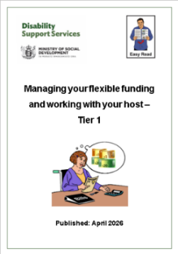
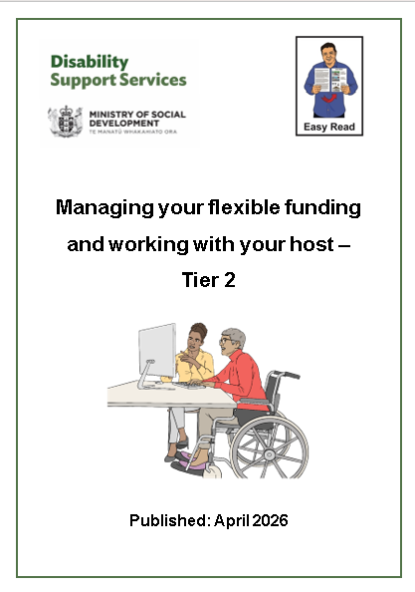
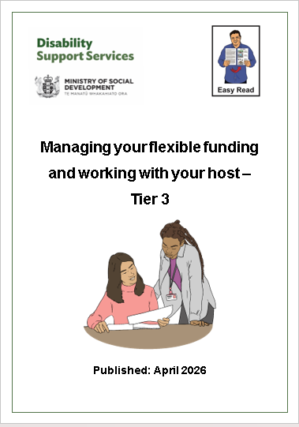
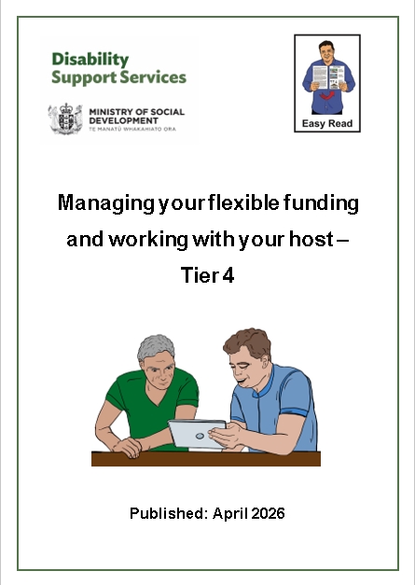

There is also Easy Read information about the other 3 tiers.

You can find this Easy Read information at:

www.disabilitysupport.govt.nz/tiers-infosheets

Hosted flexible funding

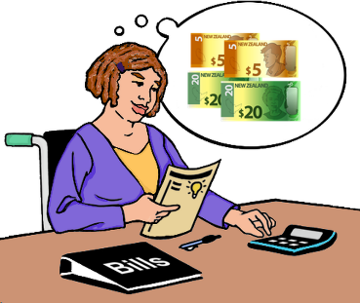
Hosted flexible funding means you have a:
flexible funding budget
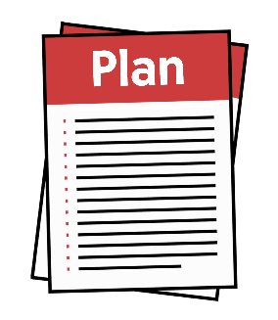
plan to arrange your own supports
host to support you to manage your funding.

Hosted flexible funding is for:
hosted EGL Personal Budgets
Individualised Funding like:
- IF Personal Care
- IF House Management.
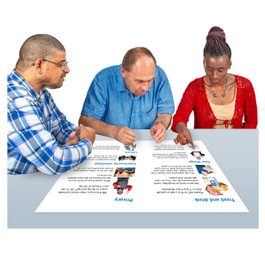
Your hosted flexible funding can be used for things that:
match your funding plan
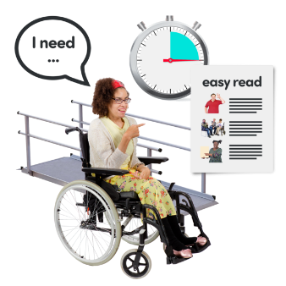
and
are part of your disability support needs.


You can talk to your host if you are not sure about what your funding is meant to be used for.

Tier guidance

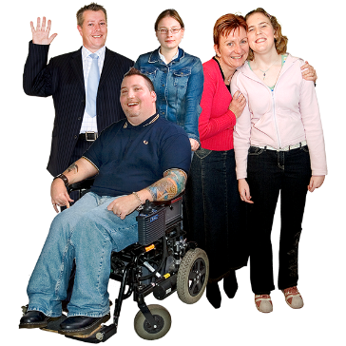
Everyone with hosted flexible funding gets guidance from their host.

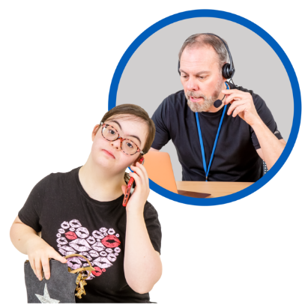
The 4 tiers say how:
often your host will check in with you
much guidance you get.
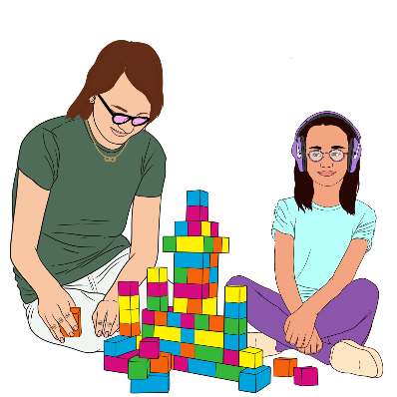

What tier you are in is based on:
your life
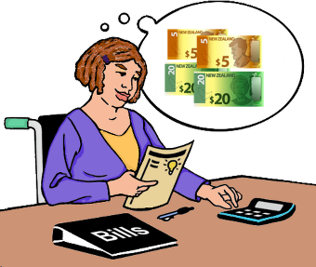
your funding
how much you have managed your funding before.
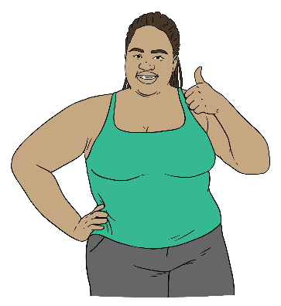
What tier you are in is also based on how well you think you can manage your funding.


What tier you are in does not change how much funding you get.

The 4 tiers are:
Tier 1 – low / little support
Tier 2 – some support
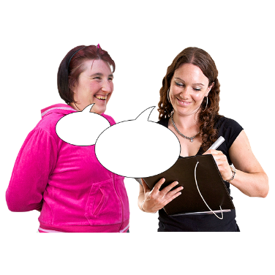
Tier 3 – regular / usual support
Tier 4 – frequent / a lot of support.
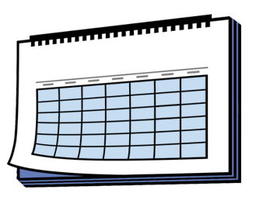

Your tier level can change over time.

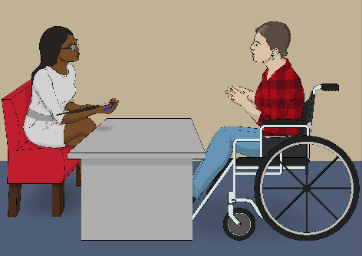
Changing your tier will be looked at during your next assessment / review by your:
Needs Assessment Service Coordination organisation
Enabling Good Lives site.

A Needs Assessment Service Coordination organisation
supports disabled people to work out:
what they need for a good life
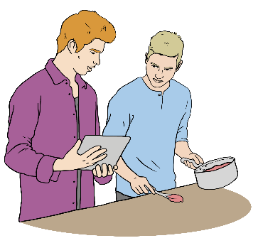
what support they can get.

In this Easy Read Needs Assessment Service Coordination organisations are called NASCs.

Your host does not choose your tier.

You can find more information about tiers at:

www.disabilitysupport.govt.nz/tiers

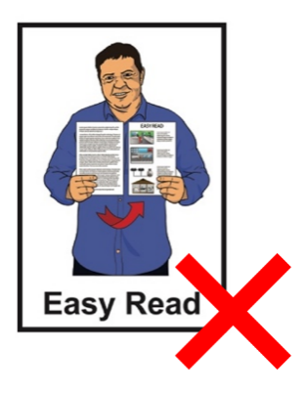
This website is not in Easy Read.

Tier 2 guidance

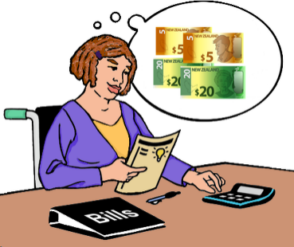
Being in Tier 2 means you:
have some experience managing your own funding
have some skills to manage your own funding
need a little guidance sometimes.
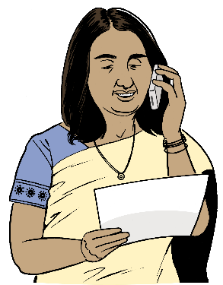

At Tier 2 your host will talk with you at least every 6 months.


You can ask to talk to your host more often if you want.

What you need to do in Tier 2

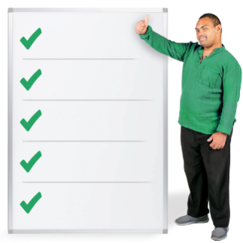
These are your responsibilities / the things you need to do when you are in Tier 2.

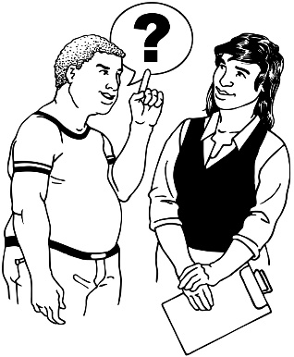
Ask your host if you have any questions about your responsibilities.

You need to use your flexible funding in ways that:
work for your disability support needs
match your funding plan
work with what your funding is for.

You also need to:
make sure the things you claim funding for match your plan
not spend any more than what is in your budget
make sure your budget will last your full funding period.


A full funding period means the 12 months from when your current funding started.


You will need to keep good records of where your funding has been spent.

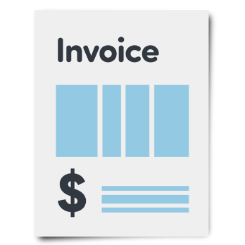
Records means proof of where the funding has been spent like:
invoices / bills from staff like support workers

receipts from things you bought with your funding.

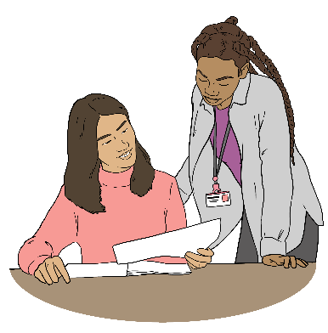
You will need to send your host any:
invoices
receipts.


You will also need to check if the supports you need can be paid for by other government agencies before using your funding.

You can get support to look at these options from:
your host
your NASC
an Enabling Good Lives site.

You also need to talk to your host for prior approval before using your funding for some things like:

travel to another country
equipment like wheelchairs
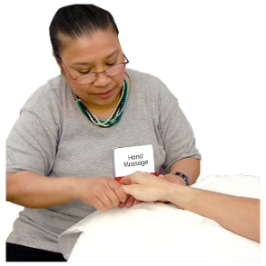
complementary therapies.

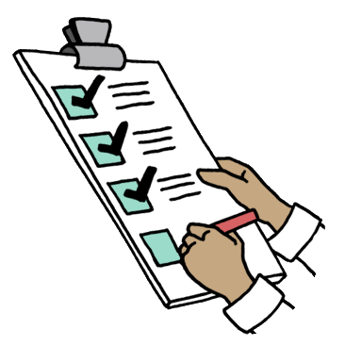
Prior approval means your host has to say yes to you paying for that
support before you can get it.

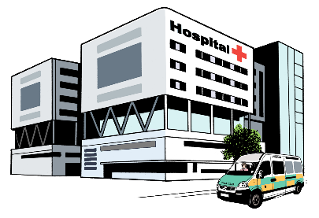
Complementary therapies are treatments to support your health
that are not usually used by the New Zealand health system like:
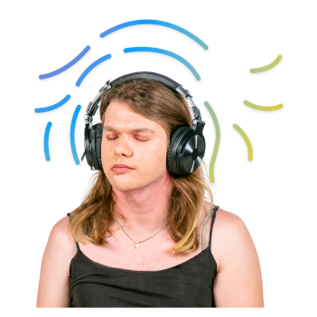
massage
meditation.

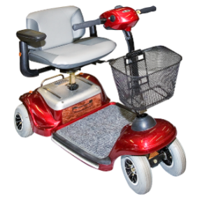
Other things you also need to talk to your host about for prior approval are things like:
buying something you have bought before that should still be okay to use
purchases that cost more than a set limit.

A set limit means the most money that can be spent on 1 thing.


Your host will tell you what they need from you if you want to spend funding on any of the things listed on
pages 14 to 15.


There are still some things flexible funding cannot be used for like:

alcohol
gambling
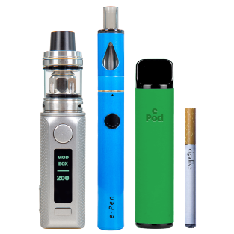
tobacco like:
- cigarettes
- vapes
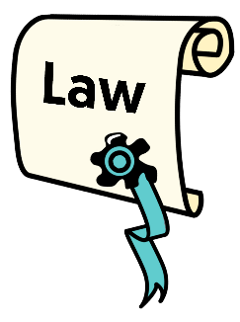
illegal activities which means things that are against the law.

Gambling is trying to win money by doing things like:
playing the pokie machines
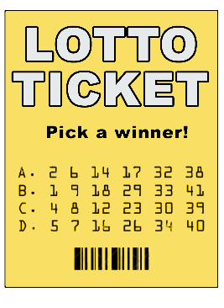
betting on horse races
buying Lotto tickets.

Here the law means the rules of Aotearoa New Zealand that everyone must follow.

What your host needs to do in Tier 2


Claims

Your host will check any claims you make to make sure they can be paid for.

Here a claim is when you send information to your host about something that needs to be paid for with your funding.

Your host will also check that what you are claiming for matches your plan.

Talking with you

Every 6 months your host will talk to you about:
the ways you use flexible funding
what your plans are for the next
6 months.

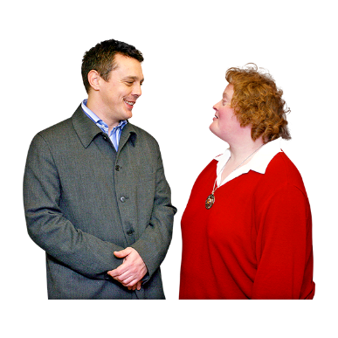
You will have a NASC / EGL site review near the end of your funding period.

Your host will talk to you before your review about:
how you are spending your flexible funding
if your spending matches your plan.
Your host will also talk to you before your review about:
if you are having a hard time managing your flexible funding
making sure you are getting enough support from your host
your plan for the next 12 months
any changes you need to make to your supports.

Guidance

Your host can provide guidance on:
using your hosted flexible funding
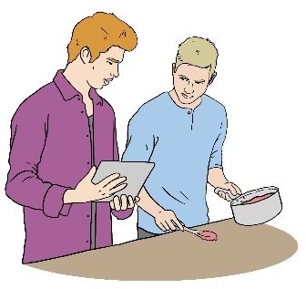
what you need to do in Tier 2
what you need to do if you hire people like support workers.

Questions and support

You can contact your host at any time if you have questions about:
using your flexible funding
making a claim
your responsibilities / things you need to do like:

- keeping records
- what you need to do if you hire workers

budgeting.

You should contact your
NASC / EGL site if:
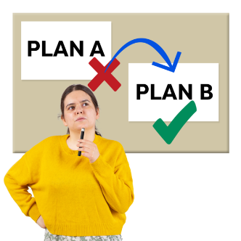
your disability support needs have changed
you want to change your funding plan.


You can find more information about everything in this document on our website at:

https://www.disabilitysupport.govt.nz/flexible-funding
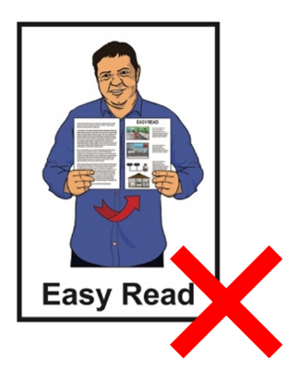

This website is not in Easy Read.

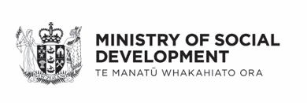
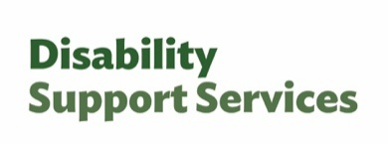
This information has been written by Disability Support Services Ministry of Social Development Te Manatū Whakahiato Ora.

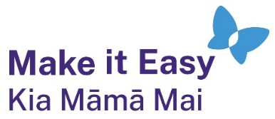
It has been translated into Easy Read by the Make it Easy Kia Māmā Mai service of People First New Zealand Ngā Tāngata Tuatahi.

The ideas in this document are not the ideas of People First New Zealand Ngā Tāngata Tuatahi.

All images used in this Easy Read document are subject to copyright rules and cannot be used without permission.


Make it Easy uses images from:

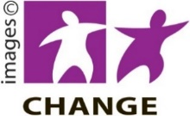
- Photosymbols

- Change Images


- Huriana Kopeke-Te Aho

- SGC Image Works

- T Wood


- Studio Rebeko

- Inga Kramer.

