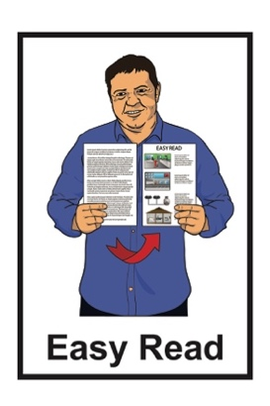
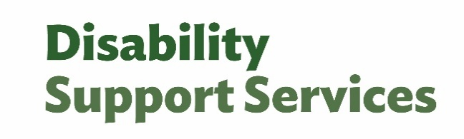


Preparing for your assessment or reassessment
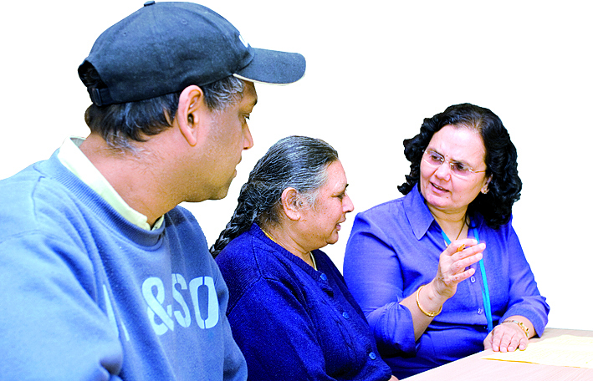

Published: June 2026

What you will find in here

Page number:


About this Easy Read 2
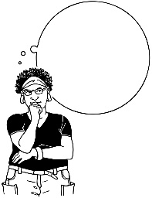

Things to think about for your assessment 7
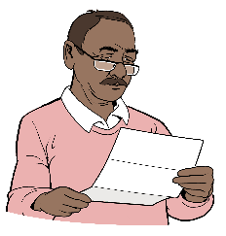

After your assessment talk 15

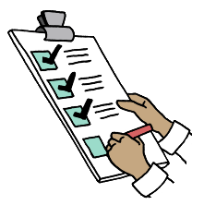
Your DSS supports 18


If you are not happy with your assessment decision 21

About this Easy Read

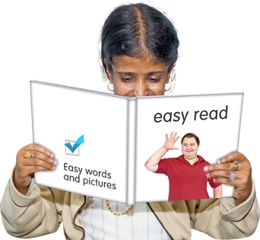
This Easy Read is from Disability Support Services at the Ministry of Social Development.


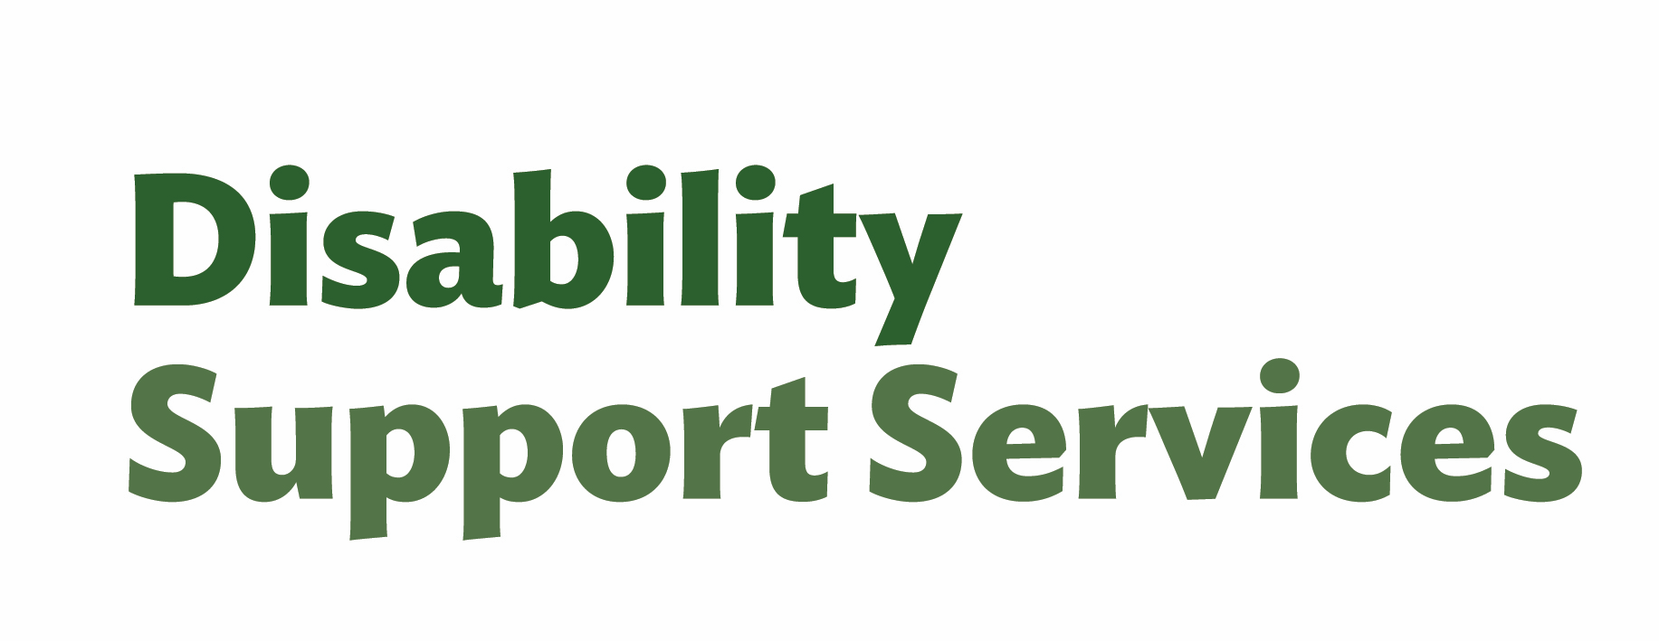
In this Easy Read Disability
Support Services will be called DSS.

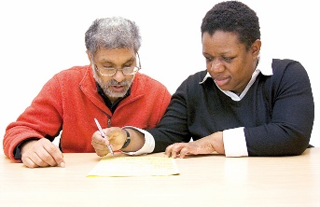
This Easy Read has information about how you can prepare / get ready for a needs:
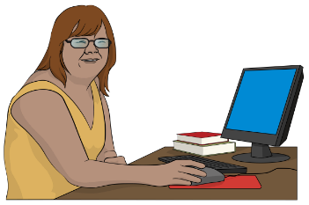
assessment
reassessment.

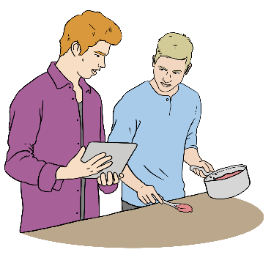
A needs assessment is where someone talks to you about:
your everyday life
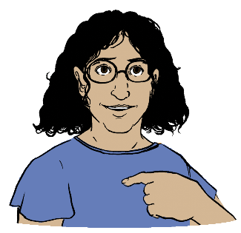
what kinds of support might be good for:
- you
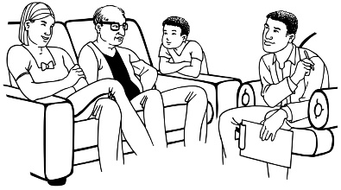
- your whānau / family
- carers

how much support you need
what times of the day you need support.

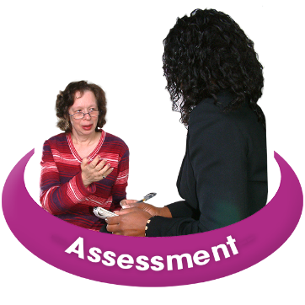
Your assessment will be with:
a Needs Assessment and Service Coordination / NASC site
or

an Enabling Good Lives / EGL site.

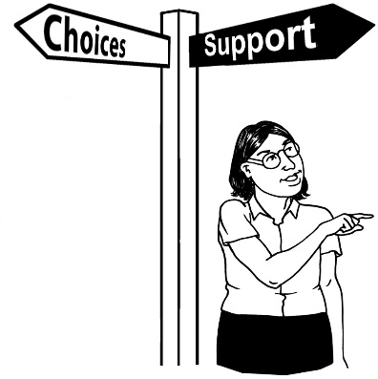
Enabling Good Lives is a different way of thinking about disability support.

Enabling Good Lives is about having:

choice and control in your life
the support you need and want
a good life.

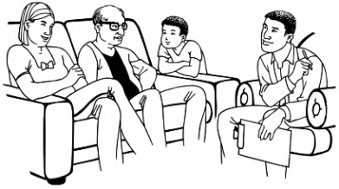
Needs Assessment and Service Coordination / NASC work with disabled people to access disability supports so they can have a good life.


This includes checking disability supports if there are
concerns / worries about:
quality
safeguarding.

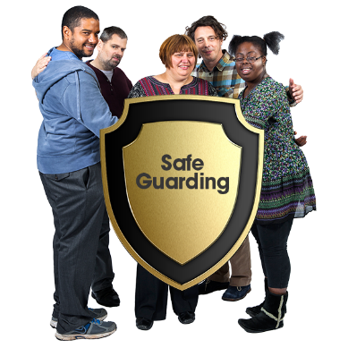
Safeguarding protects the rights of a person to make their own decisions about their life.

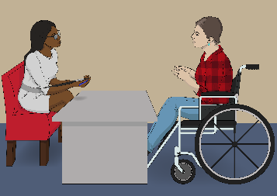
Here site means who you go to so you can get your needs assessment done.

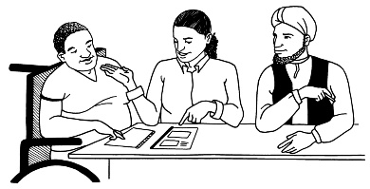
In this Easy Read the word site refers to your:
Needs Assessment and Service Coordination / NASC site
or

Enabling Good Lives / EGL site.

Things to think about for your assessment

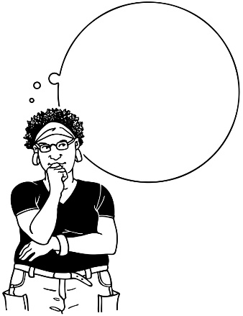

It is a good idea to think about what:
you would like to share with us
is important for us to know.

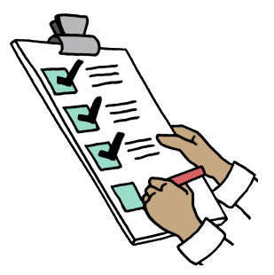
This section has examples of what might be talked about at the assessment.




Not all these examples will be part of your:
life
needs.


You may like to:
make notes about the things that mean something to you
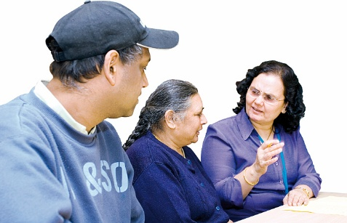
and
bring the notes with you to the assessment.

What do you do every day?
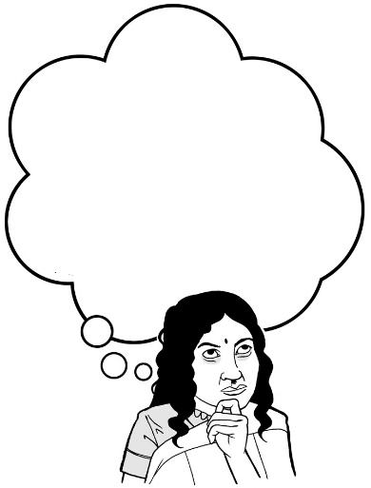
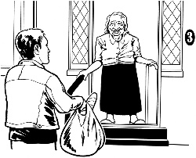
Think about:
the things you do every day
when you are busy
what would support you to make the hard parts of your day easier.


The important people in your life

Think about:

the people who are important to you
who gives you support
how you get along with people
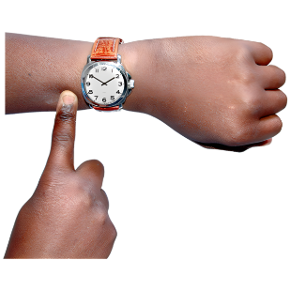
what would give your supporters more time to do things for you.

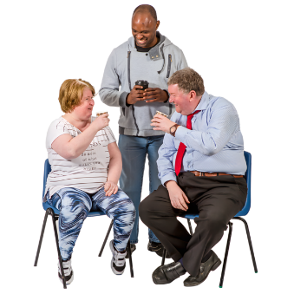
What do you do away from home?

Think about the things you do in your community.

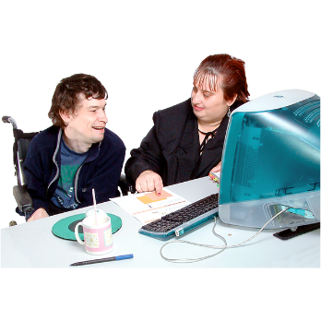
Do you:
go to school
work
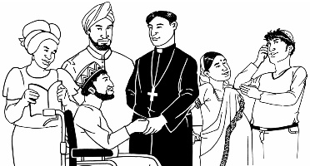
do cultural activities
do recreational activities like:

- sport
- music
- art?

Culture is a way of:
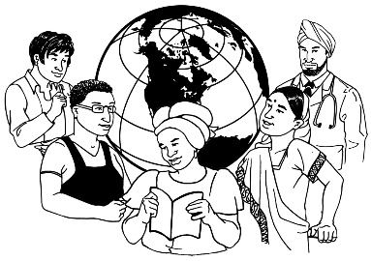
thinking that a group shares
doing things as a group.


Cultural activities are doing things with people in your culture like:
dancing
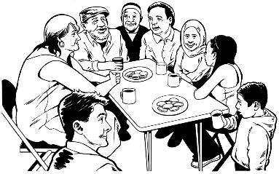
going to church
sharing meals.

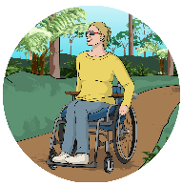
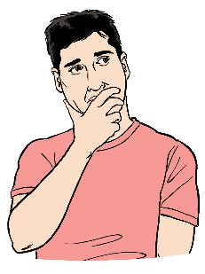
Think about things you might like to do away from your home.

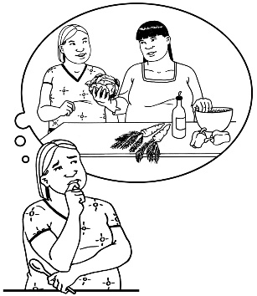
The things you are good at

Think about:
your skills
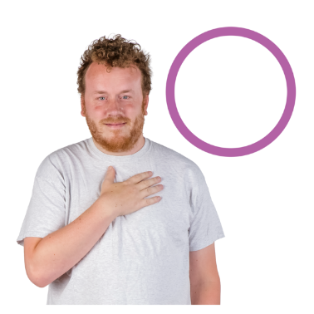
what you are good at doing
what you like to do.


Think about how these things:
support you to learn
make you happy.

Keeping safe
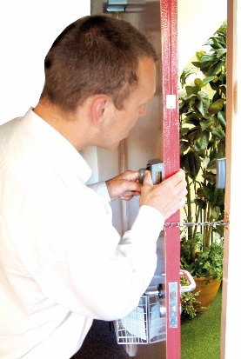
Think about how you:
keep yourself safe
take care of any risks / problems.


Decisions and choices

Think about the decisions you make every day.


What kind of decisions do you make?

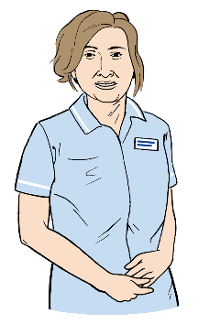

If you have carers

Think about your carers.

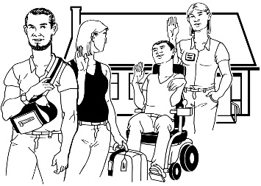
Think about what could support your carers to:
take a break

keep a good balance in their life like:
- working good hours
- staying healthy.


If this is a reassessment

Think about how things have changed in your life since the last time you talked about your needs to:
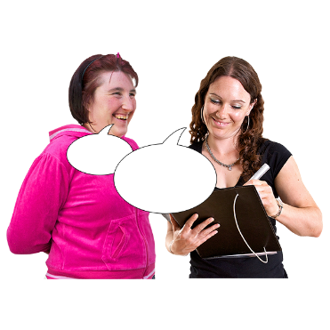
a Needs Assessment and Service Coordination / NASC site
or
an Enabling Good Lives / EGL site.

After your assessment talk

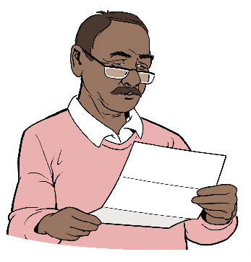
You will be sent a summary of what was talked about in your assessment.

Here a summary:

is the things talked about written down
tells you the important ideas.


It is important the summary is correct about:
what you need
what was talked about in your assessment.

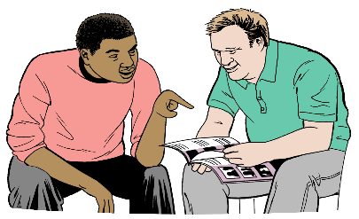
You will have time to read the summary.


You can talk about the
summary with:
your whānau / family
a support person you trust.

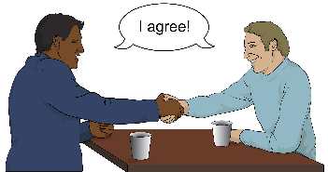
It is important to tell the site who did your assessment if:


you agree with it
or
anything needs to change.


You can also give extra information to the site who did your assessment.

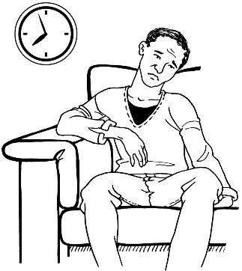
Your supports might be slow to happen if your site:
does not hear from you
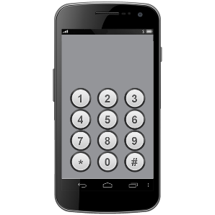
cannot contact you.

Your DSS supports

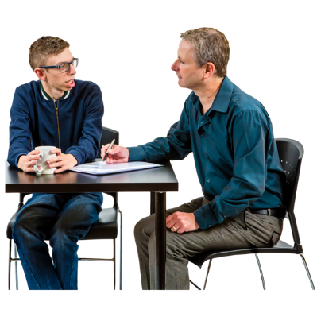

If this is your first assessment

Your site will work out if you can get support funded by DSS.

Your site will then talk with you about:
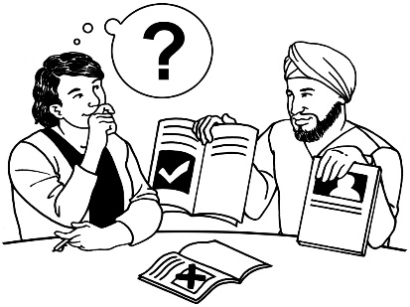
what kinds of support you can get
the ways the support can be given to you.



Not every disabled person who has an assessment can get support funded by DSS.


If you cannot get support funded by DSS your site may tell you about other kinds of support for:
you

your whānau / family
your carers.



If you are having a reassessment

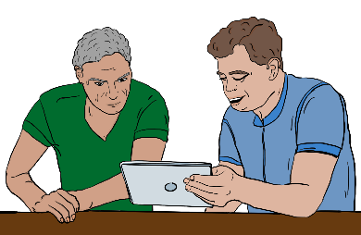
Your site will think about:
any changes:
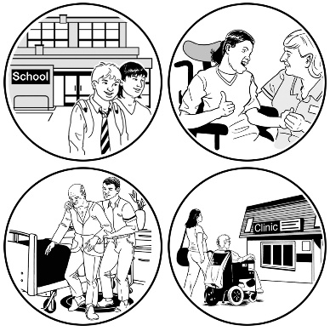
- in your life
- to your needs
the support funded by DSS you get.

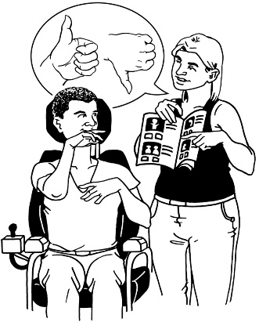
Your site will talk with you about:
what kinds of support you can get
the ways the support can be given to you.


Your site may tell you about other kinds of support that are good for:
you
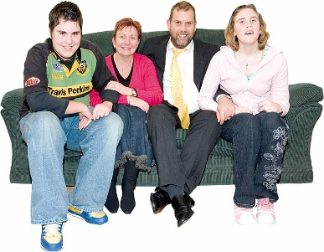
your whānau / family
your carers.

If you are not happy with your

assessment decision


There are some things you can do if you are not happy with the assessment decision made by your site.
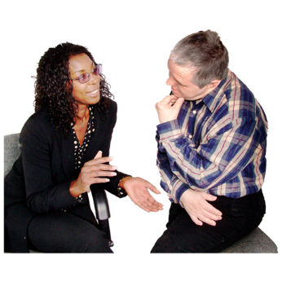

The first thing to do is talk to your site.


Your site might be able to find a solution / fix for you.

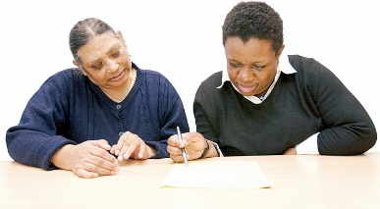
You can ask your site for a review of any part of your assessment.

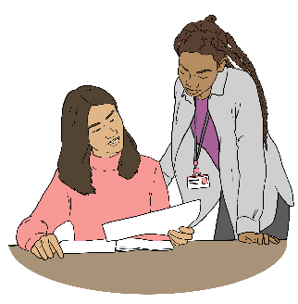
Here review means:

looking at the decisions that
were made
thinking about if the decisions need to be changed.


The DSS website has more information on:
asking for a review
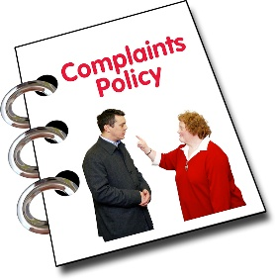
giving feedback
making a complaint.


The DSS website is:

www.disabilitysupport.govt.nz/feedback
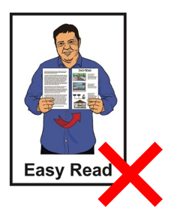

This website is not in Easy Read.

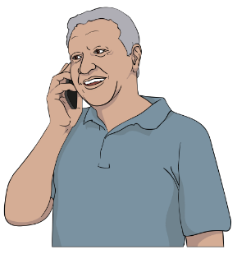
You can also phone the Whaikaha number:
0800 566 601
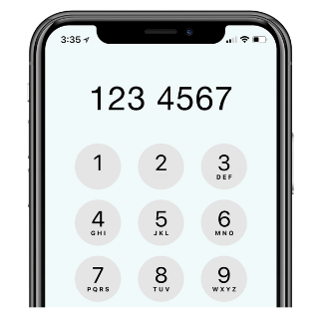
then
choose option 1 to get DSS when the voice message tells you to.


This number does not cost money to call.

You can call us:
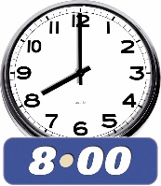
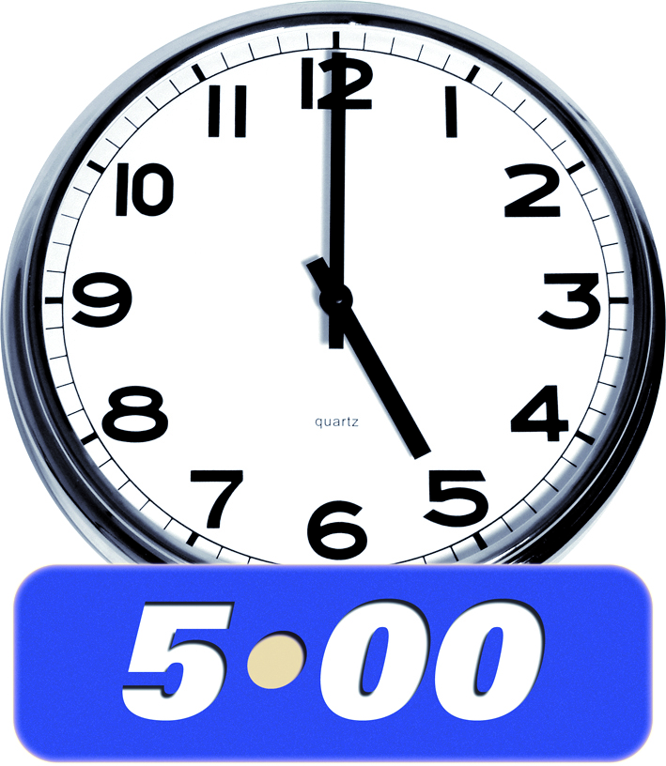
Monday Tuesday Thursday Friday:
- 8 am to 5 pm
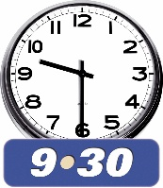
Wednesday:
- 9.30 am to 5 pm.


The Health and Disability Commissioner website also has information on your rights:

www.hdc.org.nz
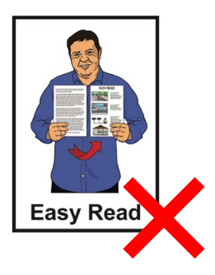

This website is not in Easy Read.


You can also phone the Health and Disability Commissioner on:

0800 11 22 33


This number does not cost money to call.


If you find it hard to use the phone the New Zealand Relay service is for people who are:

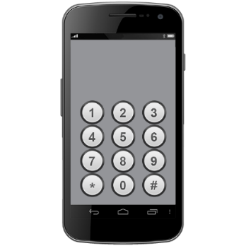
- Deaf / hard of hearing

- deafblind

- speech impaired / find it hard to talk.


You can find out more about the New Zealand Relay service at:

www.nzrelay.co.nz


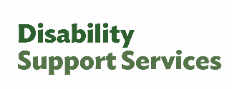
This information has been written by Disability Support Services – Ministry of Social Development.

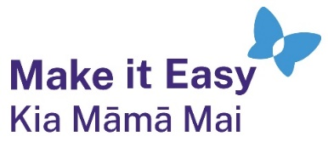
It has been translated into Easy Read by the Make it Easy Kia Māmā Mai service of People First New Zealand Ngā Tāngata Tuatahi.

The ideas in this document are not the ideas of People First New Zealand Ngā Tāngata Tuatahi.

All images used in this Easy Read document are subject to copyright rules and cannot be used without permission.


Make it Easy uses images from:


- Photosymbols

- Change Images


- Huriana Kopeke-Te Aho

- SGC Image Works

- T Wood


- Studio Rebeko

- Inga Kramer.

