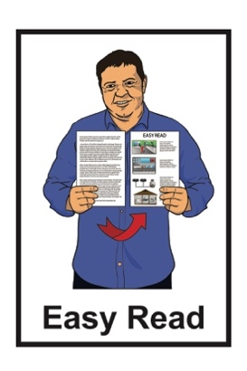
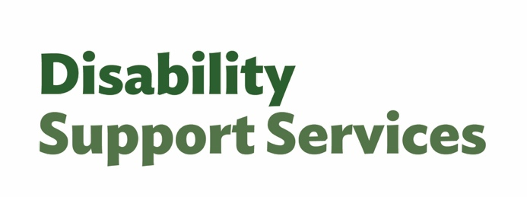

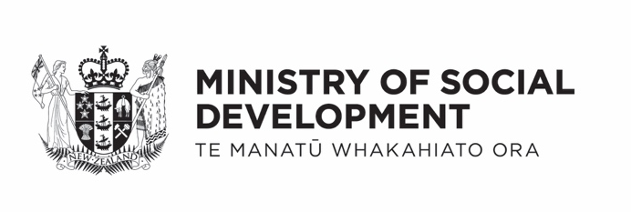

April 2026 factsheet –

Changes to flexible funding
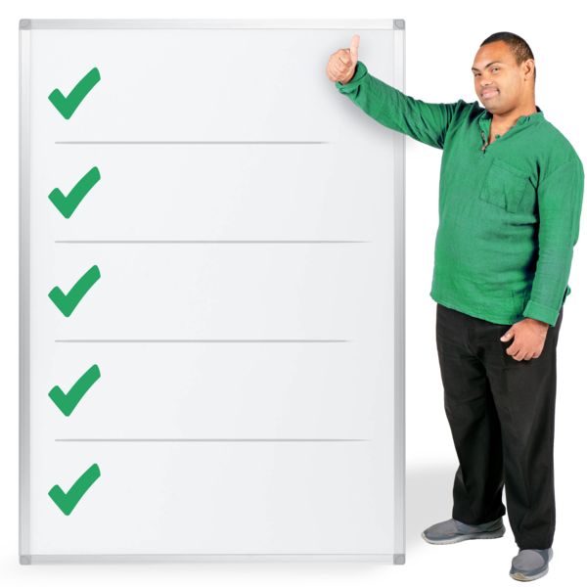

Published: April 2026

About this Easy Read

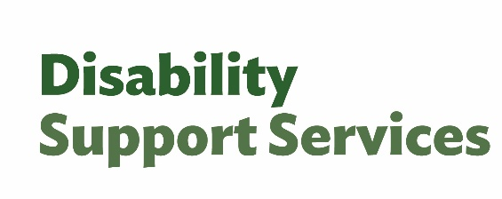
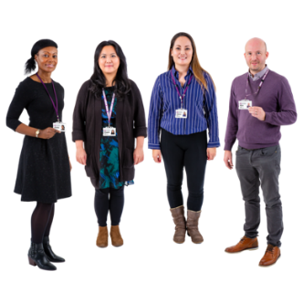
This Easy Read is from the
Disability Support Services unit at the Ministry of Social Development.
In this Easy Read:
DSS is short for
Disability Support Services
we / us means
Disability Support Services.
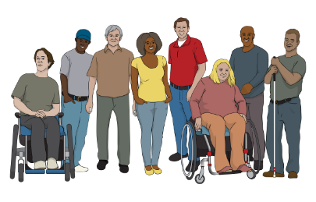

It is information for people who are getting flexible funding.


Flexible funding is money from the Government to pay for things someone needs because of their disability.
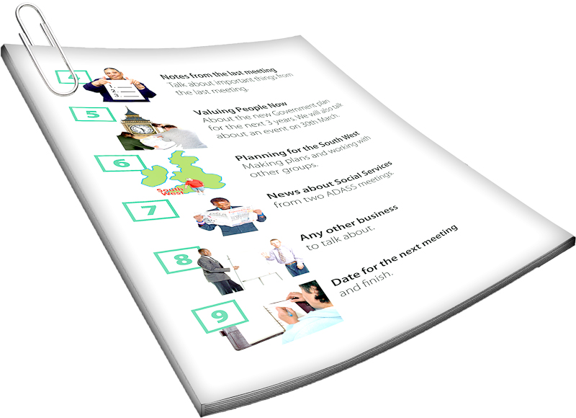
This factsheet is not for Choice in Community Living funding.

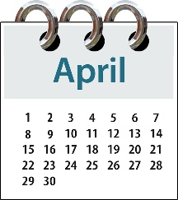
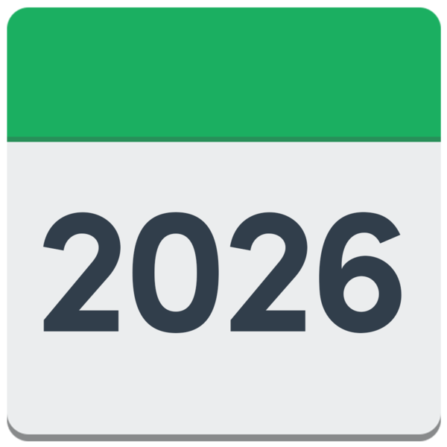
The information in this factsheet is true as of April 2026


Some of the information in this factsheet may change in the future.


This factsheet is about planned changes to flexible funding that have started since 1 April 2026.


These changes will give disabled people more choice and control over how they use their funding.

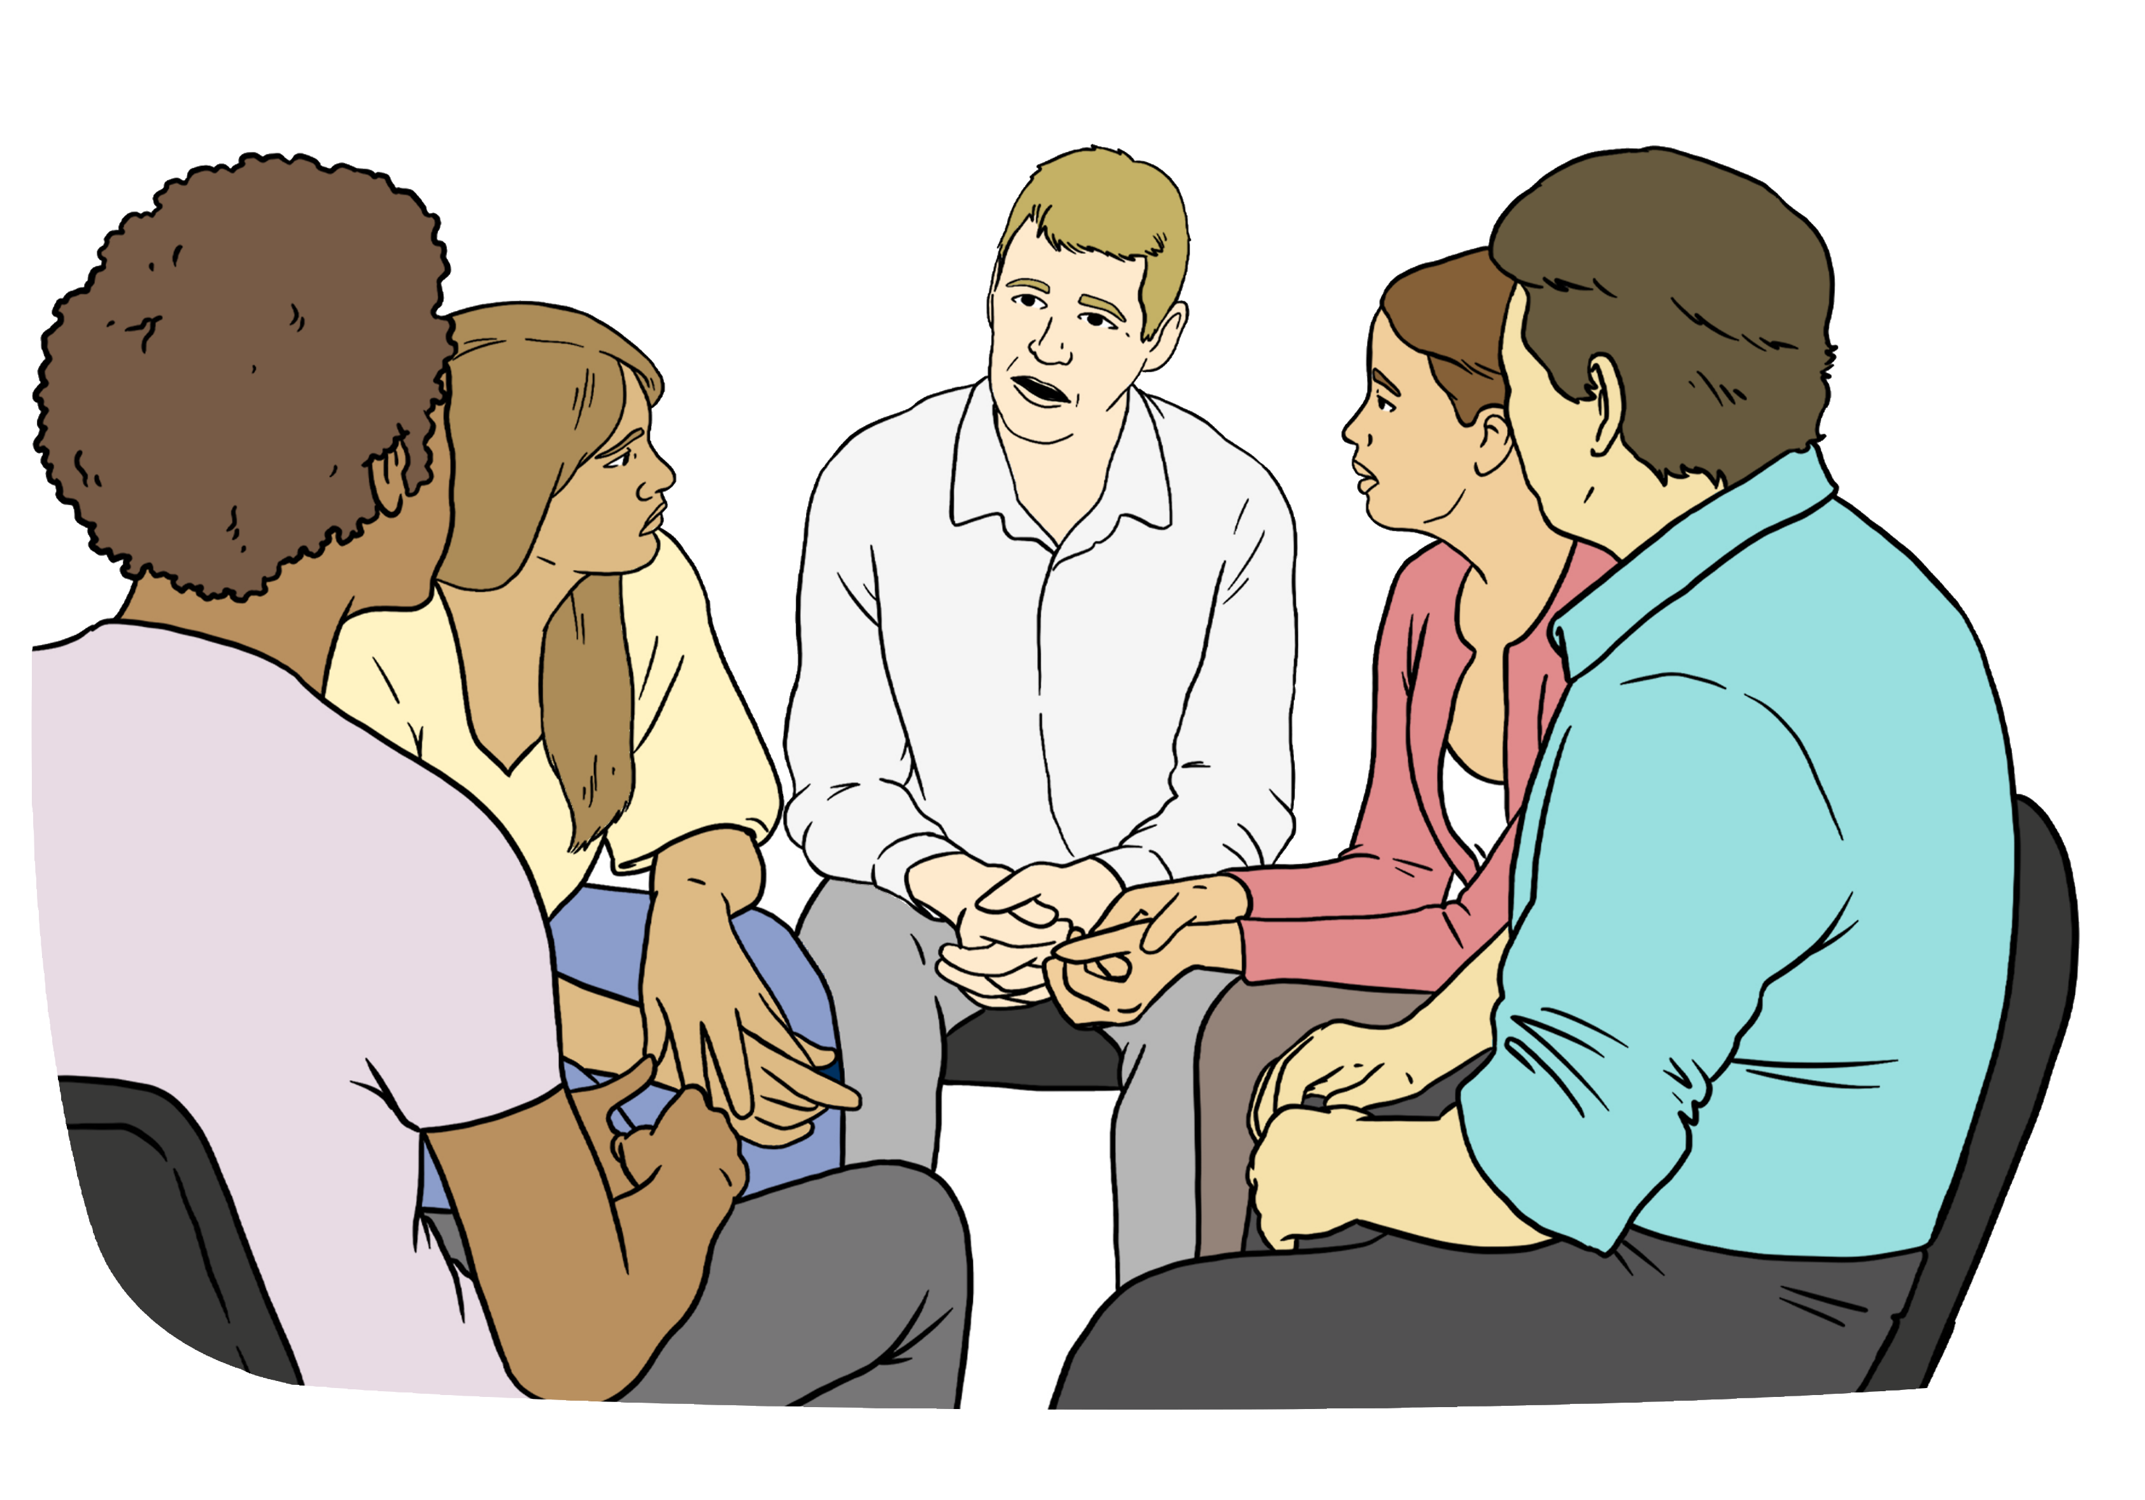
These changes have been made because of what we have heard from the disability community.

April 2026 changes

From 1 April 2026 there will be changes to flexible funding.


Purchasing rules for flexible funding will be taken away.


Purchasing rules are rules about how people can spend their disability support funding.


Flexible funding budgets will stay the same.


There will be guidance for people to manage their flexible funding.

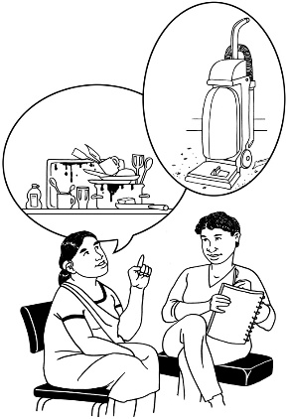
Guidance means the support your host gives you to look after your funding.

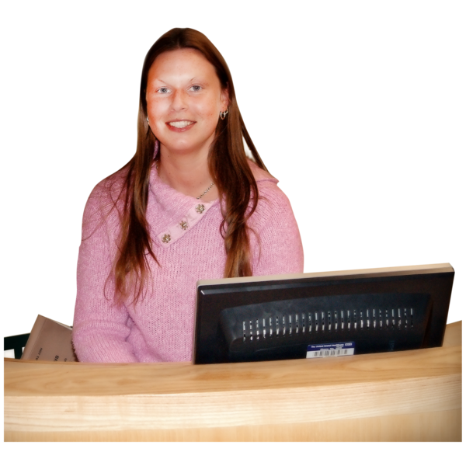
A host takes care of your flexible funding.

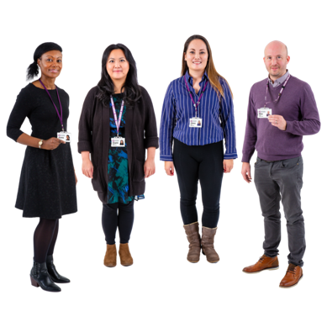
A host can be:
a person
a group

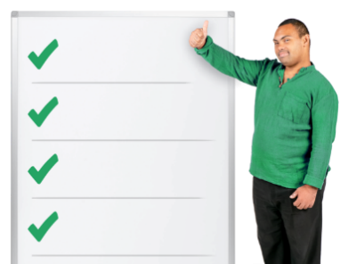
There will be 4 tiers / levels of guidance for everyone on flexible funding.

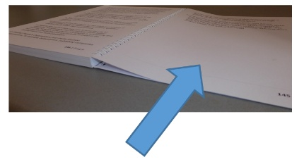
You can find out more about guidance on page 11.

Purchasing rules

The purchasing rules for flexible funding have been taken away.

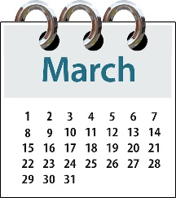
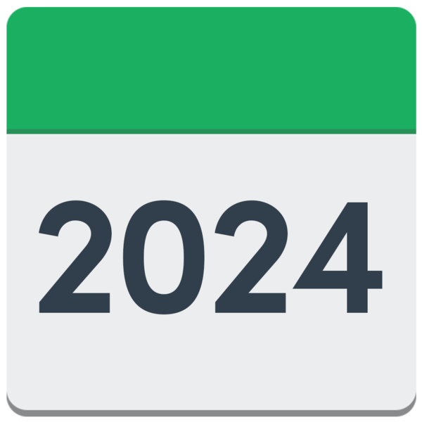
This also means the purchasing rules from March 2024.

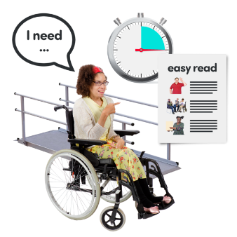
Taking away purchasing rules means you will have more choice about:
what supports work for you
respite options for carers.


Respite options means the ways carers can take breaks from caring for a disabled person.


You still need to use your flexible funding in ways that:
work for your disability support needs
match your funding plan.

You will also need to not spend any more than what is in your budget.

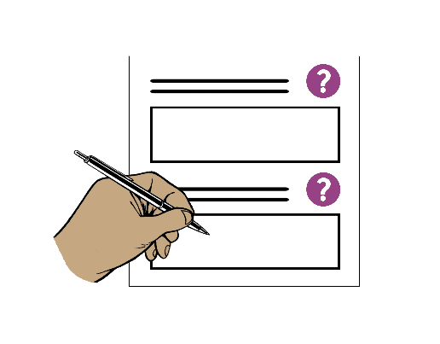
You will need to keep good records of where your funding has been spent.

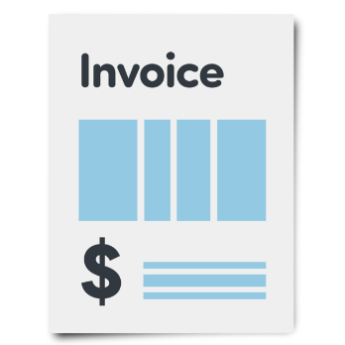
Records means proof of where the funding has been spent like:
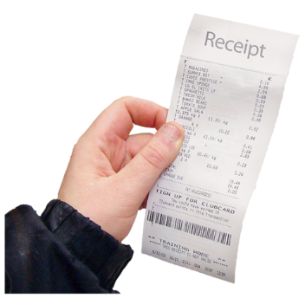
invoices / bills from staff like support workers
receipts from things you bought with your funding.


You also need to talk to your host for prior approval before using your funding for some things like:
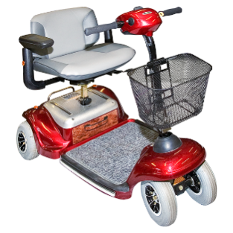
travel to another country
equipment like wheelchairs
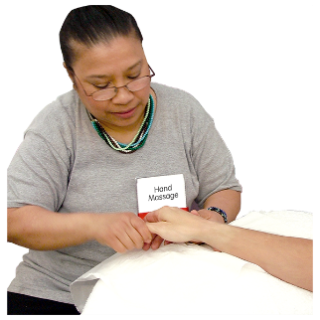
complementary therapies
buying something you have bought before that should still be okay to use
purchases that cost more than a set limit.
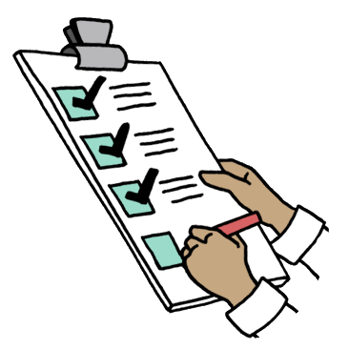
Prior approval means your host has to say yes to you paying for that
support before you can get it.

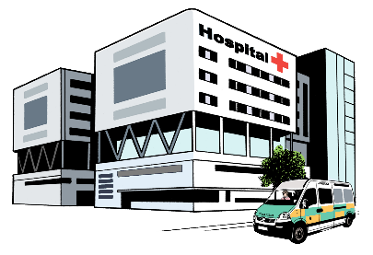
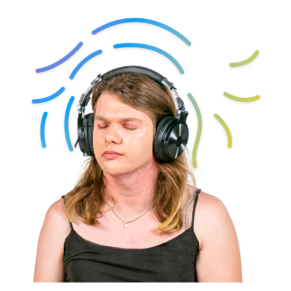
Complementary therapies are treatments to support your health
that are not usually used by the New Zealand health system like:
- massage
- meditation.

A set limit means the most money that can be spent on 1 thing.


There are still some things flexible funding cannot be used for like:
alcohol

gambling.
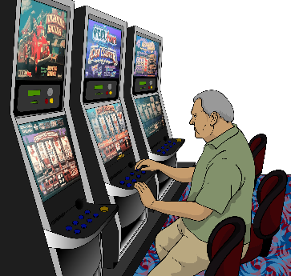
Gambling is trying to win money by doing things like:
playing the pokie machines
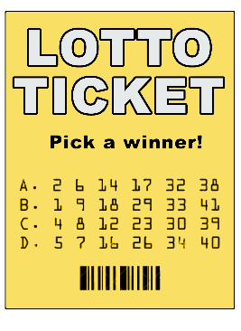
betting on horse races
buying Lotto tickets.

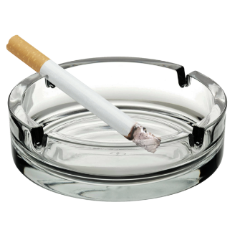
Other things flexible funding cannot be used for is:
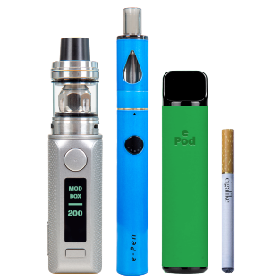
tobacco like:
- cigarettes
- vapes

illegal activities which means things that are against the law.

Here the law means the rules of Aotearoa New Zealand that everyone must follow.

Guidance

Everyone with hosted flexible funding will get guidance from their host.


How much guidance you get is based on what tier / level you are.

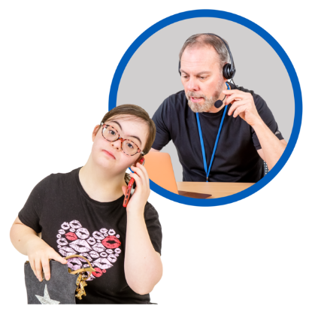
The 4 tiers are:
Tier 1 – low / little support
Tier 2 – some support
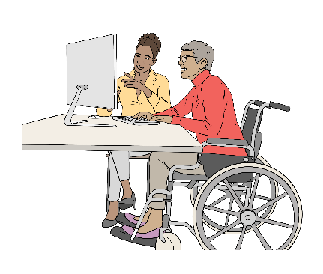
Tier 3 – regular / usual support
Tier 4 – frequent / a lot of support.


The 4 tiers say how:
often your host will check in with you
much guidance you get.


What tier you are in does not change how much funding you get.

Your tier level can change over time.


Your host will contact you after
1 April 2026 to talk to you about:
your tier
guidance.

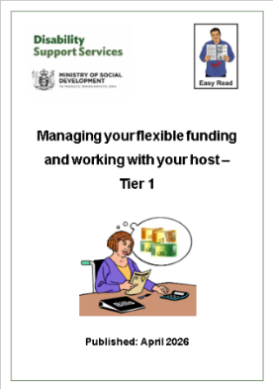
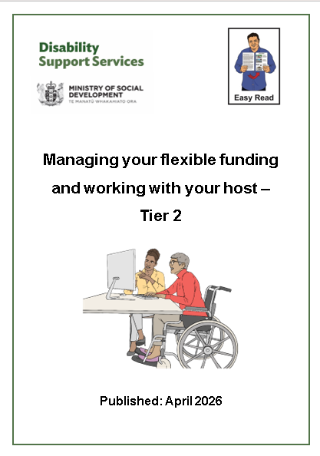
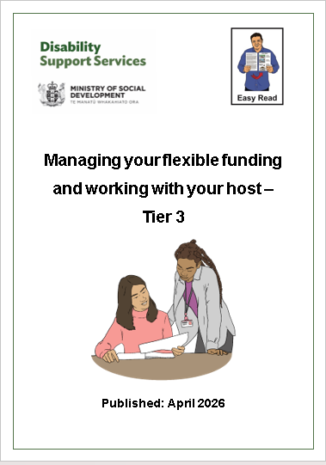
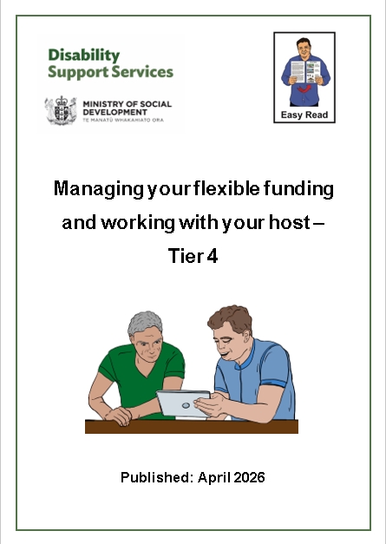
There is Easy Read information for people on each tier.

You can find this Easy Read information at:

www.disabilitysupport.govt.nz/tiers-infosheets

Your funding plan


Your funding plan is about how you use your flexible funding.

Your current funding plan will stay the same as it is for now.


Over time everyone will be moved to a new funding plan called:

My DSS Funding Plan.


This funding plan will make it easier to understand what your funding is for.

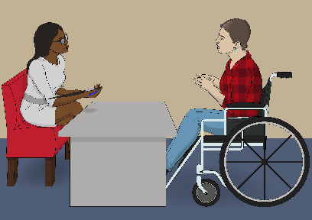
This will happen at your next reassessment / review with your:
Needs Assessment Service Coordination
organisation / NASC
or

Enabling Good Lives / EGL site.

A Needs Assessment Service Coordination organisation
supports disabled people to work out:
what they need for a good life
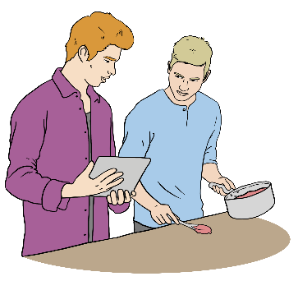
what support they can get.

In this Easy Read Needs Assessment Service Coordination organisations are called NASCs.


Enabling Good Lives is a different way of thinking about disability support.
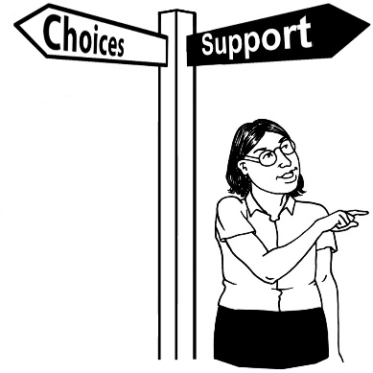
Enabling Good Lives is about having:
choice and control in your life
the support you need and want
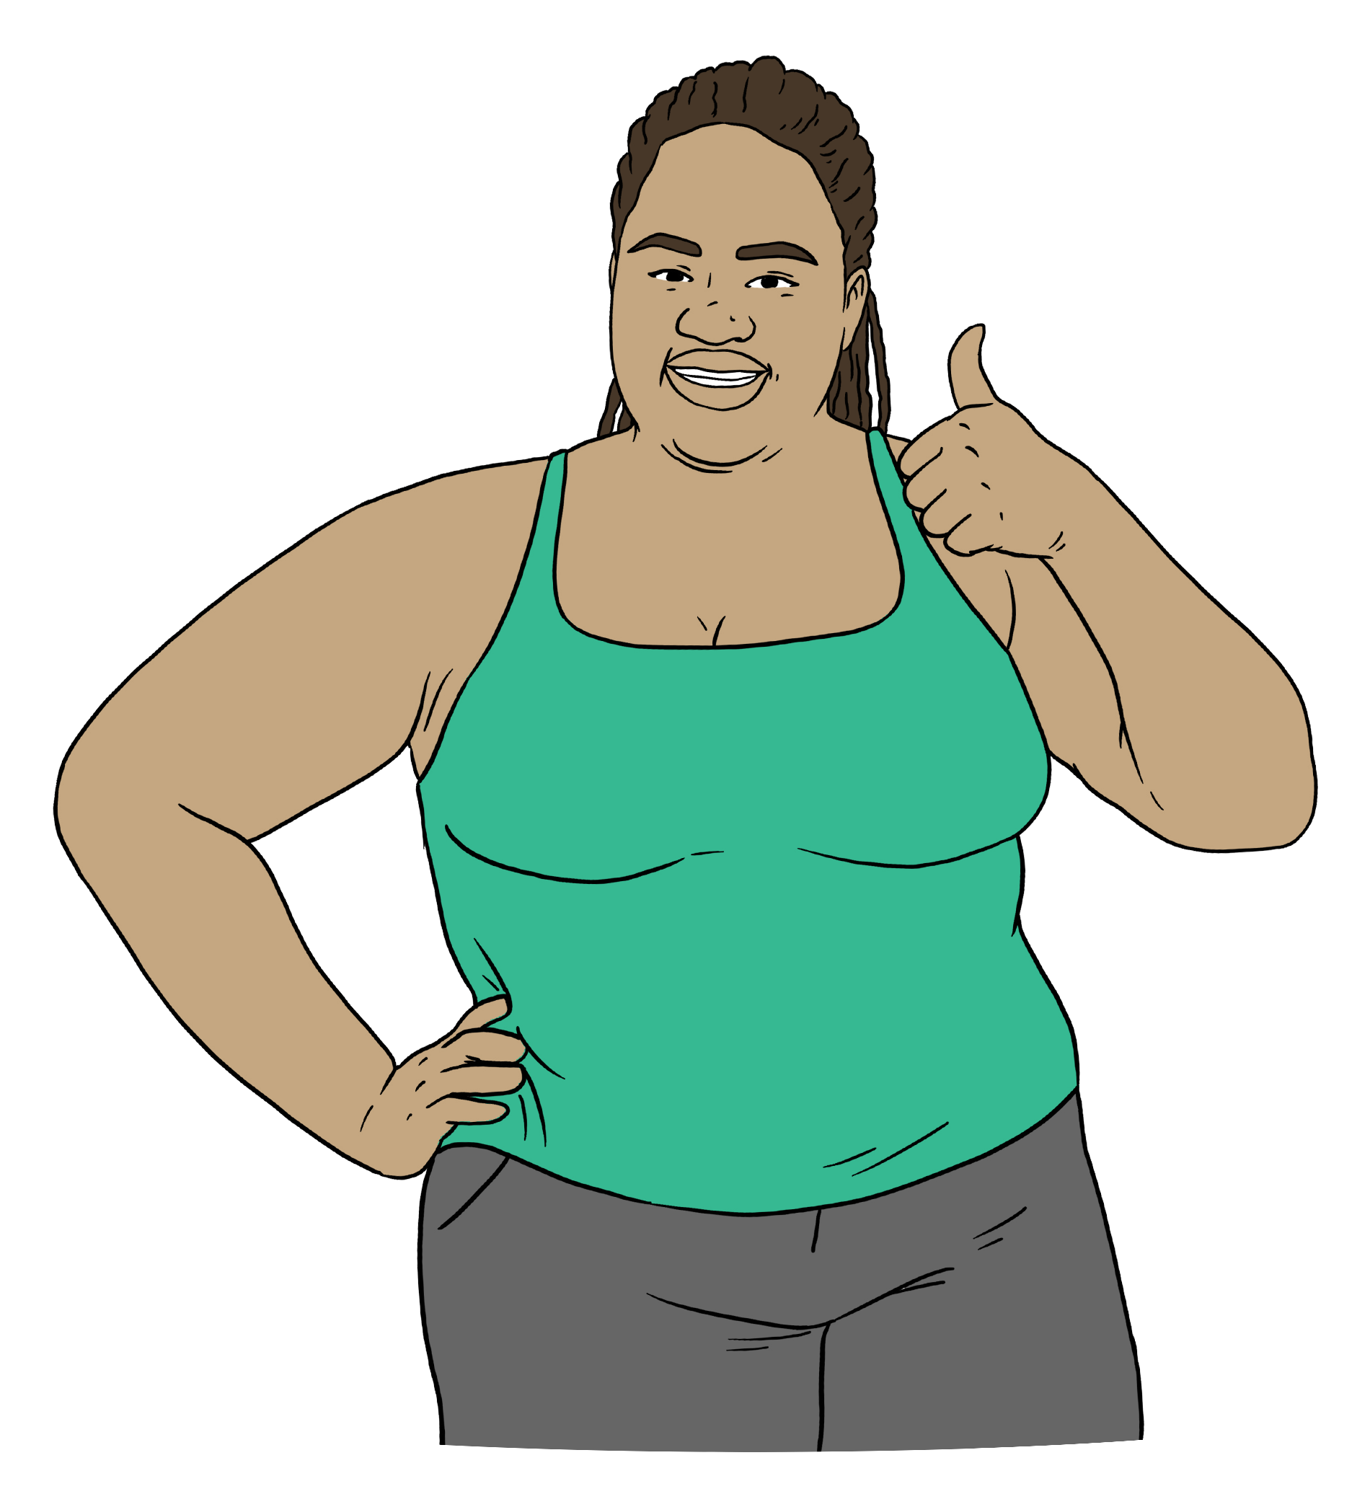
a good life.

Enabling Good Lives is also called EGL.

Your next reassessment / review


The same way of doing assessments is now used by all:
NASCs
EGL sites.

They also all use the same way of choosing how much funding each person gets.


This means everyone gets:
a better experience with DSS
better access to funding
funding that is easy to understand.

More information


You can find more information about flexible funding after 1 April 2026 on our website at:
www.disabilitysupport.govt.nz/flexible-funding


This website is not in Easy Read.

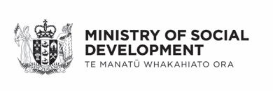
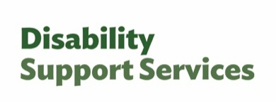
This information has been written by Disability Support Services Ministry of Social Development Te Manatū Whakahiato Ora.

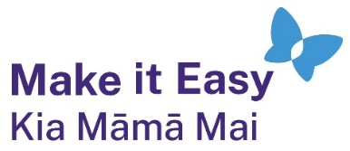
It has been translated into Easy Read by the Make it Easy Kia Māmā Mai service of People First New Zealand Ngā Tāngata Tuatahi.

The ideas in this document are not the ideas of People First New Zealand Ngā Tāngata Tuatahi.

All images used in this Easy Read document are subject to copyright rules and cannot be used without permission.

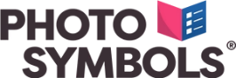
Make it Easy uses images from:

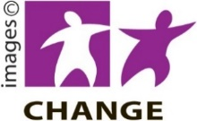
- Photosymbols

- Change Images


- Huriana Kopeke-Te Aho

- SGC Image Works

- T Wood

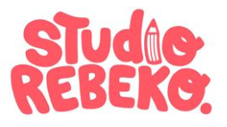
- Studio Rebeko

- Inga Kramer.

