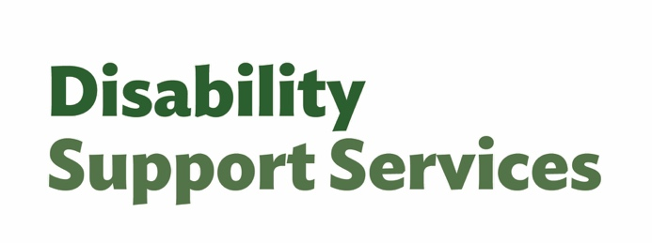
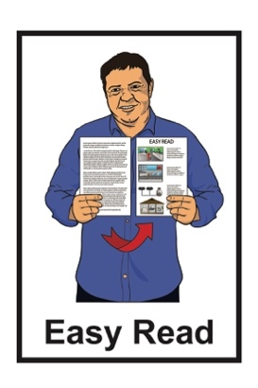
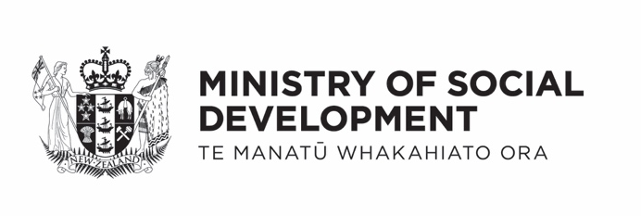

Factsheet – changes to assessments and allocations and flexible funding
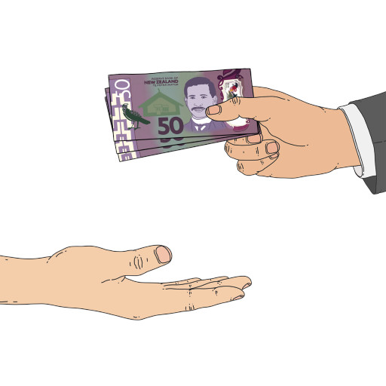

Published: September 2025

What you will find in here


Page number:

What this Easy Read is about 2
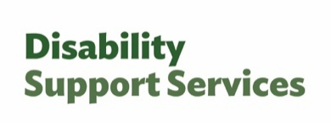

What are the main changes? 7

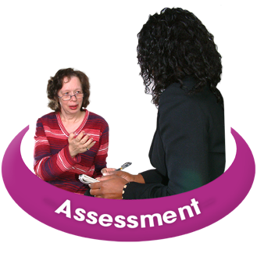
Changes to NASC assessments 9

Changes to flexible funding 13


How flexible funding budgets
will be set 17

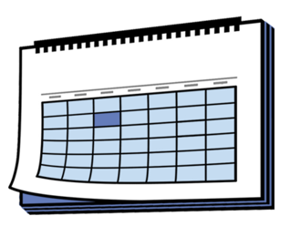
Important dates 18

More information 20

What this Easy Read is about

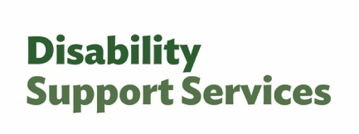
This Easy Read is from
Disability Support Services unit at the Ministry of Social Development.
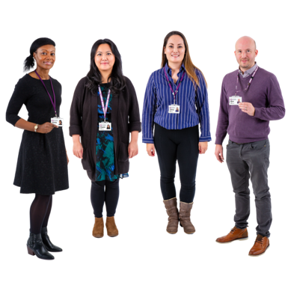

In this Easy Read we / us means Disability Support Services.

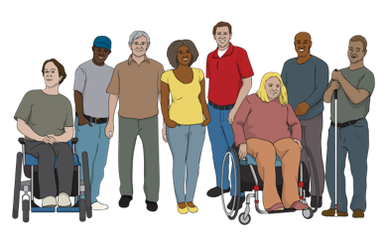
It is information for people who are getting Disability Support Services.

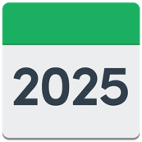
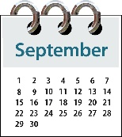
The information in this factsheet is true as of September 2025.


Some of the information in this factsheet may change in the future.

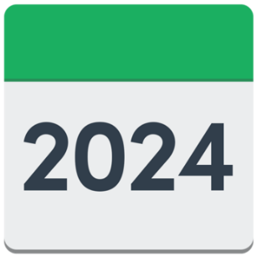
In 2024 we changed the way people can spend their disability support funding.

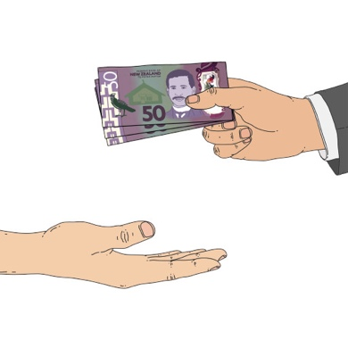
Disability support funding is
money from the Government to pay for things someone needs because
of their disability.
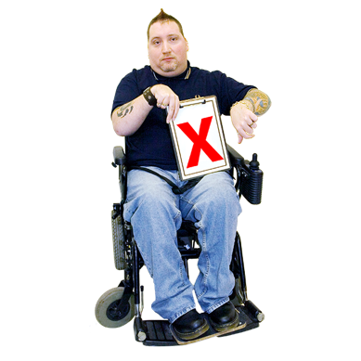

People in the disability community told us that the changes did not work well for a lot of people.

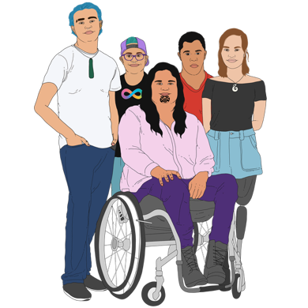
Here the disability community is:
disabled people
whānau / families
carers.


In 2026 we are going to change the rules for disability support funding to work better for disabled people.

These changes are for people who get disability support through a
Needs Assessment Service Coordination organisation.

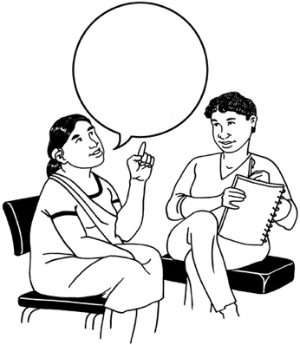
A Needs Assessment Service
Coordination organisation supports disabled people to
work out:
what they need for a good life
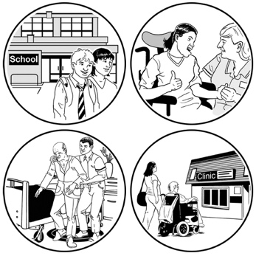
what support they can get.

In this Easy Read Needs Assessment Service Coordination organisations are called NASCs.

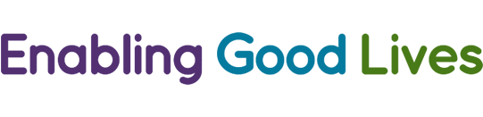
If you get support through
Enabling Good Lives everything will stay the same for now.

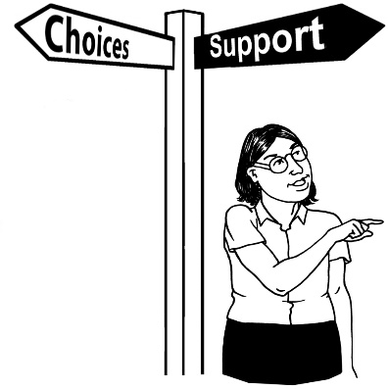
Enabling Good Lives is a different way of thinking about disability support.

Enabling Good Lives is about
having:
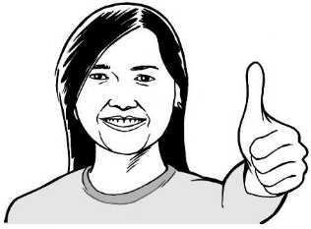
choice and control in your life
the support you need and want
a good life.

There may be changes to
Enabling Good Lives later.

Your disability support funding will stay the same until we make these changes.

What are the main changes?

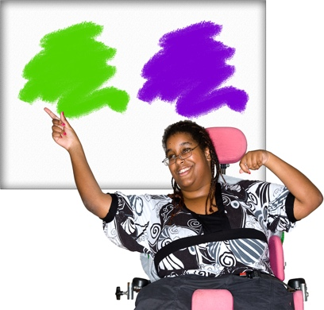
People who get flexible funding will have more choice about how to use their funding.


Flexible funding is money that you can choose how to spend.



We will take away the
purchasing guidelines.

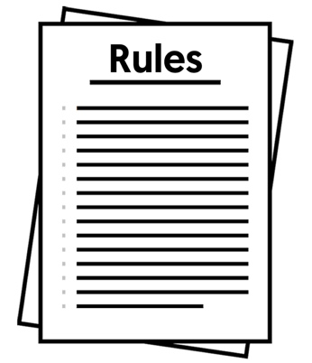
The purchasing guidelines are the rules about how people can spend their disability support funding.

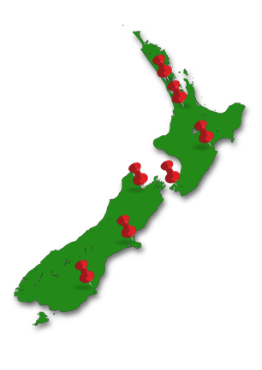
All NASCs in Aotearoa New Zealand will do their assessments the same way.

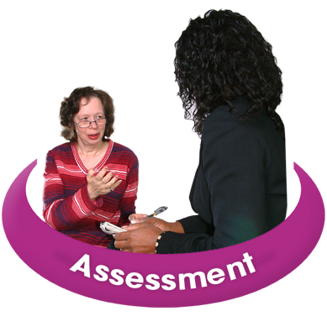
Here an assessment means
working with a NASC to decide the support you:
need
will get.

Changes to NASC assessments


People in the disability community told us assessments can be:
stressful
confusing.


We will make sure everyone gets better information about will happen at their assessment.

All NASCs in Aotearoa New Zealand will do their assessments the same way.


When all NASCs do their assessments the same way they will make decisions that are:
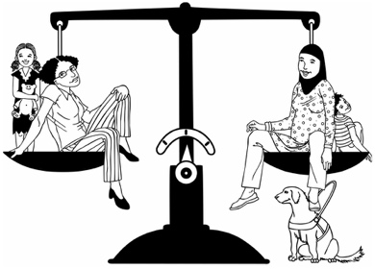
fairer
consistent / the same for everyone.

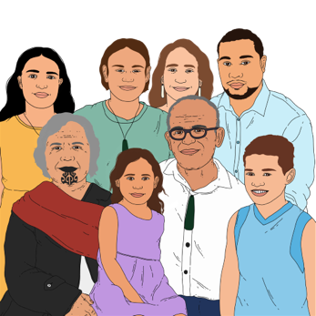
We know that a lot of important support for disabled people is done by:
whānau / families
carers.

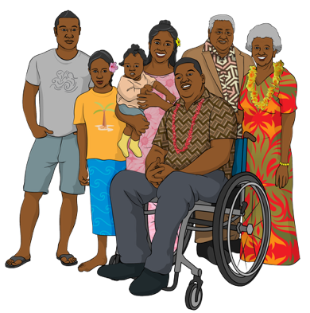
NASC assessments will look at support needs of:
whānau / families
carers.

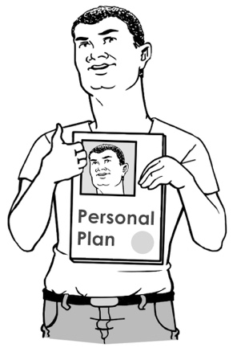
NASCs will work with disabled people to make a personal plan.


Here a personal plan is a plan for how you will use your funding.

The personal plan will say what the funding is for in a way that is easy to understand.


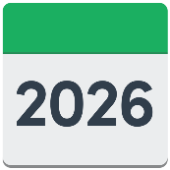
NASCs will not do any reassessments from:
1 February 2026
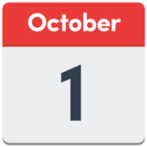
to
1 October 2026.

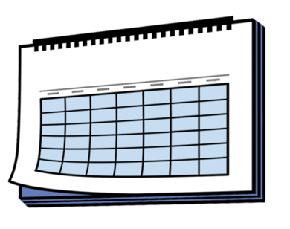
This will give them time to change how they do things.
Here reassessment means having another NASC assessment:
to make sure your support is still working for you
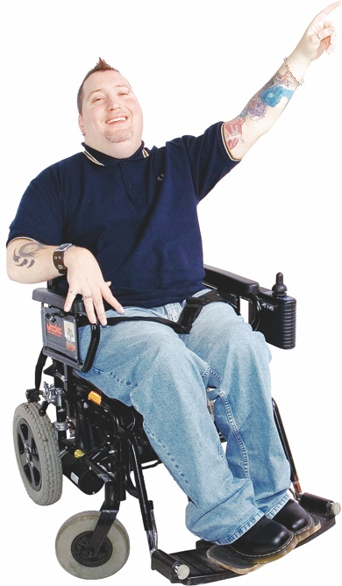
because your support needs have changed.

You can still ask for a reassessment if something in your life has changed

Changes to flexible funding

The changes to flexible funding will make it easier to use.

There will no longer be purchasing guidelines.
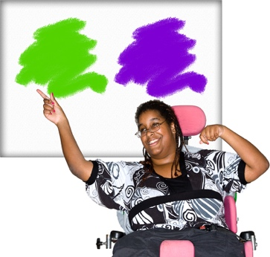

Disabled people will be able to choose how to spend their flexible funding.



There are still some things flexible funding cannot be used for like:
alcohol
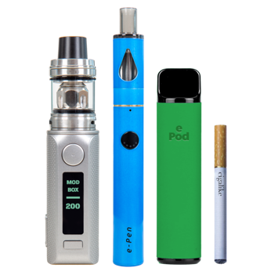
tobacco like:
- cigarettes
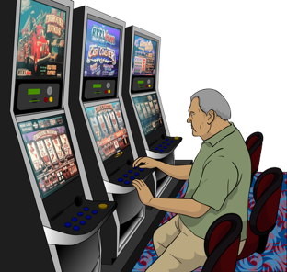
- vapes
gambling.

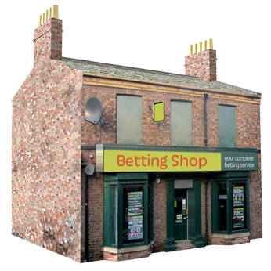
Gambling is trying to win money by doing things like:
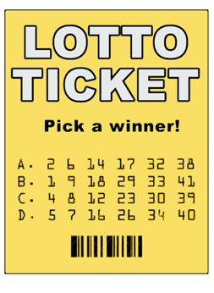
playing the pokie machines
betting on horse races
buying Lotto tickets.

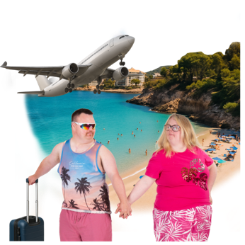
There are also some things that you need to ask about before you spend flexible funding on them like:

travel to other countries
things that cost a lot of money.


People who get flexible funding will have a budget to use.

Here a budget is the amount of money you can spend.


We will give people support to manage their budget.


If your support needs change you can talk to your:
NASC
Host.

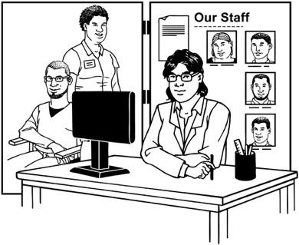
Here your Host is the organisation that supports you to manage your funding.

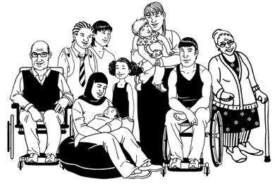
Flexible funding may not work for everyone.
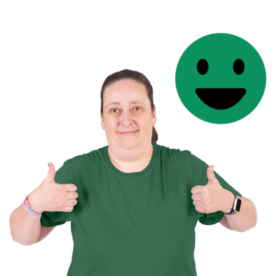

NASCs will work to make sure everyone gets support that is right for them.

How flexible funding budgets will be set

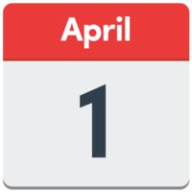
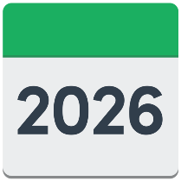
We will take the purchasing guidelines away on 1 April 2026.

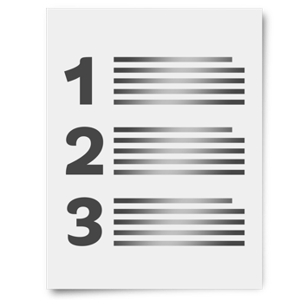
People who already have flexible funding will be given a budget.

Your budget will be worked out from how much funding you have used in the past.

It will take time for the new way of doing things to be set up.

Important dates


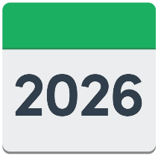
From 1 February 2026:
people using Disability Support Services for the first time will have their assessment using the new process
NASCs will stop doing reassessments until
1 October 2026.

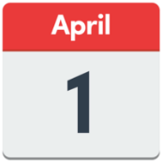
From 1 April 2026:
people who already get flexible funding will be given a budget
we will take the purchasing guidelines away
we will work with NASCs to make sure the changes happen smoothly.

From 1 October 2026:
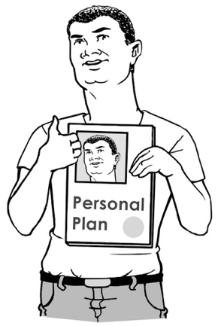
reassessments will start up again
we will start working with people to make their personal plans.

More information


We will tell you what is happening as we make each change to Disability Support Services.

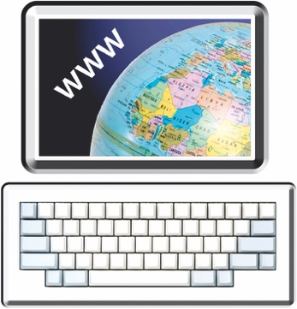
There is more information about the changes on the Disability Support Services website at:

www.disabilitysupport.govt.nz/dsschanges

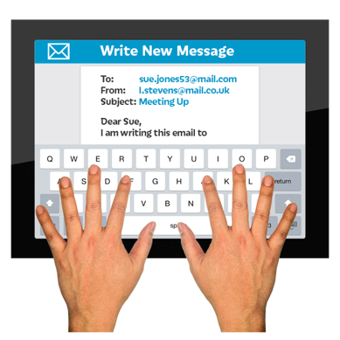
If you have any questions you can email us at:

info@disabilitysupport.govt.nz

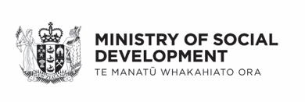
This information has been written by Disability Support Services Ministry of Social Development Te Manatū Whakahiato Ora.

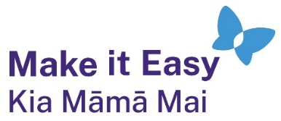
It has been translated into Easy Read by the Make it Easy Kia Māmā Mai service of People First New Zealand Ngā Tāngata Tuatahi.
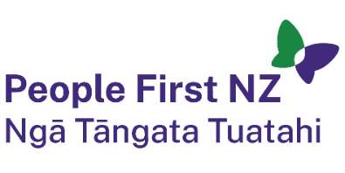
The ideas in this document are not the ideas of People First New Zealand Ngā Tāngata Tuatahi.

All images used in this Easy Read document are subject to copyright rules and cannot be used without permission.

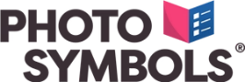
Make it Easy uses images from:

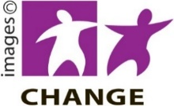
- Photosymbols

- Change Images


- Huriana Kopeke-Te Aho

- SGC Image Works

- T Wood

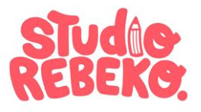
- Studio Rebeko

- Inga Kramer.

