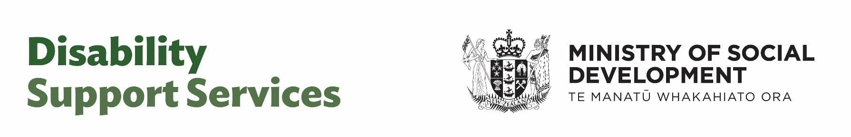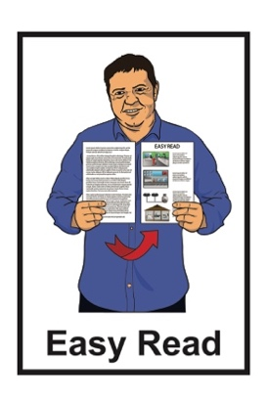

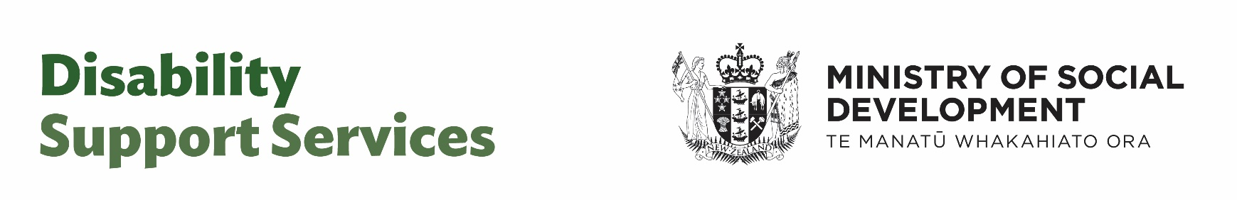

Factsheet –

Community Group Home

Pricing Model



Published: May 2025

# About this factsheet

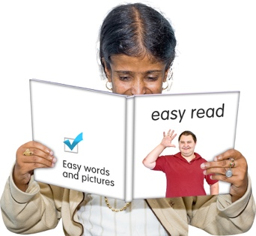

This Easy Read factsheet has information for:

disabled people

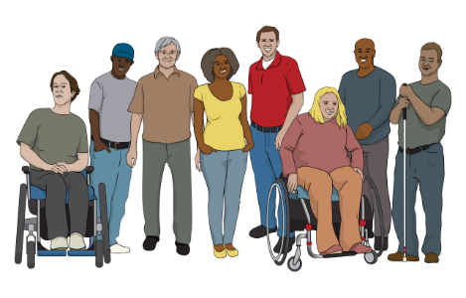

whānau / family of disabled people

carers.

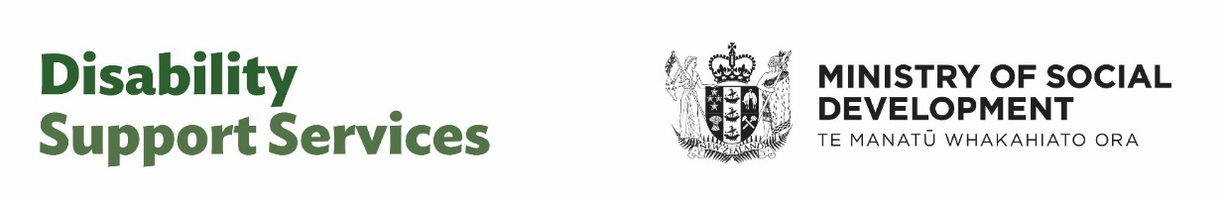

This Easy Read factsheet is from **Disability Support Services** which is part of Ministry of Social Development.

In this Easy Read factsheet Disability Service Services is also called **DSS** for short.

When you see the words   
**our / we / us** in this factsheet it means DSS.



This Easy Read factsheet is about the changes Disability Support Services are making to how they pay **residential service providers**.

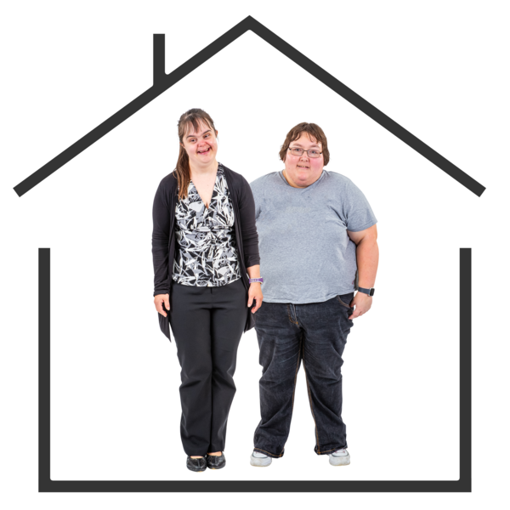**Residential service providers:**

* are places that offer residential care to disabled people
* get funding from DSS to provide residential care support.

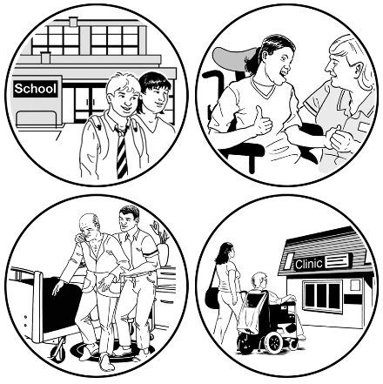

We have come up with a simple way to pay residential services providers for the support / services we fund.

This new way is called **Community** **Group Home Pricing Model**.

**Community Group Homes** are homes shared by a group of disabled people who need support.

**Pricing model** is a way of working out the right price to pay for something.

More information about the Community Group Home Pricing Model is on **page 5.**

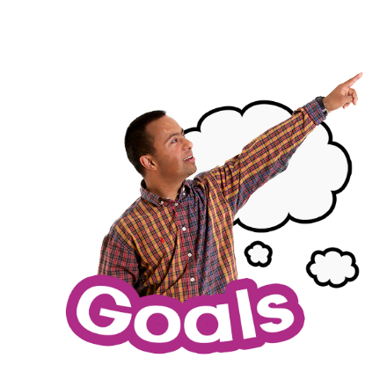

Our main goal is making sure disabled people in residential care still get the services / support they need.

We will work with residential care providers to support them as they start to use this new model.

We are doing this to follow **recommendation** 2 of the **2024 Independent Review** into DSS.

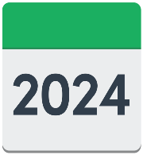



**Recommendations** are ways to make something better.

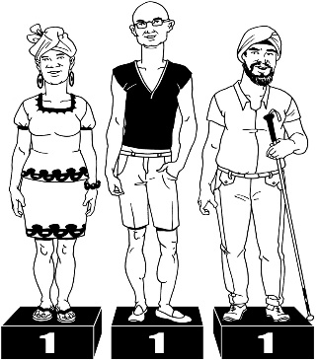Recommendation 2 was made when the review found how we used to pay was:

hard to understand

not as fair as it should be.



Information about the Independent Review is on the DSS **website**:

[**tinyurl.com/szfhvmm9**](https://tinyurl.com/szfhvmm9)

# About the new Community Group Home Pricing Model

The new pricing model is only for Community Group Home providers.

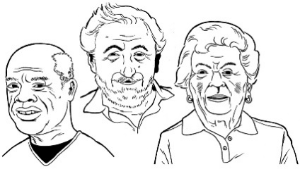It does **not** apply to DSS providers of:

aged residential care

residential care of   
children / young people in Oranga Tamariki

High and Complex Services.

We are working with those providers to make the way we pay for their services better.

The new pricing model will:

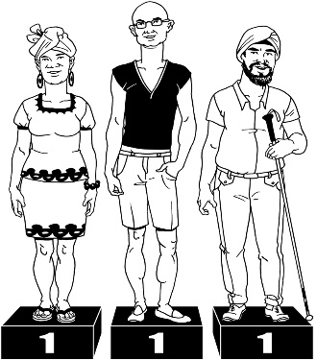be more:

* fair
* consistent – work in the same way for everyone
* transparent – easier for people to understand
* financially sustainable – easier for us to pay for

assist us in better understanding how much DSS needs to pay for residential care services.

# Will there be changes for disabled people in residential care?



Disabled people in residential care should not see any changes.

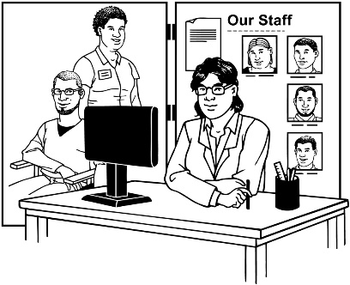The pricing model only changes how we pay providers for residential services for disabled people.

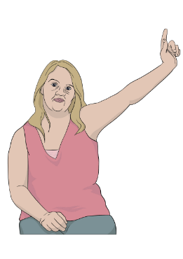For any questions disabled people should contact their providers:

NASCs - Needs Assessment Service Coordination agency

EGL - Enabling Good Lives.

# What will NASCs and EGL sites continue to be responsible for?

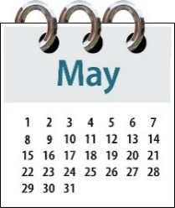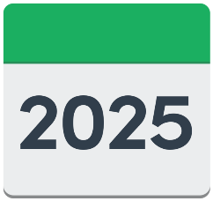

NASC / EGL site **budgets** will be confirmed after the Government puts out their Budget in May 2025.



**Budget** is the amount of money used for something.

NASC / EGL sites will still make the decision:

if someone can have DSS support

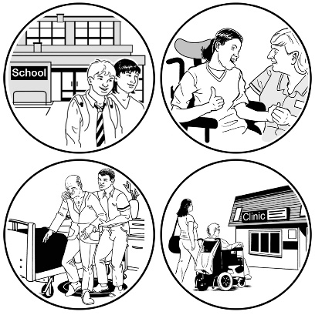about what kind of DSS support someone can have like:

* going into residential care
* support at home.

NASC / EGL sites will also still be responsible for:

assessing the needs people may have

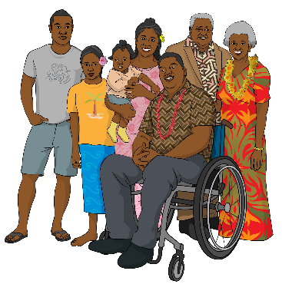talking / working with:

* disabled people
* their whānau / families.

looking at:

* 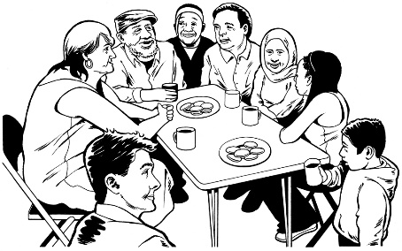supports like community groups
* government funded supports

making sure they are assisting the people who have the highest needs first.

# Who have we worked with to make

# the new pricing model?

Before we make decisions we believe it is important to talk with:

disabled people

their whānau / families.



While we were working on this model we talked about funding with:

the disability community

residential care providers.

There will be more chances for the disability community to have their say on how we make residential services better in the **future**.

**Future** means in the months / years to come.

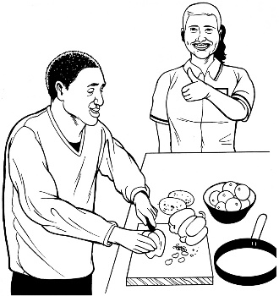This includes work on making things better such as:

how good disability support services are

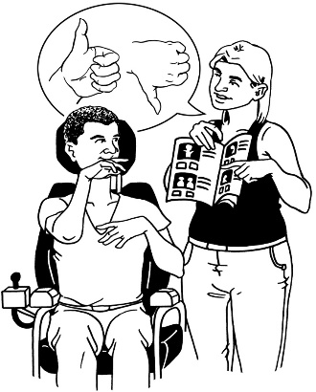how safe disability support services are

giving more options for disabled people who are looking for residential care.

# More information

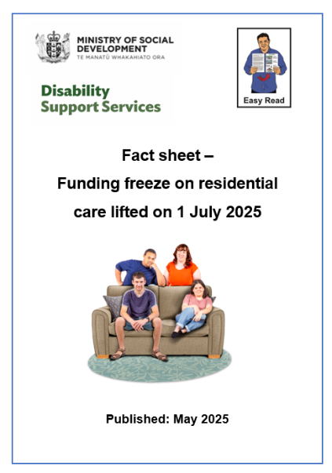

There is an Easy Read factsheet called:

**Funding freeze on residential care lifted 1 July 2025**.

You can find this factsheet on our website:

[**www.disabilitysupport.govt.nz/cgh**](https://www.disabilitysupport.govt.nz/cgh)



The factsheet is also available on the DSS website in alternate formats.

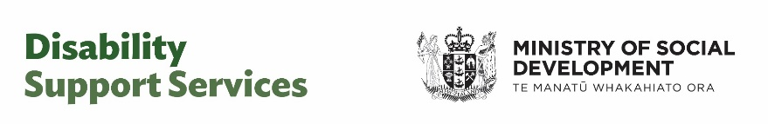This information has been written by Disability Support Services – Ministry of Social Development.

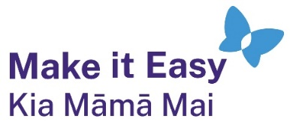It has been translated into Easy Read by the Make it Easy Kia Māmā Mai service of People First New Zealand Ngā Tāngata Tuatahi.



The ideas in this document are not the ideas of People First New Zealand Ngā Tāngata Tuatahi.



All images used in this Easy Read document are subject to copyright rules and cannot be used without permission.

Make it Easy uses images from:

* Photosymbols
* Change Images
* Huriana Kopeke-Te Aho



* SGC Image Works
* T Wood
* Studio Rebeko
* Inga Kramer.