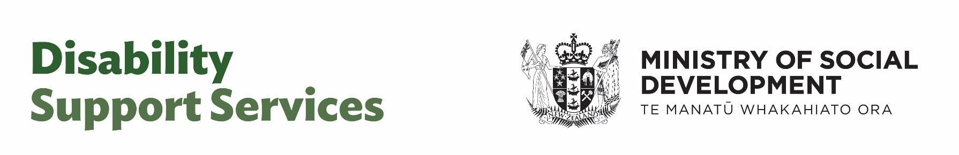

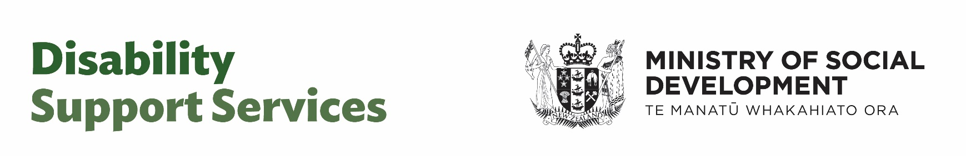

Fact sheet –

Funding freeze on residential care lifted on 1 July 2025

Published: May 2025

# About this factsheet

This Easy Read factsheet has information for:

disabled people



whānau / family of disabled people

carers.

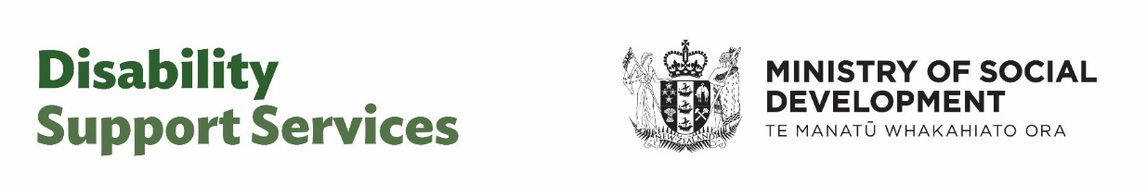

This Easy Read factsheet is from **Disability Support Services** which is part of Ministry of Social Development.

In this Easy Read factsheet Disability Service Services is also called **DSS** for short.

When you see the words   
**our / we / us** in this factsheet it means DSS.

This Easy Read factsheet is about what lifting the **funding freeze** on residential care means for:

disabled people

**NASC / EGL** sites

NASC / EGL **budgets**.

****Here **funding freeze** means the amount of money DSS was using to fund residential care was **paused**.

**Paused** means to stop something for a short amount of time.

**NASC** means Needs Assessment Service Coordination agency.

**EGL** is Enabling Good Lives.

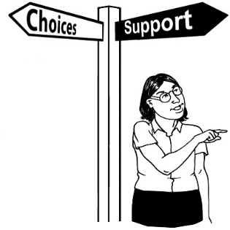

Enabling Good Lives is about having:

choice and control in your life



the support you need and want

a good life.



**Budget** is the amount of money used for something.

# Information about the funding freeze

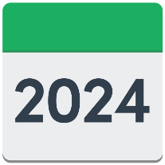

The funding freeze happened after the 2024 review of Disability Support Services.

More information about the review is available on the Disability Support website here:

[**tinyurl.com/szfhvmm9**](https://tinyurl.com/szfhvmm9)

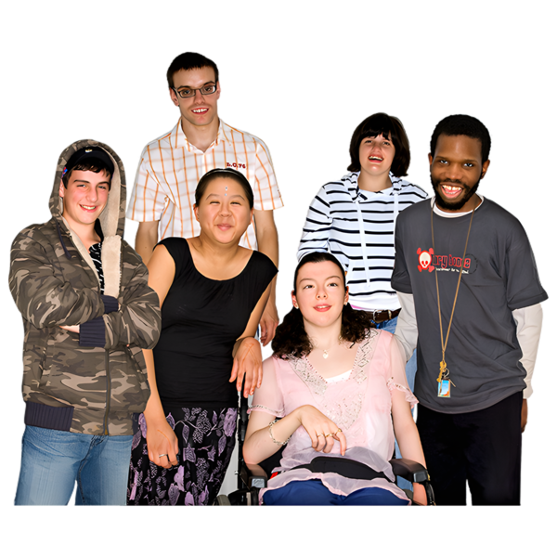

The funding freeze did not affect the number of people who could access residential care.

Disabled people still:

had access to residential care services

left residential care services.

# What lifting the funding freeze means

# for disabled people

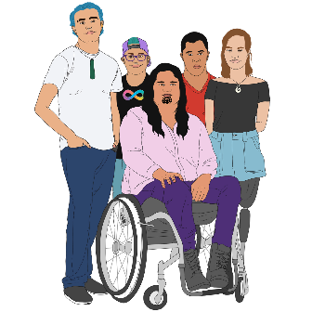

Disabled people will not see any changes straight away.

Decisions about who can get residential care funding will still be made by:

NASCs services

EGL sites.

 NASC / EGL site will also still make the decision:

if someone can have DSS support

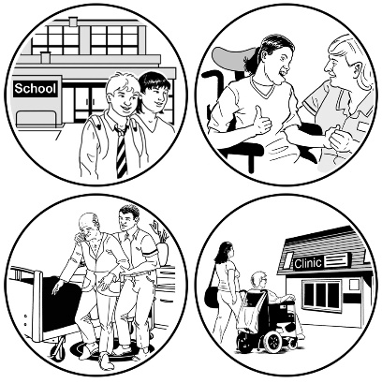about what kind of DSS support someone can have like:

* going into residential care
* support at home.

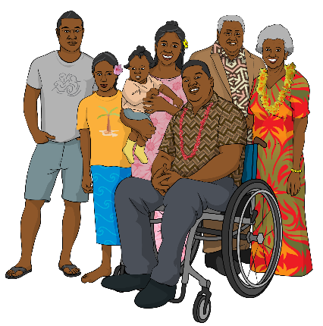NASC / EGL sites will work to get access to support with:

disabled people

whānau of disabled people.



Contact your NASC / EGL site if you have any questions about your support / services.

# What lifting the funding freeze means

# for NASC / EGL sites

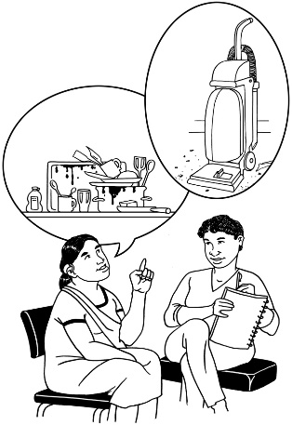NASC / EGL sites will still need to give:

support

services.



This will be for those who need them the most.

After the funding freeze is lifted NASCs will be able to work with more:

disabled people

whānau / family of disabled people.

They will assist in finding the best options for people such as:

community based support

residential care.

# Will there be changes to

# NASC / EGL budgets?

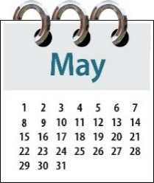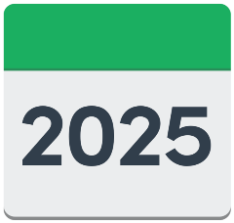

NASC / EGL site budgets will be confirmed after the Government puts out their Budget in May 2025.

# More information

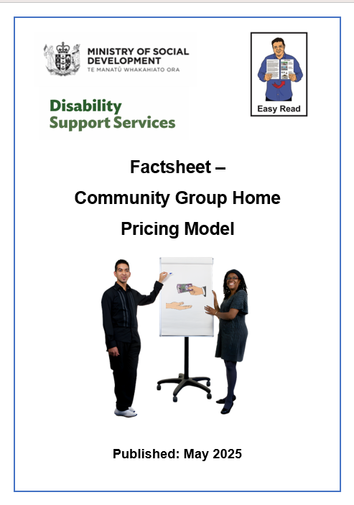

There is an Easy Read factsheet called:

**Community Group Home Pricing Model** on the DSS

You can find this factsheet on our website:

[**www.disabilitysupport.govt.nz/cgh**](https://www.disabilitysupport.govt.nz/cgh)



This factsheet has information on the new way DSS will fund residential providers.



The factsheet is also available on the DSS website in alternate formats.

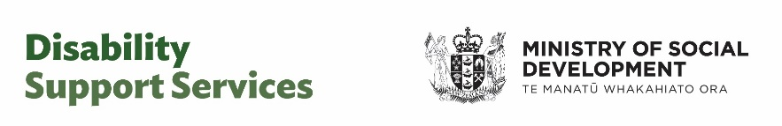This information has been written by Disability Support Services – Ministry of Social Development.

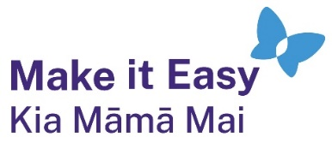It has been translated into Easy Read by the Make it Easy Kia Māmā Mai service of People First New Zealand Ngā Tāngata Tuatahi.



The ideas in this document are not the ideas of People First New Zealand Ngā Tāngata Tuatahi.



All images used in this Easy Read document are subject to copyright rules and cannot be used without permission.

Make it Easy uses images from:

* 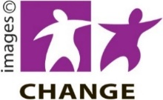Photosymbols
* Change Images
* Huriana Kopeke-Te Aho



* SGC Image Works
* T Wood
* Studio Rebeko
* Inga Kramer.