
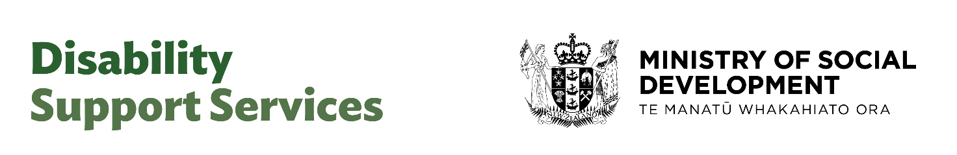

Web App User Guide
Version 4
July 2026



Document Control

Title: Web App User Guide
Owner: Alex Tierney
Version: 4.0
Effective Date: 06 August 2026

Document History

Version | Date Updated | Summary of Changes | Author(s)
V2 | 13/04/2026 | Changes in line with release 2.1 | Alex Tierney,  Rachel O’Connor
V3 | 18/05/2026 |  | Alex Tierney  Rachel O’Connor
V4 | 17/07/2026 | Changes in line with release 4. Changes to this documented were made on the following pages (all changes highlighted):  8, 9, 10, 12, 13, 15, 16, 17, 21, 29, 31, 40, 46, 50, 53, 54, 58, 62, 63, 64, 65 | Alex Tierney  Rachel O’ Connor

Contents

Document Control 2
Document History 2
1 Introduction 5
2 Dashboard 6
2.1 Searching the Dashboard 7
2.2 Assessment Statuses New 8
2.3 Action Required New 9
2.3.1 Action Required Statuses New 10
2.3.2 Picking up an Assessment 11
2.4 Recent People 11
3 Assessments Tab New 12
3.1 Searching/Viewing Assessments New 12
4 Notifications New 15
5 Switching Between Organisations New 16
6 Requesting Support and Administration New 17
6.1 Requests for Team Leaders and Managers 17
6.2 Helpdesk and Technical Support 17
7 Creating an Assessment 18
7.1 Assessment Creation 18
7.2 Holistic Section New 20
7.3 Important Information, Reflections and Support Profile Sections 22
7.3.1 Important Information 23
7.3.2 Reflections 24
7.3.3 Support Profile 26
7.3.4 Support 27
7.3.5 Draft funding plan New 29
7.4 Summary 30
7.4.1 Ending an Assessment New 30
7.5 Moderation (Confirmation of Assessment Review) 32
7.5.1 Incomplete Assessments 33
8 Allocator Reviews the Assessment 35
8.1 Picking up an Assessment 35
8.2 Moderating the Assessment 35
8.2.1 Requesting More Information 36
8.3 Assigning the Assessment to DSS 37
9 DSS Allocator Exports Assessment Results for Indicative Funding Calculation 39
9.1 Individual Assessment Export 39
9.2 Bulk Assessment Export 40
9.3 Requesting More Information 42
10 Managing the Indicative Funding Range in OBIR 43
10.1 DSS Allocator Records the Funding Range in an Individual Assessment 43
10.2 DSS Allocator Imports Funding Range File 44
10.3 NASC/EGL Allocator Reviews the Funding Range New 46
10.3.1 Manager Approval Required 47
10.4 Manager Approval 48
11 Managing Assignments New 50
11.1 Reassigning Assessments 51
11.2 Updating Disabled Person’s Details 52
11.3 Reverting an Assessment’s Status New 53
11.3.1 How to Revert an Assessment’s Status 53
11.3.2 Reversion Rules 54
12 My DSS Funding Plan 55
12.1 Overview 55
12.2 Adding a Support 55
12.3 Support Costs Calculation 57
12.4 Saving the Funding Plan as a Draft 58
12.4.1 Backdating a Funding Plan by Over a Week 59
12.5 Downloading a My DSS Funding Plan 59
12.6 Disabled Person Sign Off 61
12.7 Completing the Funding Plan 62
12.8 Creating an Additional Funding Plan New 62
12.9 Duplicating a Funding Plan New 65

Introduction

This user guide covers how to perform and manage assessments within the Outcomes Based Indicative Range (OBIR) web application. The purpose of these assessments is to understand the Disabled Person’s strengths, goals, and support needs in order to enable a good life. The information captured will be used to calculate an indicative funding range.
The system roles relate to the following:
- Assessor aligns with the Needs Assessor/Connector role

- Allocator aligns with the Service Coordinator/Budget Advisor role

- Manager aligns with the NASC/EGL manager's role

- DSS Allocator is the DSS Indicative Range team

From an application perspective, the key stages are:
- An Assessor creates an assessment within OBIR

- That assessment is assigned to an Allocator for review

- Once the review stage is complete, the assessment is assigned to a DSS Allocator to support calculation of an Indicative Range (this is currently done via Excel)

- The Indicative Range is entered into OBIR by the DSS Allocator and reviewed by the Allocator

- The assessment can then be picked up by either the Assessor or Allocator to create a “My DSS Funding Plan”

The above describes a basic, straightforward flow. However, in certain cases assessments will need to be sent back to the Assessor in order to get more information or may need to be sent to a Manager for approval if the indicative range is above a defined threshold.

OBIR Live Application URL: https://obirportal.msocio.nz/login
OBIR Training Application URL: https://obirportal.mynonprod.com/

Dashboard

Depending on your assigned role on your Dashboard, you may:

Assessor and Manager
- Launch a new assessment

- Edit, view or delete an existing assessment

- View or action your tasks

- See recent people

Allocator only
- View assigned assessments

- View and action tasks

- See recent people

If assigned both roles all the above will be accessible.

Searching the Dashboard
You can search for tasks and/or assessments created by or assigned to you by typing the Disabled Person’s NHI, First Name, and/or Last Name in the respective fields or select from the assignee dropdown and clicking Search:
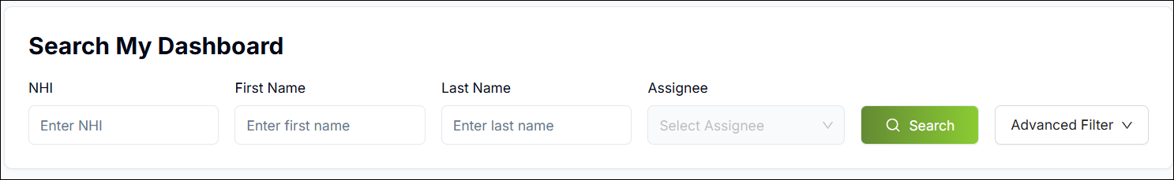
You can also filter assessments by status. To do so, click Advanced Filter and use the Next Step field to select the desired status:
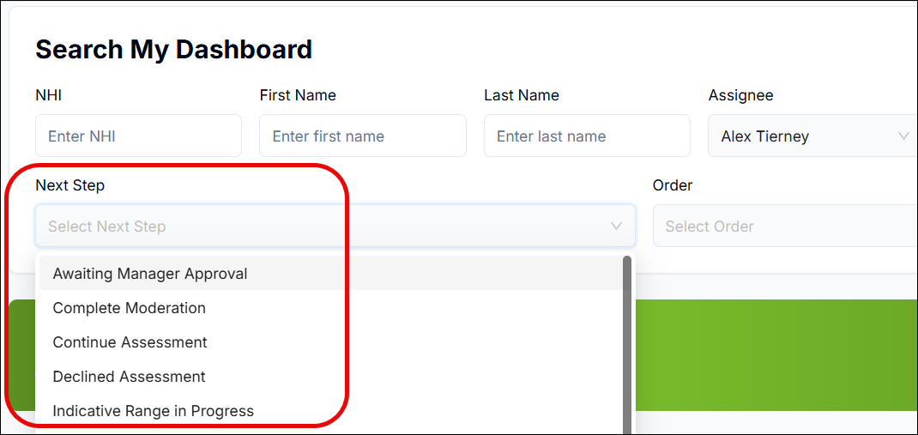
In addition, you can arrange your required actions in ascending or descending order:
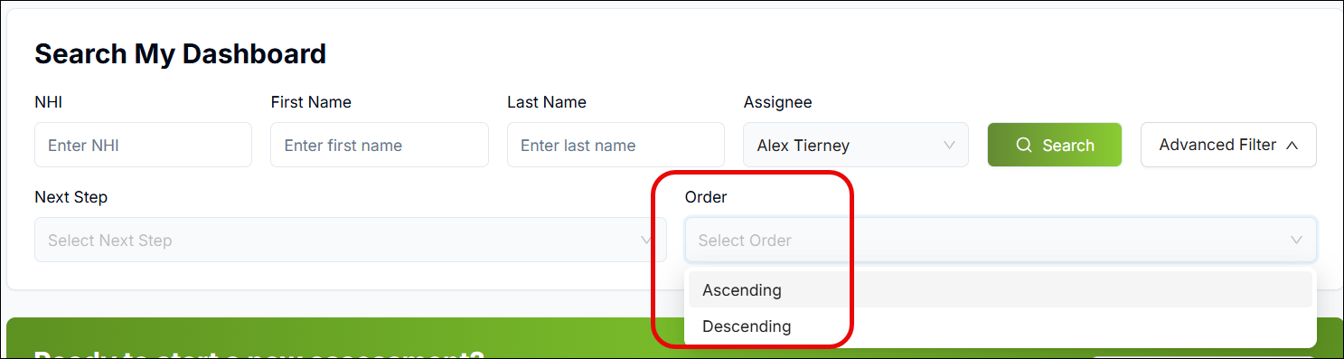
The system will then display any assessments matching the search criteria:
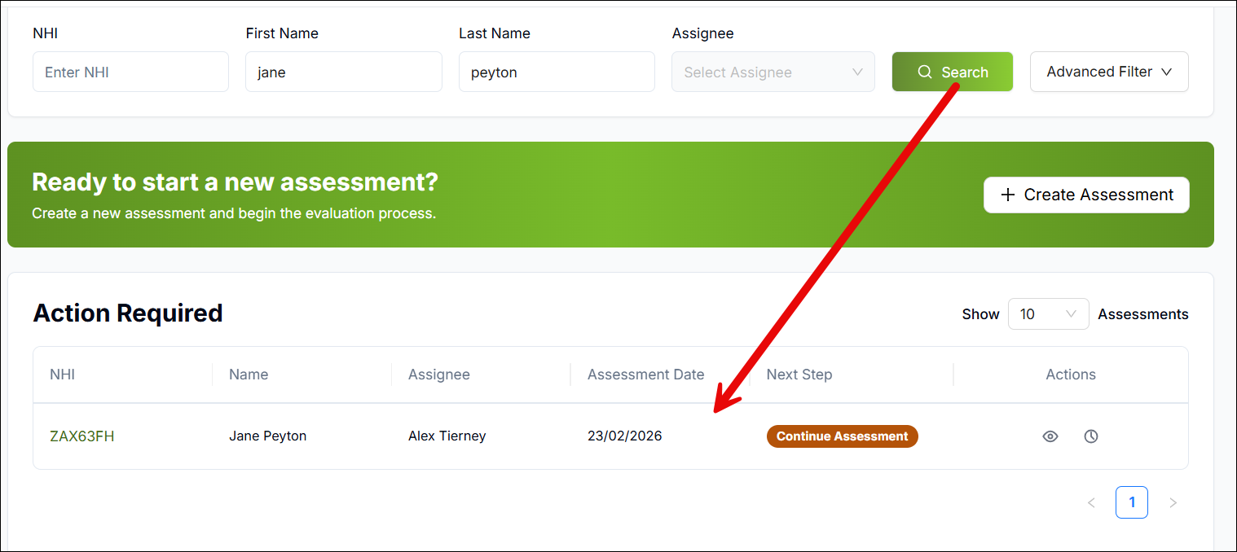

Assessment Statuses New
Assessment Status | Description | Next step status | Assignee
Draft | Assessment has been started but not finished. | Continue Assessment | Assessor
Ready for Moderation | Assessment is complete and ready to be reviewed. | Start Moderation | Allocator
Moderation in-progress | Assessment is currently being reviewed. | Complete Moderation | Allocator
Info Requested | More information is needed before it can continue. | Information Requested | Assessor
Ready for IR | Moderation is complete and assessment has been sent to DSS for IR calculation | Ready for Indicative Range | DSS
Indicative Range in-progress | Indicative Range is being worked on by DSS | Continue Indicative Range | DSS
Confirm Indicative Range | Indicative range has been sent back to the Allocator | Confirm Indicative Range | Allocator
Assessment Completed | Assessment has been finalised. | My DSS Funding Plan | Assessor/Allocator
Awaiting Approval | Waiting for approval of IR before moving forward. | Assess Approval Request | Manager
Declined | IR has been declined. | Declined Assessment | Allocator
Funding Plan Completed | Funding plan has been finalised. | No next step
Closed | Assessment has been ended without an IR and/or Funding plan | No next step

Action Required New
In the Action Required section on the Dashboard screen, you can see your tasks relating to assessments either created by you or assigned to you.
The Assessor Only role will see Continue Assessment, Info Requested and My DSS Funding Plan as next step tasks:
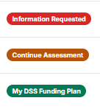

The Allocator Only role will see Start Moderation, Complete Moderation, Confirm Indicative Range and My DSS Funding Plan as next step tasks:
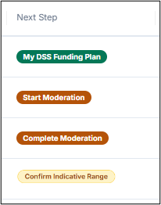
If assigned both roles all the above will be accessible.
The Manager role will see assessments where the Indicative Range requires approval:
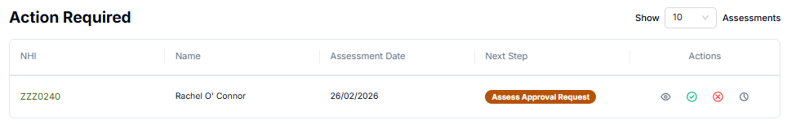
To view an assessment related to an action required, click the View icon next to it:

To view a log of previous steps related to this assessment, click the View History icon:

You can use this selector to specify how many actions you want to be displayed within the Action Required section at any one time:
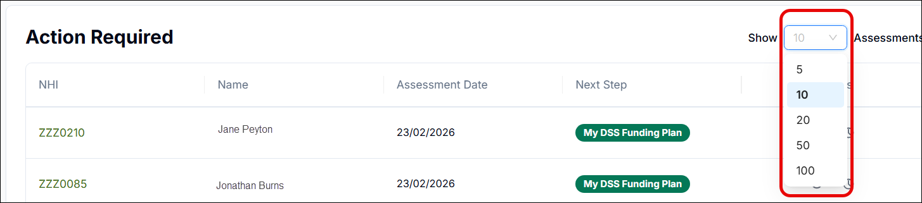

Action Required Statuses New
Status | Description | Actor
Continue Assessment | Keep working on the assessment. | Assessor
Start Moderation | Begin reviewing the assessment. | Allocator
Complete Moderation | Finish the review process and send to DSS. | Allocator
Ready for Indicative Range | DSS to start the Indicative Range step. | DSS
Continue Indicative Range | Start next stage of the Indicative Range process. | DSS
Confirm Indicative Range | Allocator to review Indicative Range | Allocator
Information Requested | Provide the missing information. | Assessor
Assess Approval Request | Manager to review the IR amount | Manager
MyDSS Funding Plan | Create or manage the funding plan in MyDSS. | Assessor/Allocator
Declined Assessment | Manager has declined the IR amount | Allocator

Picking up an Assessment
If an assessment has been assigned to you and is sitting in your Action Required section, you can pick it up by doing the following:
- Click on the Next Step status next to the assessment in question:

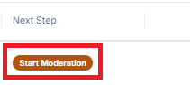

- A pop up will appear asking you to confirm; click Pick Up:

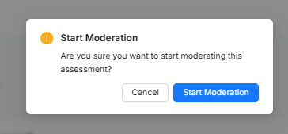

Recent People
The Recent People section will display Disabled Persons that you recently interacted with. E.g. if you just completed an assessment or saved a partial assessment as a draft, you will be able to find and view these in the Recent People section:
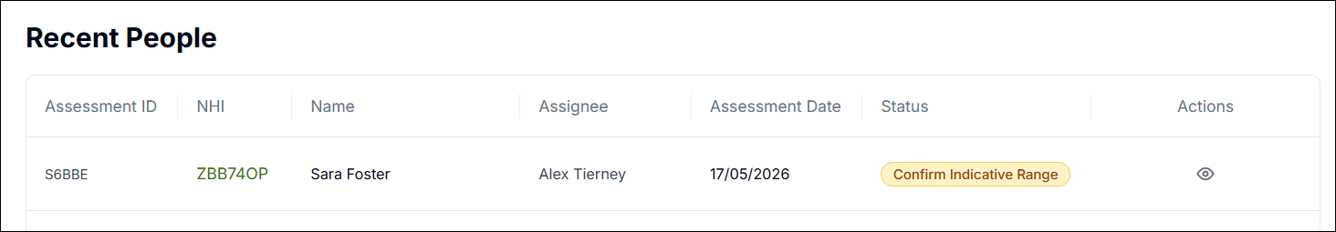
To view an assessment, click this icon:


Assessments Tab New
On this tab you can see all the assessments created within your NASC/EGL.
Users can
- view assessments
- delete draft assessments
- edit draft assessments
- view assessment history
- download assessments
You can also see who is currently working on the assessment from the assignee column.

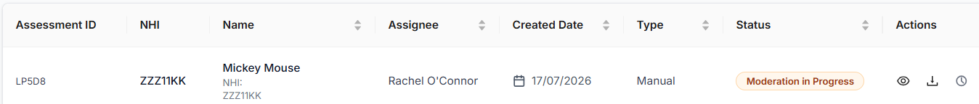

Searching/Viewing Assessments New
You can easily view an assessment by doing the following:
- Ensure the lefthand panel is expanded by clicking the icon with three lines (top left corner):



- Click Assessments:

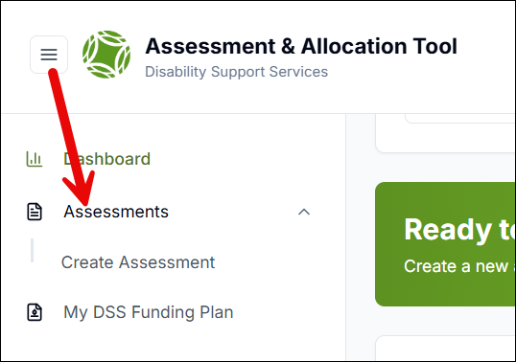

- Here you can use the Search bar and/or filters to find the assessment you need:

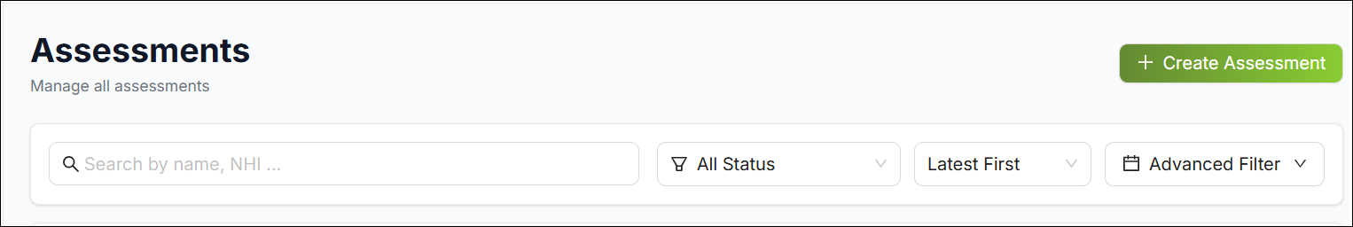

- To view an assessment, click this icon:
- To edit an assessment, click this icon:



- To delete an assessment, click this icon (Please note, only assessment creators can delete an assessment):



- To view a log of previous steps related to this assessment, click the View History icon:



This will open a History drawer where you can view both Status and Peer Review histories:

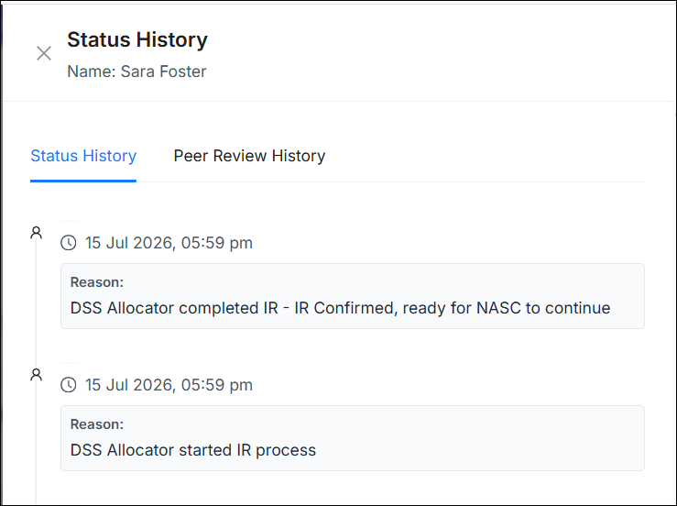

- Click the Down Arrow icon to download the completed assessment and funding plan:

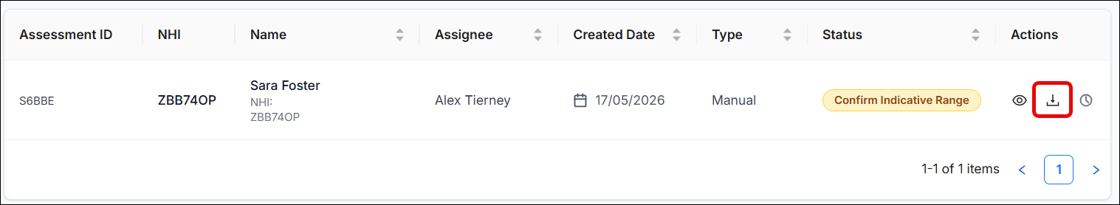

There are two download options: Download as a PDF Mind-map, or Download as an Excel file. To proceed, click the appropriate option:

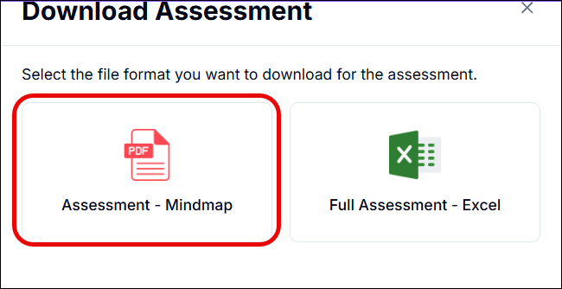

Notifications New

Email notifications will be automatically generated by the web-app during certain steps of the assessment and allocation process.
Notifications to Assessors are generated when:

  - More information has been requested by the Allocator /DSS Allocator

Notifications to Allocators are generated when:

- When an assessment has been assigned to you to review

- The Indicative Range has been calculated by the DSS Allocator

- The Manager has completed their review

Notifications to Managers are generated when:

- An Indicative Range requires approval
Note: Notifications will not be sent if you are assigning an assessment to yourself.

Switching Between Organisations New

If you are a member of multiple organisations, you can easily switch between them in OBIR, meaning you don’t have to log out and back in.
To switch to another organisation:
- Click on the Organisation field at the top right of the screen; the drop down will display all organisations you are a member of:

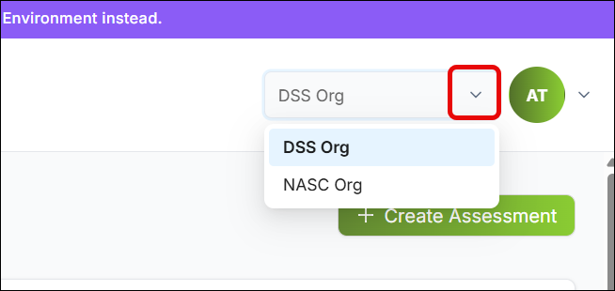

- Click on the organisation you want to switch to

- The system will take you straight into the selected organisation

Requesting Support and Administration New
If you require assistance or need to modify an assessment, please follow the instructions below.

Requests for Team Leaders and Managers
For administrative changes to specific assessments, please contact your Team Leader or Manager to action the following:
- Correcting Personal Details: If a Disabled Person’s name, DOB, gender, or NHI was recorded incorrectly, a Team Lead/Manager can update these key identifiers.
- Assessment Reassignment: If you are going on leave or a change in circumstances requires an assessment to be managed by a different user, a Team Lead/Manager can reassign the assessment to another team member.
- Status Reversions: If an assessment has been progressed prematurely or accidentally completed, you may request that a Team Lead/Manager revert the assessment to a previous status.

Helpdesk and Technical Support
For queries regarding funding calculations, system access, or technical issues, please contact the relevant support team via email:
Request Type | Support Team Email
Indicative Range Queries | DSS_IndicativeRangeSupport@msd.govt.nz
Web-app Support & Troubleshooting | DSS_Testing@msd.govt.nz
User Account Management | DSS_Testing@msd.govt.nz

Note on Account Management: When requesting to create, update, or deactivate a web-app account, ensure you attach the required Access Form to your email to avoid processing delays.

Creating an Assessment

Assessment Creation
To create an assessment in OBIR:
- On the Dashboard screen click Create Assessment:

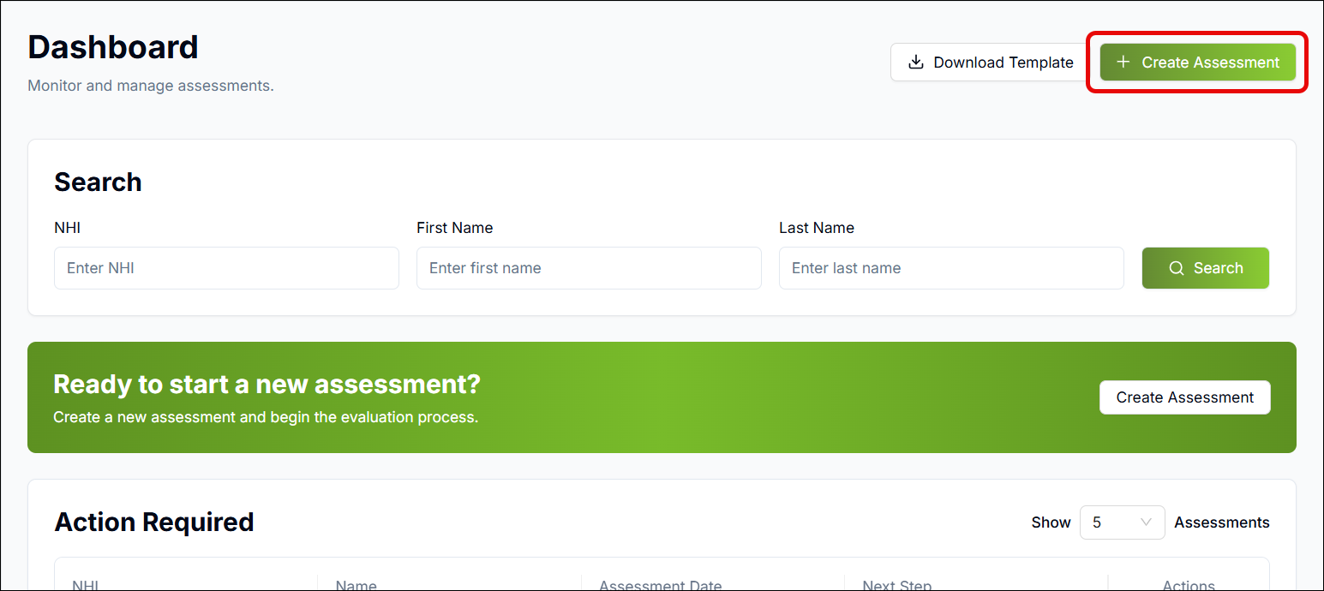

- An Assessment Type panel will slide open from the right. Click on Manual Submission:

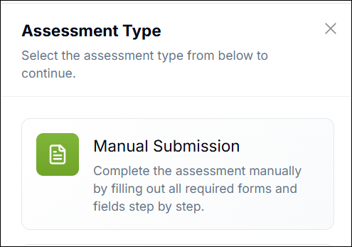

- On the Create Assessment screen, enter the following details in their respective fields:

  - NHI of the Disabled Person

  - Date of the Assessment

  - The Disabled Person’s First and Last Name

  - The Disabled Person’s DOB

  - The Disabled Person’s Gender (if you select Any Other, an additional field will appear to enable you to specify)

  - The Disabled Person’s Life Stage from the dropdown (please note, this will pre-select based on the Disabled Person’s DOB)

  - Click Standard Plan

  - Click Continue

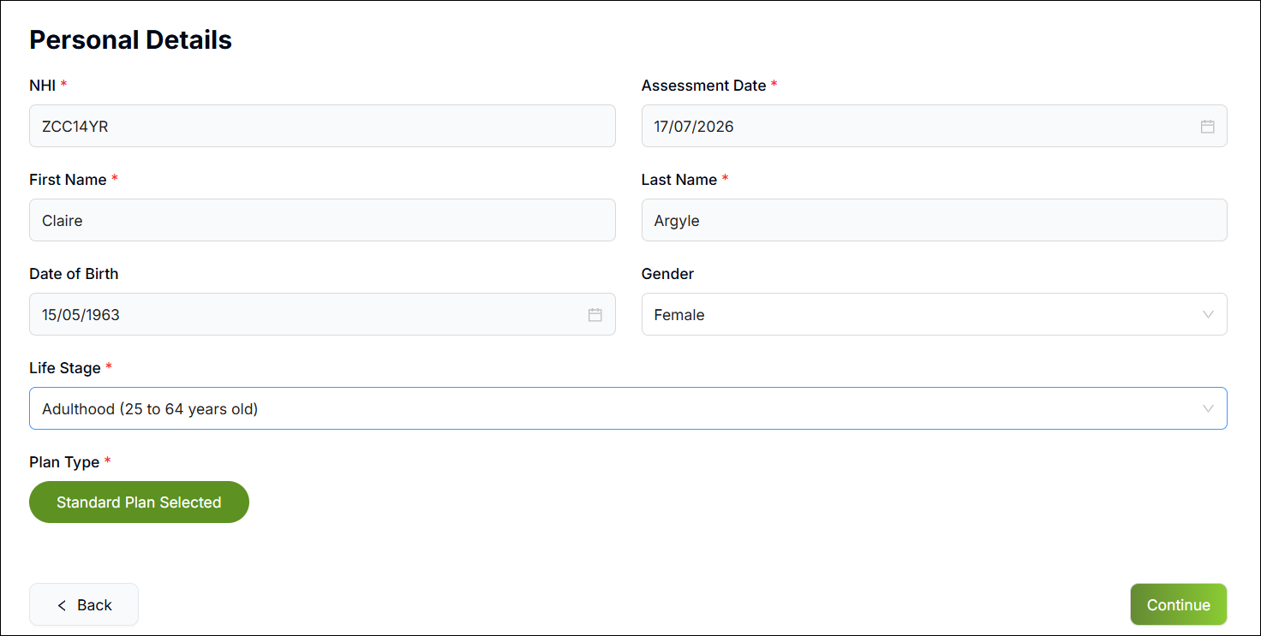

Holistic Section New
When the Holistic Section opens, you will see all assessment sections displayed in the lefthand panel:
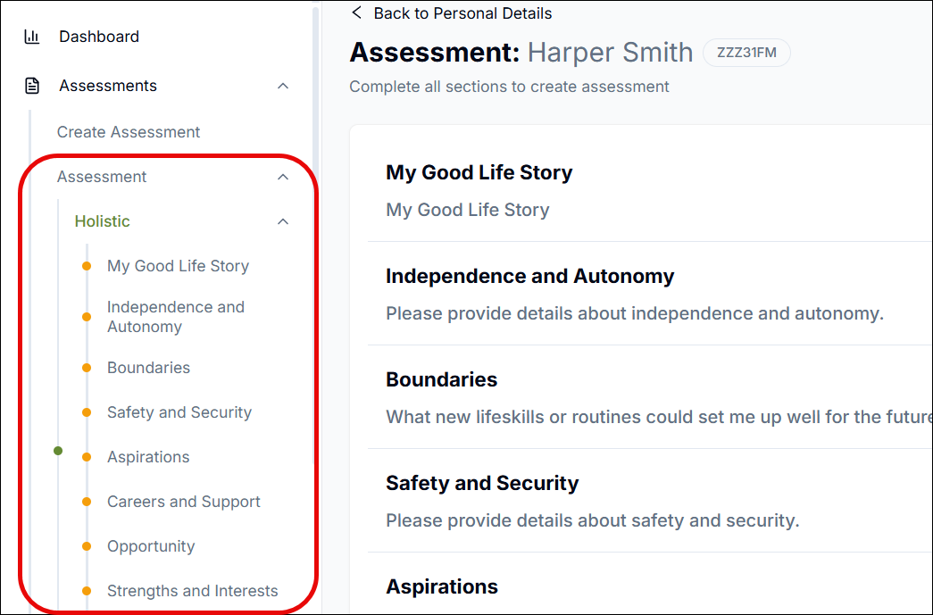
You will also see the different pages of the Holistic section displayed in the centre, with a Start button next to each stage.
Click Start next to the desired page to enter information under that category:
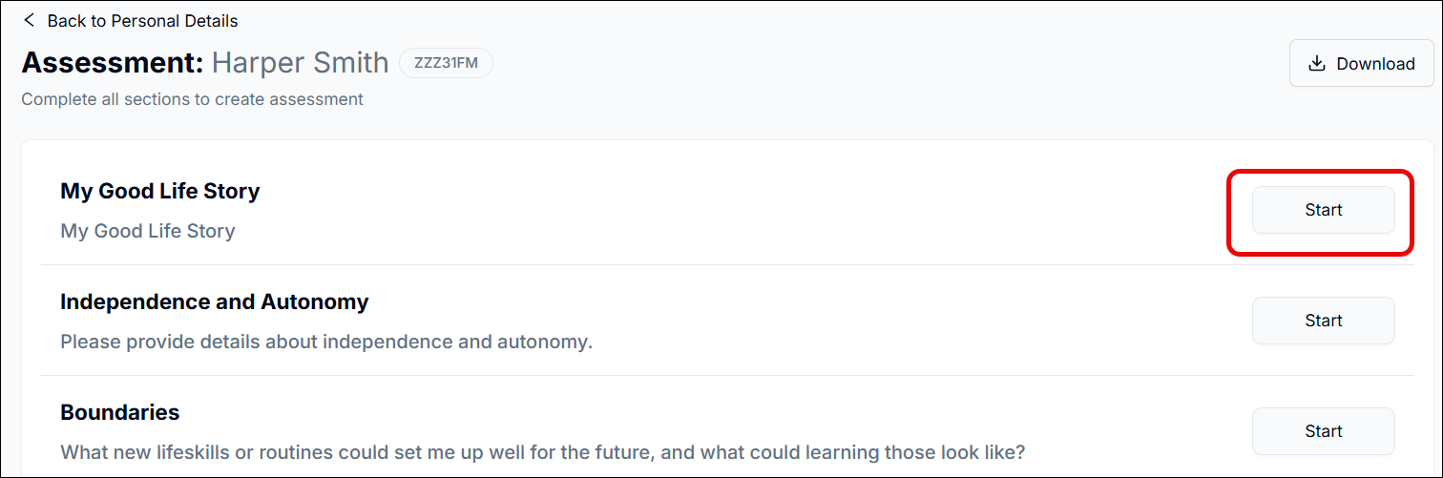
You will see a progress bar showing you how much of the Holistic section of the assessment you have completed:
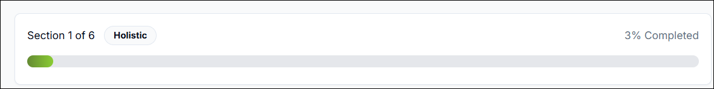
The question/topic will appear below with a free text field for you to type in details. E.g. for My Good Life Story, you should use the free text field to summarise the Disabled Person’s account of what constitutes a good life for them:
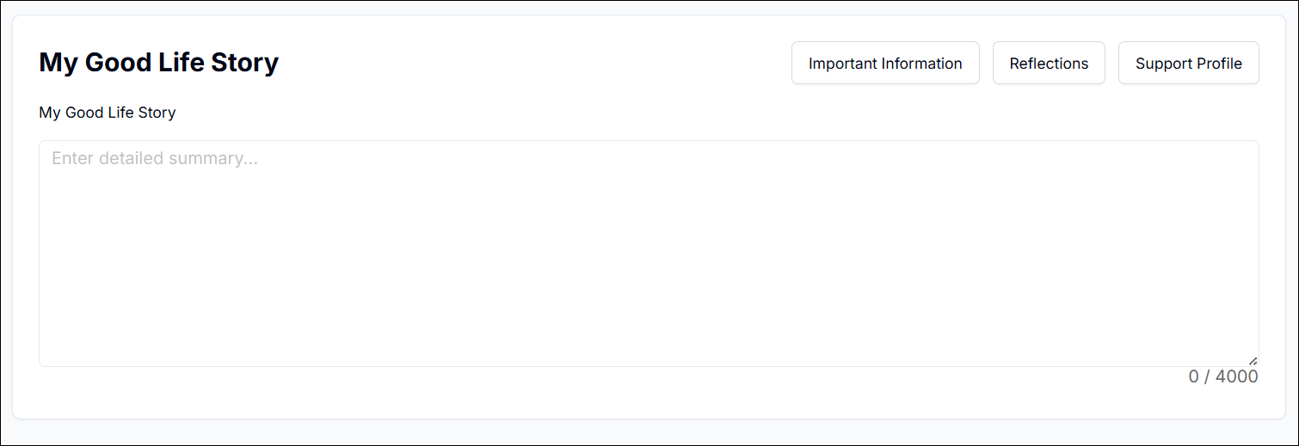
If you wish to make the free text field bigger, click on the bottom right-hand corner and drag the field down:
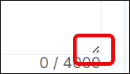
Once you’re happy, click Continue to move to the next page or select the relevant section from the lefthand navigation panel.
You can then move through the Assessment, filling out each section and clicking Continue to proceed to the next section.
You can also jump to any section by clicking on it in the Progress Bar:
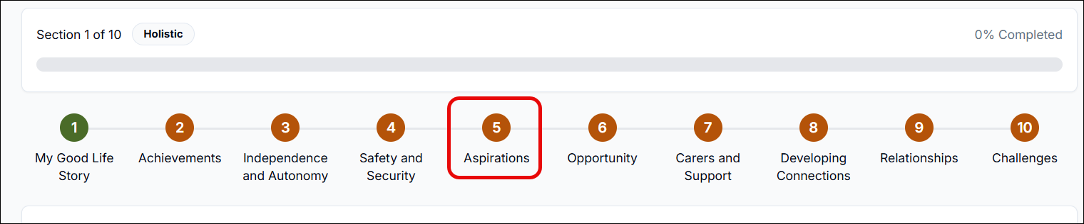
Whenever you have completed a section (including fully filling out the Important Information, Reflections and Support Profile sections), you will see that it turns green and displays a Tick icon to signify it has been completed:
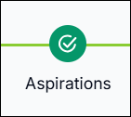
At any stage, you can click Save as Draft to save the Assessment and come back to it later:
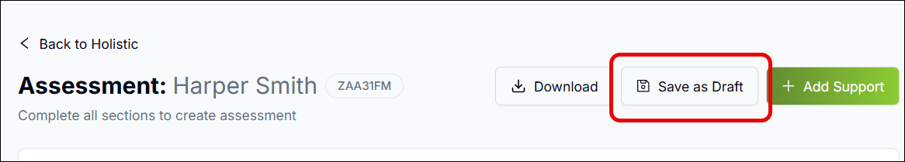

Important Information, Reflections and Support Profile Sections
In addition to answering the questions within the Holistic Section, you can at any point add information by using the Important Information, Reflections and Support Profile sections.
While you can add these from pages of the Holistic section, you can also answer and view all of your responses for each section collated together by clicking the respective option in the lefthand panel:
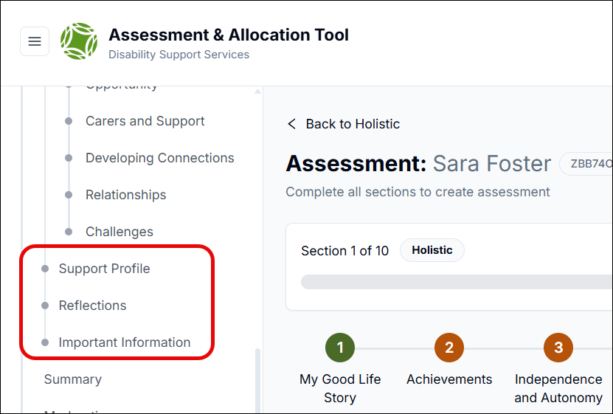

Important Information
To record important information:
- Click the Important Information tab which you will find on certain pages of the Holistic section:

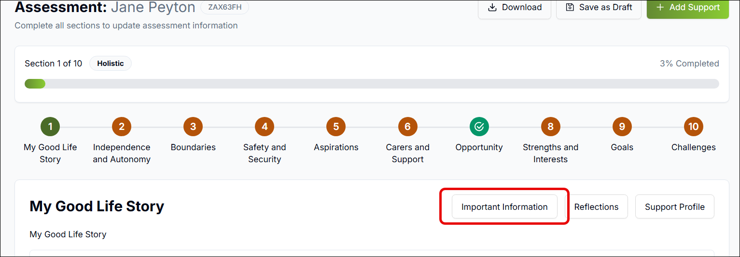

- The Important Information panel will slide open from the right, enabling you to select the appropriate responses:

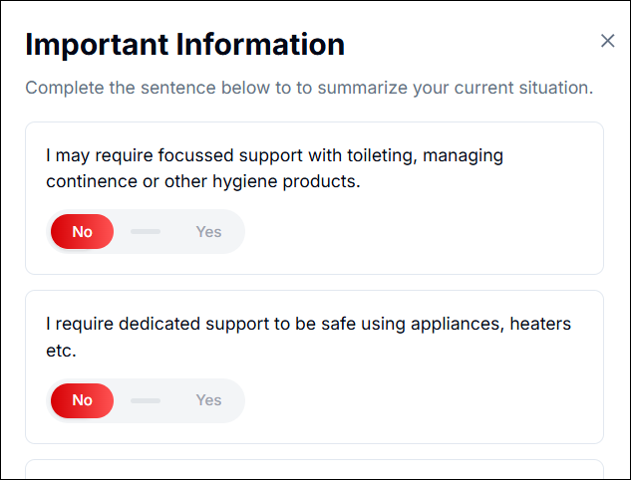

- Once done, click Save
As you proceed through the Assessment, you can click on the Important Information tab on any page where it is located to add information relevant to that page.

Reflection, Support and Important Information Colour-Coding
The Reflection, Support and Important Information tabs are colour-coded, so you can instantly see whether they have been wholly or partially filled out.
- Light Grey: This signifies that no information has been added to the respective section:

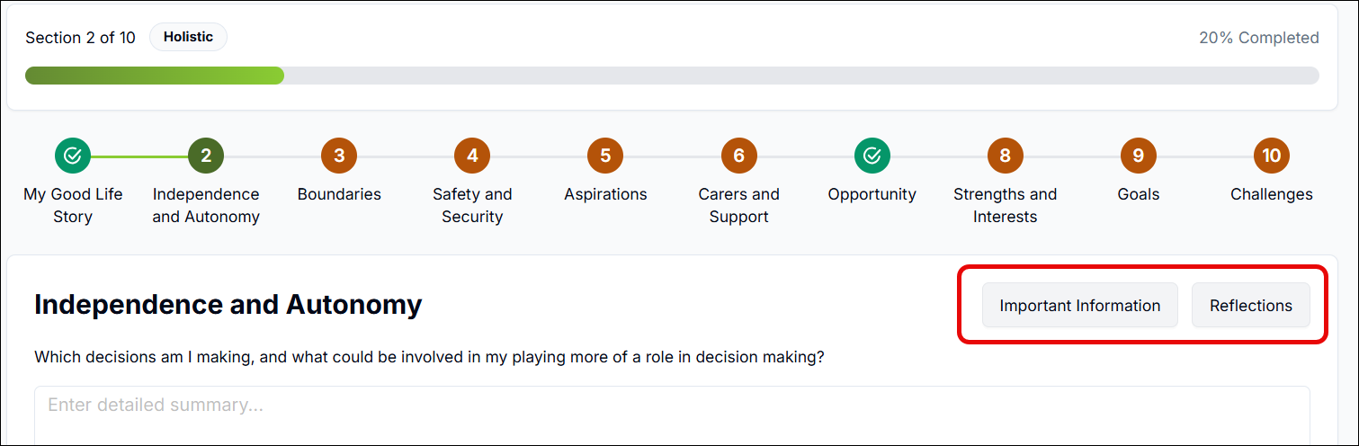

- Rust Colour: This signifies the respective section has been partially filled out:

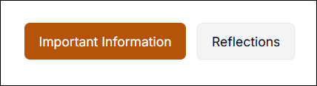

- Green: This signifies the respective section has been completely filled out:

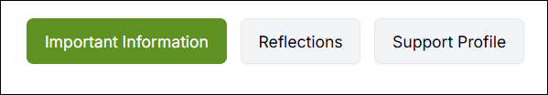

Reflections
To record reflections:
- Click the Reflections tab which you will find on certain pages of the holistic section:

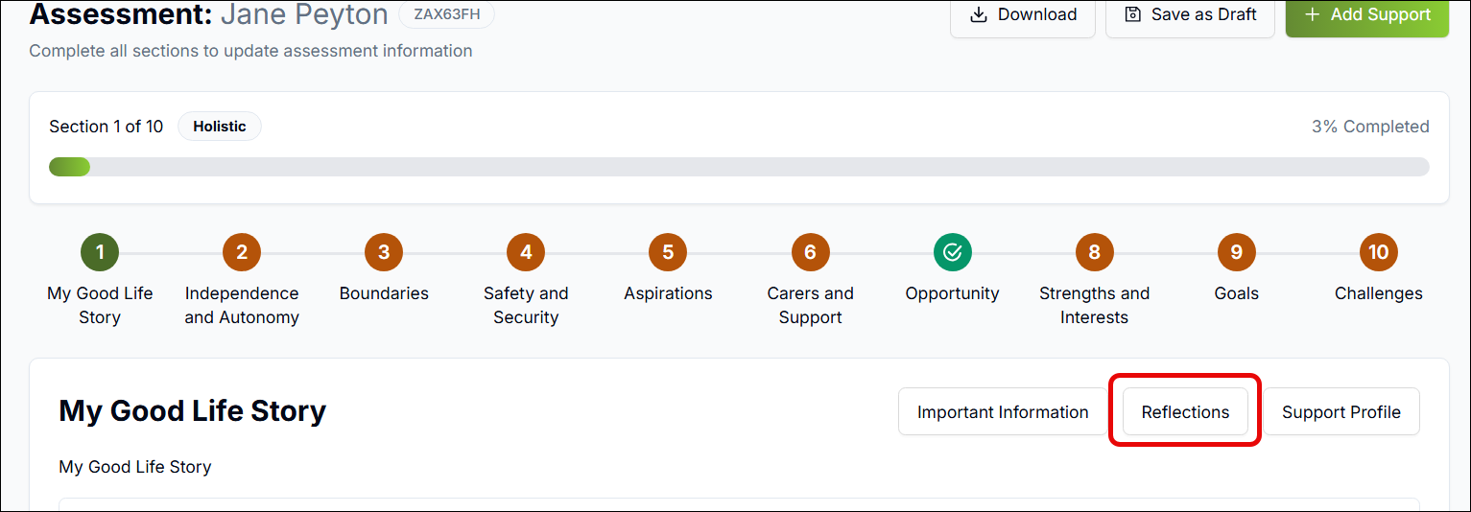

- The Reflections panel will slide open from the right, enabling you to select the appropriate responses

- There are two tabs with questions to answer (Independently and With Support):

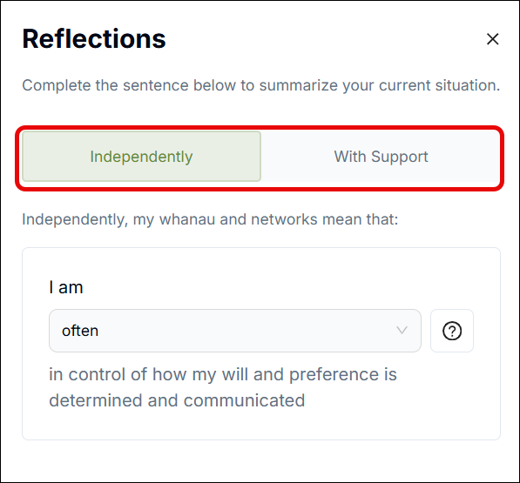

- If unsure how to answer, click the question mark icon to open the Help section for that particular question:

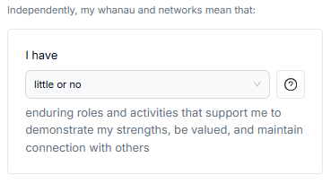

- In the Help section, in each of the three tabs (Signalling/Sustaining/Strengths), select the statement which is the most appropriate from each tab, then click Close:

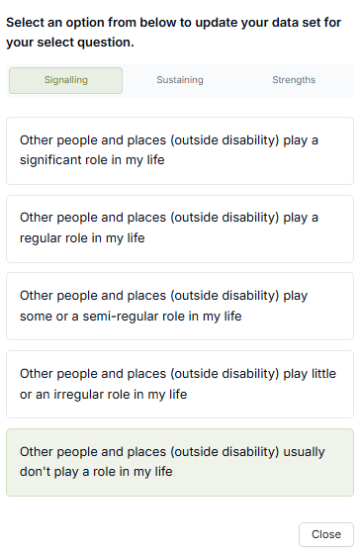

- The system will automatically populate an answer based on your three selections; however, you can update the answer if required

- Once all answers have been entered, click the X to close the Reflections tab and the information will save automatically.
As you proceed through the Assessment, you can click on the Reflections tab on any page where it is located to add information relevant to that page.

Support Profile
To record the Disabled Person’s support profile (i.e. details around the level of support they might require in order to keep them safe):
- Click the Support Profile tab which you will find on the first page of the Holistic section:

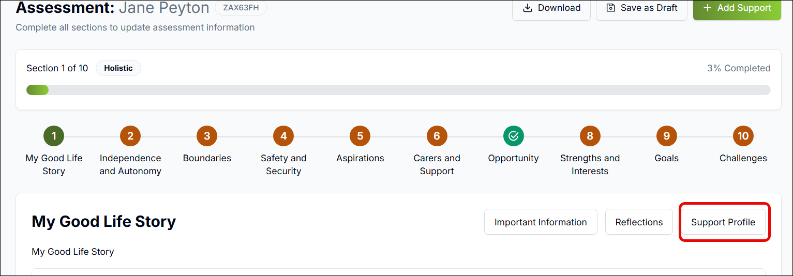

- The Support Profile panel will slide open from the right. Select the answers to the questions from the respective dropdown list:

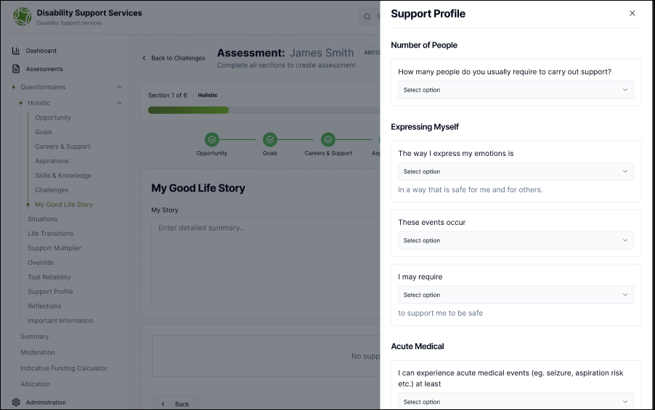

- Once done, click Complete

As you proceed through the Assessment, you can click on the Support Profile from the lefthand navigation to enter information.

Support
You can add support lines to the Disabled Person’s My DSS Funding Plan from the Holistic section. The information recorded here will be included within the calculation of support costs within the funding plan.
To add a support:
- On any page of the Holistic section, click Add Support:

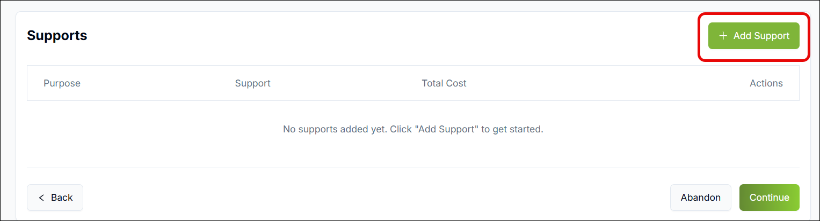

- The Support panel will slide open from the right. Here you can record the following details:

  - Area: Select the appropriate ‘Area’ for the support which captures the support category.

  - Purpose: The purpose of the support (i.e. whether it is to help with the Disabled Person’s daily routine, life skills, or communication, etc.)

  - Support: Details of the support, e.g. A cleaner to come in twice a week

  - Support Start/End Date: The start and end dates of the required support

  - Volume, Unit Type and Frequency: In this context, Unit Type refers to hours, days, weeks, etc. and the Volume determines how many of these are required. E.g. if you select Volume = 2, Unit Type = Hours, and Frequency = Weekly, that means the Disabled Person requires the support for two hours every week:

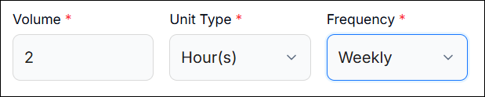

  - Unit Cost: This is the cost for each unit type you have selected. E.g. if you selected 2 hours every week, the Unit Cost will be the cost for one of those hours. Please note, if you don’t yet know the costs, you can just put placeholder values for now (these can then be updated when completing the My DSS Funding Plan)

  - Total Cost: This is automatically calculated by the system and is the total of all unit costs within the support date range you specified

  - Annualised Cost: This is how much the support will cost per year (automatically calculated by the system)

  - Managed By: Who the support will be managed by

  - Provider: The Provider (if applicable) who will be involved in the delivery of this support as part of the Disabled Person’s My DSS Funding Plan.

- The Office Use Only section will typically be filled out later on so you can leave this part blank for now. If you are filling it out, use the respective fields as follows:

  - The Purpose Code is prepopulated

  - Add the categorisation

  - Mark whether the support is jointly funded

  - The percentage will be prepopulated and is relevant to self-managed host support lines only

  - You can enter any additional notes in the Notes field

- Once you are done, click Add Support

You can see any supports you add in the Supports section on each page of the Holistic section:
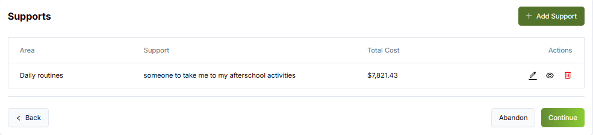
You can edit, view or delete a support by clicking the respective icons:

Supports will be visible in the My DSS Plan which can be generated once the assessment has been completed and an indicative funding range recorded.

Draft funding plan

If a potential support has been added a draft funding plan is created in the MyDSS Funding Plan page. This means that the funding plan can be worked on while the assessment is in different stages.
To access the funding plan:

- Click My DSS Funding Plan in the left menu to open the My DSS Funding Plan screen:

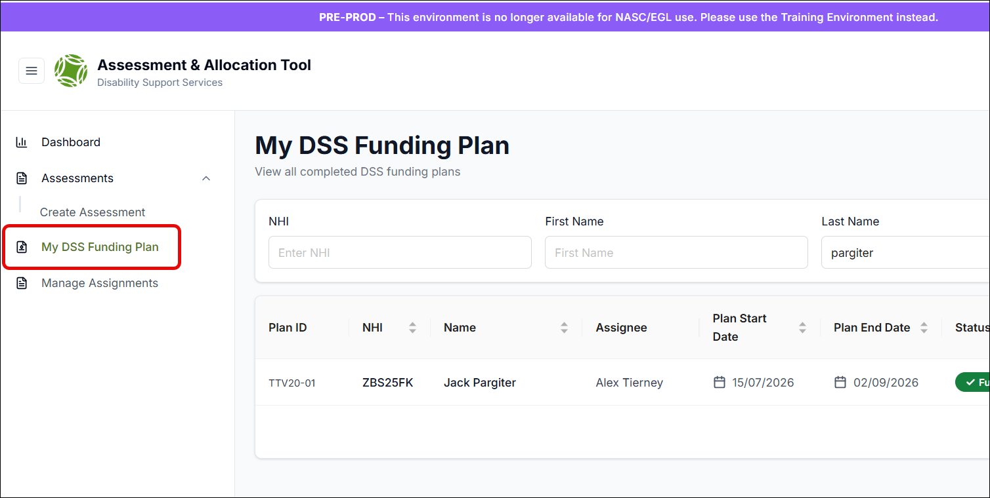

- Click the In Progress status to open the plan. You can then carry out any necessary edits and/or confirm and complete the plan.

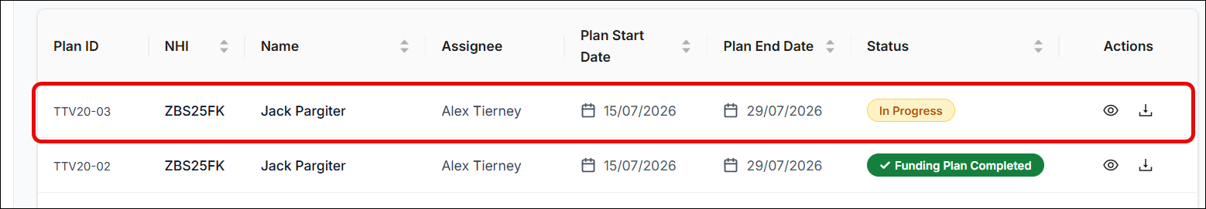

Please Note: you cannot have multiple versions of the same plan with a status of In Progress. The plan has to be updated to a status of Funding Plan Completed before you can use the duplicate function.

Summary
Once you have completed the Holistic section and click Continue, the application will take you to the Support Profile page. Keep clicking Continue to move through Reflections and Important Information.
After these pages you will arrive on the Summary page, where you can view the information you recorded in the Important Information, Reflections, Support Profile sections and any Supports added.
If you wish to revisit any of these sections and update your answer, you can click on them in the left-hand panel.
Once all information has been entered into the assessment, you can download the assessment by clicking the Download button which is available on all assessment screens from My Good Life Story to Summary:
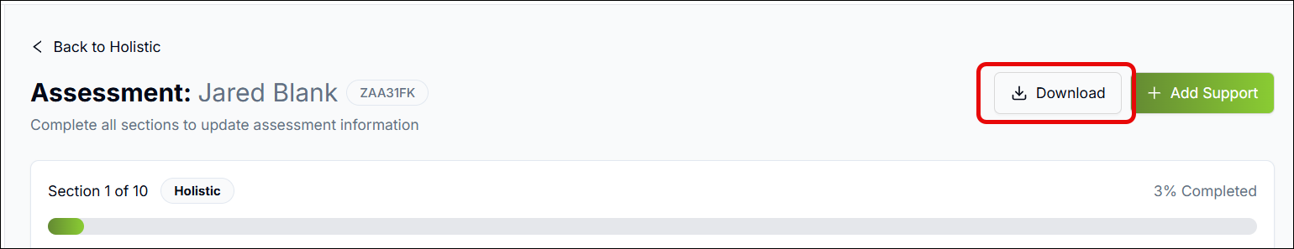
There are two download options: Download as a PDF Mind-map, or Download as an Excel file. To proceed, click the appropriate option:
Downloaded assessments can be printed/emailed to the Disabled Person for confirmation the information is complete and correct.
Once the Disabled Person is happy with the summary, mark the Disabled Person Confirmation as yes and click Continue to Moderation:
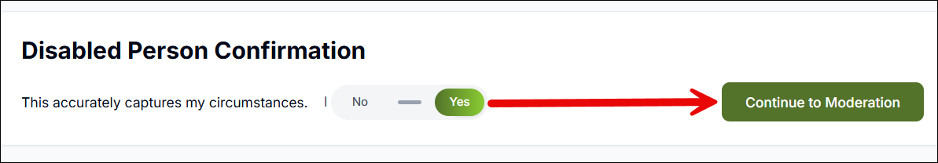

Ending an Assessment New
If you want to end the assessment you are working on without completing the workflow:
- Click the End Assessment button on the Summary screen (you will also find it on the Moderation, Allocation and MyDSS Funding Plan screens):

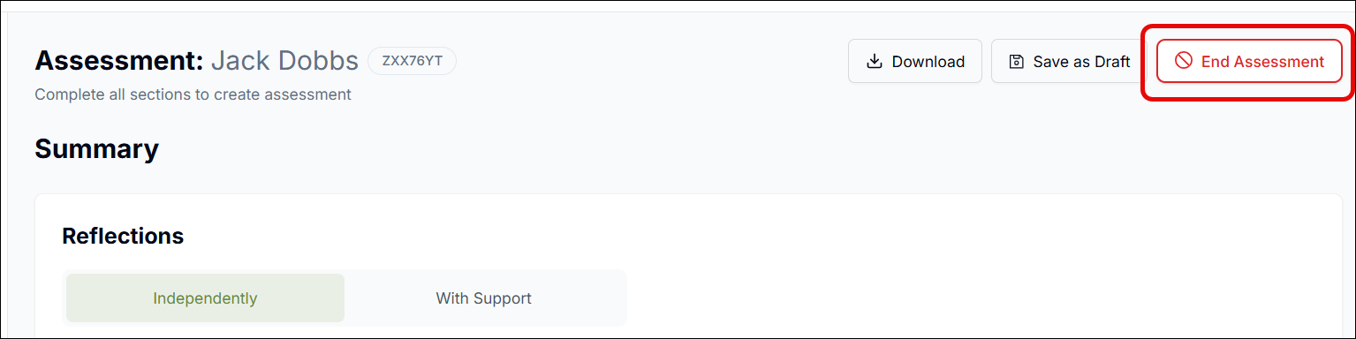

- In the pop up that opens, select the reason for ending the assessment and click Submit:

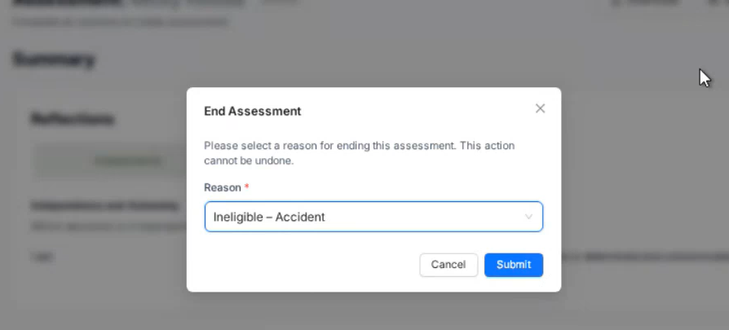

- The assessment will be marked as Closed and removed from your Action Required grid

- The assessment will still be available to view from the assessment page in the dashboard.

Moderation (Confirmation of Assessment Review)
On the Moderation page, complete the Confirmation of Assessment by entering your name and the date of the assessment review, marking the checkbox, and clicking Save Confirmation:
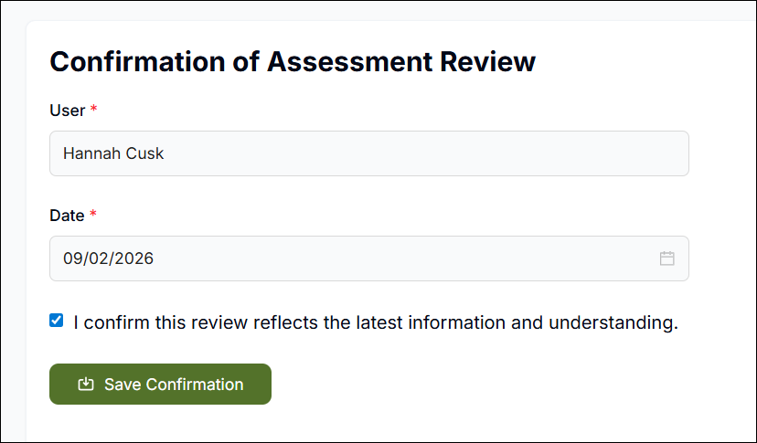
You can also add notes in the Notes field.
After saving confirmation, to complete the assessment:
- Click Complete Planning:

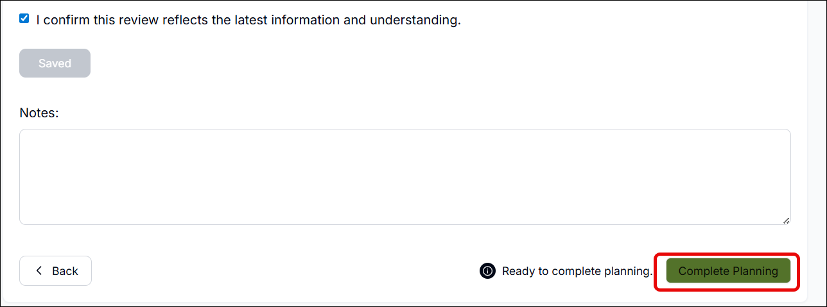

- In the pop up, select the Allocator you want to assign this assessment to. You also have the option of adding assignment notes for the Allocator’s attention using the Assignment Notes field

- If you have both Assessor and Allocator roles, you can assign the assessment to yourself to continue:

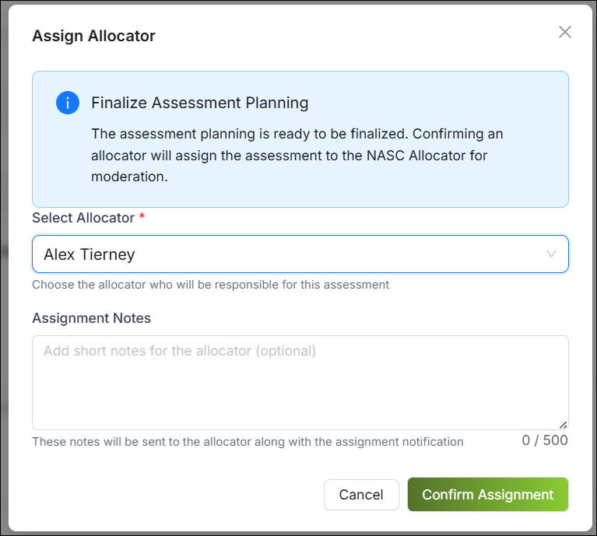

- Once you are happy, click Confirm Assignment

Incomplete Assessments
If you click Complete Planning and information is missing from the assessment, you will see a pop up appear:
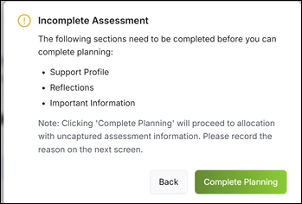
If you want to complete the assessment anyway, simply click Complete Planning. On the next screen, document the reason for incomplete answers in the Notes field, e.g. “Disabled person did not wish to answer”.
However, if you want to go back and review and/or fill in the missing sections:
- Click Back

- This will take you back to the first section where information is missing, e.g. Support Profile

- You can then proceed through the relevant sections and fill in the missing information

- Once you return to the Moderation page, re-complete the Confirmation of Assessment by entering your name and the date of the assessment review, marking the checkbox, and clicking Save Confirmation.

- Click Complete Planning once you are done.

Allocator Reviews the Assessment

Picking up an Assessment
As an Allocator, if an assessment is assigned to you, you will see it appear in your Action Required section on the Dashboard with a status of Start Moderation:
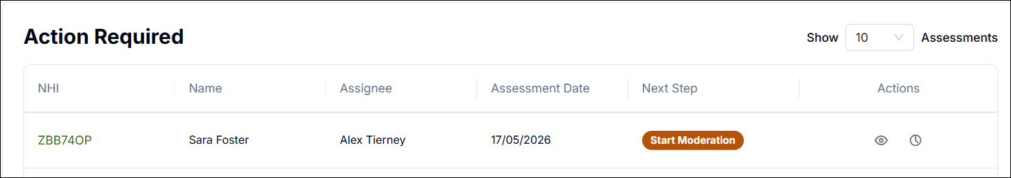
To pick up that assessment:
- Click on the Start Moderation status

- A pop up will appear asking you to confirm; click Start Moderation

- The assessment will open on the Moderation screen from where you can easily use the left-hand panel to navigate through the assessment to review the recorded information

Moderating the Assessment
You should review the assessment information and confirm this assessment is ready for indicative range. Once you are happy with your review, click Moderation in the left-hand panel:
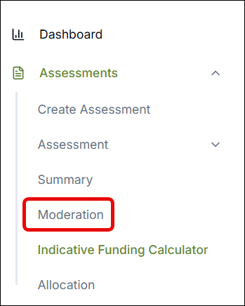
Here you will see the Confirmation of Assessment Review as completed by the Assessor (you will see the Assessor’s name and the date of assessment review):
- Replace the Assessor’s name in the User field with your own name

- Enter the date of your review in the Date field

- Ensure the checkbox is marked and click Save Confirmation

- Click Complete Moderation:

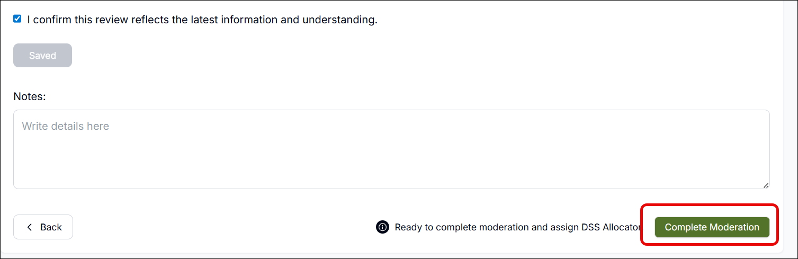

Requesting More Information
If you require more information from the Assessor who filled out the assessment:
- On the Indicative Funding Calculator screen, click Request More Info:

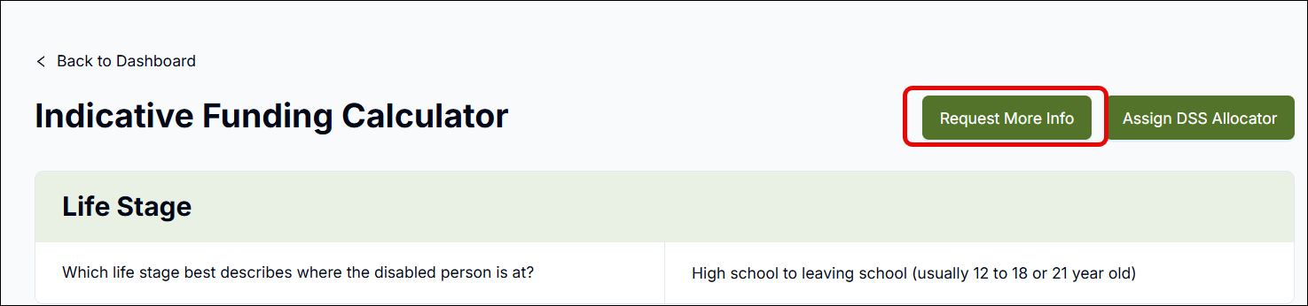
- In the pop up that opens, type in the Request Reason. You can also enter additional notes for the Assessor if you wish:

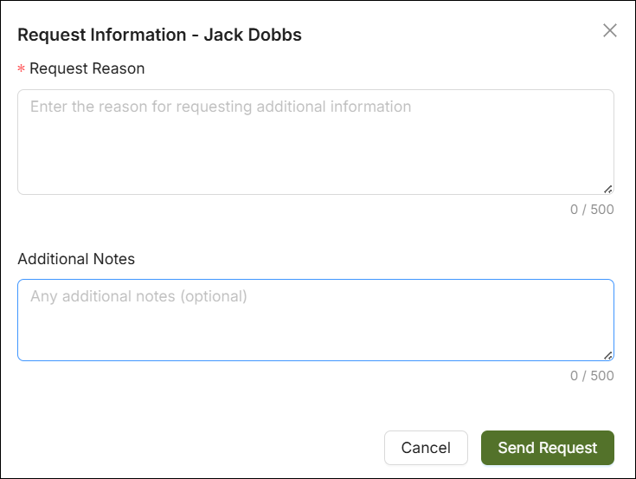

- Click Send Request

- The assessment will then appear in the Assessor’s Action Required section with a status of Information Requested:

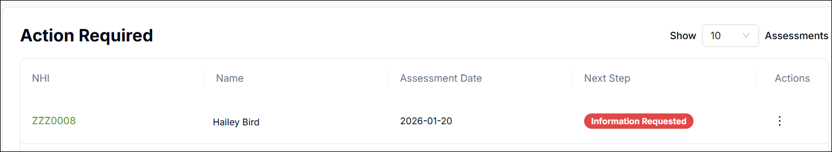

Assigning the Assessment to DSS
Once you have completed the Confirmation of Assessment Review, you should assign the assessment to the DSS Allocator who will complete the indicative funding range.
- On the Indicative Funding Calculator screen, click Assign DSS Allocator:

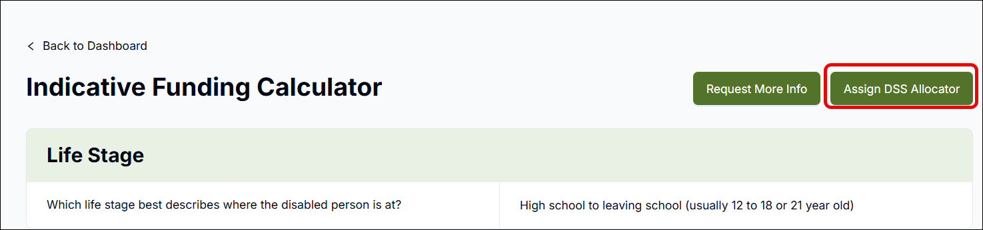

- In the pop up that opens, select the required DSS Allocator

- Enter any notes for the Allocator in the Assignment Notes field (optional)

- Once happy, click Confirm Assignment:

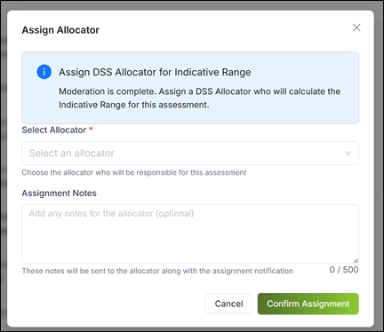

DSS Allocator Exports Assessment Results for Indicative Funding Calculation

DSS Allocators have the option of exporting assessments individually or in bulk to help them calculate the indicative funding range. Indicative range calculation is currently done through Excel.

Individual Assessment Export
To export the results of a specific assessment:
- Find the assessment on your Dashboard

- Click on the Ready for Indicative Range status next to the assessment:

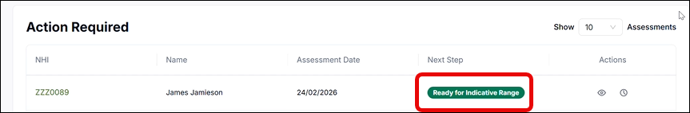

- A pop up will appear: click Pick Up:

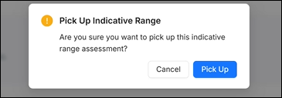

- On the Indicative Funding Calculator page, click Download:

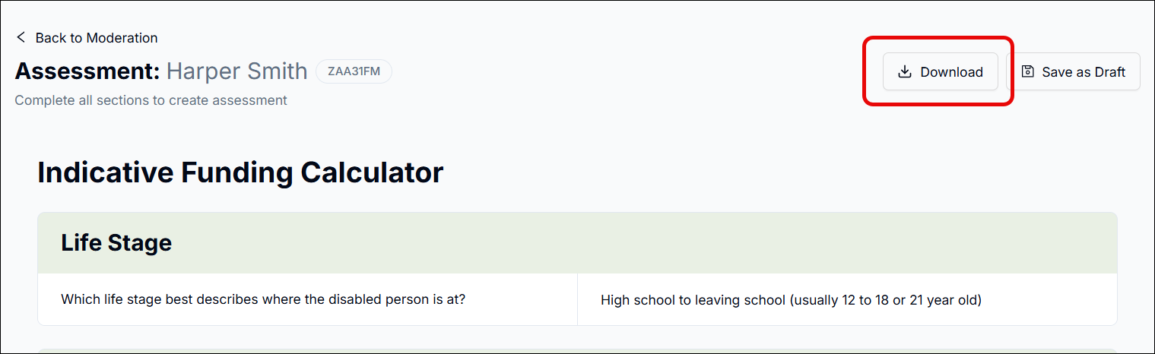

- This will download a file which you can use to copy information into Excel.

Bulk Assessment Export
To export assessments in bulk:
- Click My Indicative Range in the left-hand menu:

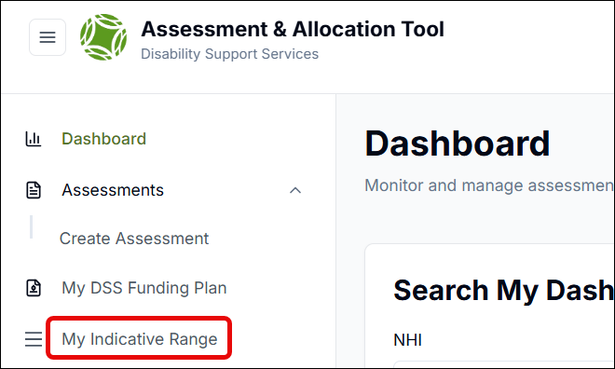

- On this screen you can use the search facility to search for and filter the assessments you require by criteria including NHI, Case Number (i.e. the assessment ID) and Status (Status should equal Ready for IR):

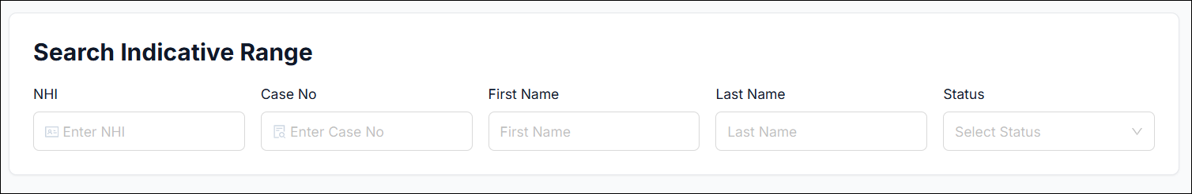

- Once you have found the assessments you wish to export, mark the checkboxes next to them (Useful Tip: Marking the checkbox at the top left of the grid will select all assessments falling within your current search parameters):

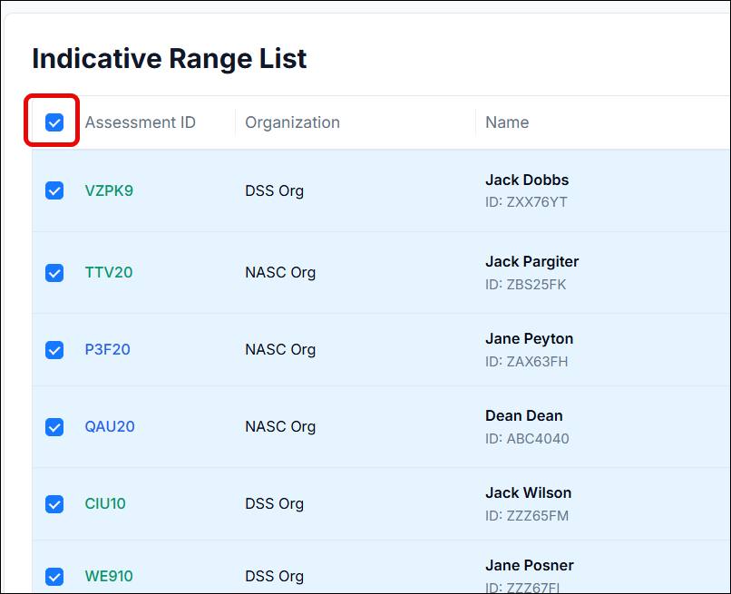

- Once you have selected your assessments, click Bulk Export:

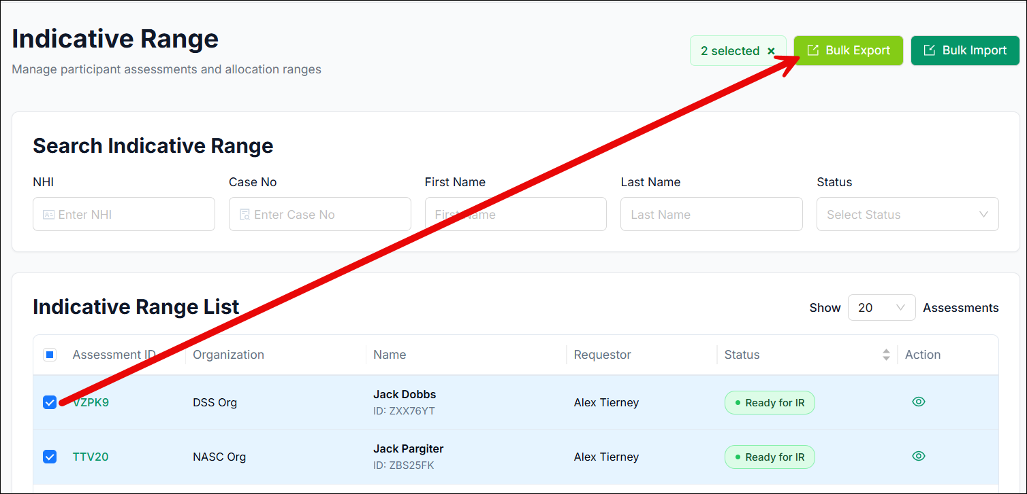

- Once exported, the status of the respective assessments will update to Indicative Range in Progress:

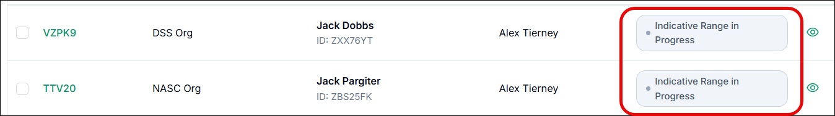

- If you want to see the Indicative Funding Calculator Information within each assessment, click the Action icon next to it:

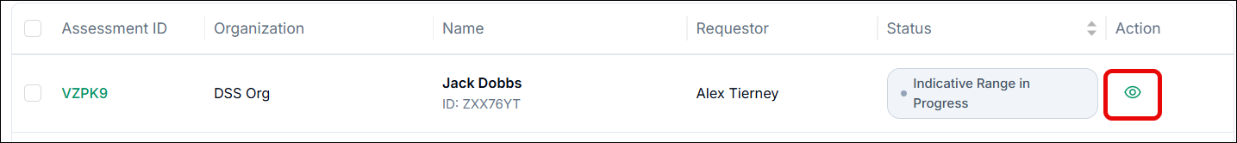

- You can also jump straight to the Allocation screen of each assessment by clicking on the status:

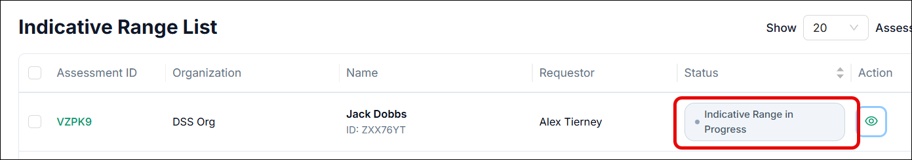

Requesting More Information
As a DSS Allocator, if you require more information from the Assessor who filled out the assessment:
- Open the assessment

- On the Indicative Funding Calculator screen, click Request More Info:

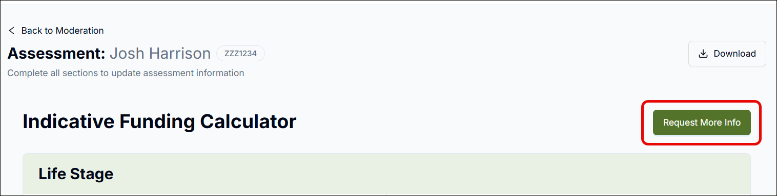

- This will open a pop up where you can explain what information you are looking for by typing details in the Request Reason field. Once you are done, click Send Request:

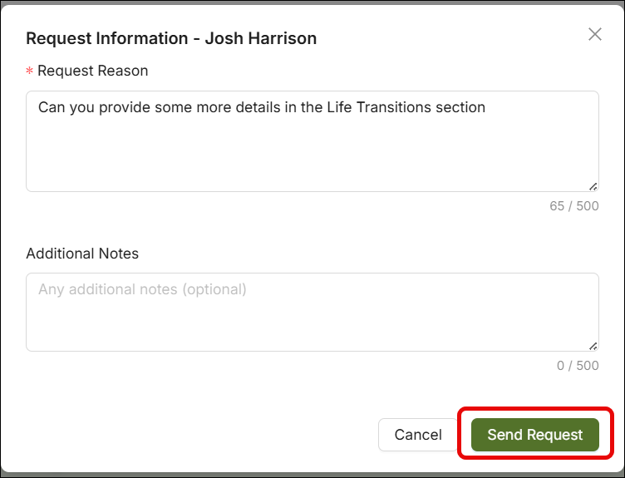

Managing the Indicative Funding Range in OBIR

Typically, the Indicative Funding Range will be calculated in Excel and recorded in OBIR by a DSS Allocator. A NASC/EGL Allocator will then review the range and apply any adjustments that may be necessary.
As a DSS Allocator, you can record the funding range in an individual assessment, or bulk import a funding range file which can automatically populate a range of assessments.

DSS Allocator Records the Funding Range in an Individual Assessment
To enter your Indicative Funding Range in an individual assessment in OBIR:
- Go to OBIR and find the assessment on your Dashboard, either via the Action Required or Recent People section

- Open the assessment by clicking on the status

- Click Allocation in the left-hand menu:

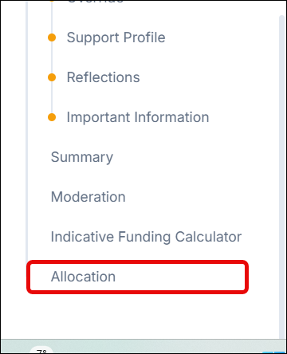
- Record the lower and upper limits of the funding range in their respective fields

- Record your confidence level in your range assessment:

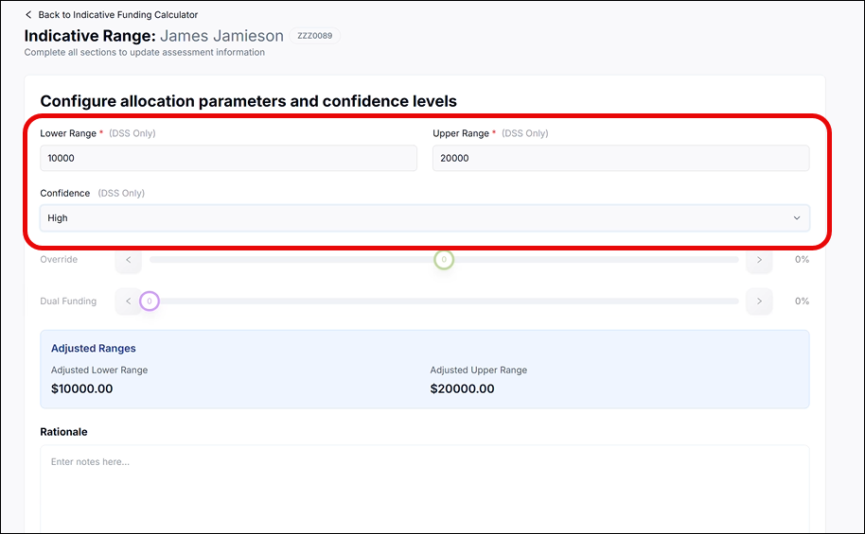

- Click Complete Indicative Range to assign the assessment back to the Allocator:

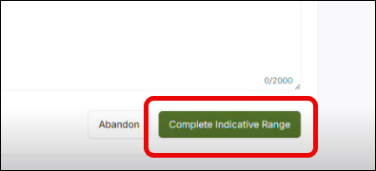

DSS Allocator Imports Funding Range File
To import an indicative range file:
- Firstly, the file intended for importation must include the following for each relevant assessment:
  - Unique Identifier(Assessment ID)
  - NHI
  - First Name
  - Last Name
  - Lower Range
  - Upper Range
  - Rationale
- Click My Indicative Range in the left-hand menu:

- On the Indicative Range screen, click Bulk Import:

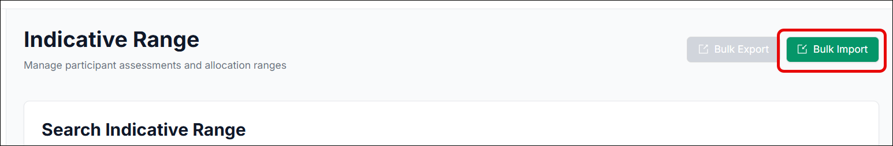

- Search for and select your file on your local machine

- Once your file has been selected, an Import Preview will show you whether there are any errors within the file:

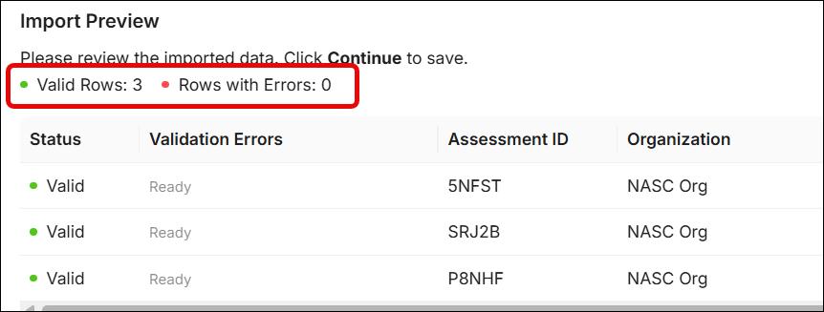

Any rows that contain validation errors will also display a validation reason. You should resolve the stated issues and then reupload the file before progressing

- Click Continue and you will see an Import Summary. If any errors occurred during the import process, the system will display details of those:

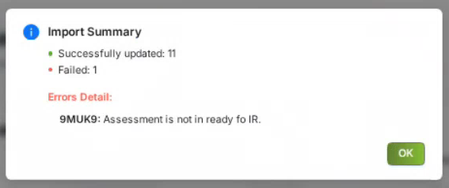

- Assessments where the information has been successfully imported will be automatically processed and assigned to the relevant NASC/EGL Allocators, and will disappear from the Indicative Range List.

- Assessments that were on the Indicative Range List that errored through the import process will remain on the list for you to resolve the related issue. Alternatively, you can click on the Assessment status, and enter the allocation information manually. Once completed the assessment will be removed from the Indicative Range List:

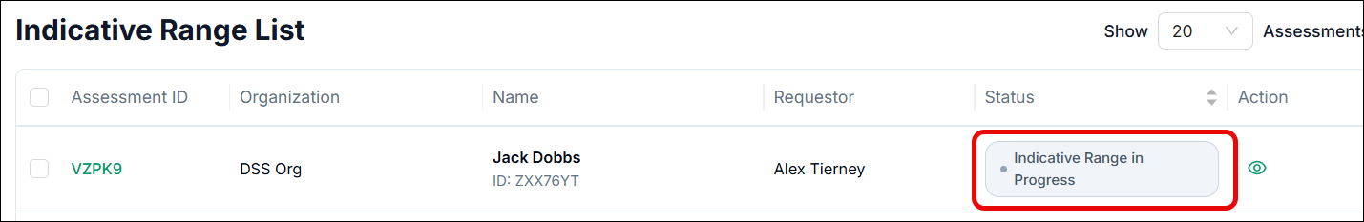

NASC/EGL Allocator Reviews the Funding Range New
As a NASC/EGL Allocator:
- Find the assessment in your Action Required section on the Dashboard and click on the status Confirm Indicative Range:

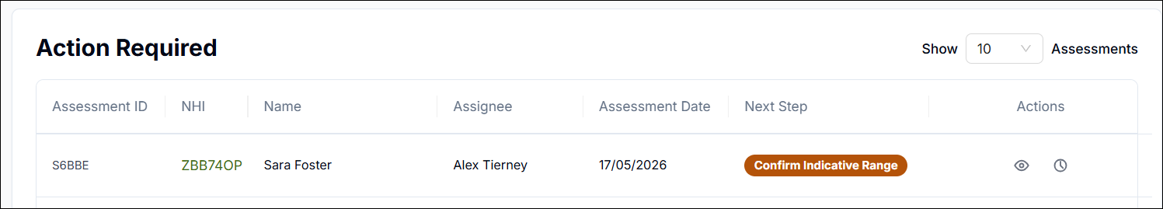

- You will see the Lower Range and Upper Range as recorded by the DSS Allocator

- You can override the given indicative range by a defined percentage of the range. E.g. if you set the slider to 25%, it will add 25% to both lower and upper ranges. Use the slider to select the appropriate percentage

- You can also use the Dual Funding slider to update the amount of funding that will be covered by another funder. E.g. if you move the slider to 25%, that means 25% of the funding will be paid by another funder, so the system will automatically adjust the lower and upper funding ranges to 75% of the previous values:

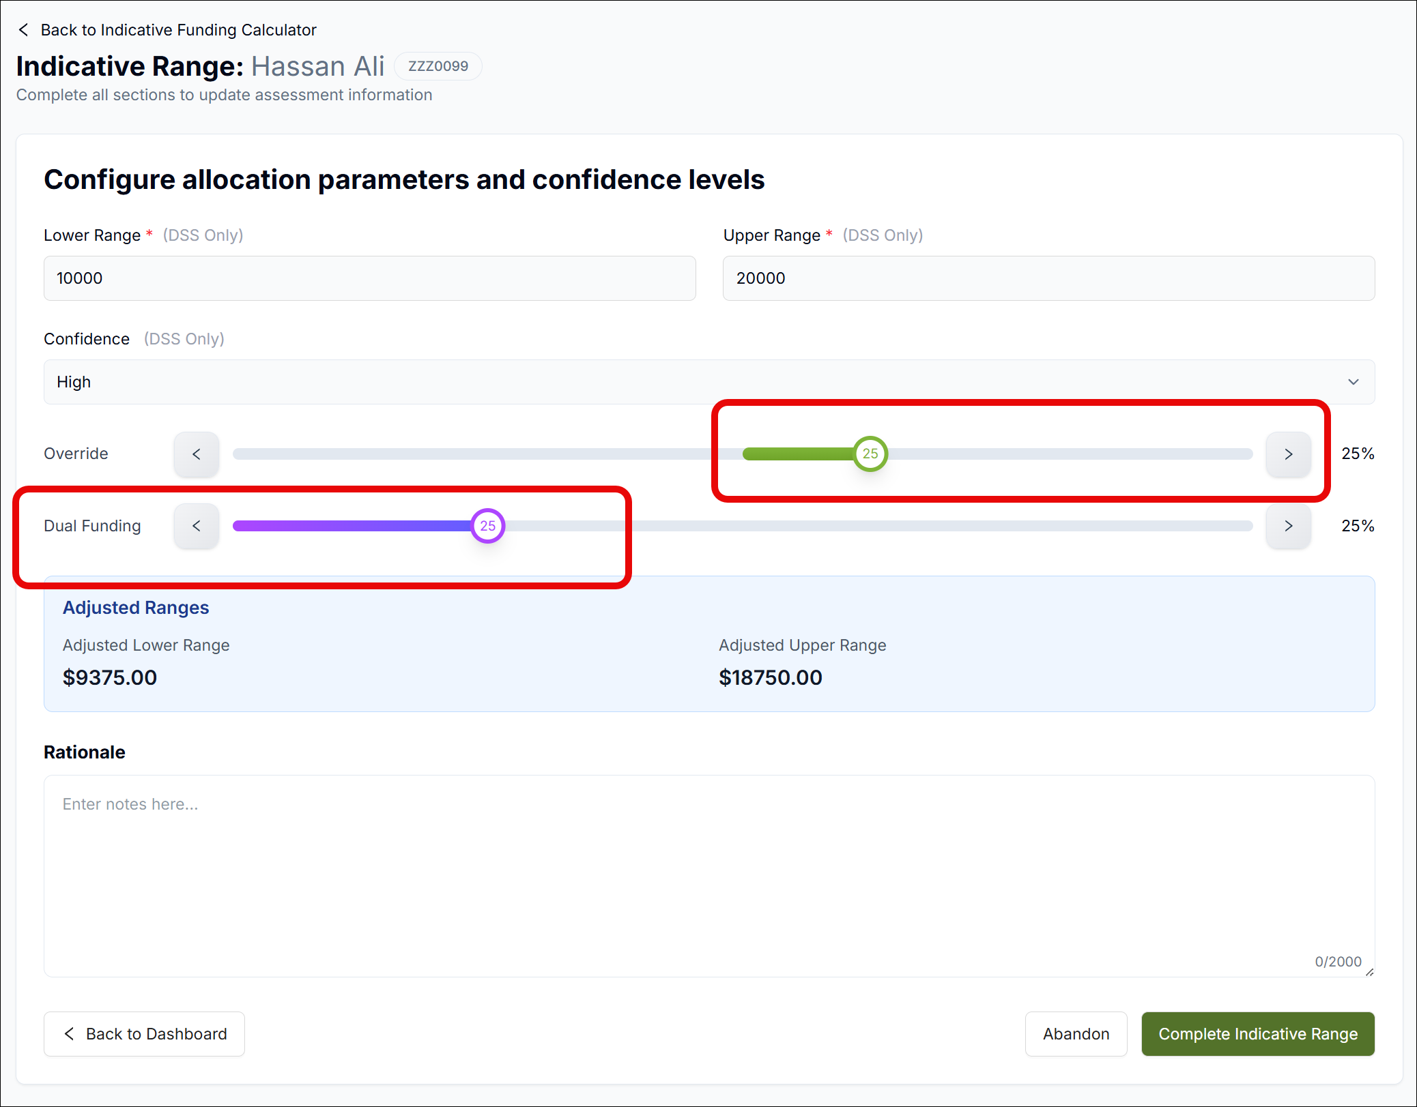

- The adjusted ranges will be displayed below

- Type your reason for the changes to the funding range in the Rationale field.

- Once you are happy, click Complete Indicative Range:

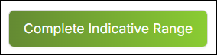

Manager Approval Required
If the override slider or dual funding slider is used or the Indicative Range is greater than $112,000, this will trigger a Manager Approval Request pop up.

If that happens, assign a Manager using the Select Manager dropdown, and enter notes for the Manager to review. Then click Request Approval:
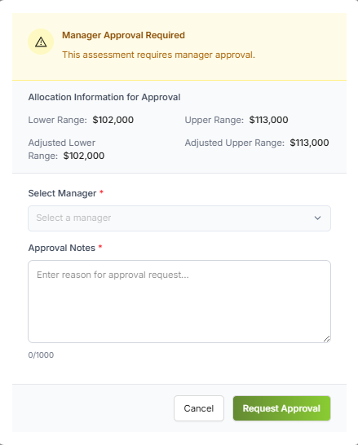

If the Manager declines the Indicative Range it will appear in your Action Required section with a status of Declined Assessment:

You can review the Manager’s comments by clicking the Clock icon, and then adjust the range in accordance with those comments.

Manager Approval
- When an assessment is assigned to you as a Manager for approval, it will appear in your Action Required section with a status of Assess Approval Request:

- Click the Eye icon to view the assessment information

- To approve the Indicative Range amount, click the green Tick icon (You can add notes to the approval if required)

- To decline the Indicative Range, click the red X icon (You must add notes to the declined Indicative Range)

- Declining an Indicative Range will automatically send the assessment back to the Allocator with the appropriate status

- Approving an indicative range will send the assessment to the Assessor to complete the funding plan.

Managing Assignments New

To assist managers in overseeing the assignment of assessments, there is a section in OBIR called Manage Assignments. Here, users with the role of Manager can view assessments no matter what stage they are at, and reassign them internally if necessary, e.g. if a key user is suddenly absent.
Managers can also update Personal Details within an assessment in case there is an information error, e.g. a mismatch between name and NHI.
Lastly, Managers can revert the status of an assessment if necessary. The revert function is subject to defined rules.
To manage assignments:
- Click Manage Assignments in the left-hand menu:

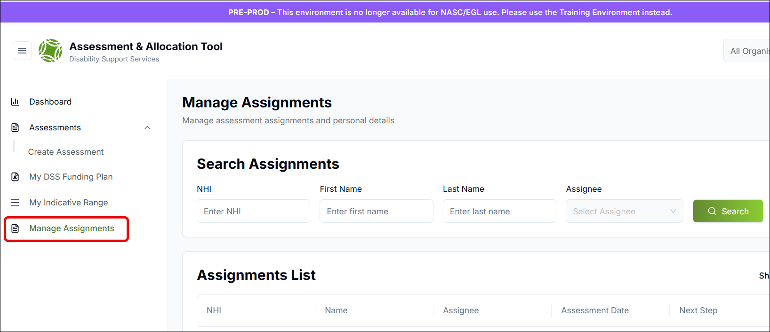

- On the Manage Assignments screen you can search for the appropriate assessments using the search facility provided:

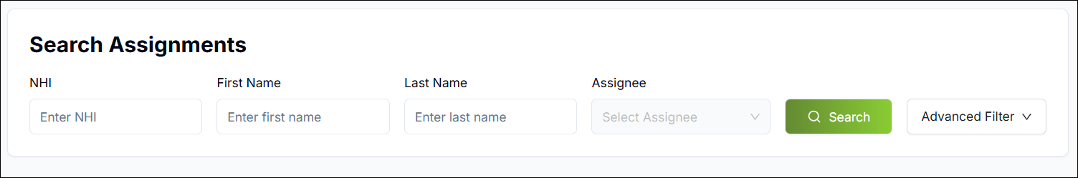

- You can also access additional search filters by clicking the Advanced Filter button. This allows you to filter by Status; choose how you want the results sorted (e.g. by Next Step, i.e. Status or by Assessment Date); and specify the order (ascending or descending):

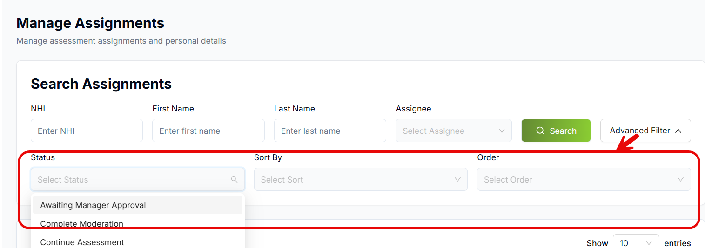

Reassigning Assessments
To reassign an assessment:
- Click the Reassign icon next to it:

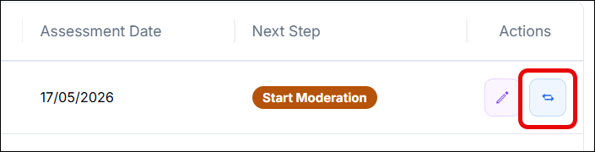

- In the window that opens, a list of eligible assignees is presented based on the status of the assessment. Select the new assignee and give the reason for reassignment, then click Reassign:

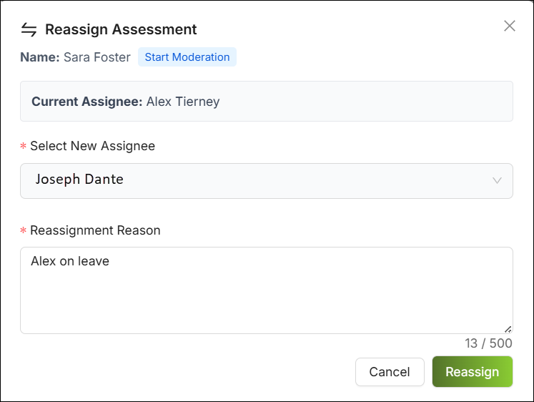

Updating Disabled Person’s Details
To update the Disabled Person’s key details on an assessment form:
- Click the Edit Details icon next to the assessment:

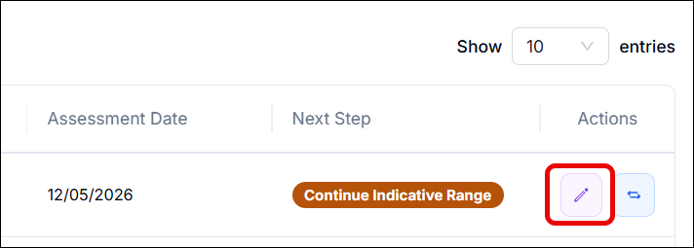

- In the window that opens, you can update their NHI, First and Last Name, DOB and gender. Provide a reason for the update in the Correction Reason field and click Save Changes:

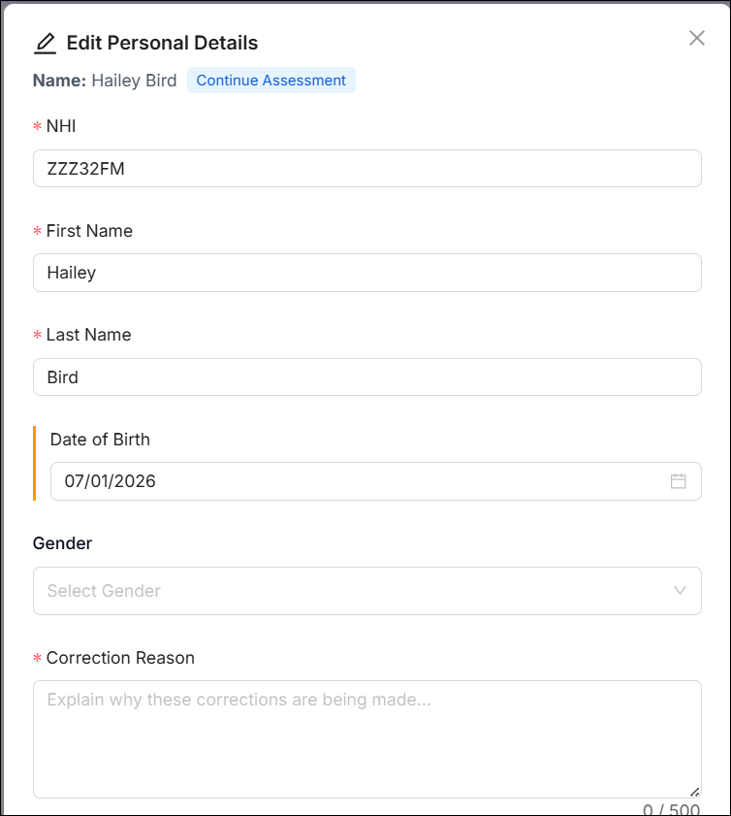

Reverting an Assessment’s Status New
Sometimes a Manager may need to revert an assessment’s status, e.g. bring it from Ready for Indicative Range back to Start Moderation. This is done subject to defined reversion rules which you will find listed below.

How to Revert an Assessment’s Status
- Open the Manage Assignments screen

- Click the Revert icon next to the assessment whose status you want to update:

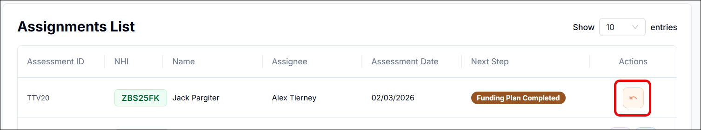

- In the pop up, select the status you want to revert to, type in a reason for the reversion, and click Save:

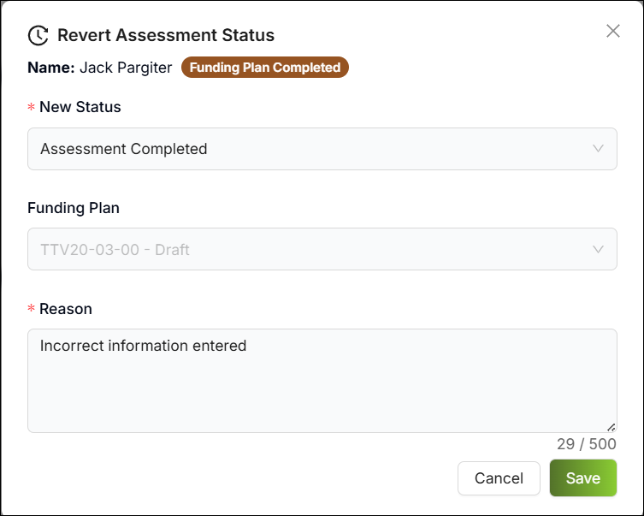

- The assessment status will immediately change to the status you selected

Reversion Rules
There are a number of rules in place which dictate what status an assessment can be reverted to. These depend on the current status of the assessment, and are as follows:
- Draft: Cannot be reverted.
- Start Moderation: Cannot be reverted. Instead the user can select 'More Information Required'
- Complete Moderation: Cannot be reverted. Instead the user can select 'More Information Required'
- Ready for Indicative Range: Can only be reverted to Start Moderation or Draft
- Continue Indicative Range: Cannot be reverted.
- Confirm Indicative Range: Can only be reverted to Start Moderation or Ready for Indicative Range or Draft
- Information Requested: Cannot be reverted.
- Awaiting Manager Approval: Cannot be reverted.
- Declined Assessment: Cannot be reverted.
- My DSS Funding Plan (Assessment Completed): Can only be reverted to Start Moderation or Draft or Confirm IR
- Funding Plan Completed: Can only be reverted to My DSS Funding Plan.
- Closed: Can only be reverted to Draft.

My DSS Funding Plan

Overview
Following completion of the assessment and indicative funding range, the Assessor or Allocator can launch the Disabled Person’s My DSS Funding Plan which will encompass the supports required, the costs of those supports, and whether the total cost falls within the indicative funding range.
To do so, the Assessor or Allocator can pick up the assessment from their Actions Required section on the Dashboard.
Simply click on the My DSS Funding Plan status next to the assessment:
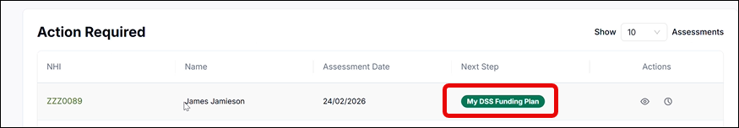
On the My DSS Funding Plan main page, you will see any supports that were added when carrying out the assessment. You can edit any of the previously added supports, or you can add a new support:
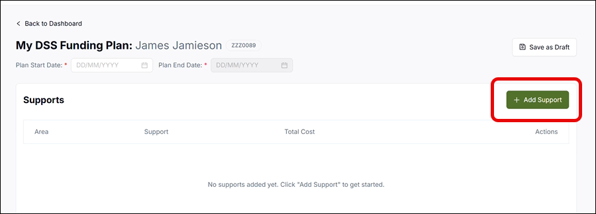

Adding a Support
When adding a support, you can capture:
  - Area: Select the appropriate ‘Area’ for the support which captures the support category.

  - Purpose: The purpose of the support (i.e. whether it is to help with the Disabled Person’s daily routine, life skills, or communication, etc.)

  - Support: Details of the support, e.g. A cleaner to come in twice a week

  - Support Start/End Date: The start and end dates of the required support

  - Volume, Unit Type and Frequency: In this context, Unit Type refers to hours, days, weeks, etc. and the Volume determines how many of these are required. E.g. if you select Volume = 2, Unit Type = Hours, and Frequency = Weekly, that means the Disabled Person requires the support for two hours every week:

  - Unit Cost: This is the cost for each unit type you have selected. E.g. if you selected 2 hours every week, the Unit Cost will be the cost for one of those hours.

  - Total Cost: This is automatically calculated by the system and is the total of all unit costs within the support date range you specified

  - Annualised Cost: This is how much the support will cost per year (automatically calculated by the system)

  - Managed By: Who the support will be managed by

  - Provider: The Provider (if applicable) who will be involved in the delivery of this support as part of the Disabled Person’s MyDSS Funding Plan.

In the office use only section:

- The Purpose Code is prepopulated

- Add the categorisation

- Mark whether the support is jointly funded

- The percentage will be prepopulated and is relevant to self-managed host support lines only

- You can add any notes you wish in the Notes field

- Once you are done, click Add Support

Support Costs Calculation
The system will calculate the sum of all the supports’ total costs and automatically populate the Current Estimate field. Click Check Funding Within Range and if the current estimate is greater than the indicative funding range, you will see an alert appear:
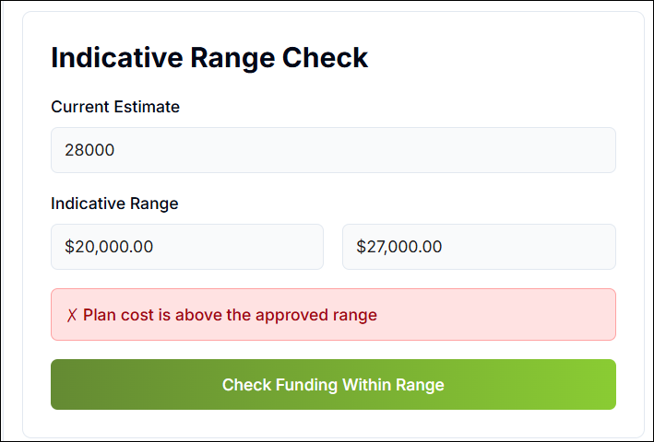
If it is within the range, you will see a confirmation that it is within range appear:
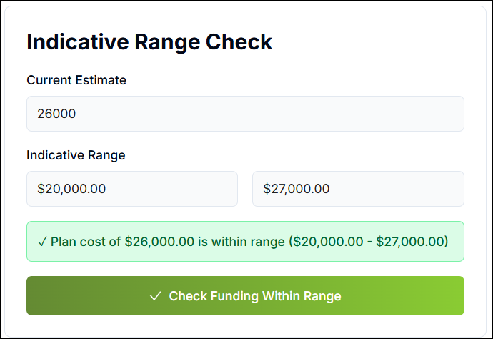

Saving the Funding Plan as a Draft
To save the My DSS Funding Plan as a draft:
- You need to first enter the Start and End Date of the plan. Please note, plans can be backdated, but if they are backdated by more than a week, you will need to give a reason for doing so:

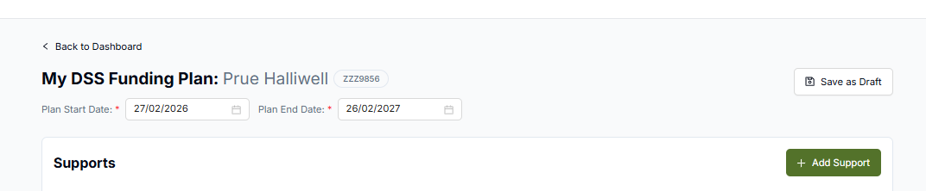

- Click the Save as Draft button:

- You can now view the plan in the My DSS Funding Plan section, which you can open from the left-hand panel:

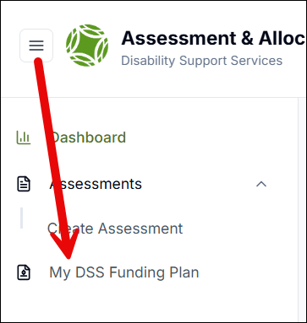

- You can also download the plan from this screen to give to the Disabled Person for review:

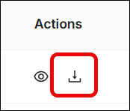

Backdating a Funding Plan by Over a Week
To backdate your My DSS Funding Plan:
- Open the relevant My DSS Funding Plan

- Use the Plan Start Date and Plan End Date fields to set the appropriate dates:

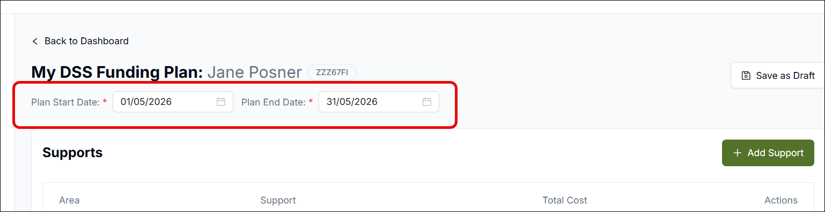

- If you select a date greater than one week in the past, a pop up will appear, prompting you to provide a reason:

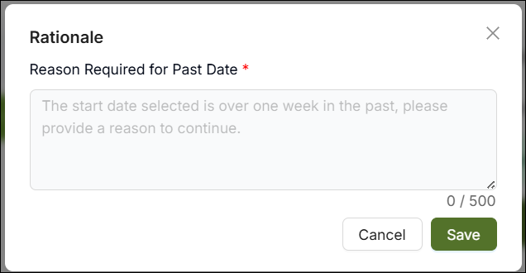

- Enter your reason in the Reason Required for Past Date field

- Click Save

Downloading a My DSS Funding Plan
Downloading My DSS Funding Plans can serve two purposes. One is to share the information with the Disabled Person, and the other is to provide it to official services involved in managing and delivering supports. Because these audiences need different types of information, you can choose from a range of templates when downloading the plans:
- The MY DSS Funding Plan Standard: This template is a user-friendly funding plan that can be supplied to the Disabled Person. You can download it in PDF as well as Excel format, to support easy printing by either the Disabled Person or the NASC/EGL organisation who can then provide it to the Disabled Person.

- The MY DSS Funding Plan: This template is for supplying to Providers and Hosts. It contains more information than the standard template, and is downloaded in Excel format exclusively.
To select the appropriate template for downloading:
- Go to the My DSS Funding Plan screen and click the Download icon next to the plan you wish to download:

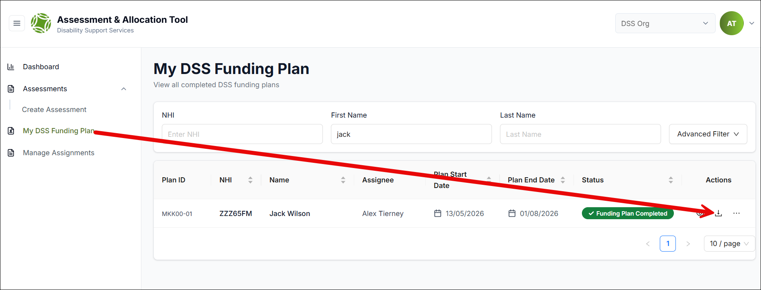

- You will be shown the three options for downloading. Simply click on the desired option to download it:

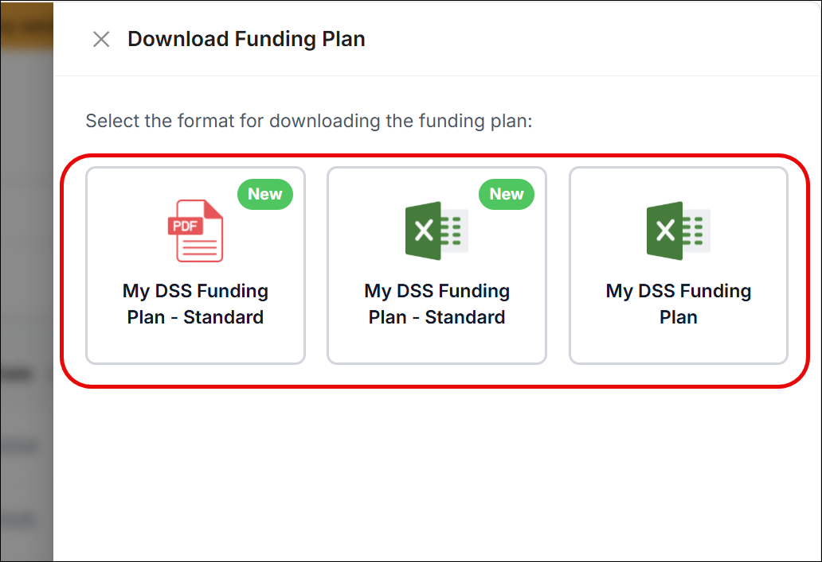

- Within the downloaded file, you will be able to see the unique identifiers for the Funding Plan as well as for each support line within the plan. This is to ensure you can easily see which assessment the plan relates to. The convention for the unique identifiers is as follows:

- The core component of the Funding Plan ID matches the ID of the assessment the plan relates to

- A single assessment may have multiple Funding Plans over time. Therefore, an extra number is added to the core ID of each Funding Plan. i.e. if an assessment has three Funding Plans, the first Funding Plan will have an extra number of 01, the second will have an extra number of 02, and the third will have an extra number of 03

- Each Plan or Support Line within each Funding Plan will have its own ID, which is the full Funding ID plus another additional number for each Support Line. I.e. if there are three Support Lines, they will go from 01 to 03.
The following is a sample illustrating an assessment with two Funding Plans that each contain two Support lines:
Assessment ID - AB5DE
My DSS Funding Plan - AB5DE-01
Support Line 1: AB5DE-01-01
Support Line 2: AB5DE-01-02

My DSS Funding Plan - AB5DE-02
Support Line 1: AB5DE-02-01
Support Line 2: AB5DE-02-02

Disabled Person Sign Off
You can record that the Disabled Person has signed off on their My DSS Funding Plan. To do so:
- Open the Funding Plan and enter the name of the Disabled Person or their carer/whanau in the Plan agreed with (Person/Carer/Whanau) field

- Enter the date in the Date field

- Mark I confirm this funding plan is accurate and complete

- Click Save Confirmation:

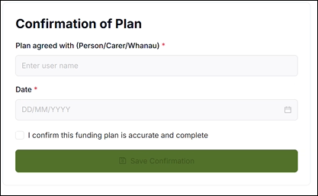

Completing the Funding Plan
You can enter any notes regarding the funding plan in the Notes field.
Once you are happy, click Complete to complete the My DSS Funding Plan. When the plan is complete it is no longer editable:
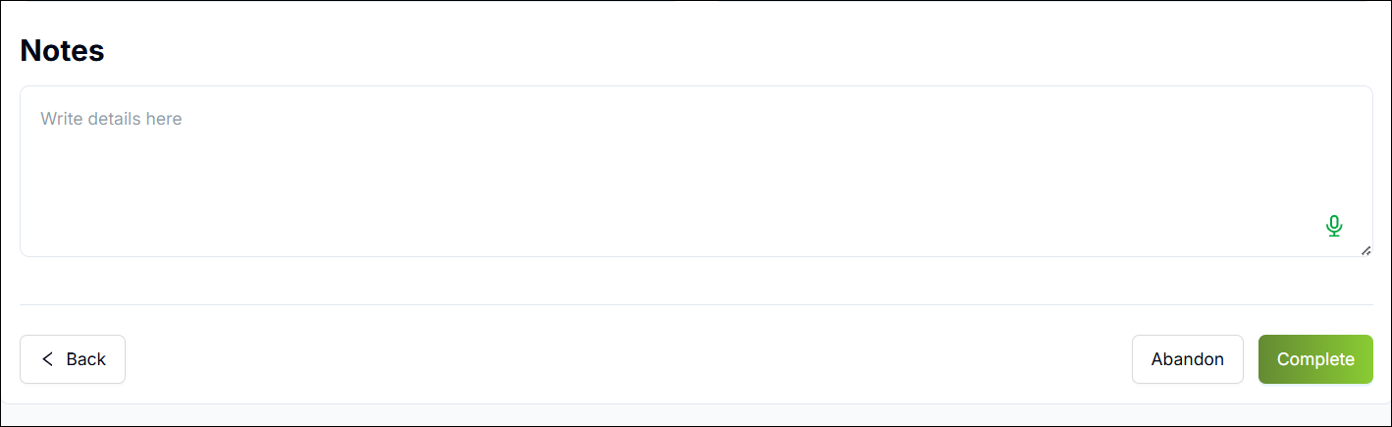

Creating an Additional Funding Plan New
My DSS Funding Plans usually last for 12 months at a time, while assessments typically have a five-year duration. This means one assessment will require multiple funding plans over the course of its lifespan.
To support this, OBIR enables users to generate multiple funding plans for the same assessment.
Once an assessment has a My DSS Funding Plan, you can create additional funding plans by doing the following:
- Click My DSS Funding Plan in the left menu to open the My DSS Funding Plan screen:

- Find the Disabled Person you want to add an additional funding plan for. If their status is Funding Plan Completed, you can add another funding plan by clicking the three dots icon:

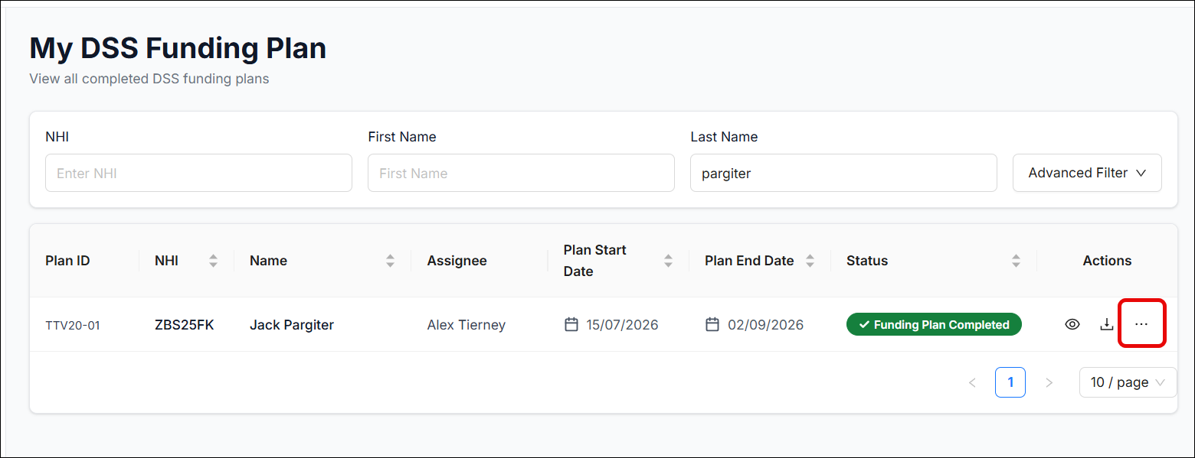

- Click Create New:

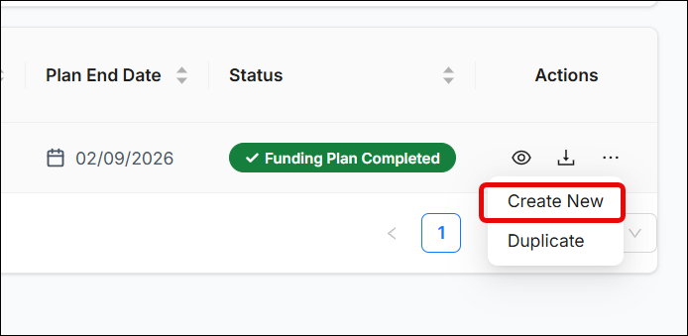

- The Plan ID increases by 1 each time a new plan is created:

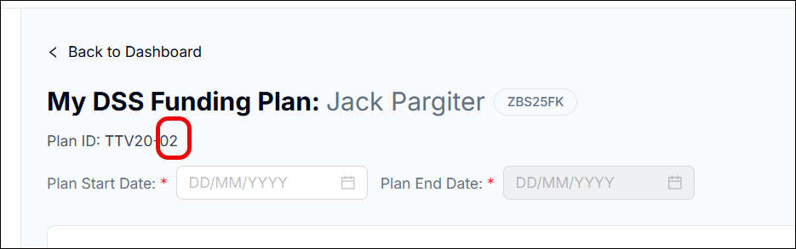

- Select the new plan start and end date:

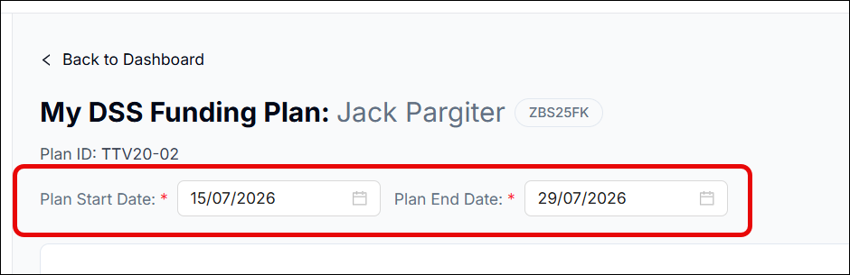

- Then add your supports as you normally would

- Use the Indicative Range Check section to check the funding is within range

- Fill out and save the Confirmation of Plan

- Once you click Complete, you will see the two plans sitting within your My DSS Funding Plan grid:

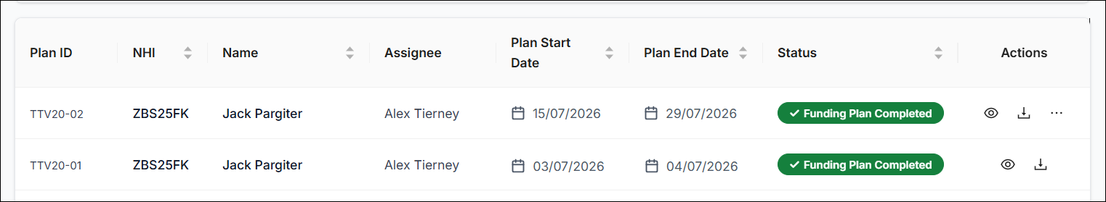

Please Note: If you have multiple funding plans with a status of Funding Plan Completed, you will only be able to use the most recent plan to create a new one:
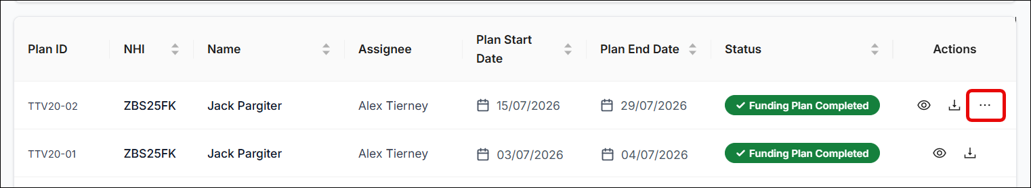
In addition, you can only access the Create New option if a plan has a status of Funding Plan Completed. If the plan has a status of In Progress, there will be no three dot icon for you to select Create New:
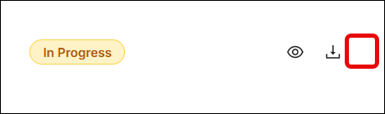

Duplicating a Funding Plan New
If you want to create a new plan that contains largely the same information as the previous plan, then you can duplicate the previous plan. This creates a new version of the plan with its own unique Assessment ID, which you can then complete, or adjust in whatever way you need to.
The advantage to duplicating a plan, as opposed to creating a new one, is that all the supports added for the previous plan will be automatically added to the duplicate. So if the supports haven’t changed, you can simply add the new plan dates, check the indicative range, sign the confirmation, and complete the plan
On the other hand, if any supports were added or taken away, you can easily make these edits within the plan before confirming and completing
To duplicate a funding plan:
- Open the My DSS Funding Plan section

- Find the relevant person/funding plan

- Click the three dots icon next to them and select Duplicate:

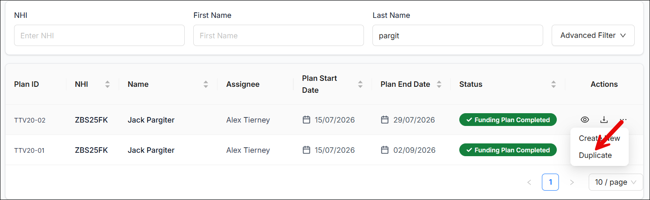

- A duplicate version of the plan will immediately appear in the grid with a status of In Progress:

- Click the In Progress status to open the plan. You can then carry out any necessary edits and/or confirm and complete the plan.

Please Note: you cannot have multiple versions of the same plan with a status of In Progress. The plan has to be updated to a status of Funding Plan Completed before you can use the duplicate function.

