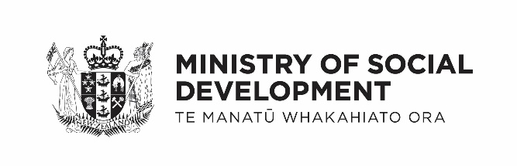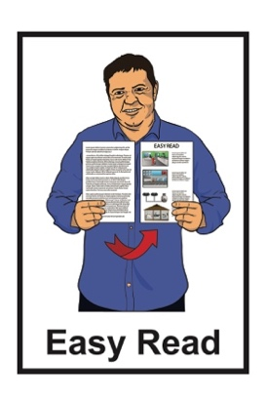

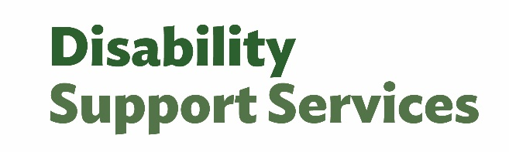

What is quality and safeguarding?

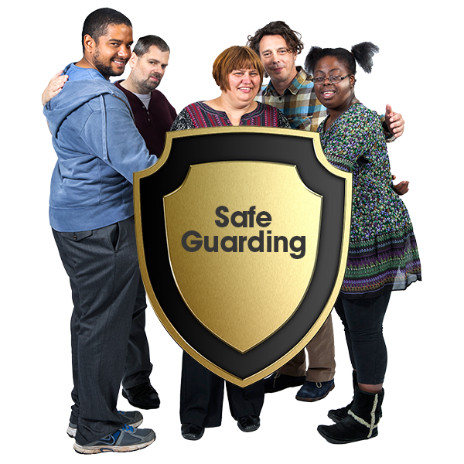

Published: March 2025

# What is this document about?

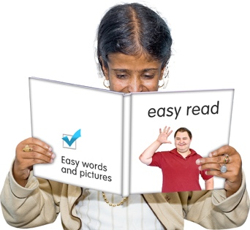This Easy Read document is from Disability Support Services at Ministry of Social Development.

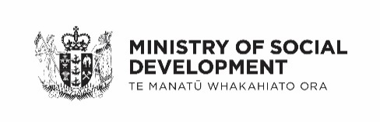In this document:

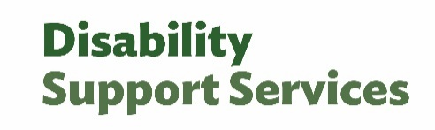MSD means Ministry of Social Development

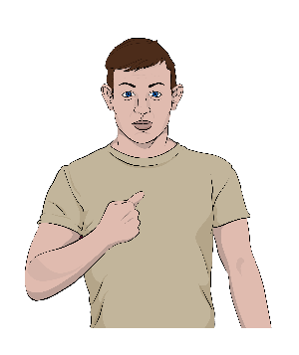DSS means Disability Support Services

the words we / ourmean Disability Support Services.

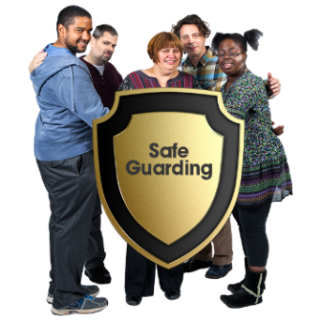

At DSS we do something called **quality and safeguarding**.

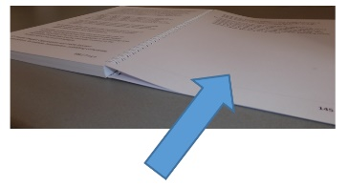There is more information about   
**quality** on **pages 4 to 9** of this document.

There is more information about   
**safeguarding** on **pages 10 to 13** of this document.

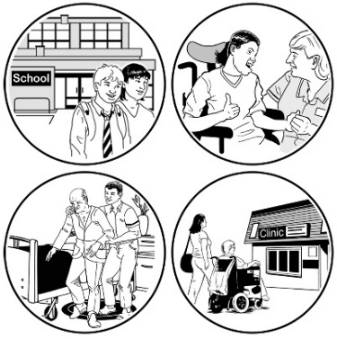This document talks about how quality and safeguarding makes DSS work better for everyone.

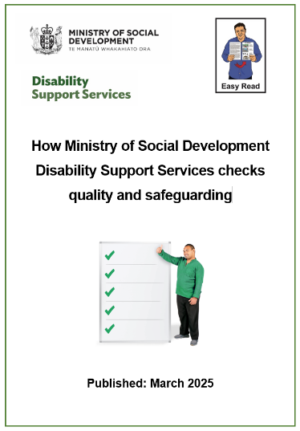There are 2 other Easy Read documents about quality and safeguarding:

* 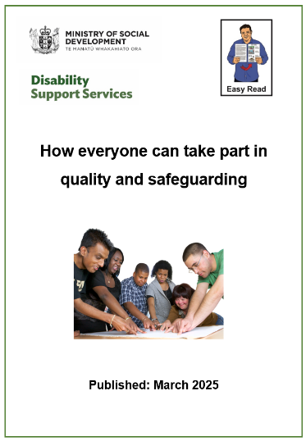**How Ministry of Social Development checks quality and safety**
* **How everyone can take part in quality and safeguarding**

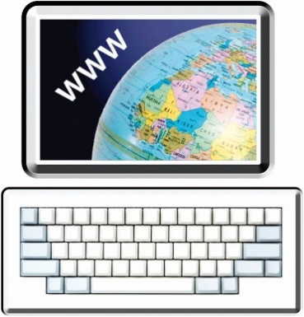You can find the Easy Read documents on the DSS **website** at:

[**www.disabilitysupport.govt.nz**](http://www.disabilitysupport.govt.nz)

# What is quality?

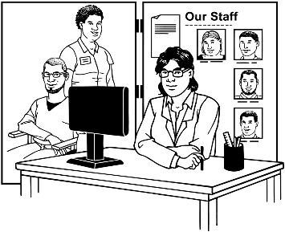

DSS **contracts** disability support providers to do disability support services.



To **contract** means to pay people from outside an organisation to do a job.

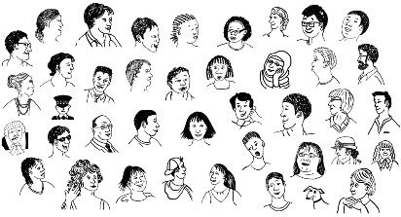Almost 50 thousand disabled people use disability support services each year.

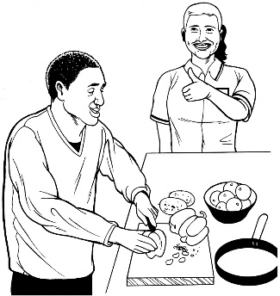DSS checks the **quality** of services to make sure:

people can get very good quality disability supports

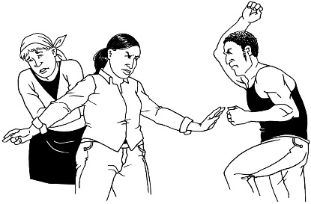disabled people and tāngata whaikaha Māori are kept safe from:

* 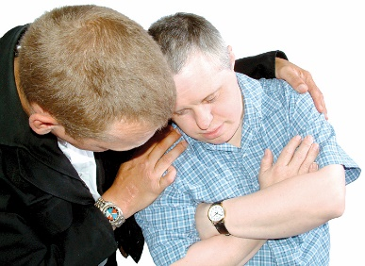abuse which is when someone treats someone else badly
* neglect which is when someone does not look after someone else when they should.



Here **quality** means things are very good for a long time.

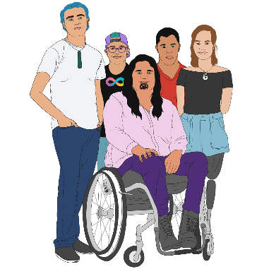High quality disability supports will make it more likely that good **outcomes** will happen for:

disabled people

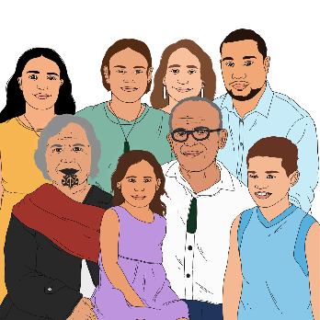tāngata whaikaha Māori

their whānau / family.

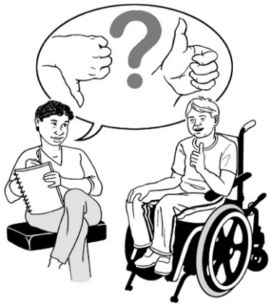**Outcomes** are how things end up   
for people.

An outcome might be if people get better after medical treatment.

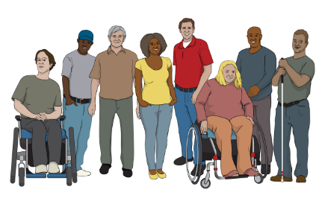Having high quality disability supports means everyone gets the same good experience when using them.

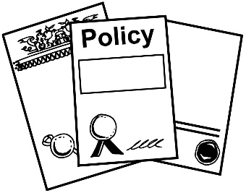High quality disability supports will have strong:

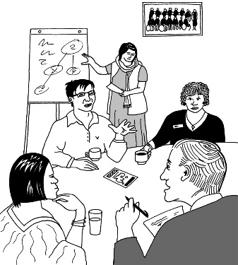policies which are rules made by the government

practiceswhich are the things done to make a system work well.

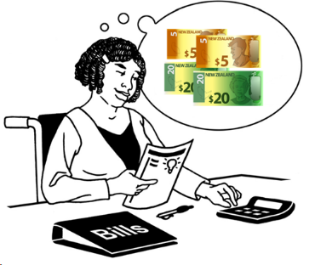

High quality disability supports will be good value for money.

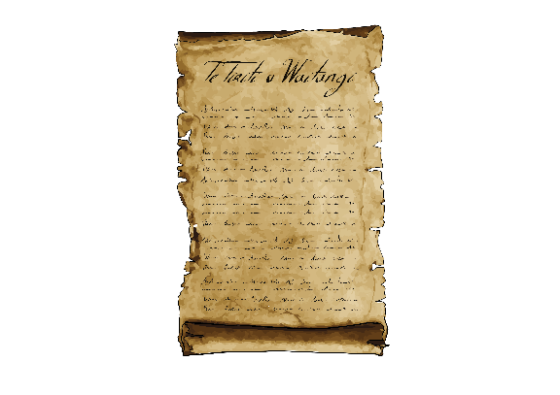

High quality disability supports will use the ideas in:

**Te Tiriti o Waitangi / the Treaty of Waitangi**

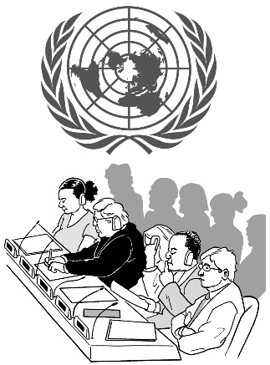**Enabling Good Lives**

**the United Nations Convention on the Rights of Persons with   
Disabilities / UNCRPD**.

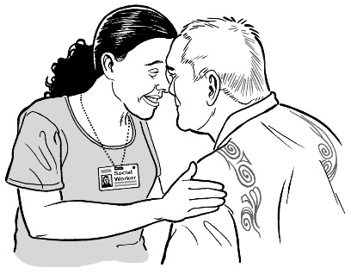**Te Tiriti o Waitangi / Treaty of Waitangi** is an important agreement between Māori and the Crown.

It is about Māori and the New Zealand Government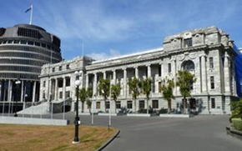 making decisions together.

**Enabling Good Lives** is a disability support system that is about having:

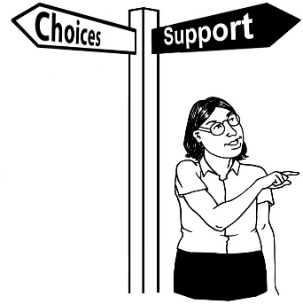choice and control in your life

the support you need and want

a good life.

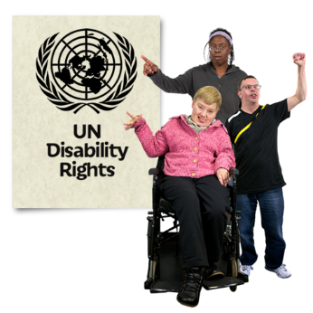The **United Nations Convention on the Rights of Persons with Disabilities / UNCRPD** is a law lots of countries have agreed to.

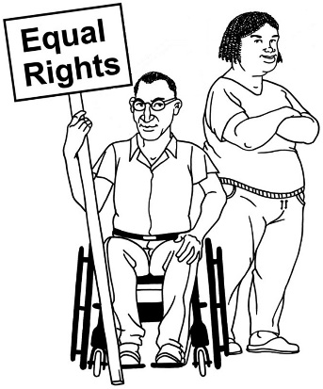It says what governments must do to make sure disabled people get the same rights as everybody else.

This is so disabled people can have a good life.

# What is safeguarding?

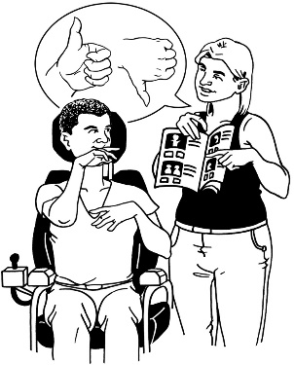Safeguarding protects the right of a disabled person to make their own decisions about their:

life

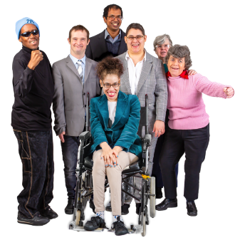safety

**wellbeing**.

**Wellbeing** means things like:

how you feel about yourself

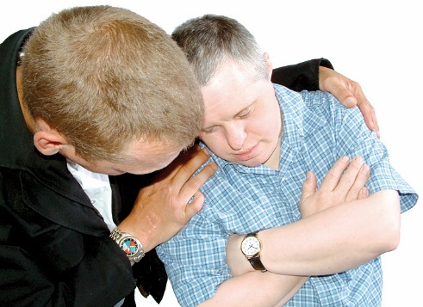looking after your body with good food and exercise

getting support when you are feeling sad or worried.

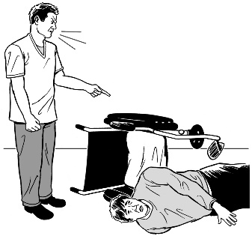Disabled people are more likely to be at risk from:

abuse

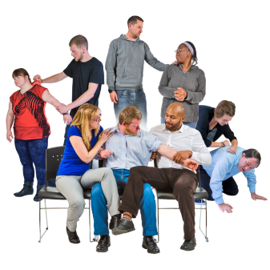neglect

violence

harm.

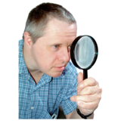Safeguarding is about making sure the risk is:

looked out for

responded to

stopped.

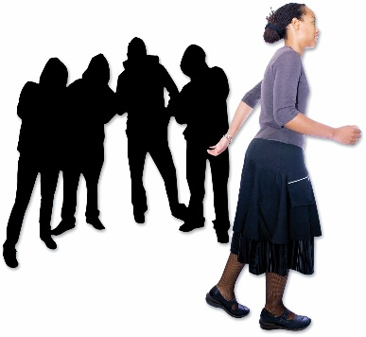Safeguarding is very important for disabled people if:

they cannot keep themselves safe

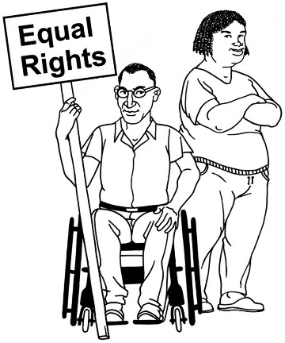they are not getting their human rights

they are at risk of:

* harm
* 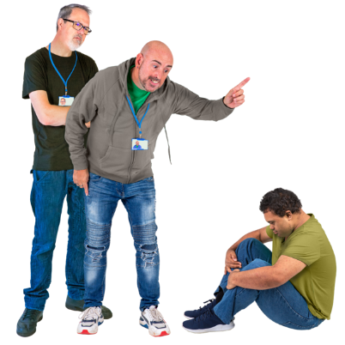violence
* abuse
* neglect.

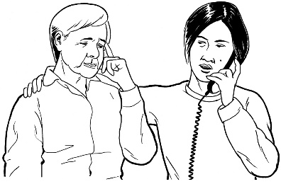There is support for people who might be in this kind of trouble.

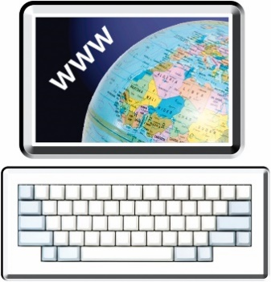Find out more about this support at this **website**:

[**www.disabilitysupport.govt.nz/  
 providers/quality-and-safeguarding**](http://www.disabilitysupport.govt.nz/providers/quality-and-safeguarding)

# How is DSS doing quality and safeguarding?

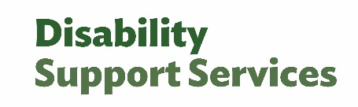DSS is working towards quality and safeguarding by doing things to:

prevent

identify

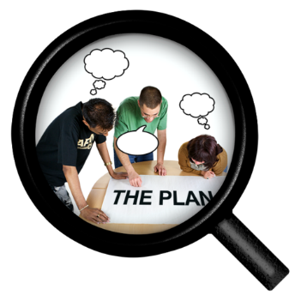respond

develop.

These things will be explained on the next few pages.

## Prevent

We will work to stop problems from happening.

## Identify

We will work out what a problem is when it happens.

## Respond

We will do something when a problem is found.

## Develop

We will work out ways disability supports can be:

made / put together

made better.

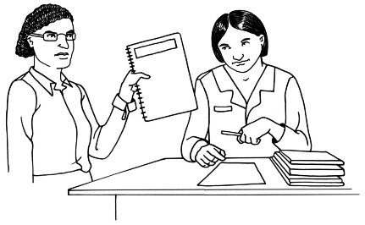We know there are gaps in quality and safeguarding:

systems

policies.

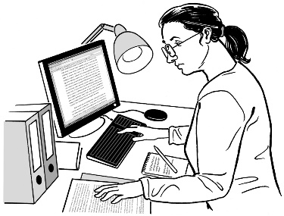

We want to:

learn what the gaps are

get better at what we do

find ways to fix those gaps.

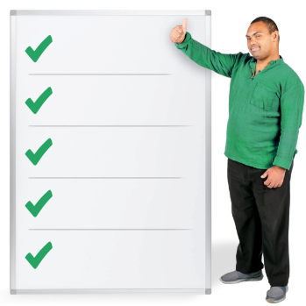We are making a **framework** to make quality and safeguarding better.

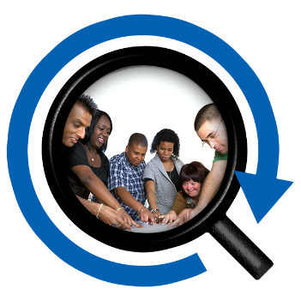

Here **framework** means a system   
for checking that things are working as they should.

# Where to get more information

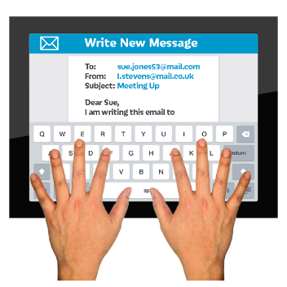If you would like to know more about the quality and safeguarding framework you can **email**:

**quality@msd.govt.nz**

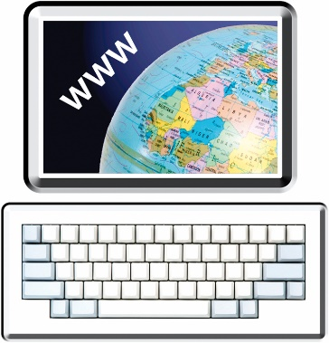

You can contact us at this **website**:

**[www.disabilitysupport.govt.nz/  
about-us/contact-us/](http://www.disabilitysupport.govt.nz/about-us/contact-us/)**

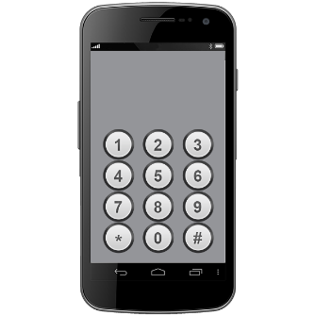

You can **phone** us on:

**0800 566 601**

If you find it hard to use the phone the **New Zealand Relay** service is for people who are:

Deaf / hard of hearing

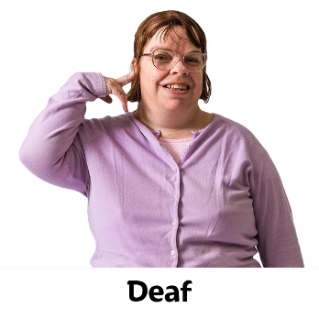deafblind

speech impaired / find it hard to talk.

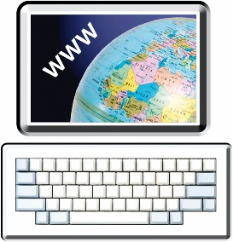

You can find out more about the New Zealand Relay service at:

[**www.nzrelay.co.nz**](https://www.nzrelay.co.nz)

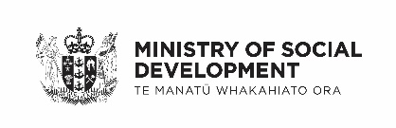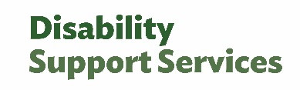This information has been written by Ministry of Social Development Disability Support Services.

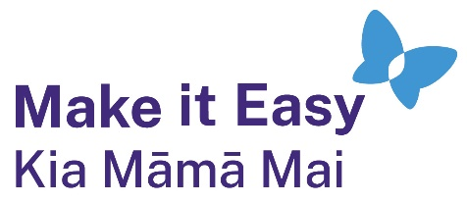It has been translated into Easy Read by the Make it Easy Kia Māmā Mai service of People First New Zealand Ngā Tāngata Tuatahi.

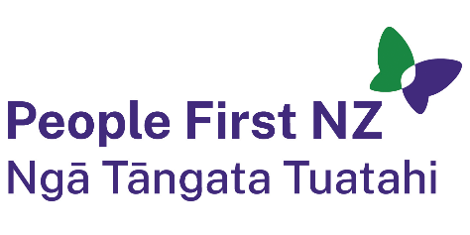

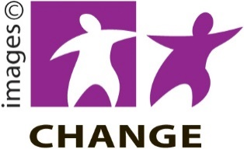The ideas in this document are not the ideas of People First New Zealand Ngā Tāngata Tuatahi.

Make it Easy uses images from:

* Photo SymbolsChangepeople.org

Photosymbols.com

* SGC Image Works
* Huriana Kopeke-Te Aho
* T.Wood.

  
All images used in this Easy Read document are subject to copyright rules and cannot be used without permission.