
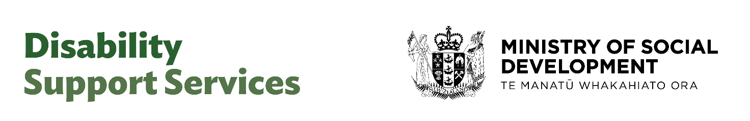

OBIR Reference
Version 1 – 4 September 2026

Contents
OBIR Reference 1
Overview 3
How to understand this document 3
An impacts-based approach 3
Selecting the appropriate lifestage 5
How OBIR uses lifestage 5
Selecting the appropriate lifestage 5
Ordinary Ranges – The Reflection Questions 7
What is the scope of the individual reflection questions? 7
Which reflection questions relate to which themes? 11
How some familiar situations might be reflected in OBIR 12
How to use the help questions, when you are unsure what rating to apply 13
How the contribution of others is understood 15
How the questions work together 15
How some familiar situations might be reflected in OBIR – Contributions of Others 19
Extraordinary ranges – The Support Profile Questions 20
What is the basis for an extraordinary range 20
Pathways to an extraordinary range 21
Distinguishing between disability support and parental support in extraordinary ranges for young children 22
Where some common risks might be reflected in the Support Profile questions 23
Taking account of the contribution of other agencies 25
Maintaining distinctions between disability-related, and non-disability related impacts in OBIR 25
Appendix One – Extraordinary Range Reference Sheets 27

Overview

How to understand this document
This reference document is intended to summarise some key information that will support those making allocations to:
- reflect as best as possible, within the options available in OBIR, the person and their situation; and
- through that, set a reliable expectation of what DSS might usually expect to contribute to the person’s support.
This guide provides observations and information to assist achieving those aims, in the context of Release 4 of the WebApp that supports OBIR.
It is not however:
- a complete ‘how to’ guide;
- a complete explanation of all elements of OBIR.
It is likely to be most useful at the Moderation stage, although knowledge of how the different questions affect the indicative range may support individual Assessors to be more confident in answering the questions upfront.

An impacts-based approach
Understanding day to day impacts on life arising from disability supports us to understand and respond to disability-related impediments to the practical realisation of Article 19 namely that:
“ States Parties to the present Convention recognize the equal right of all persons with disabilities to live in the community, with choices equal to others, and shall take effective and appropriate measures to facilitate full enjoyment by persons with disabilities of this right and their full inclusion and participation in the community, including by ensuring that:
a) Persons with disabilities have the opportunity to choose their place of residence and where and with whom they live on an equal basis with others and are not obliged to live in a particular living arrangement;
b) Persons with disabilities have access to a range of in-home, residential and other community support services, including personal assistance necessary to support living and inclusion in the community, and to prevent isolation or segregation from the community;
c) Community services and facilities for the general population are available on an equal basis to persons with disabilities and are responsive to their needs.”
The questions in OBIR are intended to support:
- understanding disability-related impacts on day to day life that may pose practical challenges to, limit the confidence of, disabled people and their whanau exercising Article 19 choices; and
- to facilitate planning to overcome those challenges
An impacts basis supports us to understand the ways that disability effects:
- how much additional time might something take;
- how often something may occur successfully, or without disruption;
- with what confidence can we undertake particular activities successfully;
- what range of opportunities are available independently;
- what range of people may or do contribute to our lives.
Responding to these and other disability-related impacts is intended to address immediate challenges, whilst broadening the practical possibilities and opportunities for disabled people and their whānau into the future.

Selecting the appropriate lifestage

How OBIR uses lifestage
Lifestage is used by OBIR to gain a general understanding of the settings and responsibilities that the disabled person may require support with, before that understanding is refined through more specific questions about parts of day-to-day life.
It is those settings and responsibilities, rather than someone’s age, that determines overall which lifestage is appropriate.
Choice of lifestage effects:
- The planning questions included in the planning mindmaps;
- The indicative range questions;
- The maximum indicative range available, given the general settings someone might be in and the responsibilities that might require support.

Selecting the appropriate lifestage
Generally, age is likely to be a good predictor of lifestage – but there are exceptions, such as where:
- a transition from one lifestage is imminent (eg. leaving high school and moving into adult life), and a range is being sought to inform planning for that next lifestage; and
- age notwithstanding, the disabled person is generally in the settings, and requiring support with the responsibilities of a later lifestage (for example, a teenage who may have left school and home early in their mid-teens).
Picking the most appropriate lifestage is a key part ensuring the most appropriate options for planning are available, and that an appropriate estimate of what DSS might expect to contribute to the upcoming transition financially.
If you are unsure, you can use the flowchart below to check:

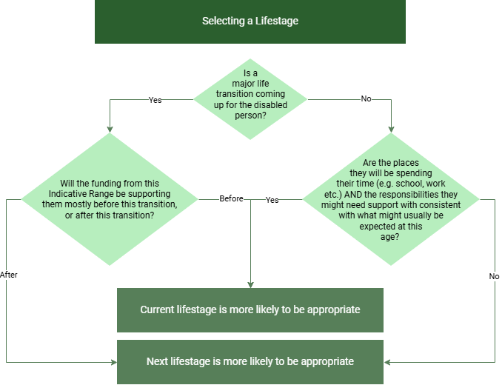

Ordinary Ranges – The Reflection Questions
Ordinary Ranges provide for a level of support to enable disabled people and their whānau to create lives for themselves, including where the disability support system is not intensively involved in the provision of their living situation.
Ordinary ranges depend on the results of the reflection questions:
- Most reflection questions address the impact of disability on day-to-day life. The more negatively the ‘without support’ options are rated, the greater the disability-related impact, and the higher the likely range;
- Some (3) reflection questions relate to the contribution of others, and impacts on them from making those contributions. Those reflection questions are discussed in a separate chapter.
Ordinary ranges respond to the impacts of disability on day-to-day living and activities. They contain relatively less (but not no) support that may be required ‘just in case’ a risk arises.
Ordinary ranges are appropriate where the person and their whānau are looking for support with the life they want to create, but where the support does not require DSS to be intensely involved in sustaining the person’s living situation.

What is the scope of the individual reflection questions?
Three resources are included below to support understanding the scope and intent of the reflection questions:
- the table below sets out the overall intent and impact of individual reflection questions;
- the table below that is a reference so that you can be sure about which specific reflection question relates to which theme; and
- the diagram below that sets out how particular reflection questions relate to some familiar themes in disability-related challenges, and where some commonly assessed challenges might be represented within the OBIR tool.
Examples included in the resources are intended as illustrative only, and are not intended as a rule.
 | Why | Maximum amount of the Indicative range affected by this indicator | Who is this question about? | What might that look like?
Routines and Tasks of Daily Living | If getting through tasks of daily living is unpredictable, or takes significant extra time, then it may:  - limit the confidence with which the disabled person, or their family, can commit to particular activities (eg. work); or  - leave less time and energy for other activities that are important for the wellbeing of the disabled person and their family.  Including support for these impacts in the indicative range allows for supports that give the person, or their family, more time and energy available for other activities that are important for their wellbeing. | 25%-30% of the maximum possible ordinary range | This question is primarily about the challenges the disabled person experiences but acknowledges interdependencies with the wider household who may be affected. | Disability-related challenges to managing day-to-day routines may arise, for example, where:  - Higher physical challenges means that some personal care and household management tasks can’t be completed independently;  - Comprehension of Personal Care and Household Management tasks limits their successful independent completion
Behaviour | If the way the person expresses emotions requires additional effort and understanding to manage, then the range of opportunities (including living situations in some life stages), that are made available to the person, or that they and their family are confident can be taken up successfully, may be constrained.  The additional effort and understanding may be:  - by the disabled person themselves, or  - take the form of support from others.  Including support for these impacts in the indicative range resources overcoming constraints to the range of opportunities available to the disabled person resulting from the way in which the person expresses emotions. | ~20%-30% of the maximum possible ordinary range | This question is about the experience of the disabled person but acknowledges that may affect others around them. | Disability-related challenges related to how the person expresses themselves appropriately may arise, for example, where:  - self-regulating responses to frustrations may require support;  - particular sensory inputs, or disruptions to routine can lead to the disabled person escalating further or faster than others might;  - frustrations navigating a less accessible world come out in ways that require support.
Hazard Self Management | Where environmental and object related hazards are more difficult for the disabled person to navigate this can lead to the range of roles and settings the disabled person can access or participate in independently narrowing.  Including support for these impacts in the indicative range resources overcoming accessibility challenges and managing everyday hazards with greater independence. | ~15%-20% of the maximum possible ordinary range | This question is about the experience of the disabled person. | Disability-related challenges to hazard self-management may arise, for example, where:  - Higher physical challenges means that some environments, objects etc. may pose higher risks than the otherwise might;  - Risk perception and assessment, or managing impulsivity is impaired;  - Vision or hearing impairment may make it more challenging to perceive or manage risk
Community Engagement | Being known for having particular strengths, and being connected in settings where those strengths are valued, enables the disabled person to access a fuller range of opportunities to engage in their communities.  Including supports to address barriers the disabled person may experience in engaging in their community in the indicative range resources the person to engage with their community with greater independence. | ~7%-15% of the maximum possible ordinary range | This question is about the experience of the disabled person. | Disability-related challenges to managing day to day routines may arise, for example, where:  - there are practical challenges or support required to participate in activities in community;  - the way the person processes information and completes activities independently limits their participation in in community
Agency and Decision making | Making practical allowance for any accommodations (time, process, technology etc.) that may be necessary for the disabled person to engage in decision making is critical for realising full inclusion and participation. | ~10%-15% of the maximum possible ordinary range | This question is about the experience of the disabled person. | Disability-related challenges to exercising agency and decision making may arise, for example where:  - The way that the person engages with information or makes their preference understood requires additional time or support as part of day-to-day decision making;  - Particular accommodations are required for communication to occur successfully.
Social engagement and social navigation | Where a disabled person experiences challenges in appropriately navigating, and engaging in, social situations then the range of opportunities that are made available to the person, or that they and their family are confident can be taken up successfully, may be constrained.  Including supports to address these challenges in the indicative range intends to increase the opportunities available to the person by enabling them to more independently, and/or appropriately, engage in social situations. | ~7%-11% of the maximum possible ordinary range | This question is about the experience of the disabled person. | Disability-related challenges to confidently navigating social interactions successfully may arise where:  - challenges processing social cues and understanding social boundaries make it more challenge to participate in social engagement successfully;  - challenges potentially engaging with others successfully (such as others understanding the disabled person’s communication method or style) may make it harder to confidently participate.
Relationships (and sex) | Understanding how a person’s experience of disability may impact relationships, and how this changes at different developmental stages can help us identify barriers to successful and safe relationships, including intimate relationships.  Including supports to address identified barriers or challenges in the indicative range resources the person to engage in safe and successful relationships more independently. | ~0%-10% of the maximum possible ordinary range | This question is about the experience of the disabled person. | Disability-related challenges to understand how relationships change at different developmental stages, and or to maintain intimate relationships, may arise where the person may require support to:  - navigate intimate relationships;  - set boundaries; and/or  - navigate others’ boundaries;  you might reflect that here
Expectations | Identifying a disabled person’s (and their family’s, where relevant) expectations for the future can support us to understand the impact that disability may be having overall on day-to-day life.  Understanding what particular impacts are contributing to lower expectations may support us to focus and prioritise challenges that are having the biggest impact on day-to-day life. | ~0.5%-3% of the maximum possible ordinary range |  | The specific challenges that influence expectations will vary across the indicators above, and from situation to situation.

Which reflection questions relate to which themes?
Scope | Preschool | Primary-Intermediate | High School | Adulthood
Routines and Tasks of Daily Living | Generally we can carry out [ ] routine activities and have time to do other things that are important for us and our child | Generally we can carry out [] of our routine tasks and activities, whilst leaving time for other things that are important to us | I can take responsibility for [ ] for the routine things that I need to do, without significant impact on other things that are important to us | I can complete [] the routine things that I need to, that allow me to present myself and my home as I want to
Behaviour | Our child [] expresses their emotions in a way that is time consuming or exhausting to manage | Our child [] expresses their emotions in a way that is time consuming or intensive to manage | The way I express my emotions [] is in a way that is time consuming or intensive to manage | The way I express my emotions [] is in a way that is time consuming or intensive to manage
Hazard Self Management | Our child can safely explore [ ] of the same range of environments as other children might | Our child can safely explore [ ] of the same range of environments as other children might | I can manage for myself [ ] of the hazards I might encounter in day to day life | I can manage for myself [] of the hazards I might encounter in day to day life
Community Engagement | Our child participates in [ ] activities and places with others their age | I am [ ] developing and pursuing my interests, in ways which create opportunities to build on them | I am [ ] developing and pursuing my interests, in ways which create opportunities to build on them | I have [ ] enduring roles and activities that support me to demonstrate my strengths and maintain connection with others
Agency and Decisionmaking | Our child is making [ ] progress to developing the skills to understand others, and make themselves understood | I have opportunities to be responsible for [ ] of my own choices, and day-to-day decisions | I am gaining [ ] experience and confidence with making day-to-day and important decisions | I am [] in control of how my will and preference is determined and communicated
Social engagement and social navigation |  | I can [ ] participate in social and family life confidently | I can [ ] participate in social and family life confidently | I am confident participating in [] social and family contexts, and can keep up with friends and make new friends as others move on
Relationships (and sex) |  |  | I understand [ ] of the things that are changing for me, and how they might change how I engage with others | I can [] maintain or continue to develop close/intimate relationships, as I choose to
Expectations | We are [ ] about possibilities for the future, given our understanding of what our child's disability could mean | I feel I have [ ] choices to maintain or return to work, education, or other activities that are important to me | We expect [ ] of our family relationship to change as I go through my teenage years | I expect to have [] the opportunities to contribute, be valued, and access the good things in life that my peers do

How some familiar situations might be reflected in OBIR
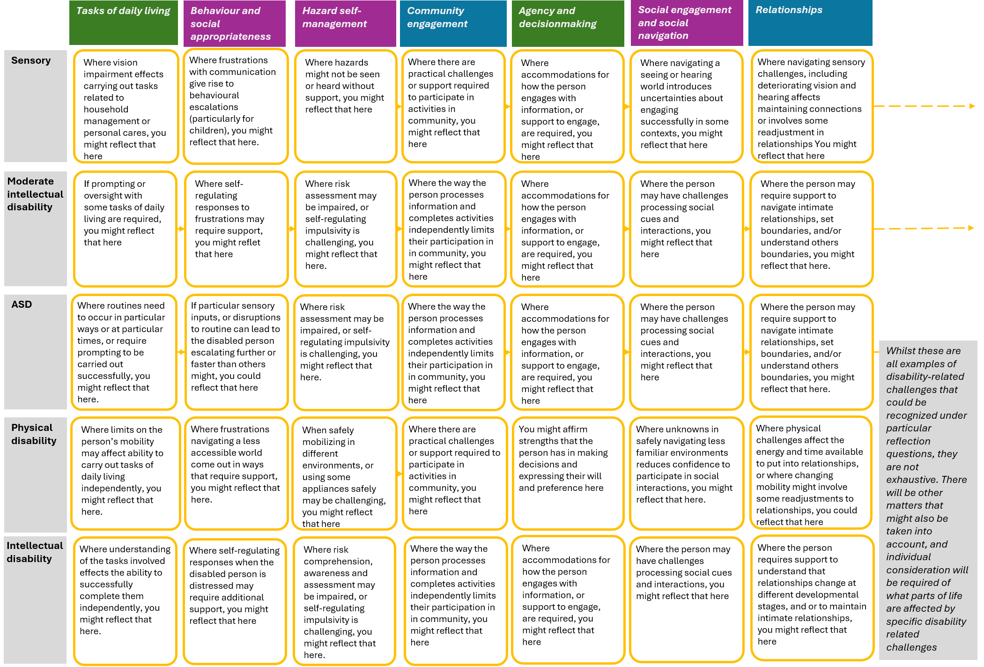

How to use the help questions, when you are unsure what rating to apply
As well as an overall 1-5 scale of rating options, each reflection question also has 3 supporting questions available to use where you are unsure what the overall answer should be. There is no requirement to use these questions, but they are your first best option for trying to determine with greater precision which rating option is most appropriate.

The supporting questions are intended to work together, and each relates to one of three themes:
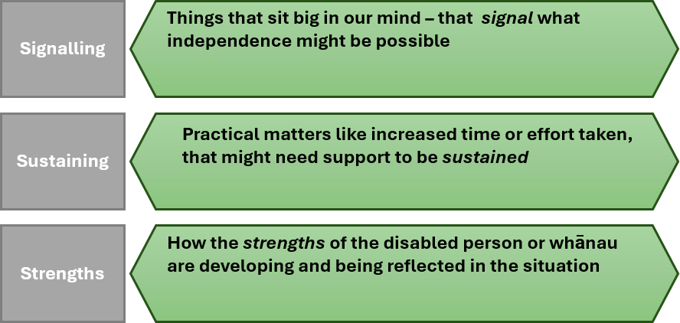

These three elements together support us to understand a more rounded picture of the impact on someone’s life. Whilst there is no requirement to use these questions, it is strongly encouraged where there is significant doubt about which overall rating should be applied
.

How the contribution of others is understood
OBIR includes a fact-based inquiry into the contribution others make to the life of the disabled person.
Understanding the contribution family and others make, the broader support network around them, and their ability to take time for their own wellbeing, are all key parts of ensuring that family carers and their needs are appropriately taken into account through the assessment.
OBIR does not advance any views on what the role of the family is or ought to be. Instead, OBIR seeks to establish what the contribution of others to the support of the disabled person is, and what effect that has on their own wellbeing, as a question of fact which a disability support system may need to respond to.
Whilst there are 6 -9 questions about disability related impacts (depending on lifestage), there are three questions related to the contributions of others to the life and support of the disabled person. As a result, we are relatively more reliant on these three questions being answered accurately, to ensure that the overall range is reliable.
These three questions must describe accurately both the availability and contribution of others to the life of the disabled person, and also the impact that has on the ability of those others to pursue things that are important for their own wellbeing.

How the questions work together
The three questions work together to create a picture of the support provided by others. Each question has a specific role to play, and it is important that they are answered within their respective scopes. Specifically:
- The questions on how available others (or in the case of minors, the immediate household) make themselves to support the disabled person establishes, as a question of fact, how much of the disability support the person requires is being provided by others
- The question on extended support networks establishes, the availability of others, beyond those most involved in the support of the disabled person, to provide relief care or emotional support, both to the disabled person and those most involved in their support
- The question on sustainability and wellbeing of those contributions supports us to understand what impact on family carers and support networks the contribution they make has, so that this can be taken into account in setting an appropriate ongoing indicative range
In some instances it may be tempting to scale down the availability question, to reflect that it can be a struggle for family to be as available as they are, or hard to sustain. However, that will result in the indicative range ‘double counting’ the sustainability challenges in the final indicative range. It is important to answer each question factually, so that they can work together to create a consistent result.
Three resources are included below to support understanding the scope and intent of the reflection questions:
- The diagram below shows, at a high level, how the answers on contributions of others are calculated together to estimate an ongoing sustainable contribution.
- The table below that is a reference so that you can be sure about which specific reflection question relates to which theme; and
- The diagram on the page after that sets out some common scenarios, and how those might be reflected in the different questions.

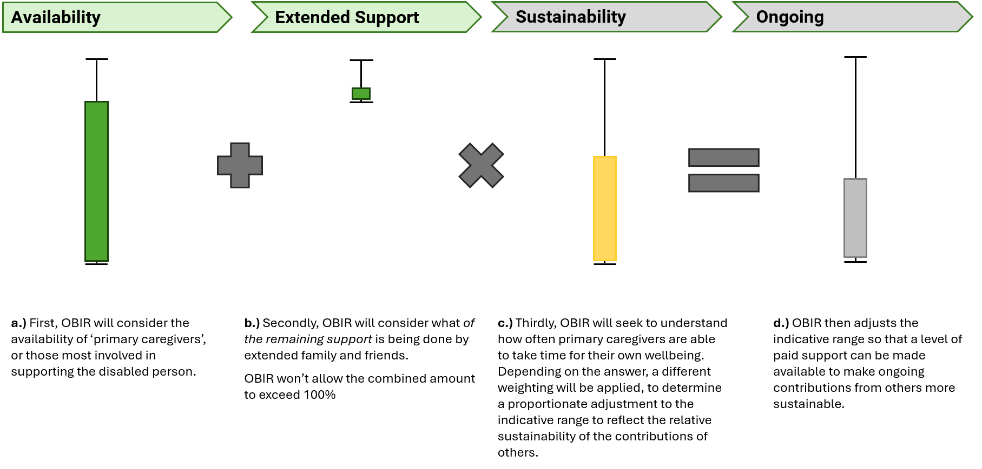

Scope | Preschool | Primary-Intermediate | High School | Adulthood
Availability | We are [ ] available to provide the level of support our child requires | We are [ ] available to provide the level of support our child requires | There are people in my life who [] are available to provide the level of practical support I require to achieve the things that are important to me. | There are people in my life who [ ] are available to provide the level of practical support I require to achieve the things that are important to me.
Extended Networks | Extended family and friends are [ ] available to support our child and us | Extended family and friends are [ ] available to support our child and us | Extended family and friends are available [ ] to provide emotional support to me or those who support me | Extended family and friends are available [ ] to provide emotional support to me or those who support me
Sustainability | I can [ ] do most of the things important for my wellbeing | My family are able to take time for themselves [] and maintain balance within the whānau unit | My family are able to take time for themselves [ ] and maintain balance within the whānau unit | Those who contribute to my life are [ ] able to balance their contribution and keeping up with the things that are important to them

How some familiar situations might be reflected in OBIR – Contributions of Others

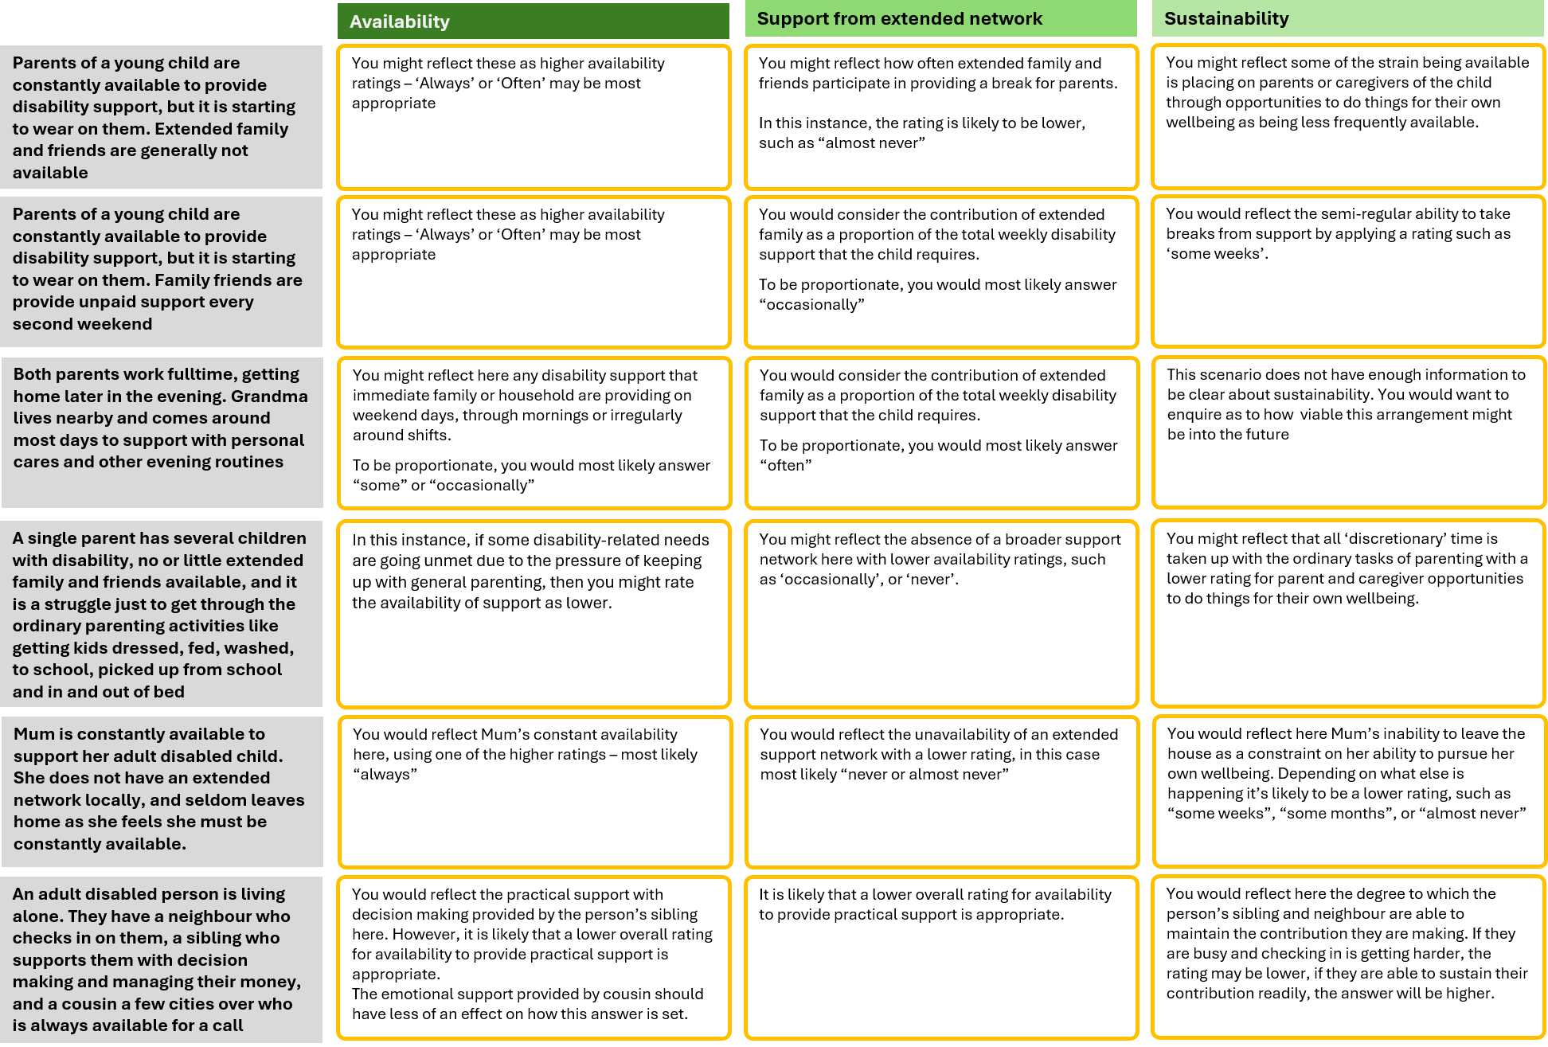

Extraordinary ranges – The Support Profile Questions
Whilst most people might be served through ‘ordinary’ indicative ranges, the questions in this section determine whether an extraordinary range might be required.
Extraordinary ranges are more appropriate where constant or near constant disability support is required.
Whether an ordinary or extraordinary range is appropriate depends on the level of safeguarding risk that may be present. This is primarily understood through the safeguarding (‘Support Profile’) questions.
The safeguarding questions have three parts to them:
- Regularity – how often does the risk eventuate?
- Incidence – at what times, or in what circumstances, does the risk usually eventuate?
- Support – What level of support is required to respond to the risk when it eventuates? This also helps us understand the intensity of the risk.
These three questions work together to determine whether a constant or near constant level of support to manage potential safety risks are required.
In any given situation there can be a range of views, often deeply held, about whether, for how long, and in what circumstances the disabled person can spend time without disability supports.
These can be sensitive questions, as they sit at the heart of disabled people and families’ sense of security, and sense of what level of independence is possible.
These questions are intended to provide a structured, reviewable, evidential basis for determining whether constant (or near constant) support is required, and if not why not.

What is the basis for an extraordinary range
For the majority of people that DSS supports, we provide support with specific elements of life through the day or week, but otherwise limit our intrusion into day-to-day life. This pattern would be supported by ‘ordinary’ indicative ranges.
An extraordinary indicative range arises where there is a need for constant or near constant disability support. Extraordinary indicative ranges are reserved for situations where safety risks occur regularly, throughout the day (and/or night), and with an intensity to warrant constant, focused disability support to manage those risks.
The decision to provide constant or near constant support has significant implications. OBIR is introducing a more structured and consistent approach to those decisions, and relies heavily on the safeguarding questions in the ‘Support Profile’ section of the webapp.

Pathways to an extraordinary range
There are two ways that an extraordinary range can be generated:
- One of the safeguarding domains across regularity, incidence, and intensity/support, rises to a level that of itself requires constant or near constant support; or
- Several safeguarding domains each create an intensive period of the day which, taken together amounts to constant support being required across the day.
For example, a person may experience intensive periods of risk of acute physical harm during the busy periods of the day, and may separately experience intense levels of safety risk related actively seeking to explore beyond where they might be expected to be during the day. By themselves they might not trigger an extraordinary range, but taken together they present a picture where constant or near constant disability support is required across the day:
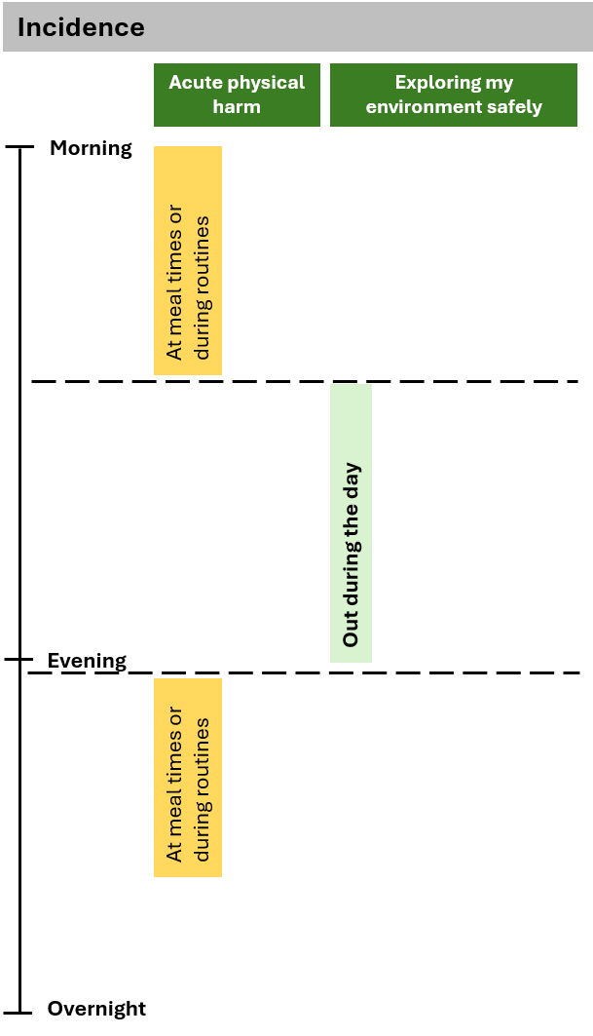
Appendix One sets out reference tables that can support you to understand how the calculator will interpret different responses, and to trace what answers may be leading to extraordinary ranges if these are unexpected.

Distinguishing between disability support and parental support in extraordinary ranges for young children
What is or is not a disability-related risk to safety will vary at different ages and stages of development. It is not straightforward to generalize across those stages of development, and each individual circumstance will require individual consideration. The table below sets out some broad parameters that may help make distinctions about where it is more or less likely that particular matters can and should be included in answers to these indicators.
Theme/ Support Profile question | More likely to be appropriate to include in rating if… | Less likely to be appropriate to include in rating if…
Acute physical harm | - … the child has difficulty swallowing safely foods that a child of this age and stage usually might be able to  - … the child requires invasive medical devices to be used appropriately in order for them to be safe  - … managing seizure activity is required for the child to be safe | - … the child would not be safe using sharp objects or items independently that another child of this age and stage would also require supervision to use
Mobility | - … the child is not mobilising, and requires constant or near constant support as a result (including additional support to maintain skin integrity)  - … the way the child has adapted to mobility challenges introduces other safety risks | - … the child may fall, bump into, or otherwise be bumped into, with much the same regularity and consequences as any other child might
Expressing myself | - …when distressed or escalated the child engages with objects, animals, or elements of the environment that may lead to those things harming the child, or pose risk to life  - …when distressed or escalated the child engages with other people, including adults, in a way that poses a risk of serious or continuing harm to them | - … the child expresses themselves in ways that are distressing or exhausting, but is not themselves unsafe or do things that may harm others
Exploring my environment | - … impulsivity or fixation leads the child to actively try and get away from where they are expected  - …the child undoes locks, moves furniture, or otherwise actively seeks to circumvent things put in place to help them stay in appropriate spaces | - … the child may wander off if unattended and something catches their attention  - … the child requires supervision generally to be safe around hazards like traffic or bodies of water

Where some common risks might be reflected in the Support Profile questions
The diagram below sets out where some risks familiar from previous needs assessment practice might be best reflected in the Support Profile questions in OBIR:

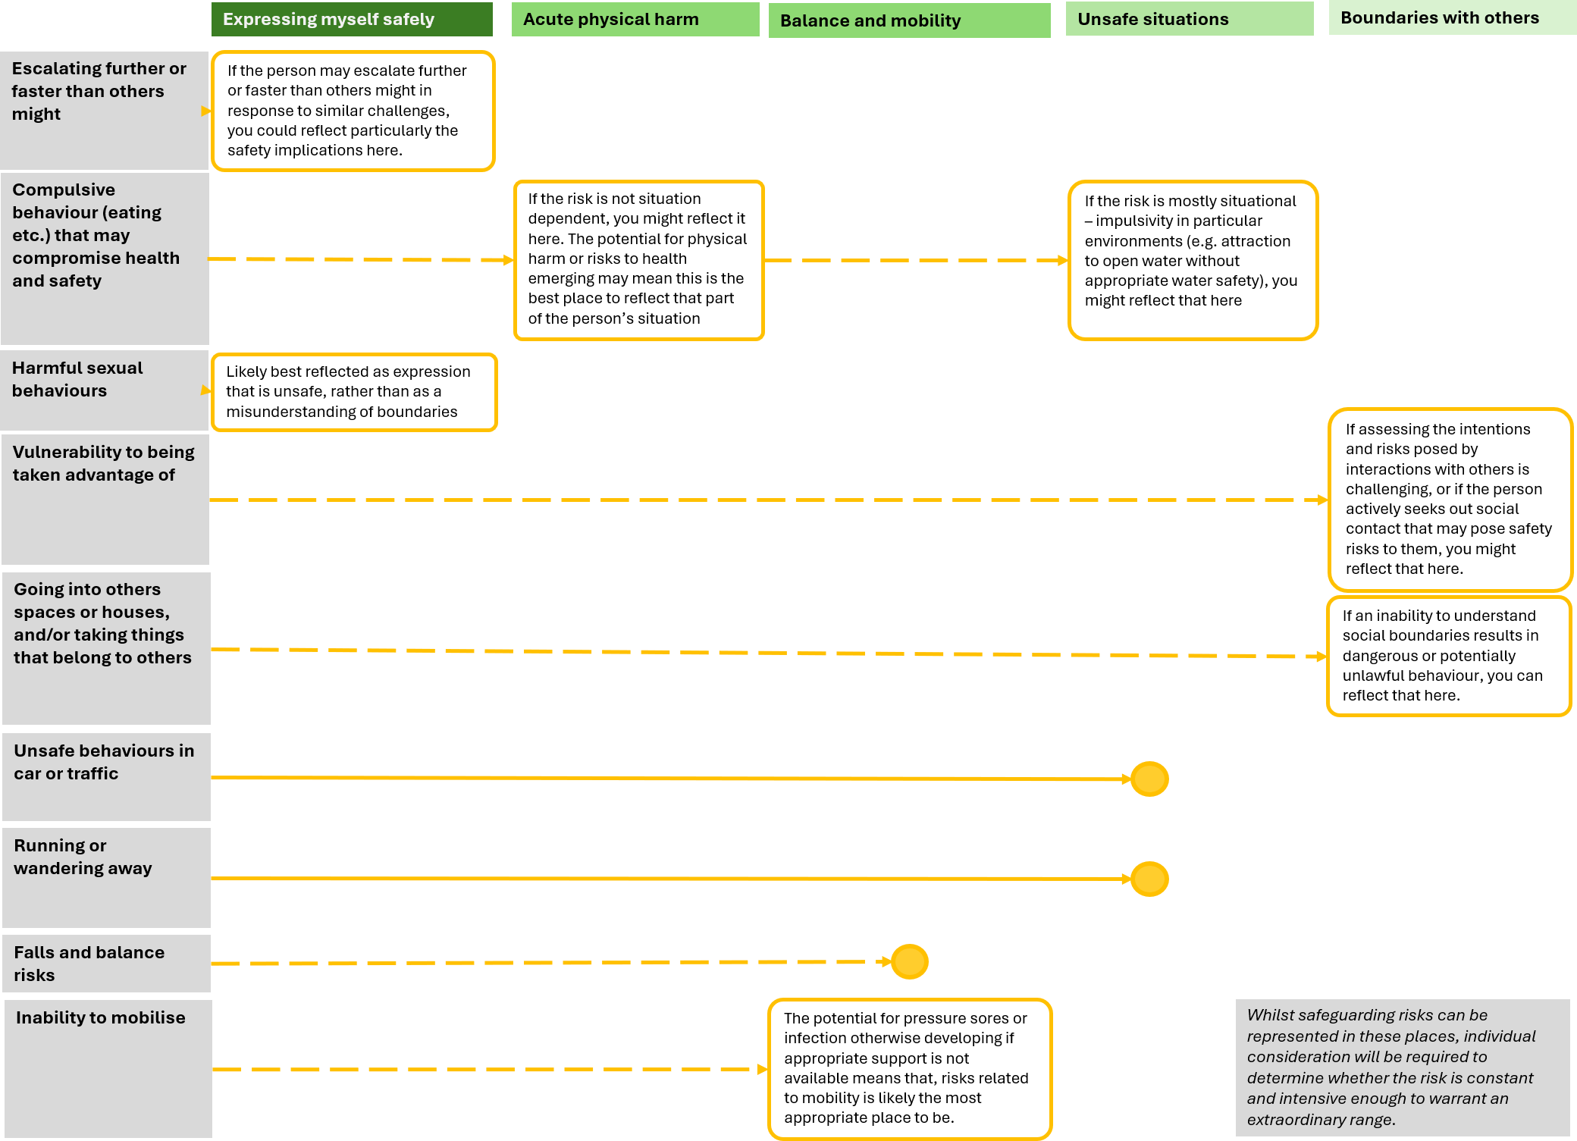

Taking account of the contribution of other agencies
In moving to an impacts approach, there is potential for matters that other agencies might contribute to becoming considered within OBIR.

Maintaining distinctions between disability-related, and non-disability related impacts in OBIR
OBIR provides several places that the distinction between disability-related impacts, and impacts arising from other causes, can be made.
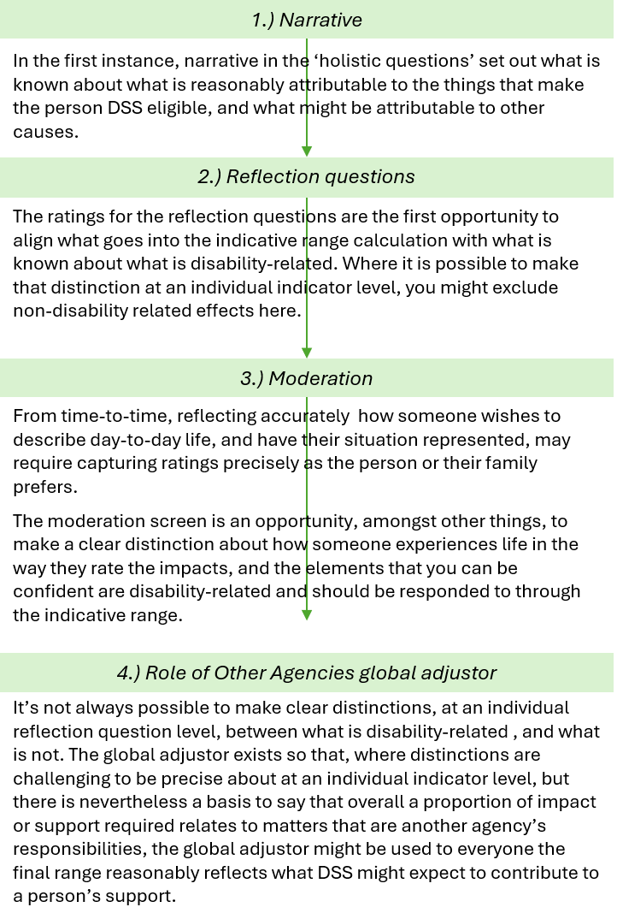
When adjusting ratings, it is important to avoid ‘double counting’ any distinctions being made. For example, if the impact ratings have been adjusted to provide only for disability-related impacts, you should be cautious about further adjusting them through moderation. If moderation has adjusted reflection question ratings to relate only to disability-related matters, we should be cautious about then using the Global override to adjust for the same reasons.

Appendix One – Extraordinary Range Reference Sheets (to come 7 September 2026)

This may not be appropriate to reflect in the Support Profile/ Safeguarding questions, but depending on the impacts may be appropriate to consider in the Reflection questions.

