

Introduction to AAFF changes

Facilitator Guide - January 2026

This session includes all sessions in a 5-part series:

- Session 1 – Setting the Scene
- Session 2 – Pre-Assessment
- Session 3 – Enquiry/Assessment Process
- Session 4 – Allocation Process
- Session 5 – Demonstration Video

Version Control

Version | Date | Relevant Updates | Sign Off

Facilitator Notes

Introduction
The training sessions can be delivered as one longer training or separately as “bite size training” to allow for flexibility to meet the needs of your organisation and team.
Overview of the AAFF training sessions
Session 1  Setting the Scene | Session 2  Pre-assessment | Session 3  Assessment Process | Session 4  Allocation Process | Session 5  Demonstration Video

A summary of each of the sessions is as follows:
Session 1 – Setting the Scene | Introductory session, designed to provide context on the journey to stabilise and strengthen the disability support services system and an overview of what is changing in relation to assessment, allocation and flexible funding (AAFF) in February 2026 and later in the year. This session will help participants understand the purpose and intent of the upcoming AAFF improvements, and the broader context of why they are happening.
Session 2 – Pre-assessment | Introducing the new Pre-assessment stage – a new step between confirmation of eligibility for assessment and the engagement with a disabled person, whānau or carer to capture disability needs. It is designed to help disabled people better prepare for the assessment process and know what to expect. The information provided includes guidelines for why and how the pre-assessment information should be delivered and used, and a look at the relevant documentation (letters and supplementary information). This session will help participants understand pre-assessment, and be able to follow the new process if it is relevant for their role.
Session 3 – Enquiry/Assessment Process | This session explains what is changing in the enquiry/assessment process – namely the introduction of a new OBIR (outcomes-based indicative range) web application tool which will be used to capture and record the information gathered in the engagement and enquiry process. This includes a high-level overview of the OBIR web application, rationale for the changes and key callouts for using the tool. This session will help participants understand upcoming changes to the assessment process and provide foundational knowledge for using the new OBIR web application tool.
Session 4 – Allocation Process | This session provides an overview of the interim allocation process that will be implemented in February 2026, including the use of the new OBIR calculator tool for indicative range calculations and My DSS Funding Plan. The information covers the purpose, objectives and benefits for the improvements, a look at the interim process steps and guidance for generating and using My DSS Funding Plans. This session will help participants understand what is changing in the allocation process and provide foundational knowledge for creating and using My DSS Funding Plans.
Session 5 – Demonstration Video | This session is a recording of the live demonstration of the new OBIR web application tool and how it will be used to carry out the assessment and allocation processes introduced in sessions 3 and 4, which was delivered as part of Train-the-Trainer training. This session will help participants see the tool in action with a fictional scenario to bring the learning to life and demonstrate good practice usage of the tool following the new processes.

Audience
All end users of the new AAFF processes and/or OBIR web application tool and/or OBIR calculator tool. This includes NASC Service Assessors, Service Coordinators, and any other relevant role across the NASC network, EGL site Connectors, Budget Advisors and any other roles at EGL sites, Hosts, and relevant team members at DSS who will directly support AAFF, e.g. by generating indicative range calculations.

Learning Outcomes
By the end of this training, learners will be able to understand:
- The broader context purpose and intent for stabilising the disability services system.
- What is changing in relation to assessment, allocation and flexible funding (AAFF) in DSS, both in February 2026 and later.
- The scope of the AAFF improvements and how these will impact existing relevant processes.
- How the changes are being implemented and the roles and responsibilities of NASCs, EGL sites, Hosts and other stakeholders to implement the new ways of working.
- How to use the OBIR web application tool to undertake assessment and allocation processes from February 2026 onwards.

Training collateral needed for this session
- Facilitator Guide (PDF)
- PowerPoint Presentation of Train-the-Trainer slides (PPTX)

Facilitator prompts
  - DO: An instruction to the Facilitator about something they need to do (e.g., DO: Display slide 1).
  - SAY: The script for the Facilitator.
  - ASK: A prompt to the Facilitator to ask a question and pause for responses from participants.
  - CLICK+SAY: An indication that the Facilitator needs to click the slide to have something appear/occur before reading the next part of the script. For example, you may be prompted to CLICK+SAY as parts of an animation are revealed on a slide.
  - Facilitator Note: A note specifically for the Facilitator that may be a suggestion, guidance, warning etc.
(e.g., Facilitator Note: Ensure your camera is on and your microphone is unmuted if you are delivering the training via Microsoft Teams.)
Note - Text contained in the Notes section of PowerPoint slides, such as “[IMAGE CREDIT Photo by Marissa Grootes on Unsplash]” is there to simply credit the image used and does not need to be mentioned in the presentation.

Handy Tip – Increase the size of your mouse pointer
Whether you are presenting online or in person, increasing the size (and possibly colour) of your mouse pointer can help participants see what you are doing more clearly. For information on how to do this, read the Know where you’re pointing section of this page - https://support.microsoft.com/en-us/windows/make-windows-easier-to-see-c97c2b0d-cadb-93f0-5fd1-59ccfe19345d

Managing questions
Each of the five training sessions contains a slide to prompt a pause to hear and respond to questions relevant to the training content that has been delivered in that session. We recommend that you note any questions that seem particularly important or would be useful to include in the FAQs document that is provided as part of this training pack and will continue to be managed and updated by DSS. These questions can be shared with DSS via dss_testing@msd.govt.nz.
If you receive a question that you do not know the answer to, or you would like to clarify before responding to the participant, please raise this via DSS (dss_testing@msd.govt.nz) so that we can respond with this information to support you in delivering this training.

Opening the Training
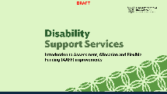 | Title Welcome Slide  - DO: Display slide 1  - DO: Welcome everyone as they join the session. Instruct them to put themselves on mute if they are joining a virtual training session. | If the session is not being delivered online, adjust some of the instructions you use here.
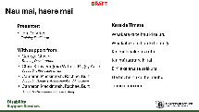 | Nau mai, haere mai  - DO: Display slide 2  - Facilitator Note: Ensure that your camera and microphone is on if conducting online. If you are recording your session you may need to re-check camera and microphone of all participants due to privacy sharing.  - DO: Start the session and introduce yourself. You may wish to start with a karakia (the karakia on the slide is provided as an example). Introduce anyone that will be supporting you or helping with the session.  Facilitator Note: If you are happy doing so, encourage learners to ask questions throughout the session (such as by ‘Raising their hand’). If you cannot answer their question immediately, then take a note of their question and either respond to it at the end of the session or at a time where you can provide a suitable answer. Otherwise, indicate that there is an opportunity for Questions and Answers at the end of the session. | If the session is not being delivered online, adjust some of the instructions you use here.
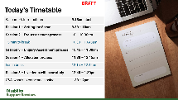 | Training Overview  - DO: Display slide 3  - SAY: Here is an overview of the training sessions we will be covering as part of the Introduction to assessment, allocation and flexible funding (AAFF) training. We will be covering 5 topics, delivered as five individual sessions.  Facilitator Note: The training can be delivered flexible as one or multiple sessions at a time. If you are delivering multiple sessions in one go we recommend scheduling appropriate breaks through the day.

Introduction - Session 1
Purpose – Introductory session, designed to provide context on the journey to stabilise and strengthen the disability support services system and an overview of what is changing in relation to assessment, allocation and flexible funding (AAFF) in February 2026 and later in the year. This session will help participants understand the purpose and intent of the upcoming AAFF improvements, and the broader context of why they are happening.
IF THIS SESSION IS BEING DELIVERED ONLINE AND YOU INTEND TO RECORD IT, YOU SHOULD START RECORDING NOW. MAKE SURE TO INFORM PEOPLE THEY MUST GIVE CONSENT FOR THE RECORDING AND GIVE THEM THE OPTION TO DECIDE IF THEY WANT TO TURN THEIR CAMERAS ON.

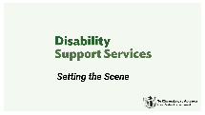 | What this session will cover  - DO: Display slide 4  - SAY: Welcome, this first session will cover how we got here. We appreciate that the level of knowledge some of you already hold on this topic may be quite high. However, this content is provided to establish a baseline understanding.
 | What this session will cover  - DO: Display Slide 5.  - SAY: Today we’ll cover the transformation journey to stabilise and strengthen the disability support system, what has been achieved so far, and introduce the changes to assessment and allocation processes that will go live in February 2026. This includes the new pre-assessment stage, using the OBIR web application tool for capturing engagement and enquiry information, and My DSS Funding Plan.
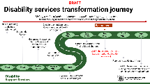 | Disability services transformation journey  - DO: Display slide 6  - SAY: Let’s look at the background to these changes. The AAFF programme is part of a wider transformation journey to stabilise disability support services.  - DO: Display slide 7  - SAY: Over the past two years, Disability Support Services has been on a significant transformation journey, responding to the findings and recommendations arising from the 2024 Independent Review. This review highlighted key challenges, including funding pressures, regional inconsistencies, and the need for tighter oversight.  - SAY: In 2026 a number of improvements in the area of assessment, allocation and flexible funding will be implemented. The improvements will be rolled out in stages. Phase 1 improvements will go live in February 2026 and relate to the assessment and allocation processes.  - SAY: Later in the year there will be a second phase of AAFF improvements, which relate to flexible funding and hosted support arrangements. We will talk a bit more about the scope of both phases of AAFF improvements later in this session.  - SAY: The overall aim of these reforms is to give disabled people more choice and control over their funding. This will be enabled by facilitating assessments and support decisions are transparent, fair, and nationally consistent.  - SAY: These changes reflect a strong commitment to ongoing improvement to stabilise disability support services, before looking to longer-term actions to further strengthen the system. | The speaking notes for this section can be reduced depending on how in depth the trainer believes they need to explain the disability services transformation journey.
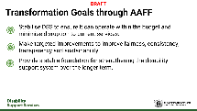 | Transformation Goals through AAFF  - DO: Display Slide 8.  - SAY: There are three immediate goals this transformation focusses on:  - CLICK + SAY: Stabilise DSS to ensure it can operate within the budget and minimise disruption to current services.  - CLICK + SAY: Make targeted improvements to improve fairness, consistency, transparency and sustainability.  - CLICK + SAY: Provide a stable foundation for strengthening the disability support system over the longer term.
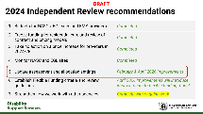 | 2024 Independent Review Recommendations  - DO: Display Slide 9.  - SAY: Let’s look at a high level at how the AAFF improvements relate to the 2024 Independent Review recommendations.  - DO: Display Slide 10.  SAY: DSS has been making good progress to stabilise the system and respond to the seven recommendations identified in the Independent Review. Recommendations 1, 3, 4 have been completed. Recommendation 7 is completed and ongoing – e.g. transfer of DSS to MSD.  SAY: The AAFF work programme introduces a number of improvements in response to recommendations 5 and 6. The implementation of these phases will be phased between February and October 2026.  SAY: The improvements to assessment and allocation processes we are covering in this training relate to recommendation 5. Further changes coming in April 2026 will also respond to recommendation 5 as well as recommendation 6. | The speaking notes for this section can be reduced depending on how in depth the trainer believes they need to explain 2024 Review Recommendations and what DSS is doing to meet these.
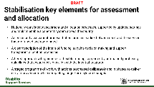 | Stabilisation key elements for assessment and allocation  - DO: Display Slide 11/12.  - SAY: The key elements of the AAFF programme to be delivered in 2026 are detailed here. This is a stabilisation activity and focused on bringing everyone to a base standard.  - SAY: This is a journey that will be achieved over time. The changes that will come into effect in February will be a step in this process. For all these steps there will be ongoing refinement as we get used to the changes and find opportunities to continually improve them and make the processes more effective.
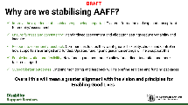 | Why are we stabilising and strengthening?  - DO: Display Slide 13.  - SAY: Detailed here are the key reasons why we are stabilising and strengthening AAFF processes, which will ultimately mean greater alignment with the DSS Enabling Good Lives principles.
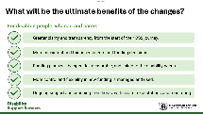 | What will be the ultimate benefits of the Changes?  - DO: Display Slide 14.  SAY: There are a range of benefits from the planned AAFF changes for disabled people, carers and whanau. The process for the assessment and allocation of disability support services and flexible funding is changing to support clearer and more consistent assessment and allocation settings, and flexible funding settings that are clear and easy to navigate.  SAY: The benefits listed here related to all of the planned AAFF programme improvements, which will be implemented in phases from February 2026 onwards. The February 2026 changes will start to introduce the first three benefits.
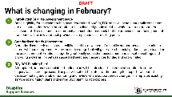 | What is changing in February?  - DO: Display Slide 15.  - SAY: There are three main changes that will occur in February:  - CLICK + SAY: Introduction of a Pre-Assessment Stage  - CLICK + SAY: A more standardised needs assessment process, supported by the use of a new a OBIR web application tool that will be used to capture and record the information gathered in the engagement and enquiry process. This replaces the SPA tool.  - CLICK + SAY: My DSS Funding Plan: the introduction of a nationally consistent funding plan template called “My DSS Funding Plan” which will progressively replace the current service coordination plans as new plans are introduced or with re-assessments.
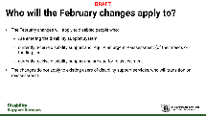 | Who will the February changes apply to?  - DO: Display Slide 16.  - SAY: The February changes will apply to disabled people who:  - Are entering the disability support system  - currently receive disability support and require an urgent re-assessment (of their needs or funding), or  - currently receive disability support and are due for re-assessment  The changes do not apply to existing users of disability support services, who will transition on reassessment. NASCs/EGL sites can pause or defer non-urgent reassessments until October to support workload management but are not required to.​
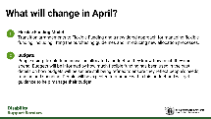 | What will change in April  - DO: Display Slide 17.  - SAY: Flexible Funding Model: Transition arrangements to Flexible Funding and a new tiered approach for managing flexible funding, including lifting the purchasing guidelines and introducing new allocation processes.  - SAY: Budgets: People using flexible funding will be allocated a budget so they know how much they can spend. Budgets will be informed by how much flexible funding has been used in the past – details on how budgets will be set are still being refined to ensure they reflect people’s needs, funding and spending. People will be expected to manage within this budget and will get guidance to help manage their budget.
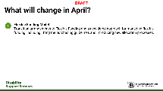 | What is not changing?  - DO: Display slide 18  - SAY: there are 5 areas that are not changing. These include; Eligibility, Assessment timeframes, referral process and systems, holistic assessments will remain optional, and existing plans of disabled people being supported.
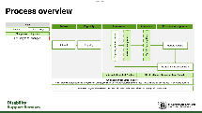 | February process for new users of disability services  - DO: Display slide 19  - DO: Display slide 20  - SAY: This simplified process overview diagram outlines the focus of our training in the context of a disabled person being supported in their journey through the disability support services that we as NASCs enable. It is designed to be high level and indicative to explain the process areas that are relevant for this training  - SAY: Our focus will be on the ‘Preparing for assessment’, ‘Assessment Process’, and ‘My DSS Funding Plan’ steps. Referral and Eligibility stages are not changing. The provision of supports stage is the focus of some of the changes that will take place in phase 2 of the AAFF improvements which will go live later in the year.
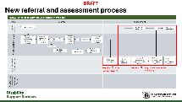 | New NASC referral and assessment process  - DO: Display slide 21  - SAY: This is an illustrative process flow diagram outlining the key steps in the referral through to service coordination process in the context of a disabled person’s user journey. It is designed to provide guidance as to the context of the changes that will go live in February relevant to the wider process. It is not intended as prescriptive direction from DSS as to how to undertake your work.  - CLICK + SAY: Step 5 – ‘Conduct pre-assessment’ will be covered in more detail in Session 2 of this training (Pre-assessment).  - CLICK + SAY: AAFF improvements relevant to steps 6 – 9 on this diagram will be explained in more detail in session 3 of this training (Assessment Process).
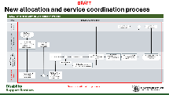 | New allocation and service coordination process  - DO: Display slide 22  - CLICK + SAY: AAFF improvements relevant to steps 9b – 18 on this diagram will be explained in more detail in session 4 of this training (Allocation Process).
 | Wrap up / Q&A  - DO: Display slide 23  - DO: Display slide 24  - SAY: This first session should have explained the following areas of the DSS transformation journey and the reason why and how DSS is stabilising and strengthening the process.  - DO: Display slide 25  - DO: Pause to hear and respond to or record questions from participants.  - DO: Display slide 26  - SAY: There is lots of further detail available online on the changes to assessments, allocations and flexible funding, as well as the wider programme of work. The links on this slide will take you to external public websites with key information.
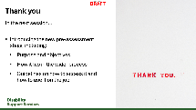 | Thank you  - DO: Display slide 27

Session 2: Pre-Assessment
Purpose – Introducing the new Pre-assessment stage – a new step between confirmation of eligibility for assessment and the engagement with a disabled person, whānau or carer to capture disability needs. It is designed to help disabled people better prepare for the assessment process and know what to expect. The information provided includes guidelines for why and how the pre-assessment information should be delivered and used, and a look at the relevant documentation (letters and supplementary information). This session will help participants understand pre-assessment and be able to follow the new process if it is relevant for their role.
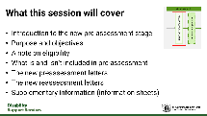 | What this session will cover  - DO: Display slide 28  - DO: Display Slide 29  - SAY: There are 6 topics this section will cover. It is intended to provide more detail on what the newly introduced pre-assessment stage is and how it will be used.
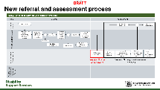 | Pre-assessment stage overview  - DO: Display slide 30  - DO: Display slide 31  - SAY: This illustrative process flow diagram is intended to show how the new pre-assessment stage fits within the wider referral and needs assessment process.
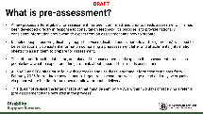 | What is pre-assessment?  - DO: Display slide 32  - CLICK+SAY: A new process after eligibility for assessment has been confirmed, and prior to needs assessment. This has been developed directly in response to consultation feedback. Its purpose is to provide nationally consistent information about what to expect from an assessment and how to prepare.  - CLICK+SAY: Disabled people receiving disability support services (disabled adults, parents and/or guardians) will need to be sent nationally consistent information comprising a preassessment letter and attachments (information sheets) to assist them to prepare for assessment.  - CLICK+SAY: The letter confirms the date, time, and place of the assessment, and explains the assessment process so people know what to expect and things to think about ahead of their needs assessment.  - CLICK+SAY: All NASC and EGL sites must follow this process and use these letter and information templates from February 2026 for routine re-assessments. Urgent re-assessments will still go ahead and may be organised via phone where the timeframe does not allow for postal delivery.  - CLICK+SAY: This does not replace the letter of receipt that must be sent by NASCs within two days of receiving a referral (pre-assessment is the next step in the process).
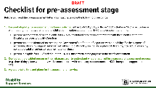 | Checklist for pre-assessment stage  - DO: Display slide 33  - SAY: It is important that before you send the pre-assessment letter to the user, or the users guardian you must have done the following three things.  - SAY: Ensured eligibility for assessment has been confirmed either by NASC/EGL or NRC, in accordance with meeting the first two criteria of eligibility confirmation set out in the NASC service specification.  - CLICK + PAUSE: Give participants time to read the three sub-bullet points, drawing attention to the third criteria being the function of the assessment.  - CLICK + SAY: Contacted the disabled person or their whānau/carer to understand what is required for a successful assessment process (e.g. time of day, place where they will be comfortable; with necessary support such as NZSL interpreter, support person etc)  - CLICK + SAY: Agreed a date, time and place for the assessment interview
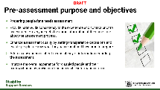 | Pre-assessment purpose and objectives  - DO: Display slide 34  - SAY: The pre-assessment process has been introduced to respond to community feedback indicating that there was a lack of clarity and consistency in this part of the process. Introducing a nationally consistent set of information and process for sharing this with disabled people, their whānau or carers prior to the engagement and enquiry taking place will help them to prepare for assessment and know what to expect early and upfront. This change is designed to improve their overall experience in relation to disability support services.  - DO: Pause and let the participants read the content on the slide.
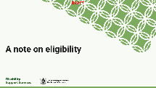 | A note on eligibility  - DO: Display slide 35  - SAY: We have already touched on eligibility not changing in Session 1, but this point is worth re-iterating here.  - DO: Display slide 36  - SAY: There is no change to the existing eligibility criteria, with the criteria for who can access DSS-funded support remaining unchanged. The pre-assessment information provides a clear distinction between being eligible for an assessment and being eligible for DSS-funded support.
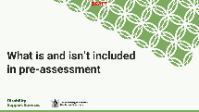 | What is and isn’t included in pre-assessment  - DO: Display slide 37  - SAY: We will clarify next what is and isn’t included within the pre-assessment information.
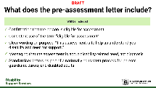 | What does the pre-assessment letter include?  - DO: Display slide 38  - SAY: The pre-assessment letters were developed and tested with the AAFF Pre Assessment NASC Expert Advisory and Testing group and the EGL National Leadership Group during November and December 2025. The Pre Assessment Lead met with each group on three separate occasions, where content was discussed with subsequent iterative amendments. The key call outs on this slide and the following slide as to what is included and excluded in the pre-assessment letters is a high-level view of how key feedback raised in these forums was noted and addressed in the development of the letters.  - CLICK + SAY: Confirmation that the person is eligible for assessment  - CLICK + SAY: Consistent use of the term “eligible for assessment”  - CLICK + SAY: Clear wording on purpose: “This assessment is to help us understand your disability and need for support.”  - CLICK + SAY: Messaging that the assessment is about disability‑related need, not diagnosis  - CLICK + SAY: Standardised letters as part of a nationally consistent process for parents, guardians, carers, and disabled adults
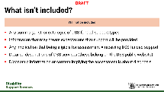 | What isn’t included?  - DO: Display slide 39  - CLICK + SAY: Any summary, list, or catalogue of DSS‑funded support types  - CLICK + SAY: Information that may create expectations that support will be provided  - CLICK + SAY: Any implication that being eligible for assessment = receiving DSS funded support  - CLICK + SAY: Detailed descriptions of DSS services (these belong on the DSS public website)  - CLICK + SAY: Diagnostic information or content implying the assessment is about diagnosis
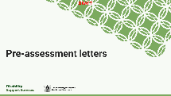 | Pre-assessment letters  - DO: Display slide 40  - SAY: Here are some key callouts in relation to the pre-assessment letters and supplementary information that will be introduced as part of this new process step.  - DO: Display slide 41  - CLICK + SAY: There will be 2 sets of letters – one set for pre-assessments and one for reassessments. Each set will have one letter for the parent/guardian/caregiver/whānau of a new Disabled Person being supported who is aged under 18 years, and another for anyone aged 18 years and over.  - CLICK + SAY: This serves as a "Welcome to your assessment" - as opposed to welcome to NASC/EGL.  - CLICK + SAY: The documents will be provided to all NASCs and EGLs as a nationally consistent standard 'letter’ (i.e. a template).  - CLICK + SAY: Areas where changes can be made on the letter templates are highlighted in different coloured font. This includes the details regarding the disabled person’s name, address and date/time, etc. of the needs assessment. We can include attachments containing the nationally consistent information, and other material that the NASC/EGL regards as appropriate ​for assessment (e.g. a pepeha of the Assessor). Once the formatting of the letters is finalised these will be shared with you.  - CLICK + SAY: All wording that is in black font on the letters must not be edited in any way. This is to ensure we maintain a standard and consistent set of information.  - DO: Display slides 42 and 43 and flick to the relevant document files giving participants time to look at the content and noting what areas can be edited.  Facilitator Note: The pre-assessment letters, re-assessment letters and supplementary information will be provided for you for the purposes of displaying to participants for this part of the training as part of the AAFF training resources. Once finalised, the master versions of these files will be stored in an accessible location which will be shared with you and administered by DSS. Details of this location will be provided.
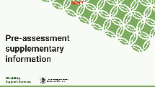 | Pre-assessment supplementary information  - DO: Display slide 44  - SAY: There is supplementary information that will be shared alongside the pre-assessment letter which we will cover in more detail now.  - DO: Display slide 45  - CLICK + SAY: Alongside the pre-assessment letter, you will provide people new to disability support services with a supplementary information sheet. This will be provided to all NASCs and EGL sites as part of a nationally consistent set of documents to support preparation for assessment.  - CLICK + SAY: The purpose of this is to support people to feel prepared for assessment by providing helpful information upfront and early.  - CLICK + SAY: The supplementary information pack includes an information sheet with questions to think about before the assessment interview.
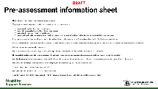 | Pre-assessment information sheet  - DO: Display slide 46 and flick to the relevant document file giving participants time to look at the content.
Wrap up / Q&A
- DO: Display slide 47
- DO: Display slide 48
- SAY: We have covered 6 key areas in relation to the new preparing for assessment stage. These are summarised as learning goals in relation to this session.
- DO: Display slide 49
- DO: Pause to hear and respond to or record questions from participants.
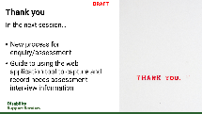 | Thank you  - DO: Display slide 50  - SAY: In the next session we will cover new process for enquiry/assessment, and provide guidance for using the new OBIR web application tool to capture and record engagement and enquiry information.

Session 3: Enquiry/Assessment process
Purpose – This session explains what is changing in the enquiry/assessment process – namely the introduction of a new OBIR (outcomes-based indicative range) web application tool which will be used to capture and record the information gathered in the engagement and enquiry process. This includes a high-level overview of the OBIR web application, rationale for the changes and key callouts for using the tool. This session will help participants understand upcoming changes to the assessment process and provide foundational knowledge for using the new OBIR web application tool.
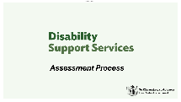 | Assessment Process  - DO: Display slide 51  - SAY: We will be discussing the changes to the Enquiry/ Needs Assessment Process. You may see some different terminology used in this training material to what you are used to. References to “assessment” relates to the engagement and enquiry process to understand the support needs of the disabled person as part of the function to assess whether DSS-funded support can be provided.  - DO: Display slide 52  - SAY: This session will cover the changes relevant to the assessment process that will be implemented in February, the purpose, objectives and benefits of these changes, and provide some high-level guidance for using the new OBIR web application tool for capturing and recording engagement and enquiry information.
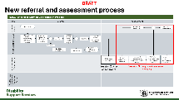 | New NASC referral and needs assessment process  - DO: Display slide 53  - SAY: This illustrative process flow diagram is intended to show the steps in the assessment process where there will be some change from February onwards.
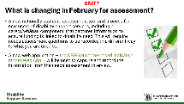 | What is changing in February?  - DO: Display slide 54  - Say: The main change to the assessment process is the introduction of a new tool which will support you to conduct a needs assessment for a disabled person seeking or already supported by DSS. It will change the process for recording information gathered from the disabled person, whānau or carer as part of the function to determine eligibility for DSS-funded support.  - Click + SAY: A new nationally standard assessment tool called the OBIR will be used to capture assessment information to ensure funding is linked to disability need. This will require the information to be recorded in a different way to what you are used to.  - Click + SAY: A new web application – the OBIR (outcome-based indicative range) Web App – will be used to capture and record the information from the needs assessment interview.
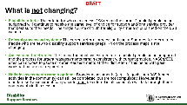 | What is not changing  - DO: Display slide 55  - SAY: We will quickly reiterate here four areas of the assessment process that are not changing as part of these February improvements. These are eligibility criteria, referral process and systems, assessment timeframes, and optional holistic assessment components.  - Click + SAY: Eligibility criteria​: The criteria for who can access DSS remain the same.  - Click + SAY: Referral process and systems:​ The current referral process and use of Socrates for referrals for People who are new to disability support services is not changing.  - Click + SAY: Assessment timeframes:​ The timing for initial assessments for disabled people being supported and the process for urgent reassessments remain consistent with current practice.  - Click + SAY: Holistic assessments remain optional:​ Broader assessments (e.g., life goals, non-DSS funded activities in the community) can still be completed but are not compulsory. ​
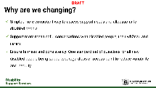 | Why are we changing?  - DO: Display slide 56  - SAY: The aim of these new processes is to better support the management of disabled people’s needs through the consistency of data capture to allow NASCs to better forecast and predict support budgets. They are designed to enable a simpler more consistent way to assess support needs by supporting more meaningful conversations that ensure fairness and consistency across the DSS system.
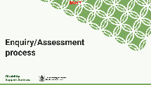 | Assessment process  - Do: Display slide 57  - Say: We will now focus on the changes relevant to individual steps in the assessment process.
New referral and assessment process steps
- DO: Display slide 58
- SAY: A reminder that the assessment process covered in this session relates to steps 6 to 9 indicated on this high-level process flow diagram. An important reminder is that this is indicative only to provide context for training, and our processes may differ. So please do not worry if some activities are mis-ordered or differ in naming convention to what we are used to.
- DO: Display slide 59
- SAY: The table here outlines further detail on the process steps. We will expand on these in the following slides.
- DO: Give the participants time to briefly understand the definitions of each process - they will be expanded on below.
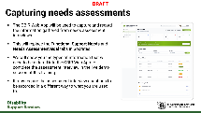 | Capturing needs assessments  - DO: Display slide 60  - SAY: The OBIR Web App will be used to capture and record the information gathered from needs assessment interviews. The screenshot on the right and those on the following slides in this session are intended as guiding visuals only – there will be an opportunity to look at the OBIR Web App in detail during the demonstration video recording (session 5). The content in this part of the training is intended to cover key callouts in relation to these activities.  - CLICK + SAY: This will replace the Functional Support Needs and Needs Assessment Goal tabs in Socrates.  - CLICK + SAY: We will show you the types of information that will need to be entered into the OBIR Web App to complete the assessment interview in the live demo session of this training. This relates to the demonstration video (session 5) of this training.  - CLICK + SAY: It may require the assessment interview questions to be recorded in a different way to what you are used to.
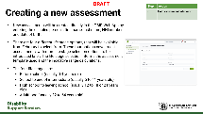 | Creating a new assessment  - DO: Display slide 61  - SAY: The process steps indicated on this and the following slides in this section will be demonstrated in the demonstration video (Session 5 of this training).  - CLICK + SAY: New assessments will be created directly in the OBIR Web App by entering the disabled person’s first name, last name, NHI number and date of birth.  - CLICK + SAY: There are four different life stage options that will be available from February to select from. These four options cover most assessments, with more life stage selection options to be introduced later. The life stage selection informs the assessment template used and the indicative range calculations.  - CLICK + SAY: The four life stages are:  - Before school (0-4 years old)  - School to end of intermediate (5 to 11 years old)  - High school to leaving school (12 to 18 or 21 years old)  - Adulthood (22 to 64 years old)
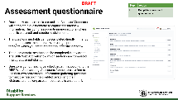 | Assessment questionnaire  - DO: Display slide 62  - CLICK + SAY: Once a new assessment is created, the NASC Assessor or EGL Site Connector will complete a questionnaire to capture the interview information. This comprises questionnaire sections (where detail is captured) and structured statements.  - CLICK + SAY: The questionnaire fields can be completed directly in the tool during the assessment interview or using a printable template which you can enter into the tool after the interview. The option to download this template will be demonstrated in the demonstration video.  - CLICK + SAY: The questionnaire sections can be completed in any order. The OBIR Web App will show which sections are completed, in progress, or not started.  - CLICK + SAY: Questions do not need to be asked verbatim according to the OBIR Web App wording. Assessors/Connectors are free to use their own professional information gathering questions to meet the needs of the disabled person and their whānau/carer as long as each focus area is covered off.
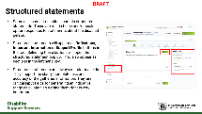 | Structured statements  - DO: Display slide 63  - SAY: Within the assessment questionnaire there are some structured statements you will need to answer. These are very important so we will talk about them in a little more detail now.  - CLICK + SAY: Some assessment questions contain structured statements. These are multi-choice and/or scale option responses to statements about the disabled person.  - CLICK + SAY: Structured statements will appear as Reflections, Important Information or Support Profile buttons in the tool. Selecting these buttons will open the structured statement pop up. They also appear as sections in the left-hand key.  - CLICK + SAY: Structured statements are always mandatory fields. They are critical input fields for generating an indicative range calculation so getting them right is very important. How to identify and complete these in the OBIR Web App will be demonstrated in the demonstration video.
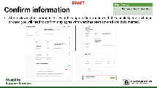 | Confirm information  - DO: Display slide 64  - SAY: After reviewing the summarised view of the captured information with the disabled person, whānau or carer, you will need to confirm they agree with what has been covered and documented. There is a confirmation field in the OBIR Web App to action this. This will be showed in the demonstration video also.
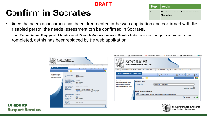 | Confirm in Socrates  - DO: Display slide 65  - SAY: Once the needs assessment has been documented in the OBIR Web App and confirmed with the disabled person, the needs assessment can be confirmed in Socrates. This is an existing step.  The Functional Support Needs and Needs Assessment Goals tabs are no longer required to be filled out with all the detail from the assessment interview, as this information will be captured in the OBIR Web App. If the field in Socrates is mandatory for workflow to trigger the next step, N/A can be entered to action this.
Wrap up / Q&A
- DO: Display slide 66
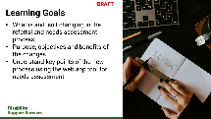 | Learning goals  - DO: Display slide 67  - SAY: Our aim for this session has been to cover:  - What is and isn’t changing in the referral and needs assessment process  - Purpose, objectives and benefits of the changes  - Understand key points of the new process using the web app tool for needs assessment
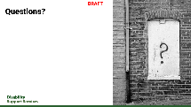 | Questions  - DO: Display slide 68  - DO: Pause to hear and respond to or record questions from participants.
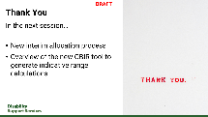 | Thank you  - DO: Display slide 69  - SAY: In the next session we will cover the interim allocation process which will be implemented from February onwards.

Session 4: Allocation process
Purpose – This session provides an overview of the interim allocation process that will be implemented in February 2026, including the use of the new OBIR calculator tool for indicative range calculations and My DSS Funding Plan. The information covers the purpose, objectives and benefits for the improvements, a look at the interim process steps and guidance for generating and using My DSS Funding Plans. This session will help participants understand what is changing in the allocation process and provide foundational knowledge for creating and using My DSS Funding Plans.
(11 minutes)  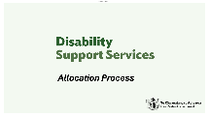 | Allocation process  - DO: Display slide 70  - SAY: In this session we will be talking about the interim allocation process that will be in place from February onwards when we go live with these improvements.
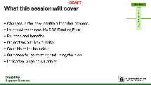 | What this session will cover  - DO: Display slide 71  - SAY: We will cover changes in the new interim allocation process, introduce the new My DSS Funding Plan, including its purpose, benefits, conditions for what can be included in the plan, guidance for generating and using the plan, and a high level view of indicative range calculations.
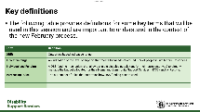 | Key Definitions  - DO: Display slide 72  - SAY: You may see some terminology that is new or unfamiliar coming up. The following table provides definitions for some key terms that will be used in this session and are important to understand in the context of the new February process. A more detailed Glossary is being developed and be available to us as a learning resource to refer back to.
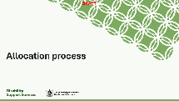 | Allocation process  - DO: Display slide 73  - SAY: In the following three slides we will look at the interim allocation process at a high level, relevant to the wider business process, and where certain process steps may look a bit different when we go live.
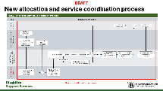 | New allocation process steps  - DO: Display slide 74  - DO: The illustrated process map on the screen shows the high-level process steps that are relevant for the interim allocation process we are discussing in this session. Please remember that these process maps are intended as guidance to illustrate what types of activities are impacted by the allocation process improvements and may not reflect exactly how we do things.
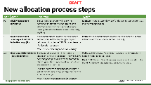 | New allocation process steps Part 2  - DO: Display slide 75  - DO: Pause to allow time for the participants to understand what is being shown in the table.  - SAY: This is a more detailed view of the individual process steps in the process flow map on the previous slide. It is intended as a reference to explain what is meant for each of the process steps, showing a description of the step and what system or systems are used to complete the step. This slide shows process steps 9b to 11.
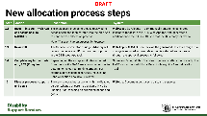 | New allocation process steps Part 2  - DO: Display slide 76  - DO: Pause to allow time for the participants to understand what is being shown in the table.  - SAY: This is a continuation of the table in the previous slide, now showing process steps 12 to 15.
New allocation process steps Part 3
- DO: Display slide 77
- DO: Pause to allow time for the participants to understand what is being shown in the table.
- SAY: This is a continuation of the table in the previous slide, now showing process steps 16 to 18.
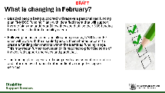 | What is changing in February?  - DO: Display slide 78  - SAY: There are a number of key changes to be aware of in the allocation process that will take place in February. Let’s recap this quickly.  - CLICK + SAY: Disabled people being supported will receive a personalised funding plan (‘My DSS Funding Plan’) with identified intent that will support them to plan and understand how they could utilise their DSS funding to meet their identified disability needs.  - CLICK + SAY: Following the assessment and allocation process, NASCs and EGL sites will work with the disabled person, their whānau or carer to create a funding plan that fits within the identified funding range. This may mean further conversation is required to prioritise some of the desired supports, services and purchases.  - CLICK + SAY: The funding plan is generated using needs assessment information and informed by a financial output indicative range for support services.
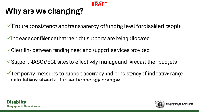 | Why are we changing?  - DO: Display slide 79  - SAY: There are five reasons we are making this change:  - To introduce more consistency and transparency of funding level for disabled people  - To increase confidence that the right supports are being allocated  - To provide a clear link between funding need and the support services provided  - To support us to effectively manage and forecast our budgets  - And finally – noting that these are temporary measures to support the accuracy and consistency of indicative range calculations ahead of further technology changes later in the year when the functionality is ready to be rolled out.
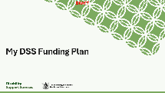 | My DSS Funding Plan  - DO: Display slide 80  - SAY: Let’s look at the My DSS Funding Plan in a little more detail now.  - DO: Display slide 81  - CLICK + SAY: My DSS Funding Plan is a templated, measurable funding tool to help disabled people and those supporting them to plan and understand how they could utilise their DSS funding, providing more clarity and control for decision making.  - CLICK + SAY: It is an agreement between the government and disabled person on the funding needs for supports and services to meet their disability need.  - CLICK + SAY: A DSS funding plan, with identified outcomes, also assists everyone involved to see and understand what DSS is funding and why.  - CLICK + SAY: We’ve included here a high-level summary of the key components of the plan. It contains:  - Identification of the purpose(s) that funding was allocated for  - Potential supports to realise specified outcomes  - How much each support will cost DSS (if anything)  - How much funding is being budgeted in total
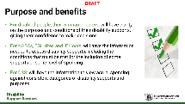 | Purpose and benefits  - DO: Display slide 82  - SAY: There are three key planned benefits for transitioning to a new, nationally consistent funding plan template. This slide explains how it will benefit disabled people, NASCs and EGL Sites, and DSS.
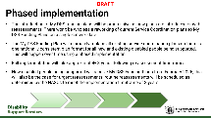 | Phased implementation  - DO: Display slide 83  SAY: It is important to reiterate here that the introduction of My DSS Funding Plan will be phased over time. There won't be wholesale reworking of current Service Coordination plans to My DSS Funding Plans on a single cutover date.  SAY: The My DSS Funding Plan will ultimately replace all existing service coordination plans so we ultimately end up with one nationally consistent plan for all new and existing disabled people being supported. This will happen over approximately 3 years, following scheduled re-assessment timeframes.​  SAY: New disabled people being supported will receive My DSS Funding Plans from February 2026, this will also be the case for urgent reassessments. Routine reassessments will transition across to the new plans when their reassessment is carried out. ​
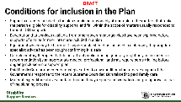 | Conditions for inclusion in the Plan  - DO: Display slide 84  - SAY: There are a number of conditions for what can be included in the My DSS Funding Plan, which have been set by DSS. We will run through them quickly here.  - CLICK + SAY: Supports or costs included in the plan should be reasonably attributable to the matters that make the person eligible for disability supports, and fall within the scope of matters usually responded to through DSS supports  - CLICK + SAY: Expectation that services available from other government agencies have been explored before supports of similar form or intent are included in a plan  - CLICK + SAY: Equipment which may be harmful if inappropriate should be included in a plan only if appropriate specialist advice has been sought confirming it is safe  - CLICK + SAY: Equipment which may be harmful if inappropriate should be included in a plan only if appropriate specialist advice has been sought confirming it is safe  - CLICK + SAY: Paid Family Care arrangements must give effect to any conditions that emerge as part of the Government’s response to the recent Supreme Court decision related to paid family care  - CLICK + SAY: Material expenditure above a certain threshold may require a conversation and pre-approval as part of the planning process  FACILITATOR NOTE: A note in relation to Paid Family Care (PFC) arrangements: The implications of the recent Supreme Court decision are currently being assessed by DSS. Further information and training about this will be released from DSS when ready to be shared.
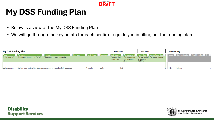 | My DSS Funding Plan  - DO: Display slide 85  - SAY: Below is a high-level view of the new My DSS Funding Plan. Note that this is indicative as the Plan template is still being signed off, so small changes to wording or format may happen between now and when we go live and start using it. Don’t worry if you are struggling to see the detail of the screenshot on this slide as the Plan will also be shown in the live demonstration video, and the recording also shows how to enter dummy details into the Plan so that we can see how it works and should be used.  - SAY: In the next few slides we will discuss the key points for the left hand three sections of the Plan to guide you in how to fill this out.
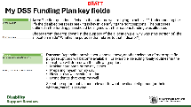 | My DSS Funding Plan key fields  - DO: Display slide 86  - SAY: Let’s look at the “Area” field first. The purpose of this field is to ask “what is the outcome we are trying to achieve?”. Understanding the life the disabled person is seeking is key in identifying the right supports. The purposes outlined in the funding plan should be aligned with the reasons funding was allocated.  This is a multiple-choice drop-down field where you can choose the purpose of the allocation (i.e. why was (this portion of) the allocation made? What is the purpose that relates to that indicator?)  - SAY: Looking at the Purpose field next, depending on what you choose for the Area field, another drop-down selection of more specific purpose options will become available. For example, selecting “Daily routines” in the Area field drop-down will make the following Purpose field options available from the drop-down in this column:  - Making hard parts of the day easier  - Preparing myself for my day  - Having my own evening routine  - Doing things that keep me well  You will select the option that is most relevant to what the disabled person (or their whānau/carer) is seeking.
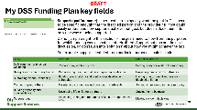 | My DSS Funding Plan key fields  - DO: Display slide 87  - SAY: Looking at the Support field now, which is about the specific goal or outcome for the allocation, this is a free text field. You will need to type text here to specify what the goal of the support is. This needs to be specific enough that the disabled person and the provider / IF host could easily understand how supports achieve that goal but doesn’t lock them into only one way of being supported.  SAY: A note here that it is recommended we do not jump straight to this section – the goals need to flow from the purposes for which funding was allocated, not retrofitted. Support options are the next discussion, so don’t rush into ‘solutions’ about how you might achieve the goal.  SAY: In the table at the bottom of the slide there are some examples of what could be entered in the support field, depending on what Area and Purpose options have been selected; to give you an idea of what type of information would be appropriate for this field.
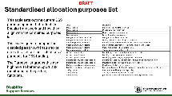 | Standardised allocation purposes list  - DO: Display slide 88  SAY: This table sets out the current DSS Area and Purpose field options that will be available as dropdowns to select from in the My DSS Funding Plan. Again, noting that these are a point in tie view, and as Plan testing and sign off is completed there may be some small changes.  SAY: The options are designed to reflect the Enquiry framework and how they align with the combined purposes list. This is designed to support the disabled person (whānau and/or carers) to set out their intentions / purposes for DSS funding. The Purpose list groups this at a high level to better support DSS monitoring and reporting functions.
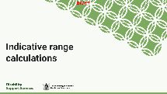 | Indicative range calculations  - DO: Display slide 89  - SAY: We will now provide a bit more information about indicative range calculations.
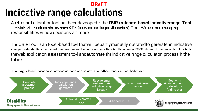 | Indicative range calculations  - DO: Display slide 90  - SAY: A refreshed allocation tool has been developed – the OBIR (outcome-based indicative range) Tool – which will replace the current SPA (service package allocation) Tool. We are not changing responsibilities or how decisions are made.  - SAY: The OBIR Tool is an Excel-based tool that will be partly manually operated to generate an indicative range calculation for each assessment when we go live in February. DSS plans to integrate this into the web application assessment tool and automate the indicative range calculation process in the future; initially it will be a largely manual process to transfer information between this Excel-based calculator and the OBIR Web App and to calculate the indicative range for funding. This will be actioned by a centralised team in DSS as an interim process.  - SAY: The process flow diagram at the bottom of the slide illustrates how generating indicative range calculations fits into the wider business process for allocation.  - Do: Display slide 91  - CLICK + SAY: The indicative range calculation is generated using the assessment interview information captured in the web application.  - CLICK + SAY: The NASC/EGL site is responsible for the accuracy, completeness and quality of the data collected in the assessment interview. This information directly affects the output of the indicative range calculation. The funding decision remains with the NASC/EGL site.  - CLICK + SAY: The indicative range calculation output:  Is an indication of the level of support that meets the needs of around 80% of people in similar circumstances. It is a guide for what might be provided to meet those needs.  Is not an approved allocation of resources or a commitment. I.e. it’s not a budget or a capped allocation amount of money that can be spent, but rather intended to act as a guide when putting together a package of support services that is appropriate.
Wrap Up / Q&A
- DO: Display slide 92
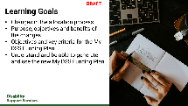 | Learning Goals  - DO: Display slide 93  SAY: In this session we have covered changes in the allocation process, the purpose, objectives and benefits of the changes, and provided guidance on the new My DSS Funding Plan so that you can understand and be able to generate and use the new My DSS Funding Plan.
Questions
- DO: Display slide 94
- DO: Pause to hear and respond to or record questions from participants.
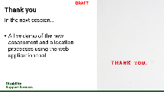 | Thank you  - DO: Display slide 95  - SAY: In the next session we will play a recording of a live demonstration of the assessment and allocation process as it will be carried out using the OBIR Web App tool when we go live with the AAFF improvements. This was first delivered to AAFF trainers as part of our Train-the-Trainer training.

Session 5- Live demo with case study
Purpose – This session is a recording of the live demonstration of the new OBIR web application tool and how it will be used to carry out the assessment and allocation processes introduced in sessions 3 and 4, which was delivered as part of Train-the-Trainer training. This session will help participants see the tool in action with a fictional scenario to bring the learning to life and demonstrate good practice usage of the tool following the new processes.
(4 minutes)  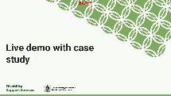 | Display the demonstration video/s  - DO: Display slide 96  - SAY: We will now play the demonstration video/s of the new processes carried out using the OBIR Web App tool. Please note down any questions you have during the video and we will review these after the recording.  - DO: Play the demonstration video/s
Wrap Up / Q&A
- DO: Display slide 97
- DO: Pause to hear and respond to or record questions from participants.
Learning Goals
- DO: Display slide 98-101
- SAY: The purpose of the demonstration video/s was to show you how the tools will be used in practice to help you to understand and be able to follow the new assessment and allocation processes in the OBIR Web App.

Q&A, What’s to come and closing
Purpose – This section is an opportunity to hear, record and respond to any remaining questions from participants relating to any of the AAFF training sessions if additional time for questions is needed. If there are no further questions you can skip forward to Next Steps so that the participants know what to expect and what learning support and resources will be provided in the lead up to, and following go live.
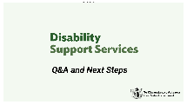 | Q&A and Next Steps  - DO: Display Slide 102  - SAY: Before we complete this training we will provide an opportunity for us to discuss any remaining questions relating to any of the AAFF training that has been provided to you, and talk about what you can expect in terms of training information and support as we prepare to go live.
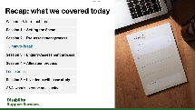 | Recap: what we have covered  - DO: Display slide 103  - SAY: Here is a recap of the training sessions that have been delivered for NASC / EGL Site training on the AAFF Phase 1 improvements that will go live in February 2026.
 | General Q&A  - DO: Display slide 104  - SAY: This is an opportunity for us to discuss any remaining questions relating to any of the AAFF training that has been provided to you.  - DO: Pause to hear and respond to or record questions from participants.
 | Next Steps  - DO: Display slide 105  - SAY: Let’s talk about the next steps after this training is completed.
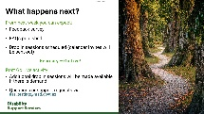 | What happens next?  - DO: Display slide 106  - SAY: The DSS team will organise for drop-in sessions to be scheduled in the lead up to go live where you will have the opportunity to ask more questions or clarify anything relating to the upcoming changes. Additional drop-in sessions will be scheduled after go live if there is demand for them.  - SAY: There will also be an FAQs document published that contains common or important questions and answers relating to the AAFF improvements. It will be managed and updated by DSS to add or evolve the content as we roll out the changes. This will be an important reference document that we can use and refer back to when questions arise.
 | Additional information and support available to you  - DO: Display slide 107  - SAY: There are a number of information and support resources being developed by DSS to support us to prepare for the upcoming improvements and smoothly transition to using the new tools and ways of working. The key items are listed here. We will receive more information from DSS with the locations of where relevant documents will be saved and accessible from.
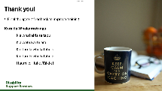 | Thank you  - DO: Display slide 108  - DO: Thank the participants for attending and close the training with a karakia if appropriate. An example karakia has been provided on the slide as a reference.
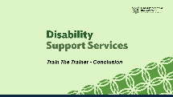 | Closing  - DO: Display slide 109 to complete the training

