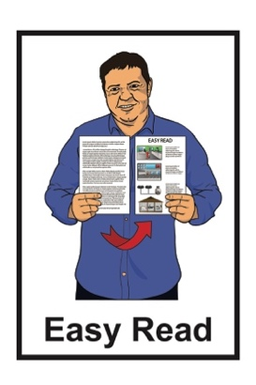
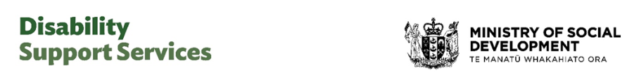

Factsheet:

Government introduces the Disability Support Services Bill
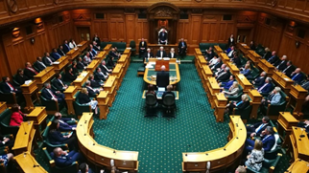

Published: May 2026

What is in here

Page number:
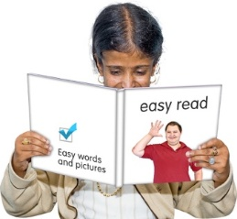

About this Easy Read 2

What is Disability
Support Services? 6
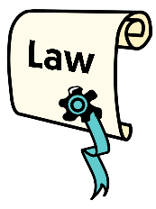

What would the DSS Bill do? 10
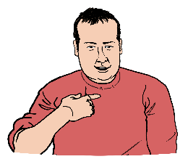

What does this mean for
disabled people now? 17
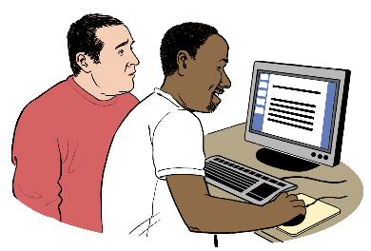

Have your say about the DSS Bill 20

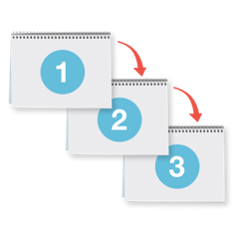
What happens next? 21

About this Easy Read

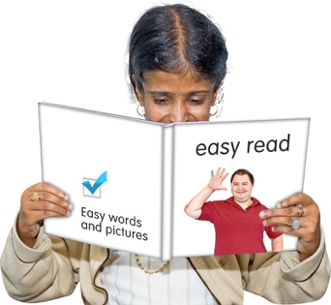
This Easy Read is from Disability Support Services at the Ministry of Social Development.

In this Easy Read Disability Support Services will be called DSS.
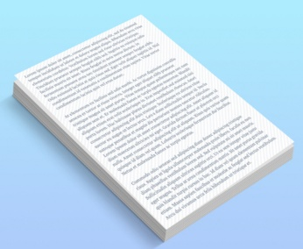

Where it says we / our / us in this Easy Read document it means DSS.

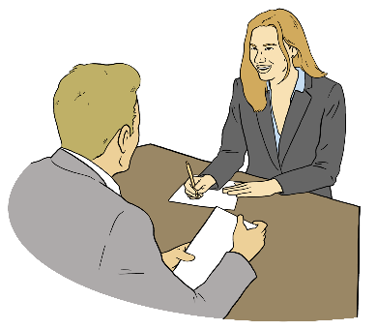
This Easy Read is about the Disability Support Services Bill the Government has introduced / shown to Parliament.

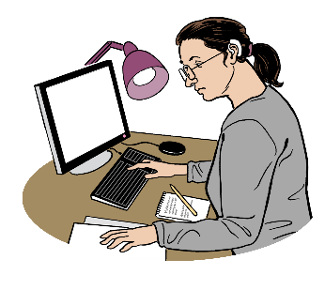
Parliament is the part of the Government where decisions are made about how New Zealand should be run.

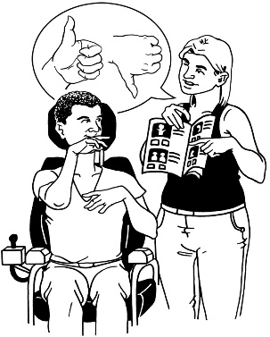
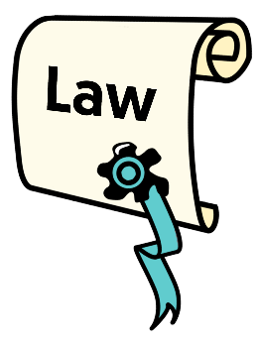
The Disability Support Services Bill is a law the Government has made about Disability Support Services.

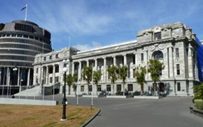
Here a Bill is when the Government:
makes a:
- new law
or
- changes an old law
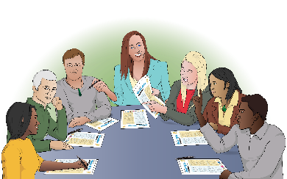
and
shows it to Parliament to find out what they think about it.
A law is a rule made by the Government that everyone must follow.

The Disability Support Services Bill is now going through a Parliamentary process.

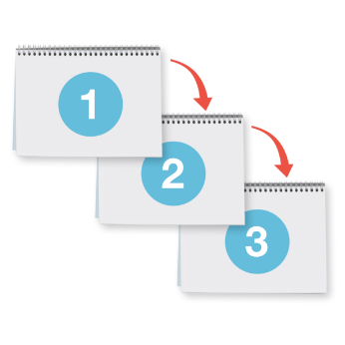
Parliamentary process means the steps to take a bill to a vote in Parliament.


As part of this process people can make a submission on what:
they think about this Bill
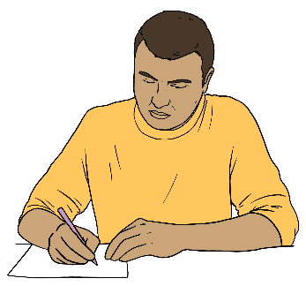
things should be changed to make it work better for disabled people.

Here a submission is a way to tell the Government what you think
about the Bill.


Information about making a submission is on page 20.

What is Disability Support Services?


DSS funds / pays for support for disabled people.


These funds support disabled people to live as independently as possible.

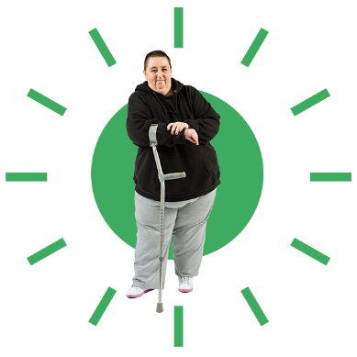
Here independently means:
doing things for yourself
making your own choices.

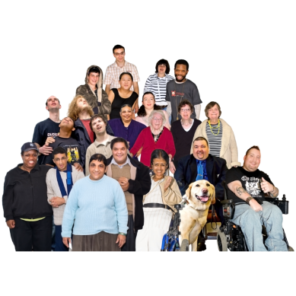
There are about 55 thousand people getting funded support from DSS each year like:
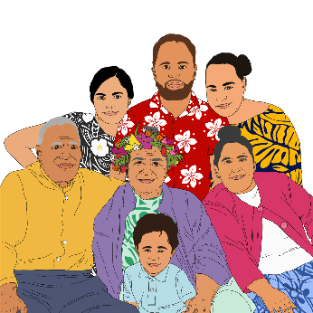
disabled people
whānau / families of disabled people.
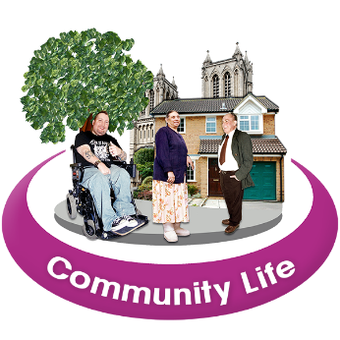
People being funded are living in:
the community
residential care.

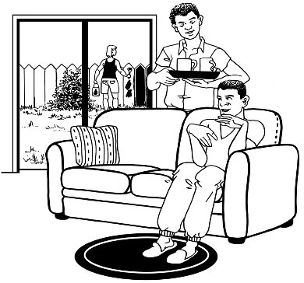
Residential care is when disabled people:
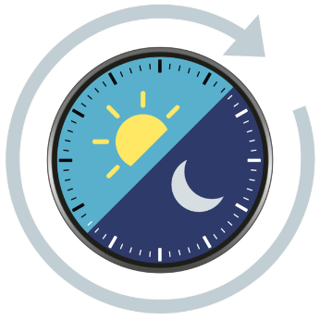
live in a home / flat in the community
get support all through the day and night.

There are about 100 thousand people getting environmental support services to assist them to take part in:
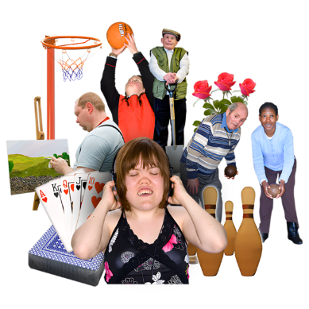
family life
community life.

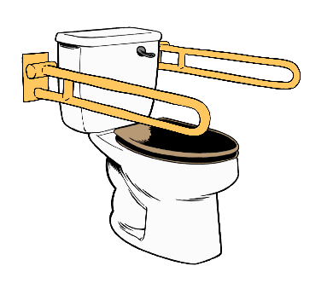
Environmental support services can be things like:
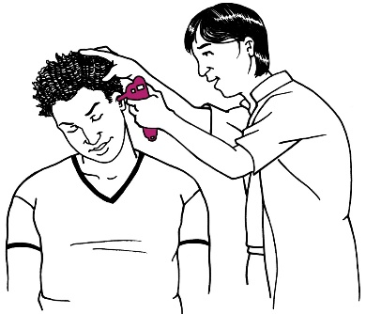
changing something like a bathroom so it works better for a disabled person
supporting people to get hearing aids
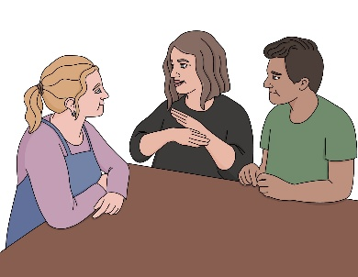
getting Deaf people New Zealand Sign Language interpreters when they need them.
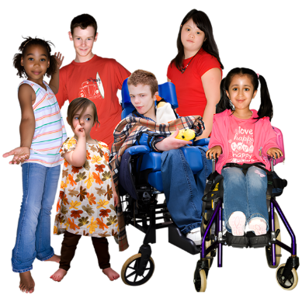

Around 26 thousand children get child development services each year.


These services support children to reach their developmental milestones.

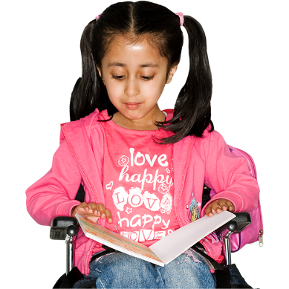
Developmental milestones are times when children can do something at a certain age.

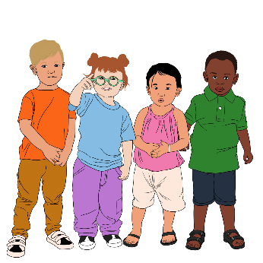
Developmental milestones can be things like when children start to:
walk
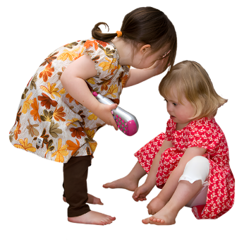
talk
play with other children.

What would the DSS Bill do?
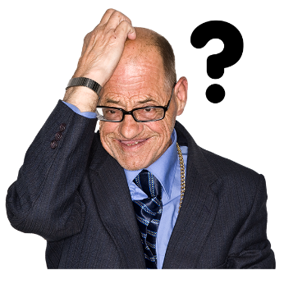

DSS can be very hard to work out how to use.

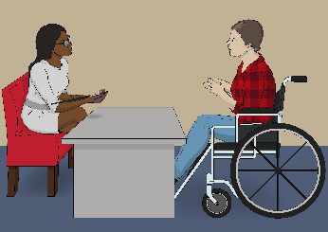
The Bill is about:
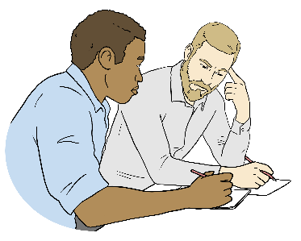
- what people told us to do to make DSS work well for a long time
- having a fair way for disabled people to get funding.

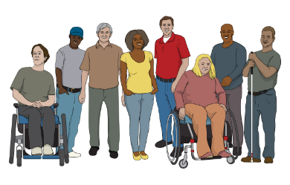
The people who told us what to do about the Bill were:
disabled people
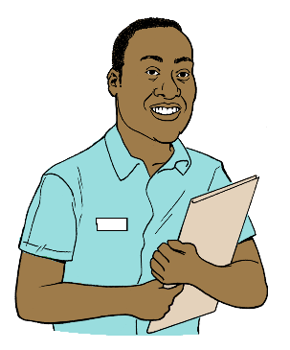
whānau / families of disabled people
carers of disabled people.
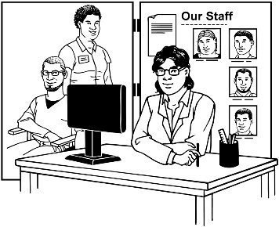
This Bill should work to make DSS easier to use.

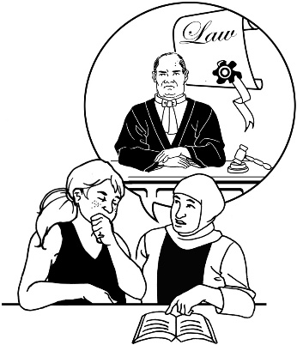
DSS says this Bill does 3 main things:
makes a clear legal foundation for DSS
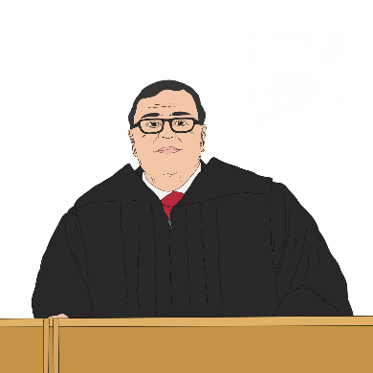
sets out what it means for a disabled person to employ a family member to give them care
answers the decision by the Supreme Court about how paid family care works.

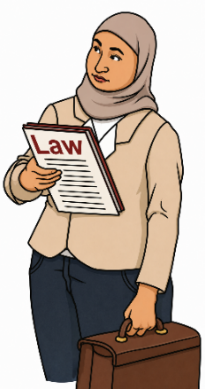
Here clear legal foundation means people will know:
the role DSS has as it will be clear in the law
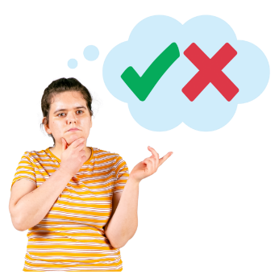
the purpose of / reason for DSS as it will be clear in the law
what the DSS does
how decisions are made at DSS.

Here employ means when a disabled person pays a member of their family to do the job of caring for them.

For more information about the Supreme Court decision visit our website at:

www.disabilitysupport.govt.nz/court
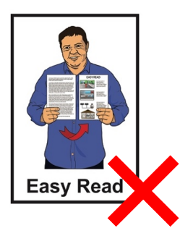

This website is not Easy Read.

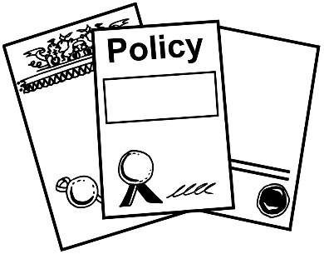
The Bill should give people a clear idea about DSS:
policies
funding / money.

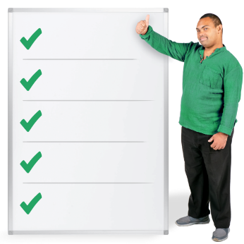
Here policies are the rules around how the DSS supports disabled people.

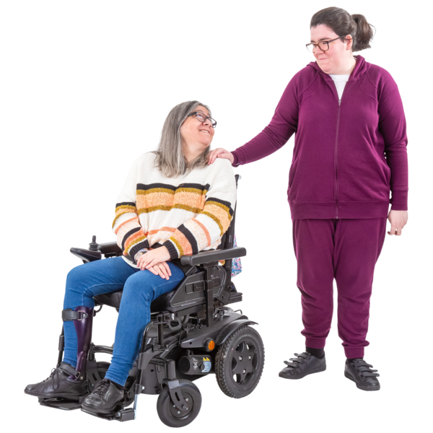
Family carers

Whānau / family play a big part in caring for their disabled family members.

DSS is working on ways to support carers better.

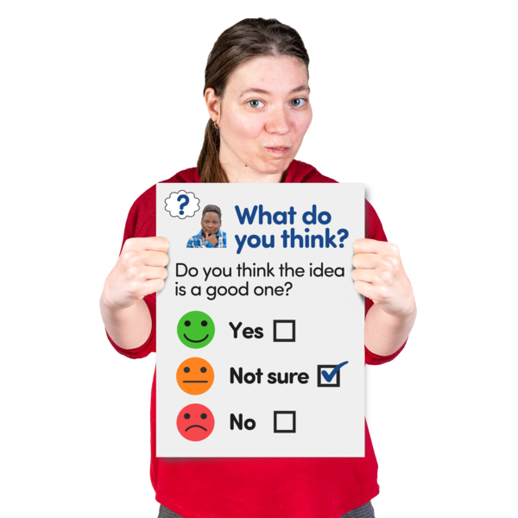
DSS will be asking for people to tell them about what they think about this Bill.

We want to hear from:
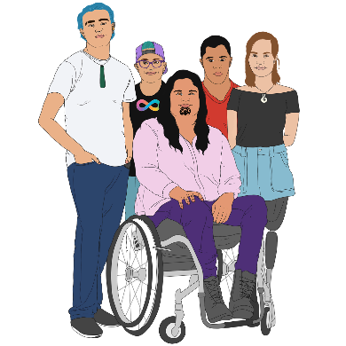
disabled people
whānau / families
carers.

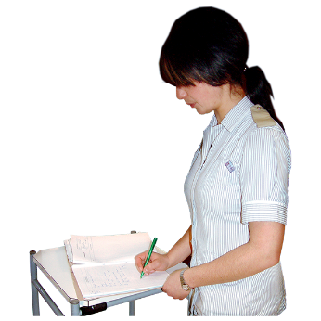

The Bill should reduce some things going wrong like when:
support:
- changes for no reason
- stops for no reason
services start costing disabled people more money which makes them hard to get.

Some court cases have shown there have been problems with how disabled people have been able to get the support they need through DSS.

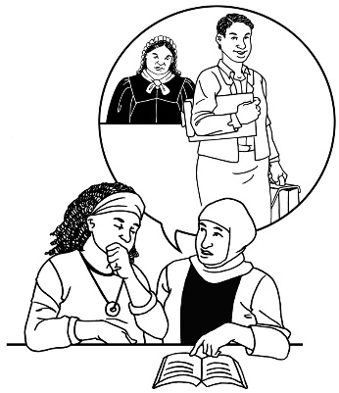
Here a court case is a legal way to sort out things like:
problems
arguments.
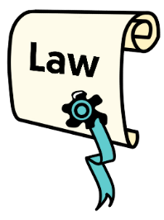
Legal means things about the law.

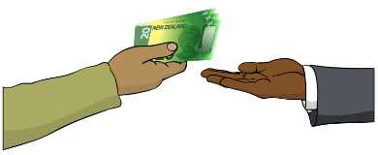
The Bill makes it clear the
Crown / Government:
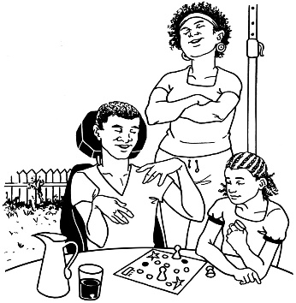
does not employ family carers
was never meant to employ family carers.

What does this mean for
disabled people now?


What does this mean right now?

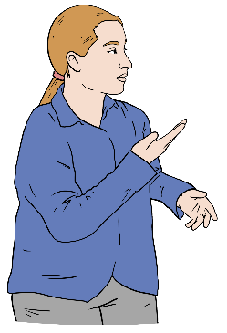
There are no changes to:
the disability support disabled people are getting now
the money disabled people are getting now
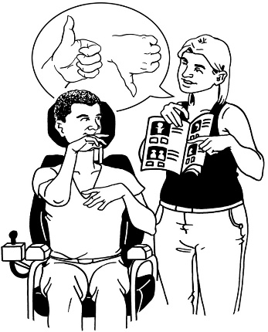
who can get disability support services.

People should keep getting the support they get now.


What supports will change in the future?

The future is time that has not yet happened.

Parliament is now looking at the Bill.

Any changes will be made through the Parliamentary process.
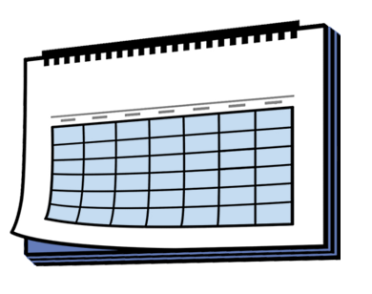

It will take time to make the changes to the DSS Bill.

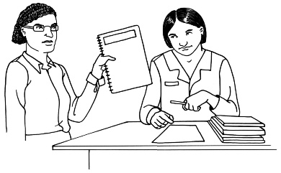
For any changes to DSS in the future we will:
get information to those people who need it like disabled people

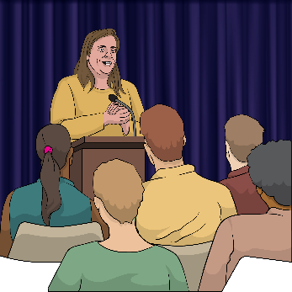
work with people working in disability support to make sure changes will work to make life better for disabled people
- talk with the disability community to find out what they think about the changes.

Have your say about the DSS Bill


You can tell us what you think about the DSS Bill by making a submission.

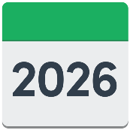
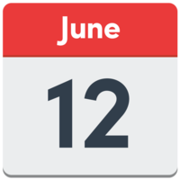
You need to make your submission by Friday 12 June 2026.

Visit this website to make your submission:

www.disabilitysupport.govt.nz/submission

This website is not in Easy Read.


You can find information in Easy Read about how to make a submission at this website:

https://tinyurl.com/59sja8dw

What happens next?

The Bill had its first reading in Parliament on 21 May 2026.


The Social Services and Community select committee is now considering / thinking about the Bill.

A select committee is when a small group of Members of Parliament take a close look at the Bill.


Information about this process is on the New Zealand Parliament website:

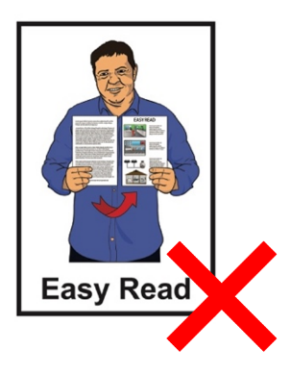
https://www3.parliament.nz/en/pb/sc

This website is not in Easy Read.
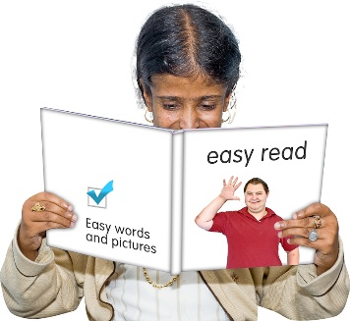
You can find information about Parliament in Easy Read at this website:

https://tinyurl.com/bdfeyajy

You can also find out more information on the website of Minister of Disability Issues Louise Upston:

www.beehive.govt.nz/minister/hon-louise-upston

This website is not in Easy Read.
This information has been written by Disability Support Services at the Ministry of Social Development.

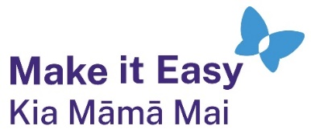
It has been translated into Easy Read by the Make it Easy Kia Māmā Mai service of People First New Zealand Ngā Tāngata Tuatahi.

The ideas in this document are not the ideas of People First New Zealand Ngā Tāngata Tuatahi.

All images used in this Easy Read document are subject to copyright rules and cannot be used without permission.


Make it Easy uses images from:

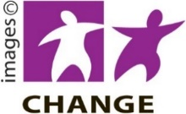
- Photosymbols

- Change Images


- Huriana Kopeke-Te Aho
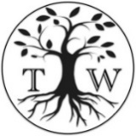
- SGC Image Works

- T Wood


- Studio Rebeko

- Inga Kramer.

