
Save this form to your desktop before filling it out
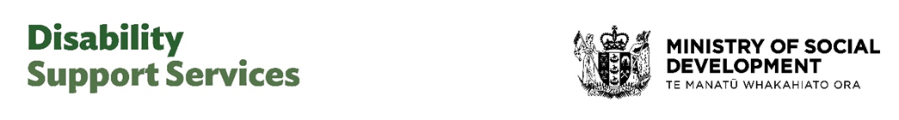
DSS funded services and supports

Complaints Form

If you are unhappy with the quality of disability services or supports funded by Disability Support Services, Ministry of Social Development (DSS), you can make a formal complaint by answering the following questions. You can also use this form to complain if your services or supports are not responsive to Te Ao Māori, or do not meet your cultural needs and expectations.

Please tell us about yourself.
We ask for your contact information so we can respond directly to you. If you don’t want your details to go beyond the DSS complaints team, we will keep your details private. If you do not want to tell us your name, we will still look into your complaint but will not be able to let you know the outcome. Please provide as much information as you feel comfortable sharing with DSS.

Name | Please type your name here
Phone | (Phone number | Email | Please type your email address here

Address | Please type your physical address here

How would you like us to contact you?

- Phone | - Email | - Relay service | - Other | - I don’t want to be contacted
- Post
Can we share your name and your complaint with other people and the service provider?

- Yes, you can share my complaint and my name with the service provider and relevant people at DSS, Ministry of Social Development.
- You can share the details of my complaint, but I want my name kept private.
- No, you cannot share my complaint, my name, or my information with the provider.
- I don’t know. If you choose this option, we will contact you to talk with you about it.

I am making this complaint as a person who is:

- The person receiving the supports or services | - A family member, whānau or friend of the person receiving services
- A staff member of a disability provider | - A member of the public
- Other disability or health professional

If you are making this complaint on behalf of someone else, is the person who received the service aware that you are making a complaint on their behalf? (required information)

- Yes | - No
If no, is there a reason why the person is not aware of this complaint?
Please type your answer here
Who are you complaining about?

Name of organisation | Please type your answer here
Name of the person (if complaint is about a  person) | Please type your answer here
Where in NZ are the supports / services that this  complaint is about (town, city, rural area, region)? | Please type your answer here
Have you complained about this to anyone else? | - Yes | - No

Who else have you told about your complaint?
For example: a disability service, Health and Disability Commissioner (HDC), the Ombudsman, Needs Assessment Service Coordination agencies, I have complained to DSS about this issue before etc.
Please type your answer here

Tell us about your complaint or what made you unhappy.
Provide some details to help us understand your concerns. You can include what happened, when it happened and who was involved, or the decision made by the provider that you are unhappy about.

Please type your answer here

How can we help you make your situation better?
Please type your answer here

Thank you for taking the time to provide details of your complaint to DSS, Ministry of Social Development.

Email the completed form to quality@msd.govt.nz

If you have asked us to contact you, we will aim to be in touch within five working days. If you want to contact us again, please email or phone:

- Email quality@msd.govt.nz
- Phone 0800 566 601

