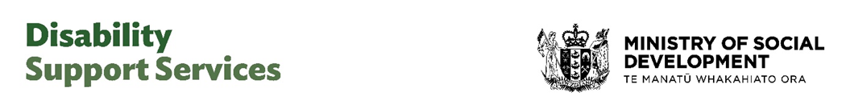
June 2026 factsheet—DSS consultation
Adapted in 2026 by Accessible Formats Service,
Blind Low Vision NZ, Auckland
TN: The logo on the top of the page is Disability Suport Services and Ministry of Social Development Te Manatū Whakahiato Ora

Have your say on further improvements to services
We are inviting disabled people, families, whānau and carers to help shape further improvements to disability support services.
We want to improve services in key areas that the disability community has told us matter most to them.

We are building on what you've already told us
Your feedback has already shaped some important changes.
Over the past two years, we have listened to the disability community and taken action to stabilise the disability support system.
This has made access to DSS-funded supports more fair, consistent and sustainable, while restoring more choice and control for people who use flexible funding.
We know there is more to do.
You have told us what the issues are—now we want to know what good looks like for you.
Your input will help shape the next improvements to services and supports.

Seeking community input to improve key areas
We are asking for your input on some key areas:
- Outcomes that matter—being clearer about the difference that DSS-funded supports make in disabled people's everyday lives and safety.
- Earlier, proactive and planned support—planning the right support at the right time as people's needs change over time.
- Feedback and complaints—making it easier to speak up about the services of DSS providers.
- Better options for carer respite—improving options for respite so it is easier for carers to take a break.
- More choice and control in services—offering more flexibility in the supports we fund, outside of flexible funding.
- Improved information and advice—making it easier to get information and access DSS supports and services.

Consultation dates
- Opens on Monday, 8 June 2026
- Closes at 5pm Friday, 31 July 2026

How to have your say
From 8 June to 31 July, you can take part in the consultation in a way that works for you:
- Complete an online survey. You can answer as many or as few questions as you like.
- Make a written or recorded submission—you can find the questions in the full discussion document, and the summary.
- Join an online or in-person workshop. There are many dates to choose from.

Find the consultation documents or register for a workshop
To find the consultation documents or register for a workshop go to www.disabilitysupport.govt.nz/haveyoursay.
The consultation documents include summaries in alternate formats as well as Tongan, Samoan and te reo Māori translations.

What happens next
After the consultation closes, we will:
- review and summarise what we hear
- share a summary of what you told us
- use your feedback to make improvements.

More information
Go to www.disabilitysupport.govt.nz/haveyoursay.
End of June 2026 factsheet – DSS consultation

