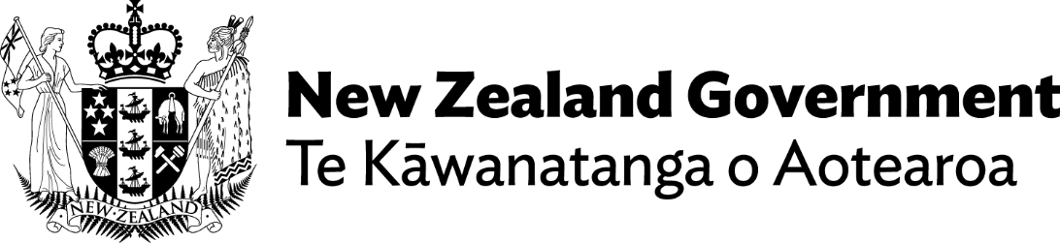

Foundational legislation strengthens support
Adapted in 2026 by Accessible Formats Service,
Blind Low Vision NZ, Auckland
Transcriber's Note: The logo at the top of the page is New Zealand Government — Te Kāwanatanga o Aotearoa
Hon Louise Upston
Minister for Disability Issues
1 September 2026

Foundational legislation strengthens support
The voice of the disability community is reflected in Disability Support Services legislation which passed its final reading in Parliament today.
Minister for Disability Issues Louise Upston says the new legislative framework for DSS will be crucial in delivering improved support for thousands of New Zealanders who rely on it.
"This is an important piece of legislation which helps strengthen support for disabled people and those who care for them. Our opportunity now is to continue making further improvements," Louise Upston says.
"I again acknowledge the disability community and the Social Services and Community Select Committee for their input to the recent process. As a direct result of their feedback, important changes agreed to by the House include:

- Making the overall intent in representing the current state of Disability Support Services clearer. This includes clarity about the role of families, and better recognising the importance of choice, safety and dignity.
- The legislation explicitly makes it clear that the Government, through DSS, will continue to support families by contributing to care for disabled people. No additional expectations will be placed on families.
- The legislation makes it clear disabled people will have a stronger voice in future decisions. It explicitly requires formal consultation through disabled people's representative organisations on future Support Programmes.
- Addressing concerns around the United Nations Convention on the Rights of Persons with Disabilities and Enabling Good Lives, the legislation now reflects the language of the UNCRPD and the EGL principles.
"As Minister, I recognise that the intent of the Bill as first presented wasn't as clear as it should have been. Through the Select Committee process and community submissions, we heard this and we have acted.
"This legislation is important because Disability Support Services has been operating without a legal framework.
"It reflects the way DSS already works. It does not change current eligibility, entitlements or support, or introduce income or asset testing where it is not currently used.
"It will improve consistency, fairness, transparency and sustainability, building on our work after the 2024 Independent Review.
"Over the past two years our Government has taken urgent action to introduce a nationally consistent assessment process, stabilise its services, improve its financial sustainability, and give people more choice and control over flexible funding.
"We have also committed to $2.1 billion in additional funding through successive budgets which means DSS now has more ongoing funding to support disabled people than ever before. There are more improvements needed and we will soon begin consulting on a carers' package," Louise Upston says.
Relevant link
https://www.disabilitysupport.govt.nz/improving-dss/dss-legislation or here www.disabilitysupport.govt.nz/dss-leg
End of Foundational legislation strengthens support

